BAKARE SHARAFADEEN OMOGBOLAHAN

17/ENG04/014

ELECT ELECT

Section A

Question 1

Develop the theoretical framework required for the correction of the power factor for a multi - sectioned industrial complex from $Cos ∅_{1}$ to $Cos ∅_{2}$ where $∅_{1}>∅_{2}$; $P_{1}=P_{2}$; $Q_{1}>Q_{2}$; and $S_{1}>S_{2}$ to determine the kVAR rating of the capacitor $(Q_{CAP})$ and the magnitude of the capacitor (C) in farads required to correct the power factor of the complex. **USE APPROPRIATE PHASOR DIAGRAMS.**

Answer

]



kVAR supplied by p.f correction equipment= Qcap= Q1 -Q2

Qcap= kVAR1- kVAR2

Qcap= P2(tan Θ1-tan θ2)

Recall Q= V2/XC

Therefore XC=V2/ Qcap

Also for capacitors; XC= 1/2πfC

Therefore C= 1/2πfXC

Question 2

What determines the power factor of the Dangote Cement Factory at Abajana, Kogi State?

Answer

The power factor of Dangotes Cement Factory at Abajana, Kogi State is determined by both the Apparent power (S) in KVA and the Working power (P) in KW, in other words by Dividing the working power by the apparent power.

For a more practical and effective method; it is known that the power factor of dangotes cement factory varies along the time. So, only typical values are obtained, potentially, the highest and lowest values of these parameters (Apparent and Working power). To acquire information about the power factor, connect an energy analyzer with the recording capacity. Then, analyzing the obtained data in typical days of the factory; should give the potential values needed to obtain the power factor.

Power factor is an expression of energy efficiency. It is usually expressed as a percentage—and the lower the percentage, the less efficient power usage is.

Power factor (PF) is the ratio of working power, measured in kilowatts (kW), to apparent power, measured in kilovolt amperes (kVA). Apparent power, also known as demand, is the measure of the amount of power used to run machinery and equipment during a certain period. It is found by multiplying (kVA = V x A). The result is expressed as kVA units.

PF expresses the ratio of true power used in a circuit to the apparent power delivered to the circuit. A 96% power factor demonstrates more efficiency than a 75% power factor. PF below 95% is considered inefficient in many regions.

Question 3

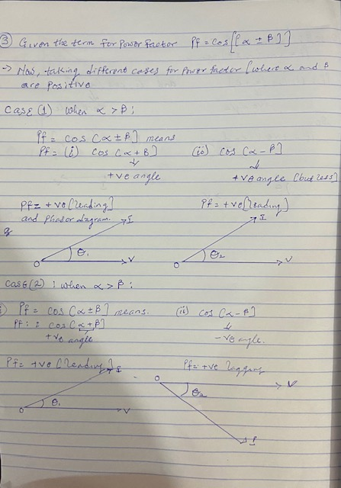 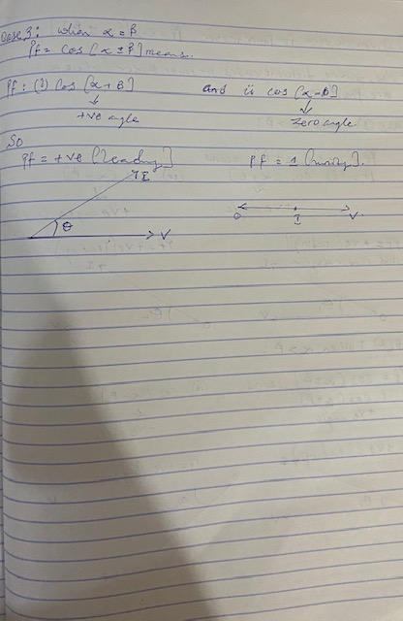

The power factor (pf) of Eleme Petrochemical Industry PortHarcourt is given as $\operatorname{Cos}\left(α±β\right)$; what is the state of the pf of the complex when $α>β$; $β>α$ and $α=β$. Draw the respective Phasor diagrams.

Answer

Question 4

For $α>β$; Write an expression for P and Q respectively with units in W and VAR. What does P and Q REPRESENT?

Answer

P=I*Vcos(α±β)

Q=I*Vsin(α±β)

Where,

P: active power(kW)

Q: reactive power(kVAR)

Question 5

Justify the need for power factor correction to ABUAD and PHCN or an IPP

Answer

Energy and power saving has always been an issue of great concern in the electrical power system, especially in electrical power supply stations,reducing the losses of electrical energy constitutes a great part, Power factor correction of a power system is avery important and vital method to achieve savings, both of energy and cost. If there is low power factor, the system will draw more current and the excessive heat generated will damage/shorten the equipments life.

An insight is using ABUAD MEDICAL CENTRE having various sophiscated laboratories and equipments, if the power factor is low, then it will affect the durability and life span leading to excessive of cost and reduced productivity. The amount of activities that’s taken place so the power factor correction is a necessity and it lower cost.

* Savings on the electricity bill
* Power factor correction eliminates penalties on reactive energy, decreases demand on kVA, and reduces power losses generated in the transformers and conductors of the installation.
* Increased available power
* Fitting PFC equipment on the low voltage side increases the power available at the secondary of a MV/LV transformer. A high power factor optimises an electrical installation by allowing better use of the components.
* Reduced installation size
* Installing PFC equipment allows conductor cross-section to be reduced, as less current is absorbed by the compensated installation for the same active power.
* Reduced voltage drops
* Installing capacitors allows voltage drops to be reduced upstream of the point where the PFC device is connected, therefore preventing overloading of the network and reducing harmonics.

Question 6

Why is Q needed in an industrial complex with numerous induction motors?

Answer

* Voltage control in an electrical power system is important for proper operation for electrical power equipment to prevent damage such as overheating of generators and motors, to reduce transmission losses and to maintain the ability of the system to withstand and prevent voltage collapse.
* Decreasing reactive power causing voltage to fall while increasing it causing voltage to rise. A voltage collapse may be occurs when the system try to serve much more load than the voltage can support.
* When reactive power supply lower voltage, as voltage drops current must increase to maintain power supplied, causing system to consume more reactive power and the voltage drops further . If the current increase too much, transmission lines go off line, overloading other lines and potentially causing cascading failures.
* If the voltage drops too low, some generators will disconnect automatically to protect themselves. Voltage collapse occurs when an increase in load or less generation or transmission facilities causes dropping voltage, which causes a further reduction in reactive power from capacitor and line charging, and still there further voltage reductions. If voltage reduction continues, these will cause additional elements to trip, leading further reduction in voltage and loss of the load. The result in these entire progressive and uncontrollable declines in voltage is that the system unable to provide the reactive power required supplying the reactive power demands
* First, the transmission system itself is a nonlinear consumer of reactive power, depending on system loading. At very light loading the system generates reactive power that must be absorbed, while at heavy loading the system consumes a large amount of reactive power that must be replaced. The system’s reactive-power requirements also depend on the generation and transmission configuration.

Section b

1. **An industrial load absorbs 5 MVA at a pf of 40% capacitive at 6kV. To improve the pf up to 85% capacitive, determine Q and C of the required capacitor. State how the correcting equipment will be integrated into the industrial power network for this load.**

**Solution:**

1. *Preamble:*

Apparent power (S) = 5MVA

Voltage = 6KV

Initial power factor= 40%=0.4 leading

Improved power factor=85%=8.5 leading

Where; power factor= $\cos{∅_{1}}$

$\cos{∅_{1}}=0.4$

$∅_{1}=\cos^{-1}*0.4$

$∅_{1}={66.42}^{°}$

Where , S= 5Mva

$$\cos{∅_{1}}=\frac{P}{5*{10}^{6}}$$

P= $0⋅4*5×{10}^{6}$

$$P=2MW$$

$$\sin{∅_{1}}=\frac{-Q}{5*{10}^{6}}$$

-Q= $0⋅916*5×{10}^{6}$

$Q=-4.6MVAR$.

$NOTE$: when improving the power factor,

$${∅_{1}>∅_{2 } , P}_{1}=P_{2, } Q_{1}>Q_{2}, S_{1}>S_{2}$$

Therefore; where ${ P}_{1}=P_{2 }$

Power factor= $\cos{∅_{2}}$

$\cos{∅_{2}}=0.85$

$∅_{2}=\cos^{-1}*0.85$

$∅_{2}={31.788}^{°}$

$\cos{∅_{2}}=\frac{P}{S_{2}}$

$S_{2}$ = $0⋅85*2×{10}^{6} S_{2}=2.35MVA$

$$\tan{∅_{2}}=\frac{{-Q}_{2}}{P}$$

${-Q}_{2}$ = $\tan{0.85*2*{10}^{6}}$

$Q_{2} =-1.24MVAR$.

Where, $Q_{1}= Q_{cap}+ Q_{2}$

, $Q_{cap}= Q_{1}- Q_{2}$

$Q_{cap}=-4.6*{10}^{6}-1.239*{10}^{6}$

$Q_{cap}=-5.8393MVAR$

Obtaining the value for C;

Recall; C= $\frac{Q_{C}}{V_{rms}^{2}*2πf}$

Note: standard frequency in Nigeria = 50Hz

C= $\frac{-5.83*{10}^{6}}{{6000}^{2}*2π*50}$

C= - 515.4*10-6 Farads $≈- 515.4μF$

**7b) State how the correcting equipment will be integrated into the industrial power network for this load.**

From the question, it is stated that the industrial power network is operating on a capacitive load, it can be concluded that it will have a leading (capacitive) power factor; which means that the correcting equipment (capacitor of the minimal size ( -515.4 $μF$)) which will be integrated in parallel to the industrial power network. This industrial power requires a minimal capacitor because it already deficient with leading VARs (it operates at a lagging PF) and thus this deficient power network will absorb the leading VARs and tend to improve its lagging PF to unity.

1. **An industrial load absorbs 5 MVA at a pf of 40% inductive at 6kV. To improve the pf. Up to 85% inductive, determine Q and C of the required and necessary capacitor. State how the correcting equipment will be integrated into the industrial power network for this load. How different are the values of Q7 and Q8 in terms of magnitude and type of pf correction?** *Preamble:*

Apparent power (S) = 5MVA

Voltage = 6KV

Initial power factor= 40%=0.4 lagging

Improved power factor=85%=8.5 lagging

Where; power factor= $\cos{∅_{1}}$

$\cos{∅_{1}}=0.4$

$∅_{1}=\cos^{-1}*0.4$

$∅_{1}={66.42}^{°}$

Diagrammatic representation:

Where, S= 5Mva

$$\cos{∅_{1}}=\frac{P}{5*{10}^{6}}$$

P= $0⋅4*5×{10}^{6}$

$$P=2MW$$

$$\sin{∅_{1}}=\frac{Q}{5*{10}^{6}}$$

Q= $0⋅916*5×{10}^{6}$

$Q=4.6MVAR$.

$NOTE$: when improving the power factor,

$${∅_{1}>∅_{2 } , P}_{1}=P_{2, } Q_{1}>Q_{2}, S_{1}>S_{2}$$

Therefore; where ${ P}_{1}=P_{2 }$

Power factor= $\cos{∅_{2}}$

$\cos{∅_{2}}=0.85$

$∅_{2}=\cos^{-1}*0.85$

$∅_{2}={31.788}^{°}$

Where :

$$\cos{∅_{2}}=\frac{P}{S_{2}}$$

$S_{2}$ = $0⋅85*2×{10}^{6} S_{2}=2.35MVA$

$\tan{∅_{2}}=\frac{Q_{2}}{P}$

$Q_{2}$ = $\tan{0.85*2*{10}^{6}}$

$Q_{2} =1.24MVAR$.

Where, $Q_{1}= Q_{cap}+ Q_{2}$

, $Q_{cap}= Q_{1}- Q_{2}$

$Q_{cap}=4.6-1.239$

$Q_{cap}=3.26MVAR$

Obtaining the value for C;

Recall; C= $\frac{Q_{C}}{V_{rms}^{2}*2πf}$

Note: standard frequency in Nigeria = 50Hz

C= $\frac{3.26*{10}^{6}}{{6000}^{2}*2π*50}$

C=295*10-6 Farads $≈ 295μF$

*From the example used, it has been proven that when correcting a power factor, the following conditions must be met: ${∅_{1}>∅_{2 } , P}_{1}=P_{2, } Q_{1}>Q_{2}, S_{1}>S_{2}$*

**8b) State how the correcting equipment will be integrated into the industrial power network for this load.**

From the question, it is stated that the industrial power network is operating on an inductive load, it can be concluded that it will have a lagging (inductive) power factor; which means that the correcting equipment (capacitor of the appropriate size (295 $μF$)) which will be integrated in parallel to the industrial power network as demonstrated in Fig 1b.

**8c) How different are the values of Q7 and Q8 in terms of magnitude and type of pf correction?**

* Observing values in terms of magnitudes; with the same supplied voltage, the capacitor needed in Q7 is minimal ( $- 515.4μF)$ and is less required compared to that of Q8 having a high capacitive value of ($295μF)$. Also, the Qcap of the capacitive load is more reactive tending towards the negative ( $-5.8393MVAR)$ than that of inductive load which is tending towards positive ($3.26MVAR)$.
* The type of power factor correction used is AUTOMATIC POWER FACTOR CORRECTION.

1. **The National Universities Commission (NUC) Complex in Abuja has a total load of 100kW. It is powered by a 415 V, three phase, 4 wire power supply. The power factor is 0.85lagging and NUC desires to avoid the payment of penalties for this poor power factor. What Should the facility manager advise NUC management to do? If an improved pf of 0.95 lagging is desired, determine the magnitude of the required Q and C.**

Solution:

1. The facility manager should advice the NUC management to improve the power factor of the installations. If this is optimized, the payment penalties for low power factor will be reduced and at least 20% of the monthly electricity bill will be saved. Not only will that be saved, the rate of electricity consumption will also be lowered.
2. *Preamble:*

Real power (P) = 100kW

Voltage phase = 415V

Initial power factor=0.85 lagging

Improved power factor=0.95 lagging

Where; power factor= $\cos{∅_{1}}$

$\cos{∅_{1}}=0.85$

$∅_{1}=\cos^{-1}*0.85$

$∅_{1}={31.788}^{°}$

Where, P= 100KW

$$\cos{∅_{1}}=\frac{100K}{S}$$

S= $0⋅85*100×{10}^{3}$

$$S=85KVA$$

$$\tan{∅_{1}}=\frac{Q}{P}$$

Q= $0.6197*100×{10}^{3}$

$Q=62KVAR$.

$NOTE$: when improving the power factor,

$${∅_{1}>∅_{2 } , P}_{1}=P_{2, } Q_{1}>Q_{2}, S_{1}>S_{2}$$

Therefore; where ${ P}_{1}=P_{2 }$

Power factor= $\cos{∅_{2}}$

$\cos{∅_{2}}=0.95$

$∅_{2}=\cos^{-1}*0.95$

$∅_{2}={18.19}^{°}$

Where :

$$\cos{∅_{2}}=\frac{P}{S_{2}}$$

$S_{2}$ = $0⋅95* 100*{10}^{3} S_{2}=95000VA$

$\tan{∅_{2}}=\frac{Q_{2}}{P}$

$Q_{2}$ = $\tan\left(18.19\right)*100*{10}^{3}$

$Q_{2} =32868.4 VAr$.

Where, $Q_{1}= Q_{cap}+ Q_{2}$

, $Q_{cap}= Q_{1}- Q_{2}$

$Q_{cap}=61974.4-32868.4$

$Q_{cap}=29106VAR=29KVAr$

Obtaining the value for C;

Recall: C= $\frac{Q_{C}}{V_{rms}^{2}*2πf}$

Note: standard frequency in Nigeria = 50Hz

C= $\frac{29.1*{10}^{3}}{{415}^{2}*2π*50}$

C=537.9*10-6 Farads $≈ 537.9μF$

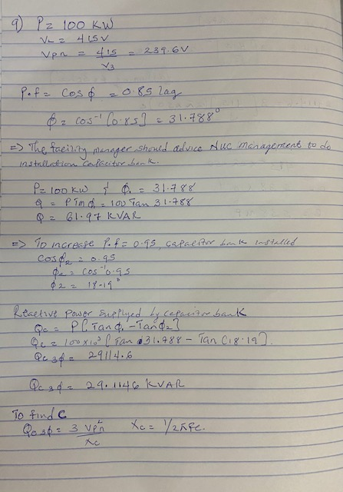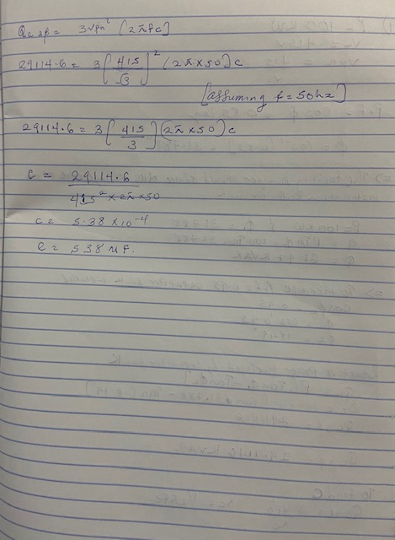

10 **From the calculated values below, it can be deduced that (M2) has a lower reactive power which will not only reduce the problems of low power factor, cables and windings of the motor insulation failure and direct tripping of the motor but also reduce the utility bill charged per reactive power (**this can be seen from the below calculations)**.**

Given the details in the table above:

* Load 20kW at a PF of 0.85 (M1):

The reactive power can be calculated as : Q=P tan $∅$

$∅={COS}^{-1}0.85$ $∅=31.788$

Q = 20 ${10}^{3}*\tan\left(31.79\right){ Q}_{0.85}$*= 12394.88 KVAr

The cost of reactive power is given as : 12394.88*#25/kVAR = #309,872 .

* Load 20kW at a PF of 0.95 (M2):

The reactive power can be calculated as: Q=P tan $∅$

$∅={COS}^{-1}0.95$ $∅=18.19$

$Q_{0.95}$ = 20 ${10}^{3}*\tan\left(18.19\right)$



$Q_{0.95}$*

= 6573.68.

The cost of reactive power is given as: 6573.68*#25/kVAR = #164,342.

1. **The apparent power which is the most useful power has to be of low operating cost and reasonable consumption: knowing that the KVA is most considered when billing. It can be observed from the calculations that M2 has a lower cost in apparent power than M1.**

Given the details in the table above:

* Load 20kW at a PF of 0.85 (M1):

The Apparent power can be calculated as:

$s_{0.85}$ = P/Cos ($∅)$

$s_{0.85}$ = $20*{10}^{3}/0.85$

$s_{0.85}$ = 23529.411 VA

The cost of Apparent power is given as: 23529.411* #70/kVA = #1,647,058.77

* Load 20kW at a PF of 0.85 (M1):

The Apparent power can be calculated as:

$s_{0.95}$ = P/Cos ($∅)$

$s_{0.95}$ = $20*{10}^{3}/0.95$

$s_{0.95}$ = 21052.63VA

The cost of Apparent power is given as: 21052.63* #70/kVA = #1,473,684.1

**Poor power factor means drawing more power from the electricity network to do the same amount of work. Therefore, the cables need to be larger and this will cost more money. Also, low power factor can cause losses in the motor parts, increase in heat gain and reduce the life span of the motor. So, M2 with a high-power factor has been recommended to prevent the above**

The client is advised to buy Motor M2 because of the low reactive power due to the high power factor of (0.95).

Also when the rates for the reactive power are to be paid, the client pays less if he uses the motor M2.