MODILIM TOCHUKWU ADRIAN
17/ENG04/041
ELECTRICAL/ELECTRONICS ENGINEERING
ELECTRICAL MACHINES
EEE 326

1.
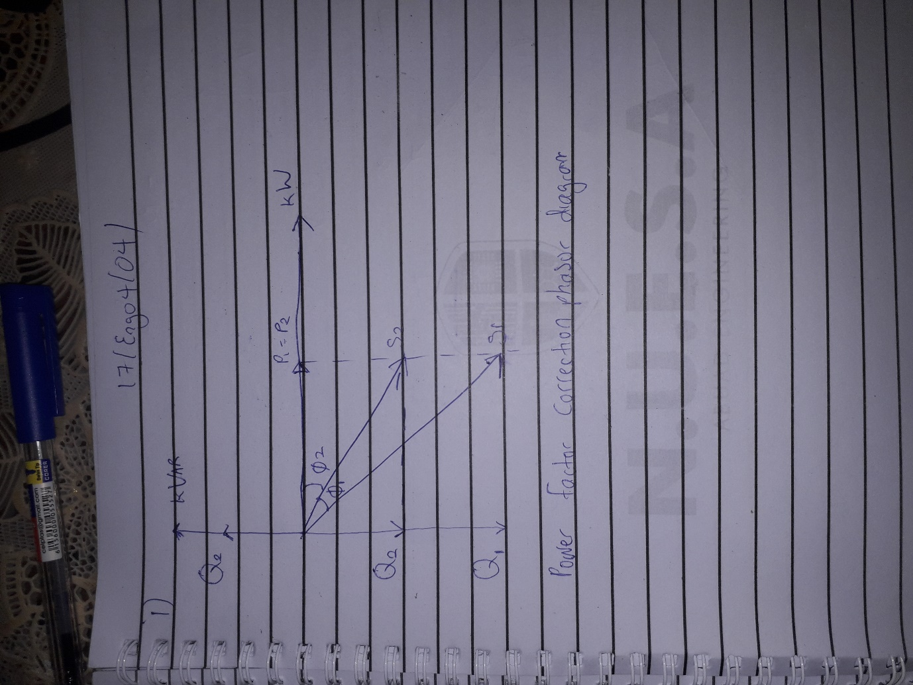

2 .
In AC circuits, the power factor is the ratio of the real power that is used to do work and the apparent power that is supplied to the circuit. The power factor can get values in the range from 0 to 1. When all the power is reactive power with no real power (usually inductive load) - the power factor is 0.

The power factor is the ratio of the real power that is used to do work and apparent power is supplied to the circuit. The power factor ranges in values from '0 to 1'. The power factor to the apparent power is measured in (KVA). The combination of reactive power and true power is called apparent power, and it is the product of a circuit's voltage and current, without reference to phase angle. Apparent power is measured I n the unit of Volt-Amps (VA) and is symbolized by the capital letter S.

3 . COS(α-β) = PF
Where: α=phase of the voltage
β=phase of the current
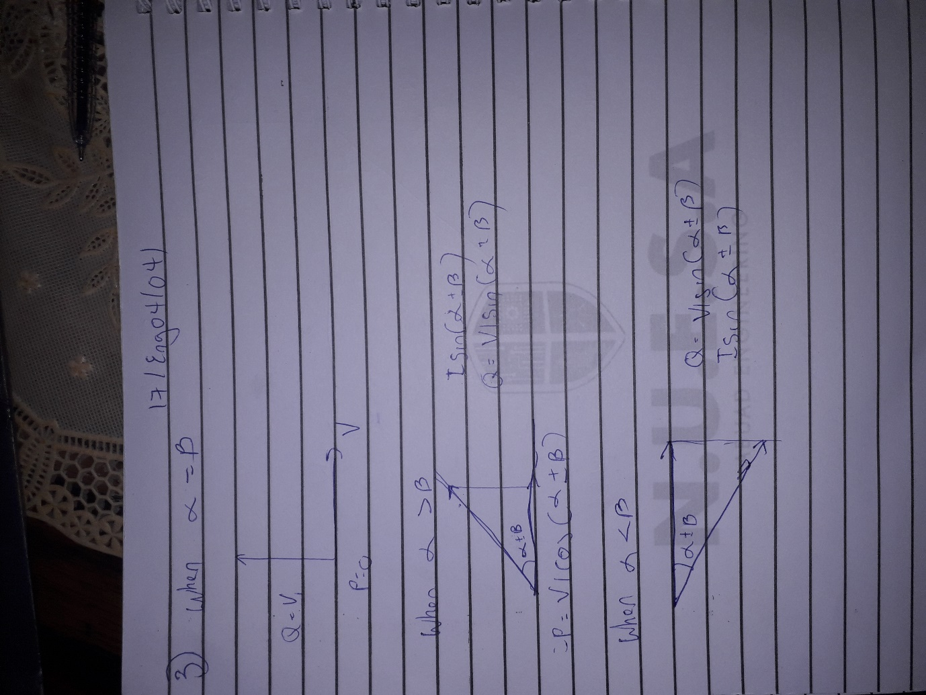

4. For α>β, which indicates a lagging ( inductive ) Power factor
P = S cos (α ±β)
Q = S sin(α ±β) but S =V_RMS*I_RMS

Therefore;
P = V_RMS*I_RMS cos (α ±β)
Q = V_RMS*I_RMS sin (α ±β)

Where: P = real (active) power in W, KW
Q = reactive power in VAR, KVAR
ANSWER:
P =VIcos( α ± β)
Q = VIsin( α ± β)

5 .
- To reduce the energy loss in conductors
- To improve voltage
- To utilise the full capacity of transformers, switches, circuit boards , buses and conductors for active power only to help lower the cost of investment capital and cost.
- To lower the cost of electric energy when the electric utility rates vary with the power factor at required rates.

6 . Reactive power is required to maintain the voltage to deliver active power(watts) through transmission lines. Motor loads and other loads require reactive power to convert the flow of electrons into useful work.

7 . True power = 0.4 × 2×10⁶
= 2MW
θ₁ = cos⁻¹ (0.4) = 66.42°;
θ₂ = cos⁻¹(0.85) = 37.79°;

Tan θ₁ = Tan(66.42) = 2.29°
Tan θ₂ = Tan(37.79) = 0.78°

Required capacitor (C) = P (tanθ₁ – tanθ₂)
= 2×10⁶ ( 2.29 – 0.78)
= 3020KVAR

Reactive Power (Q) = P ( sinθ₁ – sinθ₂)
= 2×10⁶ ( 0.92 – 0.61)
= 958KVAR

8 ..

9 . True power = 100KW
α = cos⁻¹(0.85) = 31.79°.
β = cos⁻¹(0.95) = 18.19°

Tan α = 0.62°
Tan β = 0.33°

Required Capacitor (C) = P (tan α – tan β)
= 100×10³( 0.62 – 0.33)
= 29KVAR

Reactive Power (Q) = P (sinα – sinβ)
= 100×10³ ( 0.53 – 0.31)
= 23KVAR

10
Using the table of calculation below it would show the induction motor(M2) is closer to a power factor of 1 which is the ideal pf and as such it wastes less power
As given in the beer analoghy the induction motor hass more useful power(beer) than the wasted power(foam)

s/n | M₁ | M₂
 | Given : PF= 0.85, real power, P =20kw, V_{L}=415 | Given : PF= 0.95, real power, P =20kw, V_{L}=415
1 | Apparent power, s required = $\frac{P}{PF}$ =$\frac{20*{10}^{3}}{ 0.85 }=23529.4 VA$ | Apparent power, s required = $\frac{P}{PF}$ =$\frac{20*{10}^{3}}{ 0.95 }=21052.6 VA$
2 | $θ_{1}=\cos^{-1}{(0.85)}$ =31.7883$°$  Reactive power Q₁ =sin $θ_{1}*S$  Q₁ = sin (31.7883) x $23529.4$  Q₁ =12394.8VAR | $θ_{1}=\cos^{-1}{(0.95)}$ = 18.1948$°$  Reactive power Q₁ =sin $θ_{1}*S$  Q₁ = sin (18.1948) x $21052.6$  Q₁ =6573.7 VAR

