NAME: YAHYA FAWAZ OLAWOLE
MATRIC NO: 17/ENG04/075
COURSE: ELECTRICAL ELECTRONICS ENGINEERING
EEE 326
SECTION A

Question 1
Develop the theoretical framework required for the correction of the power factor for a multi - sectioned industrial complex from $Cos ∅_{1}$ to $Cos ∅_{2}$ where $∅_{1}>∅_{2}$; $P_{1}=P_{2}$; $Q_{1}>Q_{2}$; and $S_{1}>S_{2}$ to determine the kVAR rating of the capacitor$(Q_{CAP})$ and the magnitude of the capacitor (C) in farads required to correct the power factor of the complex. USE APPROPRIATE PHASOR DIAGRAMS.

Where:
Θ₁> θ₂
P₁=P₂
Q₁>Q₂
S₁>S₂

kVAR supplied by p.f correction equipment= Q_{cap}= Q₁ -Q₂
Q_{cap}= kVAR₁- kVAR₂
Q_{cap}= P₂(tan Θ₁-tan θ₂)
Recall Q= V²/X_{C}
Therefore X_{C}=V²/ Q_{cap}
Also for capacitors; X_{C}= 1/2πfC
Therefore C= 1/2πfX_{C}

Question 2
What determines the power factor of the Dangote Cement Factory at Abajana, Kogi State?
The power factor of the dangote cement factory at abajana, kogi state is determined by its apparent power {KVA} and real power {KW}. Where the apparent power = real power + reactive power. The reactive power is the useless power or whereas the power that sustains the electromagnetic field and the real power is the power actually being used

Question 3
The power factor (pf) of Eleme Petrochemical Industry Port Harcourt is given as $\operatorname{Cos}\left(α±β\right)$; what is the state of the pf of the complex when $α>β$; $β>α$ and $α=β$. Draw the respective Phasor diagrams.

When α>β, the state of the P.F is lagging or Inductive
When α<β. The state of the P.F is leading or Capacitive
When α=β. The power factor is unity. It is neither leading nor lagging.
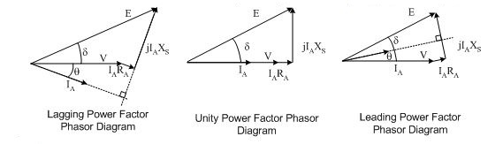

Question 4
For $α>β$; Write an expression for P and Q respectively with units in W and VAR. What does P and Q represent.
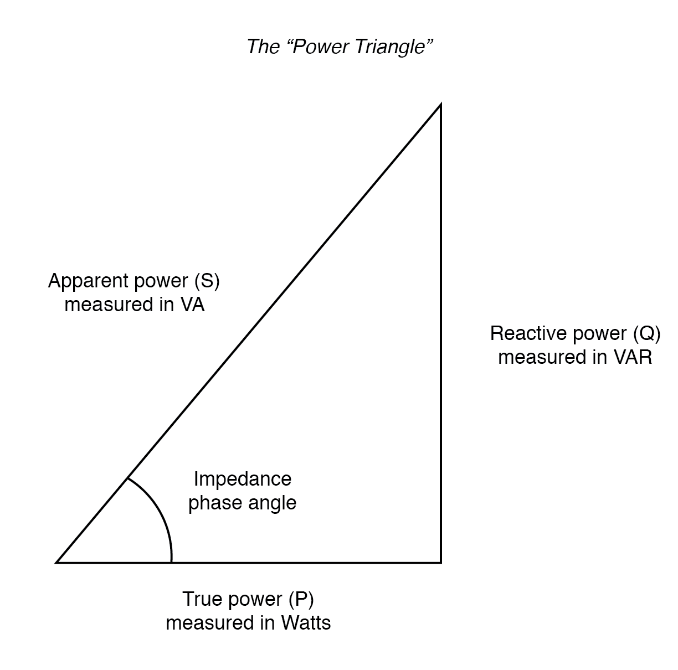
From the power triangle, using Pythagoras theorem;
P= IV*cosθ
Q= IV*sinθ

Question 5
Justify the need for power factor correction to ABUAD and PHCN or an IPP.

. saving electricity bill, as ABUAD is charged for reactive power when the power factor drops below a certain level
. There will be improved voltage and reduced voltage drops.
. Electric cables will carry less load.
. Sustainable development is achieved as the carbon footprint is minimized.
. increase available power
. reduce installation size and maintains electric cables

Question 6
Why is Q needed in an industrial complex with numerous induction motors?

The reactive power drawn by the motor is needed because it is the energy needed to maintain the motor's internal magnetic field. It also damages such as overheating. Without the reactive power the system will fail.

SECTION B

8} An industrial load absorbs 5 MVA at a pf of 40% capacitive at 6kV. To improve the pf up to 85% capacitive, determine Q and C of the required capacitor. State how the correcting equipment will be integrated into the industrial power network for this load.

S_{old}= 5MVA
P.F_{old}= 0.4 leading
P.F_{old}= P/S Therefore; P= 0.4*(5*10^6)= 2MW
Q_{old}= √(5*10^6)²-(2*10^6)²= 4.58MVAR

P.F_{new}=0.85
S_{new}= (2*10^6)/0.85= 2.35MVA
Q_{new}=√(2.35*10^6)²-(2*10^6)²=1.23MVAR

Q_{cap}= Q_{OLD}-Q_{NEW}=4.58-1.23=3.35MVAR

X_{C}=V²/Q
X_{C}=(6*10^3)²/3.35*10^6
X_{C}= 10.75H

C=1/2ΠfX_{c}= 1/(2*3.142*50*10.75)= 29.6mF
This type of PF correction is Static.

8b)
From the question, it is stated that the industrial power network is operating on an inductive load, it can be concluded that it will have a lagging (inductive) power factor; which means that the correcting equipment (capacitor of the appropriate size (29.6mF) which will be integrated in parallel to the industrial power network

Question 9
The National Universities Commission (NUC) Complex in Abuja has a total load of 100kW. It is powered by a 415 V, three phase, 4 wire power supply. The power factor is 0.85lagging and NUC desires to avoid the payment of penalties for this poor power factor. What Should the facility manager advise NUC management to do? If an improved pf of 0.95 lagging is desired, determine the magnitude of the required Q and C.

P= 100KW, V=415V, P.F_{OLD}= 0.85 lagging
S_{OLD}=P/ P.F_{OLD}= (100*10^3)/0.85=1.18*10^5 VA
Q_{OLD}= √(1.18*10^5)²-(100*10^3)² =62.6*10^3VAR

AT 0.95 P.F
S_{NEW}=1.05*10^5VA
Q_{NEW}=√(1.05*10^5)²-(100*10^3)²=32.02KVAR

Q_{cap}= Q_{OLD}-Q_{NEW}=62.6-32.02=30.58KVAR

X_{C}=V²/Q
X_{C}=(415)²/30.58*10^3
X_{C}= 5.63H

C=1/2ΠfX_{c}= 1/(2*3.142*50*5.63)= 56.5Mf

.

The facility manager should advice the NUC management to improve the power factor of the system to at least 0.95 PF to prevent reactive power charges and save electric bills.

Question 10
Undertake a comparative analysis as an Electrical Power Management Consultant and use techno – economic facts and data to advice a client (Globacom Nigeria Ltd) requiring a 20kW induction motor to power its intended fruit juice factory from motor choices $M_{1} and M_{2}$ given the following details:
Motor/parameters | $$M_{1}$$ | $$M_{2}$$
kW | 20 | 20
Phases | 3 | 3
Line Voltage | 415 | 415
pf | 0.85 | 0.95
S | $$S_{1}$$ | $$S_{2}$$
Q | $$Q_{1}$$ | $$Q_{2}$$
PREVIOUS METER READING (kWhr) | 23,000
NEW METER READING (kWhr) | 25,000
kWhr charge | #55/kWhr
Demand(kW) Charge | #35/kW
Capacity (kVA) Charge | #70/kVA
Reactive Power (kVAR) Charge | #25/kVAR
Justify clearly your choice of recommended motor.

As an electrical power management consultant I would advise the client to buy Motor M2 because of the low reactive power {for my calculations below} compared to motor M1 and also due to the high power factor of (0.95).

Also when the rates for the reactive power are to be paid, the client pays less if he uses the motor M2. He saves on the electricity bill

P= 20KW, P.F_{M1}=0.85
S_{M1}=P/P.F= (20*10^3)/0.85= 23.5KVA
Q_{M1}=√(23.5*10^3)²-(20*10^3)²= 12.3Kvar

P.F_{M2}=0.95
S_{M2}= P/P.F_{M2}= (20*10^3)/0.95= 21.1KVA
Q_{M2}=√(21.1*10^3)²-(20*10^3)² =0.67Kvar

