NAME: NDIBE ARIZE CHUKWUEMEKA
MATRIC NO: 17/ENG06/056
DEPT: MECHANICAL ENGINEERING
COURSE: EEE 326

- Θ₁> θ₂
P₁=P₂
Q₁>Q₂
S₁>S₂

kVAR supplied by p.f correction equipment= Q_{cap}= Q₁ -Q₂
Q_{cap}= kVAR₁- kVAR₂
Q_{cap}= P₂(tan Θ₁-tan θ₂)
Recall Q= V²/X_{C}
Therefore X_{C}=V²/ Q_{cap}
Also for capacitors; X_{C}= 1/2πfC
Therefore C= 1/2πfX_{C}

- The amount of inductive loads needed for the cement operations affect the power factor at the Obajana plant. Inductive loads such as induction motors used to drive the fans, coolers, rotary kilns e.t.c These motors need reactive power to sustain their magnetic fields, therefore the more reactive power is spent, the less true power is used from the apparent power supplied by the coal, gas and LPFO power plants supplying the industry.
- When α>β, the state of the P.F is lagging or Inductive
When α<β. The state of the P.F is leading or Capacitive
When α=β. The power factor is unity. It is neither leading nor lagging.
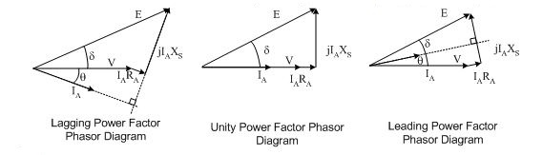

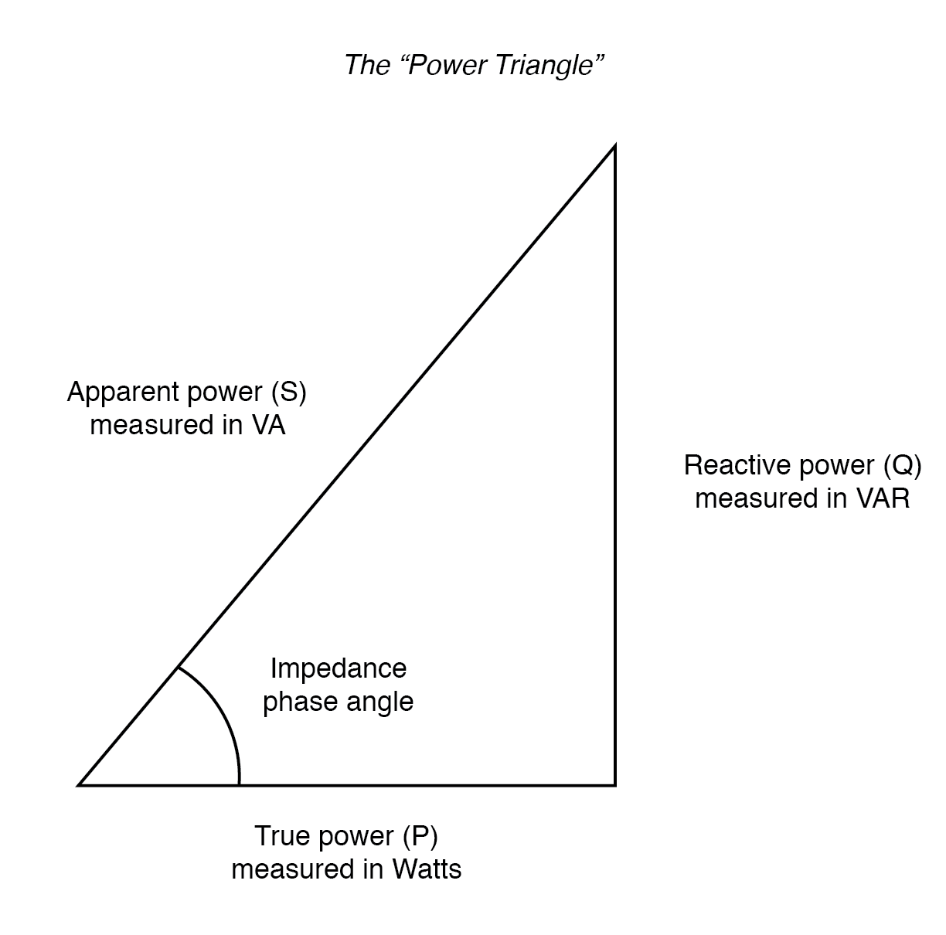
From the power triangle, using Pythagoras theorem;
P= (√S²-Q²)watts or P= S*cosθ
Similarly; Q= (√S²-P²)VAR or Q= S*sinθ
- There will be reduced charges on the electricity bills as industries or institutions as big as ABUAD are charged for reactive power when the power factor drops below a certain level
There will be improved voltage.
Electric cables will carry less load.
Sustainable development is achieved as the carbon footprint is minimized.
- The reactive power drawn by the motor is related to the energy needed to maintain the motor's internal magnetic field. If the motor is unloaded the total effect is a low active power draw with a relatively high reactive power draw, while if the motor is loaded the active power is increased while the reactive power is unchanged.

- S_{old}= 5MVA
P.F_{old}= 0.4 leading
P.F_{old}= P/S Therefore; P= 0.4*(5*10^6)= 2MW
Q_{old}= √(5*10^6)²-(2*10^6)²= 4.58MVAR

P.F_{new}=0.85
S_{new}= (2*10^6)/0.85= 2.35MVA
Q_{new}=√(2.35*10^6)²-(2*10^6)²=1.23MVAR

Q_{cap}= Q_{OLD}-Q_{NEW}=4.58-1.23=3.35MVAR

X_{C}=V²/Q
X_{C}=(6*10^3)²/3.35*10^6
X_{C}= 10.75H

C=1/2ΠfX_{c}= 1/(2*3.142*50*10.75)= 29.6mF
This type of PF correction is Static.

- P= 100KW, V=415V, P.F_{OLD}= 0.85 lagging
S_{OLD}=P/ P.F_{OLD}= (100*10^3)/0.85=1.18*10^5 VA
Q_{OLD}= √(1.18*10^5)²-(100*10^3)² =62.6*10^3VAR

AT 0.95 P.F
S_{NEW}=1.05*10^5VA
Q_{NEW}=√(1.05*10^5)²-(100*10^3)²=32.02KVAR

Q_{cap}= Q_{OLD}-Q_{NEW}=62.6-32.02=30.58KVAR

X_{C}=V²/Q
X_{C}=(415)²/30.58*10^3
X_{C}= 5.63H

C=1/2ΠfX_{c}= 1/(2*3.142*50*5.63)= 56.5Mf

- P= 20KW, P.F_{M1}=0.85
S_{M1}=P/P.F= (20*10^3)/0.85= 23.5KVA
Q_{M1}=√(23.5*10^3)²-(20*10^3)²= 12.3Kvar

P.F_{M2}=0.95
S_{M2}= P/P.F_{M2}= (20*10^3)/0.95= 21.1KVA
Q_{M2}=√(21.1*10^3)²-(20*10^3)² =0.67Kvar

The client is advised to buy Motor M2 because of the low reactive power due to the high power factor of (0.95).
Also when the rates for the reactive power are to be paid, the client pays less if he uses the motor M2.

