NAME: BODUNDE OLAOLUWA JOSEPH
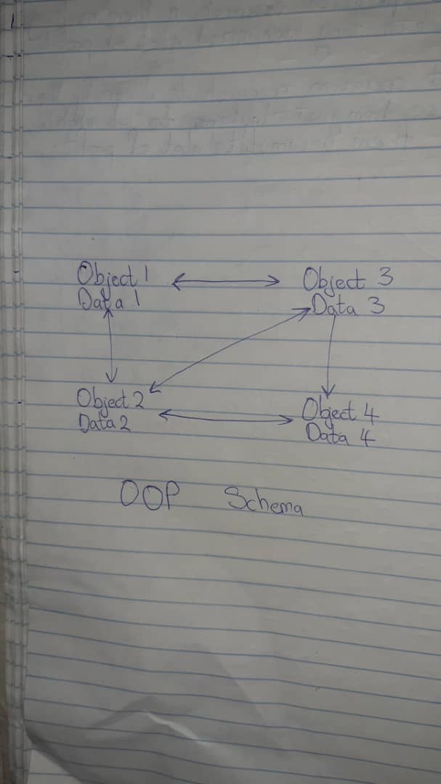
MATRICNO:17/SCI01/022
1.
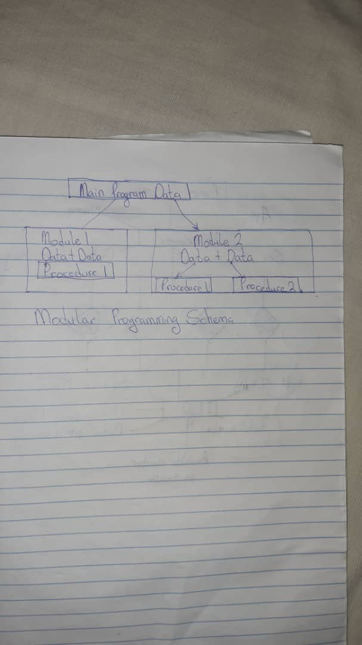
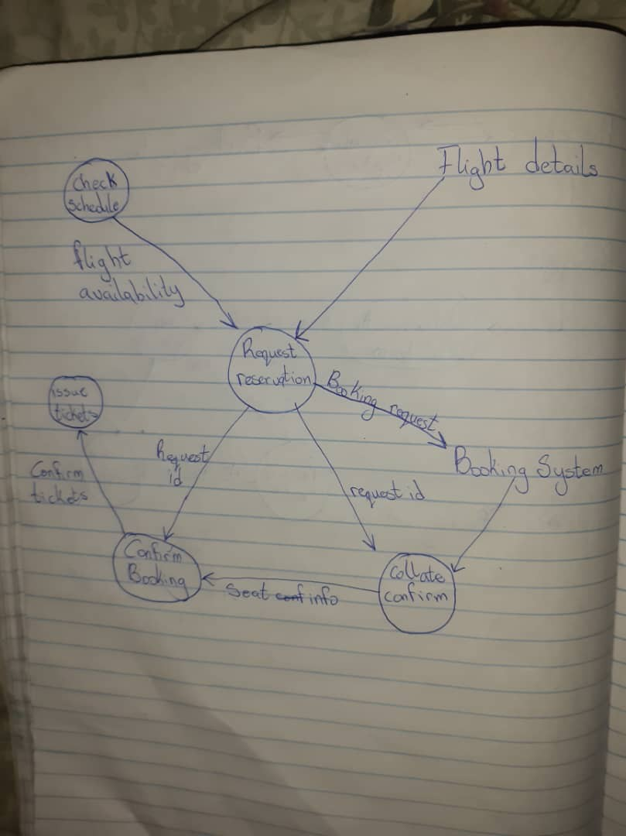
2.SCHEMAFORMODULARPROGRAMMINGFORAIRLINERESERVATION
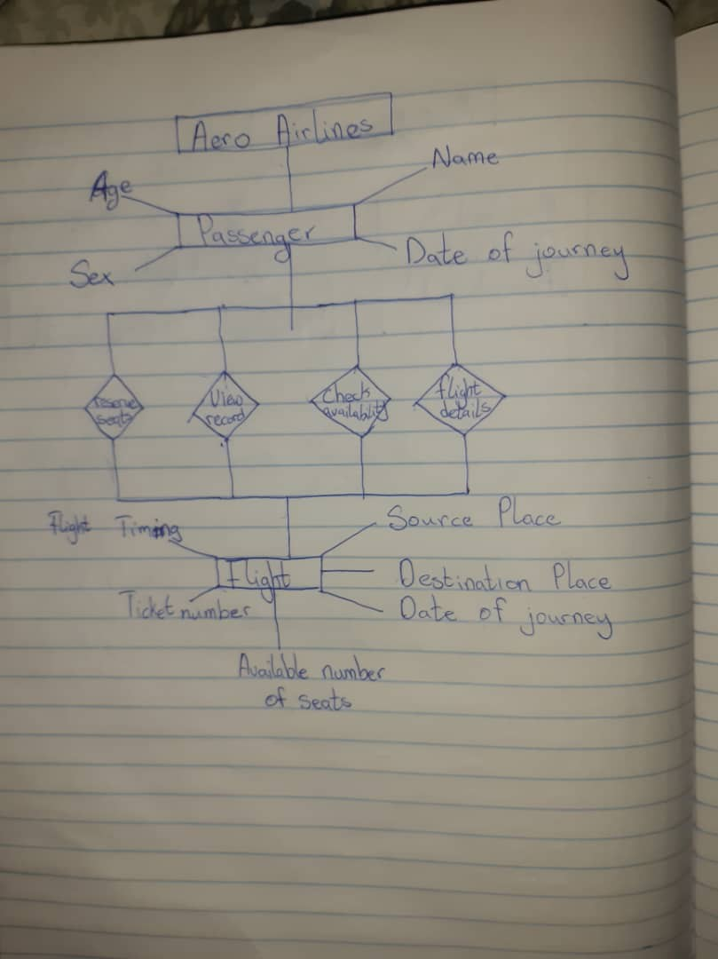
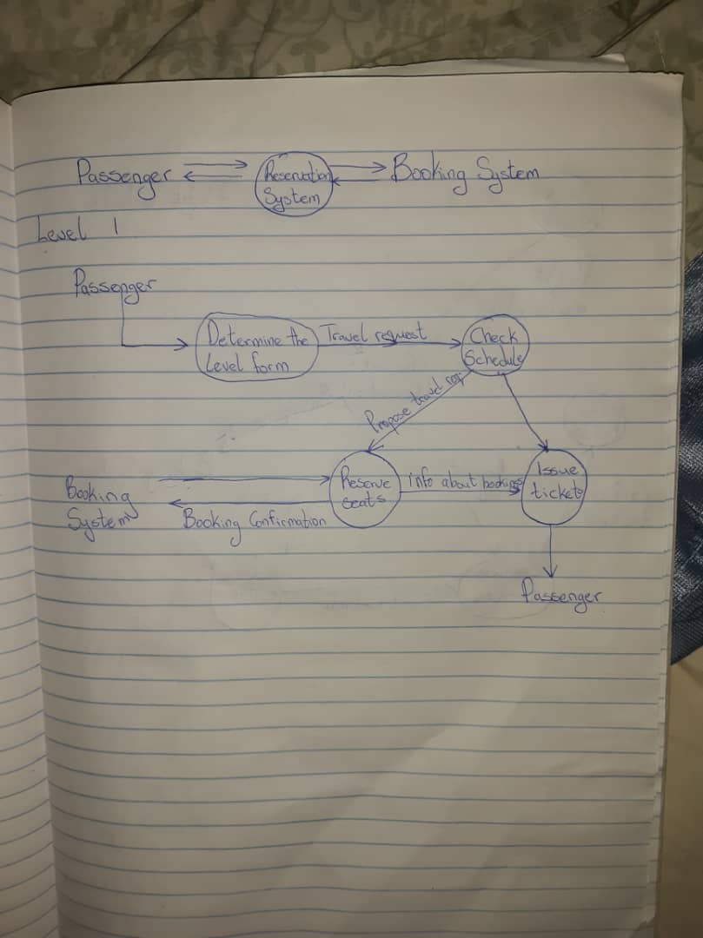
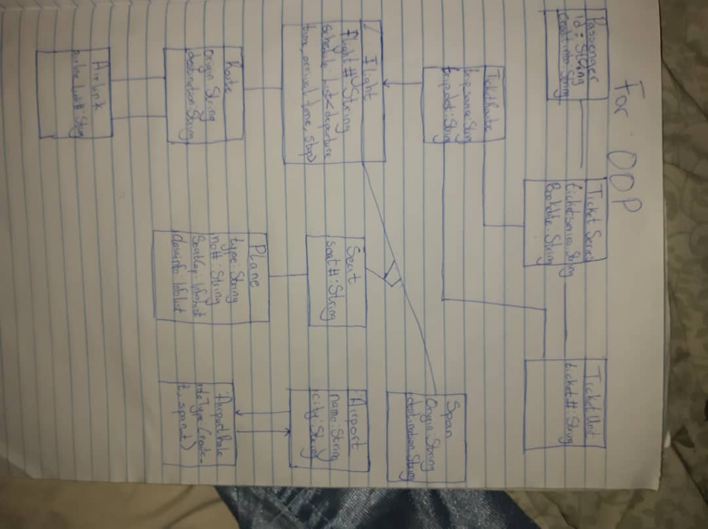
SCHEMAFOROBJECTORIENTEDPROGRAMMINGFORAIRLINERESERVATION

