ELECTRICAL MACHINES

ADEGOKE OLAYINKA D.
17/ENG06/002
MECHANICAL ENGR.
POWER FACTOR CORRECTION
SECTION A (ANSWERS ONLY)

1. 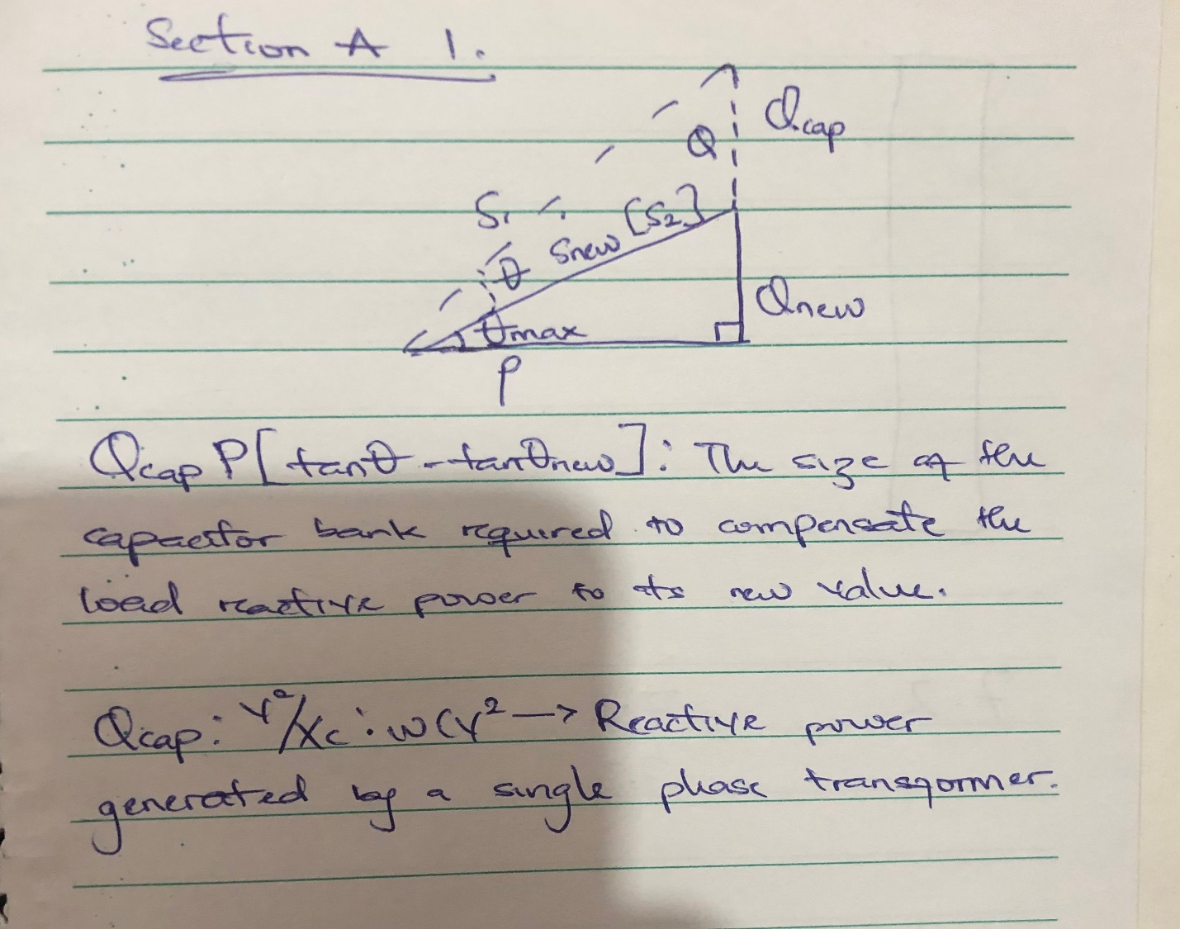

2. Power factor is an expression of energy efficiency. It is usually expressed as a percentage—and the lower the percentage, the less efficient power usage is.
Power factor (PF) is the ratio of working power, measured in kilowatts (kW), to apparent power, measured in kilovolt amperes (kVA). Apparent power, also known as demand, is the measure of the amount of power used to run machinery and equipment during a certain period. It is found by multiplying (kVA = V x A). The result is expressed as kVA units.
PF expresses the ratio of true power used in a circuit to the apparent power delivered to the circuit. A 96% power factor demonstrates more efficiency than a 75% power factor. PF below 95% is considered inefficient in many regions.
3.
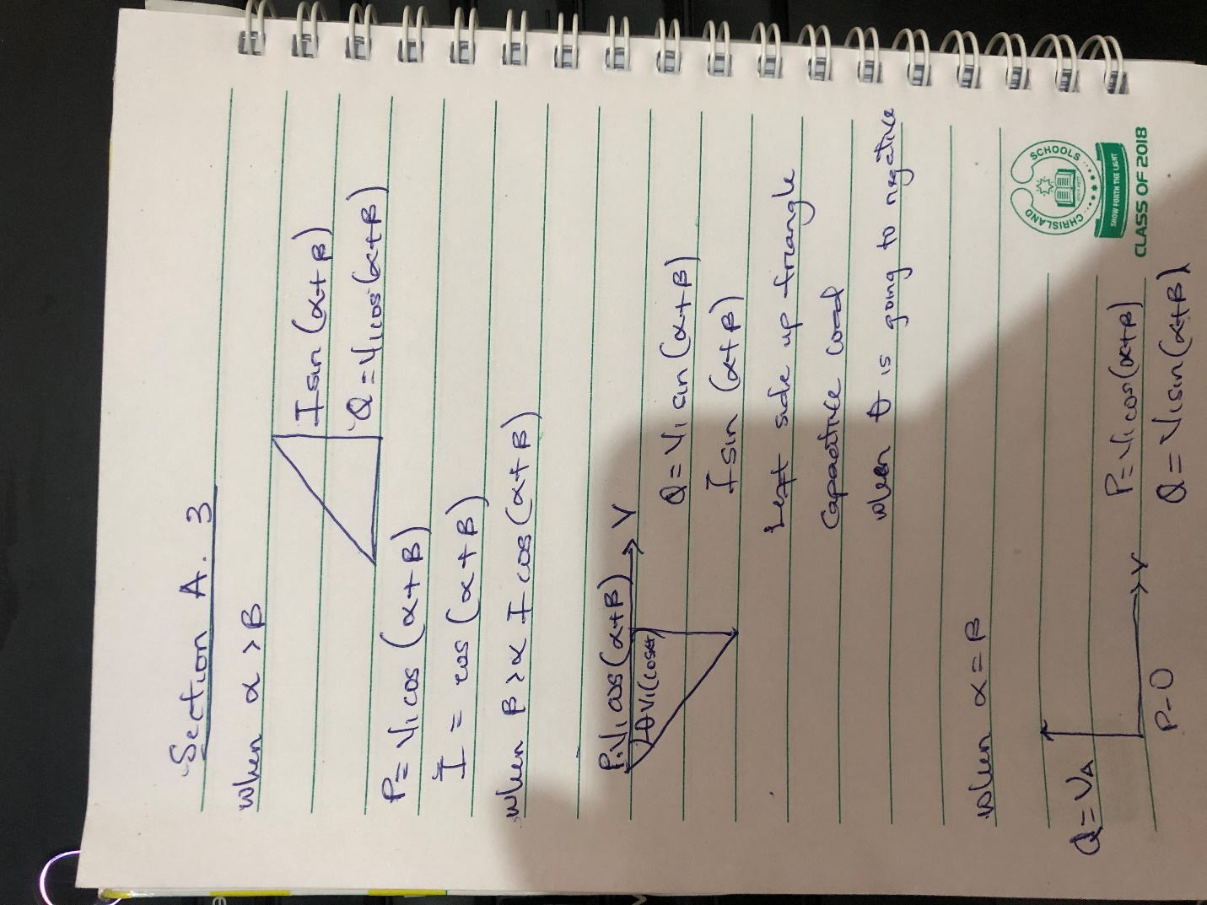

4. P=I*Vcos(α±β)
Q=I*Vsin(α±β)
Where,
P: active power(kW)
Q: reactive power(kVAR)

5.
- Savings on the electricity bill
- Power factor correction eliminates penalties on reactive energy, decreases demand on kVA, and reduces power losses generated in the transformers and conductors of the installation.
- Increased available power
- Fitting PFC equipment on the low voltage side increases the power available at the secondary of a MV/LV transformer. A high power factor optimises an electrical installation by allowing better use of the components.
- Reduced installation size
- Installing PFC equipment allows conductor cross-section to be reduced, as less current is absorbed by the compensated installation for the same active power.
- Reduced voltage drops
- Installing capacitors allows voltage drops to be reduced upstream of the point where the PFC device is connected, therefore preventing overloading of the network and reducing harmonics.

- 6. Voltage control in an electrical power system is important for proper operation for electrical power equipment to prevent damage such as overheating of generators and motors, to reduce transmission losses and to maintain the ability of the system to withstand and prevent voltage collapse.
- Decreasing reactive power causing voltage to fall while increasing it causing voltage to rise. A voltage collapse may be occurs when the system try to serve much more load than the voltage can support.
- When reactive power supply lower voltage, as voltage drops current must increase to maintain power supplied, causing system to consume more reactive power and the voltage drops further . If the current increase too much, transmission lines go off line, overloading other lines and potentially causing cascading failures.
- If the voltage drops too low, some generators will disconnect automatically to protect themselves. Voltage collapse occurs when an increase in load or less generation or transmission facilities causes dropping voltage, which causes a further reduction in reactive power from capacitor and line charging, and still there further voltage reductions. If voltage reduction continues, these will cause additional elements to trip, leading further reduction in voltage and loss of the load. The result in these entire progressive and uncontrollable declines in voltage is that the system unable to provide the reactive power required supplying the reactive power demands
- First, the transmission system itself is a nonlinear consumer of reactive power, depending on system loading. At very light loading the system generates reactive power that must be absorbed, while at heavy loading the system consumes a large amount of reactive power that must be replaced. The system’s reactive-power requirements also depend on the generation and transmission configuration.

SECTION B
1.
Load(s) = 5000KVA
Power factor = 40% = 0.4 (capacitive)
Frequency = 50Hz
P = ׀s׀cosØ
P = ׀s׀Pf _{(old)} = 5000×10³(0.4) = 2000KW
Ø _{(old)} = cos⁻¹Pf _{(old)} = cos⁻¹ (0.4) = -66.42
The angle will be negative because the old power factor is inductive
Using trigonometry
Tan 𝜃old= Q_{(old)} ̸ P
Q_{old} = Ptan_{(old)} = (2000×10³)(tan(-66.42))
Q_{(old)} = -4582178.329 var
_{(new)} = cos⁻¹Pf_{(new)} = cos⁻¹(0.85) = -31.79 (because also its capacitive)
Tan_{(new)} = Q_{(new)} ̸ P
Q_{(new)} = Ptan𝜃_{(new)} = 2000×10³(tan(-31.79)) = -1239569.332 var
ΔQ = Q_{(new)} – Q_{(old)}
ΔQ = -1239569.332 – (-4582178.329)
ΔQ = 3342608.997 var

C=ΔQ/(2πf (Vs²))
C =
$$\frac{3342608.997}{2×3.142×50×{\left(6000\right)}^{2}}$$
C= 2.96×10⁻⁴
C= 29.6mf

8. Load(s) = 5000KVA
Power factor = 40% = 0.4 (inductive)
Frequency = 50Hz
P = ׀s׀cosØ
P = ׀s׀Pf _{(old)} = 5000×10³(0.4) = 2000KW
Ø _{(old)} = cos⁻¹Pf _{(old)} = cos⁻¹ (0.4) = 66.42
The angle will be positive because the old power factor is inductive
Using trigonometry
Tan 𝜃old= Q_{(old)} ̸ P
Q_{old} = Ptan_{(old)} = (2000×10³)(tan(66.42))
Q_{(old)} = 4582178.329 var
_{(new)} = cos⁻¹Pf_{(new)} = cos⁻¹(0.85) = 31.79 (because also its inductive)
Tan_{(new)} = Q_{(new)} ̸ P
Q_{(new)} = Ptan𝜃_{(new)} = 2000×10³(tan(31.79)) = 1239569.332 var
ΔQ = Q_{(old)} – Q_{(new)}
ΔQ = 4582178.329 – 1239569.332
ΔQ = 3342608.997 var

C=ΔQ/(2πf (Vs²))
C =
$$\frac{3342608.997}{2×3.142×50×{\left(6000\right)}^{2}}$$
C= 2.96×10⁻⁴
C= 29.6mf
If this load is an electric motor or most any other industrial AC load, it will have a lagging (inductive) power factor, which means that we’ll have to correct for it with a capacitor of appropriate size, wired in parallel. This correction, of course, will not change the amount of true power consumed by the load, but it will result in a substantial reduction of apparent power.

9. Real power, p=100KW
V=415V 3 phase transformer
Original pf=0.85
Improved Pf desired=0.95
Recall, Pf=cosθ
Therefore, θ= cos⁻¹(pf)
θ₁=cos⁻¹(0.85) =31.7883
θ₂=cos⁻¹(0.95) =18.1949
Tan θ₁=tan (31.7883) =0.6197
Tan θ₂=tan (18.1949) =0.3287
Therefore,
Reactive Power, Q=Psin (θ₁ ± θ₂)
= (100×10³) ×sin(31.7883-18.1949)
=23.503KVAR
Required capacitor, C=P (tan θ₁ ±tan θ₂)
= (100×10³) × (0.6197-0.3287)
=29.1KVAR

10. S₁ = 23529.41176 var
S₂ = 21052.63158 var
Where S₁ and S₂ are gotten from the equation P/ Pf
Where P₁ and P₂ = 20×10³
𝜃₁ = cos⁻¹(0.85) = 31.79
𝜃₂ = cos⁻¹(0.95) = 18.19
Q₁ = sin(31.79) × 23529.41176
Q₁ = 12395.46948 var

Q₂ = sin(18.19) × 21052.63158
Q₂ = 6571.981313 var
The above equation is to show the different induction motor the amount of reactive power they both posses
In order to pick the best choice of induction motor, the client must consider the following factors:
- Determine cost-effectiveness AC motors are available in a range of efficiencies. Although the economics will vary by application, replacing an old standard-efficiency motor with a newly installed, premium-efficiency motor under typical operation will often pay for its price in reduced energy bills within a year or two.

Consider downsizing when a motor is operating at less than 40% of its rated output. The following circumstances are opportunities for choosing premium-efficiency motors:
When purchasing a new motor where lower-energy-efficient units can still be sold Instead of rewinding failed standard-efficiency or energy-efficient motors.To replace an operable-but-inefficient motor for greater energy savings and reliability
- Account for the motor’s impact on power factor Power factor is an indicator of how much of a power system’s capacity is available for productive work. Low power factor is undesirable because it increases the load on a building’s electrical system, and utilities sometimes charge customers a penalty for facilities with low power factor. Because power factor is lower when a motor is lightly loaded, be sure to choose the right-sized motor. You can also specify a motor with a high power factor, but such models sometimes have lower efficiency. The ultimate selection depends, in part, on whether a facility is subject to power factor penalty charges. A facility with a significant number of induction motors and a low power factor can solve the problem with premium-efficiency motors that are properly sized. If new motors are not an option, other power factor–correction methods are available, including static capacitor banks, rotary condensers, and static and dynamic volt-ampere reactive devices.

From the above factors mentioned above, the best and most economical motor choice to go with would be motor 2(M2)
The calculation solved aboved showed that MOTOR 2 (M2) is the best optio because when the reactive power is low it saves cost and increases efficiency.
