NAME: ADEBIYI ITUNUNOLUWA ISAAC
MATRIC NO: 18/MHS01/013
DEPARTMENT: ANATOMY
COURSE: BCH 204

QUESTION: WHAT DO YOU UNDERSTAND BY THE TERM ''BIOLOGICAL VALUE OF PROTEINS"
Biological value (BV) is a measure of the proportion of absorbed protein from a food which becomes incorporated into the proteins of the organism's body. It captures how readily the digested protein can be used in protein synthesis in the cells of the organism. Proteins are the major source of nitrogen in food. BV assumes protein is the only source of nitrogen and measures the proportion of this nitrogen absorbed by the body which is then excreted. The remainder must have been incorporated into the proteins of the organisms body. A ratio of nitrogen incorporated into the body over nitrogen absorbed gives a measure of protein "usability" – the BV.
Unlike some measures of protein usability, biological value does not take into account how readily the protein can be digested and absorbed (largely by the small intestine). This is reflected in the experimental methods used to determine BV.
BV uses two similar scales:
- The true percentage utilization (usually shown with a percent symbol).
- The percentage utilization relative to a readily utilizable protein source, often egg (usually shown as unitless).
These two values will be similar but not identical.
The BV of a food varies greatly, and depends on a wide variety of factors. In particular the BV value of a food varies depending on its preparation and the recent diet of the organism. This makes reliable determination of BV difficult and of limited use — fasting prior to testing is universally required in order to ascertain reliable figures.
BV is commonly used in nutrition science in many mammalian organisms, and is a relevant measure in humans.^{[1]} It is a popular guideline in bodybuilding in protein choice.
FACTORS AFFECTING BV
The determination of BV is carefully designed to accurately measure some aspects of protein usage whilst eliminating variation from other aspects. When using the test (or considering BV values) care must be taken to ensure the variable of interest is quantified by BV. Factors which affect BV can be grouped into properties of the protein source and properties of the species or individual consuming the protein.

Three major properties of a protein source affect its BV:
- Amino acid composition, and the limiting amino acid, which is usually lysine
- Preparation (cooking)
- Vitamin and mineral content
Amino acid composition is the principal effect. All proteins are made up of combinations of the 21 biological amino acids. Some of these can be synthesised or converted in the body, whereas others cannot and must be ingested in the diet. These are known as essential amino acids (EAAs), of which there are 9 in humans. The number of EAAs varies according to species (see below).
EAAs missing from the diet prevent the synthesis of proteins that require them. If a protein source is missing critical EAAs, then its biological value will be low as the missing EAAs form a bottleneck in protein synthesis. For example, if a hypothetical muscle protein requires phenylalanine (an essential amino acid), then this must be provided in the diet for the muscle protein to be produced. If the current protein source in the diet has no phenylalanine in it the muscle protein cannot be produced, giving a low usability and BV of the protein source.
In a related way if amino acids are missing from the protein source which are particularly slow or energy consuming to synthesise this can result in a low BV.
Methods of food preparation also affect the availability of amino acids in a food source. Some of food preparation may damage or destroy some EAAs, reducing the BV of the protein source.
Many vitamins and minerals are vital for the correct function of cells in the test organism. If critical minerals or vitamins are missing from the protein source this can result in a massively lowered BV. Many BV tests artificially add vitamins and minerals (for example in yeast extract) to prevent this.

QUESTION 2: LIST AND EXPLAIN THE VARIOUS METHODS OF ASSESSMENT OF PROTEIN QUALITY.

Protein quality describes characteristics of a protein in relation to its ability to achieve defined metabolic actions. Traditionally, this has been discussed solely in the context of a protein's ability to provide specific patterns of amino acids to satisfy the demands for synthesis of protein as measured by animal growth or, in humans, nitrogen balance. As understanding of protein's actions expands beyond its role in maintaining body protein mass, the concept of protein quality must expand to incorporate these newly emerging actions of protein into the protein quality concept.
METHODS OF ASSESSMENT OF PROTEIN QUALITY:
- Biological Value (BV)
- Net Protein Utilization (NPU)
- Amino Acid Score
- Protein Efficiency Ratio (PER)
- Net Protein Ration (NPR)

Biological Value (BV) Biological value, as defined by Thomas (4) and Mitchell (5,6) has long been considered the method of choice for estimating the nutritive value of proteins. It has been defined as the "percentage of absorbed nitrogen retained in the body" and a complete evaluation of the dietary protein includes measurement of the Biological Value and the Digestibility. These values are obtained by measuring the fecal and urinary nitrogen when the test protein is fed and correcting for the amounts excreted when a nitrogen-free diet is fed.
The BV :
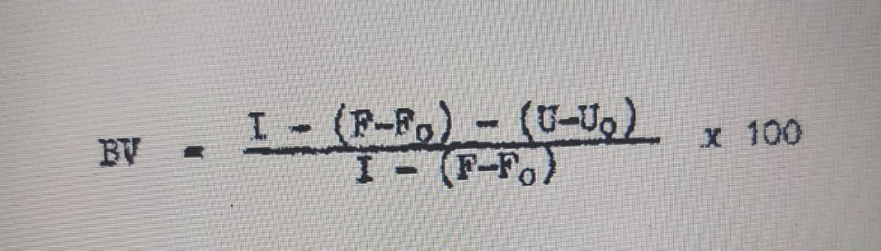
where I = Nitrogen intake of test protein F = Fecal nitrogen Fo = Fecal nitrogen on nitrogen-free diet (Metabolic N) U = Urinary nitrogen Uo = Urinary nitrogen on nitrogen-free diet (Endogenous N)

Net Protein Utilization (NPU): Like Biological Value, NPU estimates nitrogen retention but in this case by determining the difference between the body nitrogen content of animals fed no protein and those fed a test protein. This value divided by the amount of protein consumed is the NPU which is defined as the "percentage of the dietary protein retained". Miller (12) proposed a procedure which involved replicate groups of 4 weanling rats housed in group cages which were fed either the "protein-free" or the "test" diet for 10 days.
Amino Acid Score Block and Mitchell (17) originally proposed that since all amino acids must be present at the site of protein synthesis in adequate amounts if protein synthesis is to proceed, a comparable deficit of any amino acid would limit protein synthesis to the same degree. Thus, they suggested that if the composition of an "ideal protein" was known, i.e., a protein which contained every essential amino acid in sufficient amounts to meet requirements without any excess, then it should be possible to compute the nutritive value of a protein by calculating the deficit of each essential amino acid in the test protein from the amount in the "ideal protein".
Protein Efficiency Ratio (PER) As has been indicated, qualitative differences in protein quality can be demonstrated by many methods. Protein Efficiency Ratio (PER) has been the method most widely used because of its simplicity. Osborne, Mendel and Ferry (30) observed that young rats fed certain proteins gained little weight and ate little protein whereas those which were fed better quality proteins gained more weight and consumed more protein. In an attempt to compensate for the difference in food intake, they calculated the gain in weight per gram of protein eaten and this has been called PER. It is known that the PER for any protein is dependent upon the amount of protein incorporated in the test diet. Standardized conditions have therefore been proposed (31). These include the use of 10 weanling rats per test group, diets containing 9.09% protein (N × 6.25), a test period of 4 weeks' duration, and that each experiment include a group which receives standardized casein. The PER is calculated as the average total weight gain divided by the average grams of protein consumed. Since PER in various laboratories was not constant for the same protein, it was recommended that a corrected value be calculated using an assumed PER of the standardized casein of 2.50 (Corrected PER = 2.50 × PER/PER of reference casein).
REFRENCES:
https://en.wikipedia.org/wiki/Biological_value#:~:text=Biological%20value%20(BV)%20is%20a,the%20cells%20of%20the%20organism.
https://academic.oup.com/ajcn/article/87/5/1576S/4650447#:~:text=Current%20protein%20quality%20methods%20assess,value)%20determines%20net%20protein%20utilization.

