Name: Opoola Temitope Susan
Matric No 18/MHS02/164
Department: Nursing
Course Code: PHS212
Date: Tuesday 2nd, June,2020
Write short notes on any two eye defects
Astigmatism
A common form of visual impairment in which part of an image is blurred due to an irregularity in the dome-shaped curvature of the front surface of the eye, the cornea. With astigmatism, light rays entering the eye are not uniformly focused on the retina. The result is blurred vision at all distances. Significant astigmatism can cause headaches, eye strain, and seriously blurred vision. Astigmatism is often not detected during routine eye screening in schools. It may coexist with other refractive errors such as nearsightedness and farsightedness.
Most people are born with it, but experts don’t know why. You can also get it after an eye injury, an eye disease, or surgery.Astigmatism is corrected with slightly cylindrical lenses that have greater light-bending power in one direction than the other. Use of these lenses elongates objects in one direction and shortens them in the other, much like looking into a distorting wavy mirror.
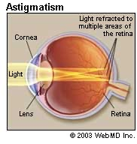
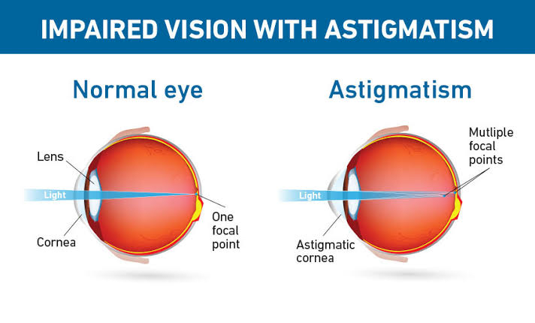

Myopia(nearsightedness)
This is a defect of vision in which far objects appear blurred but near objects are seen clearly. The image is focused in front of the retina rather than on it usually because the eyeball is too long or the refractive power of the eye’s lens too strong. Myopia typically begins in childhood, and you may have a higher risk if your parents are nearsighted. In most cases, nearsightedness stabilizes in early adulthood but sometimes it continues to progress with age.
Myopia can be corrected by wearing glasses/contacts with concave lenses these help to focus the image on the retina.
