Name: Oghenefejiro Agwere
Department: Electrical/Electronics
Matric No: 17/ENG04/003
Course code: EEE 326

1. 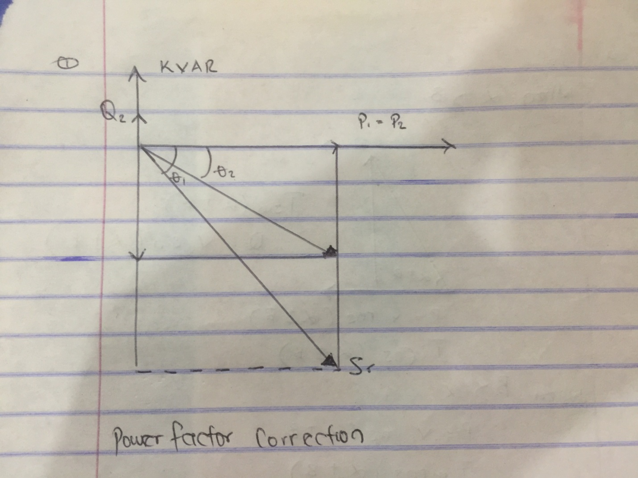

2 . The power factor is the ratio of the real power that is used to do work and apparent power is supplied to the circuit. The power factor ranges in values from '0 to 1'. The power factor to the apparent power is measured in (KVA).The combination of reactive power and true power is called apparent power, and it is the product of a circuit's voltage and current, without reference to phase angle. Apparent power is measured in the unit of Volt-Amps (VA) and is symbolized by the capital letter S.

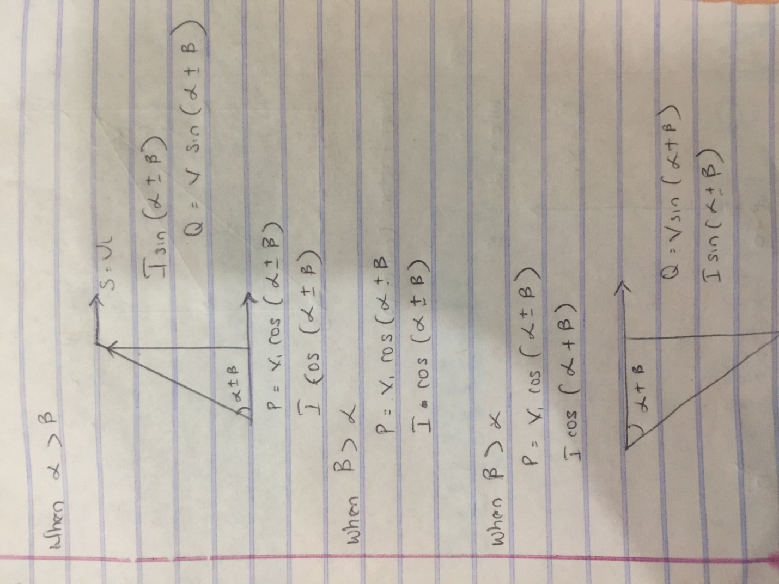

3 .

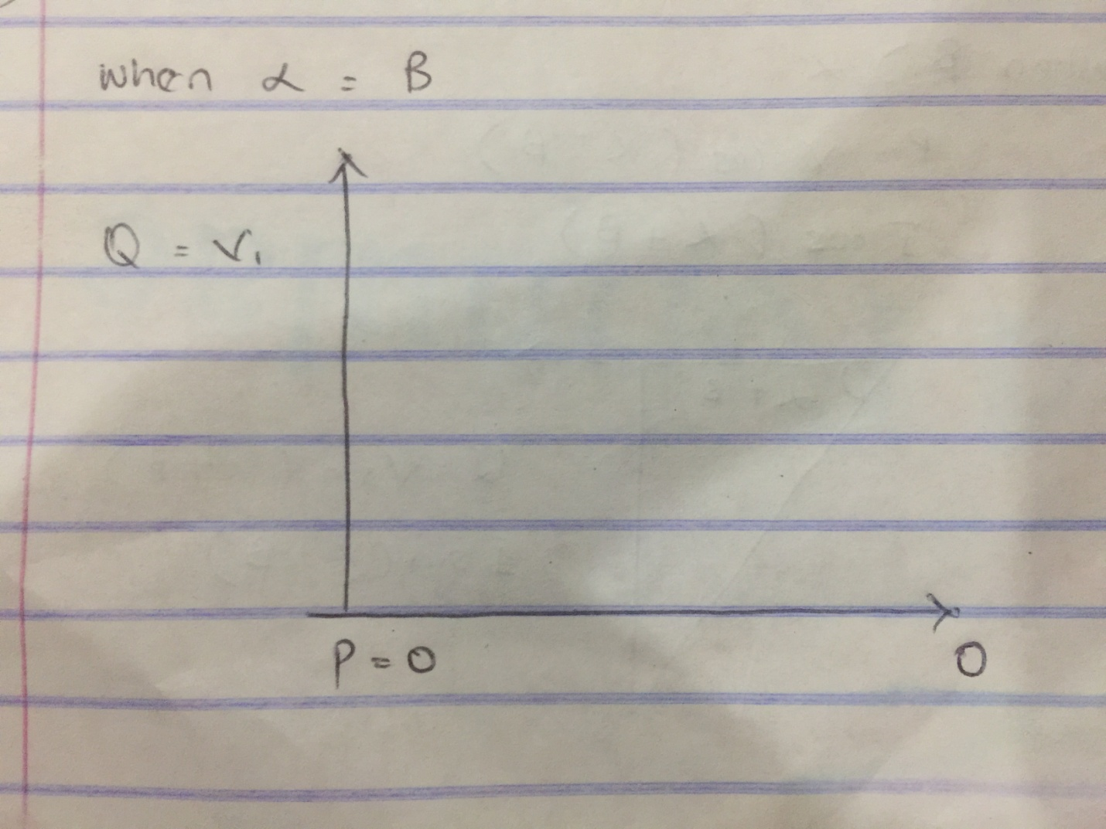

4.
P =VIcos( α ±β)
Q = VIsin( α ±β)

5 .
- To reduce the energy loss in conductors
- To improve voltage
- To utilise the full capacity of transformers, switches, circuit boards , buses and conductors for active power only to help lower the cost of investment capital and cost.
- To lower the cost of electric energy when the electric utility rates vary with the power factor at required rates.

6 . Reactive power is required to maintain the voltage to deliver active power(watts) through transmission lines. Motor loads and other loads require reactive power to convert the flow of electrons into useful work.

7 . True power = 0.4 × 2×10⁶
= 2MW
θ₁= cos⁻¹ (0.4) = 66.42°;
θ₂= cos⁻¹(0.85) = 37.79°;

Tan θ₁= Tan(66.42) = 2.29°
Tan θ₂= Tan(37.79) = 0.78°

Required capacitor (C) = P (tanθ₁– tanθ₂)
= 2×10⁶( 2.29 – 0.78)
= 3020KVAR

Reactive Power (Q) = P ( sinθ₁ – sinθ₂)
= 2×10⁶( 0.92 – 0.61)
= 958KVAR

8 . The load flow study determines the voltage, current , power and reactive power in different points of the system under simulated conditions of normal operation. The load study is important in optimizing existing network ensuring an economical and effective distribution of load and planning ahead for future networks.

9 . True power = 100KW
α = cos⁻¹(0.85) = 31.79°.
β =cos⁻¹(0.95) = 18.19°

Tan α = 0.62°
Tanβ = 0.33°

Required Capacitor (C) = P (tanα – tan β)
= 100×10³( 0.62 – 0.33)
= 29KVAR

Reactive Power (Q) = P (sinα – sinβ)
= 100×10³ ( 0.53 – 0.31)
= 23KVAR

10 . Recent development of modern technologies, devices and equipment and materials in the field electrical power engineering has induced a refined look at the issues of increasing economic efficiency, environmental performance, operation reliability. Considering the higher requirements regarding reliability and fault tolerance, we use positional control or torque control motor after required feedback to verify correct motor position . Stepper motors are the best options for telecommunications applications, but a D.C motor with feedback or an inverter duty with an encoder often is used for tight torque n steel or paper lines as well as similar applications.

