NAME: Amaino Samuel O
MATRIC NO: 18/eng08/026
DEPARTMENT: Biomedical Engineering
COURSE CODE: BME312
COURSE TITLE: Biological Systems Control and Modelling

ASSIGNMENT
PID CONTROLLER ASSIGNMENT
QUESTION 1
ZIEGLAR-NICHOLS OPEN-LOOP TUNING RULE
%start up

clear all
clc

num=[1]
den=[2 1]

sys=tf(num, den)
H=1 %tf of 1

M=feedback(sys,H) %Open Loop it takes the feedback command as G/1+GH
step(M)
hold on

%% Closed Loop
kp=10
ki=0
kd=7

Gc=pid(kp,ki,kd)
Mc=feedback(Gc*sys, H)

step(Mc)
grid on

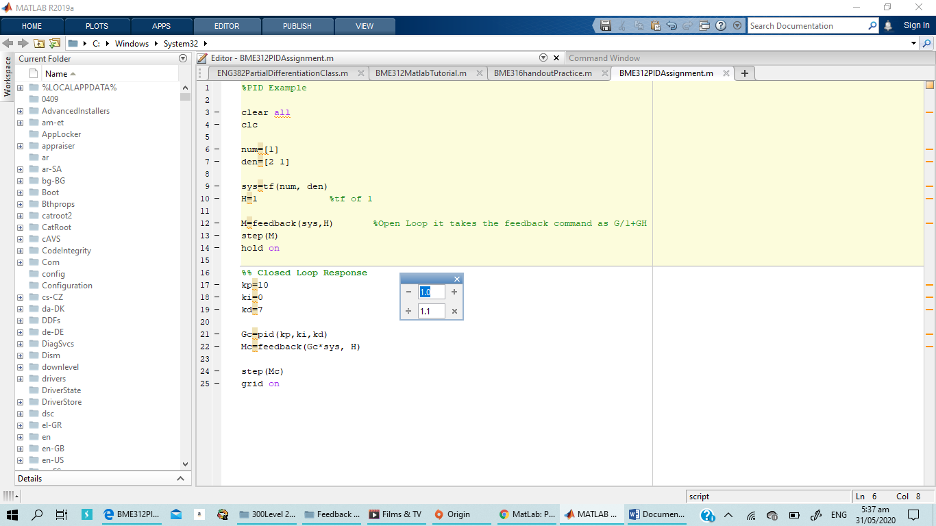
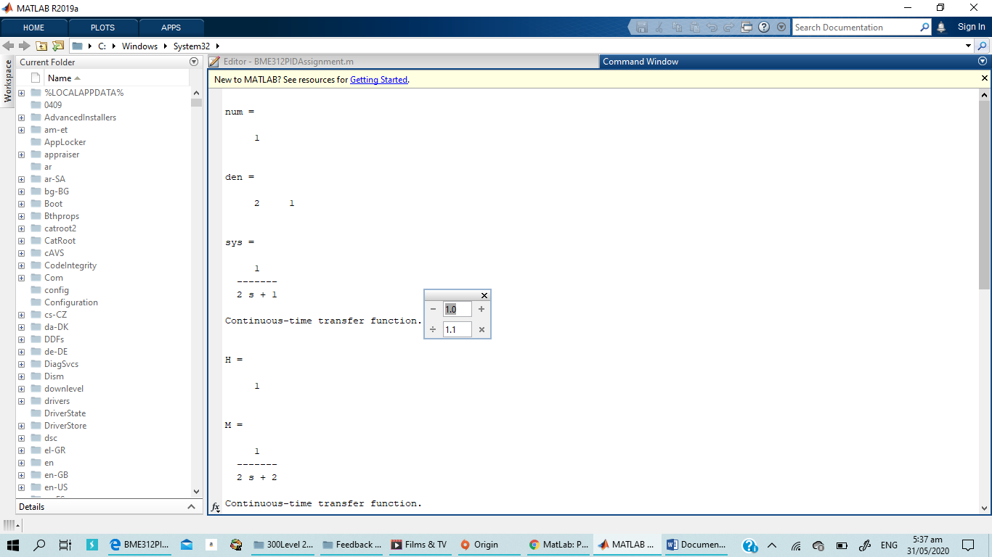
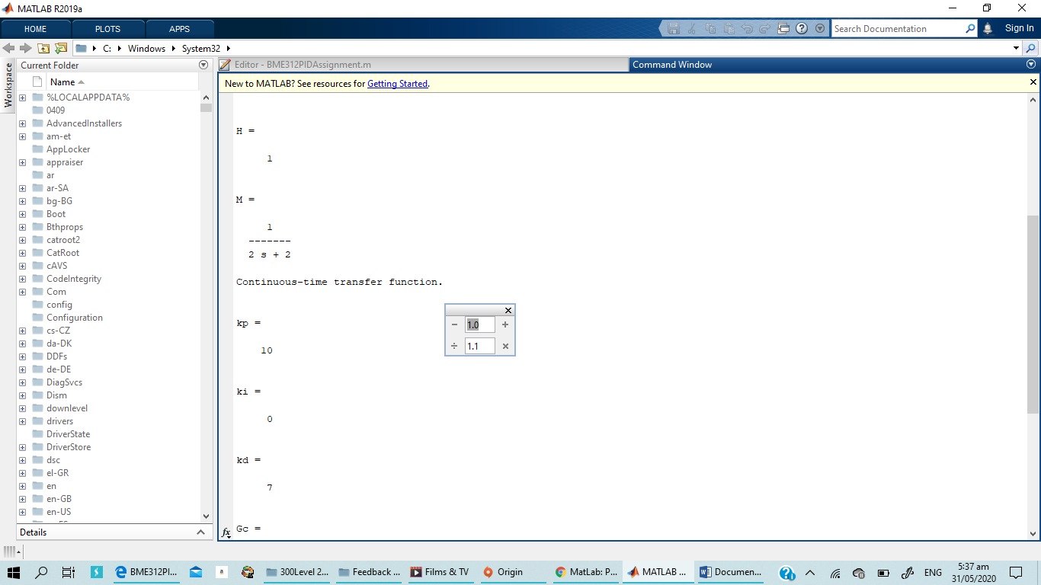
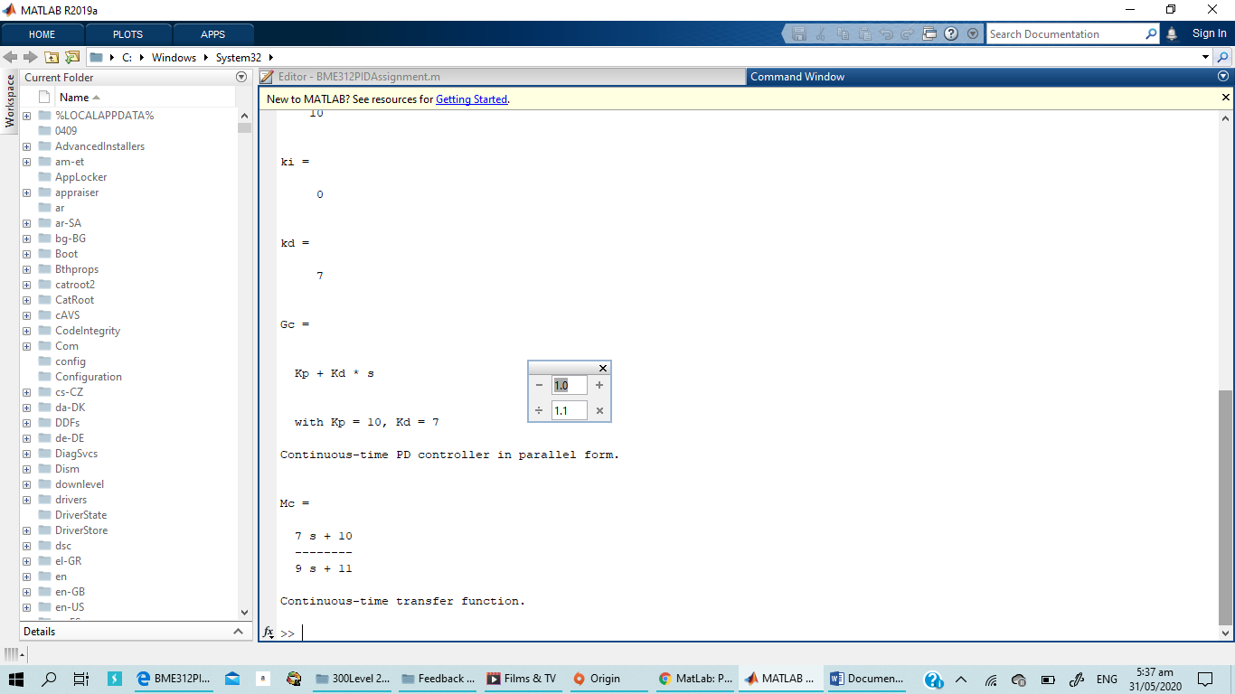
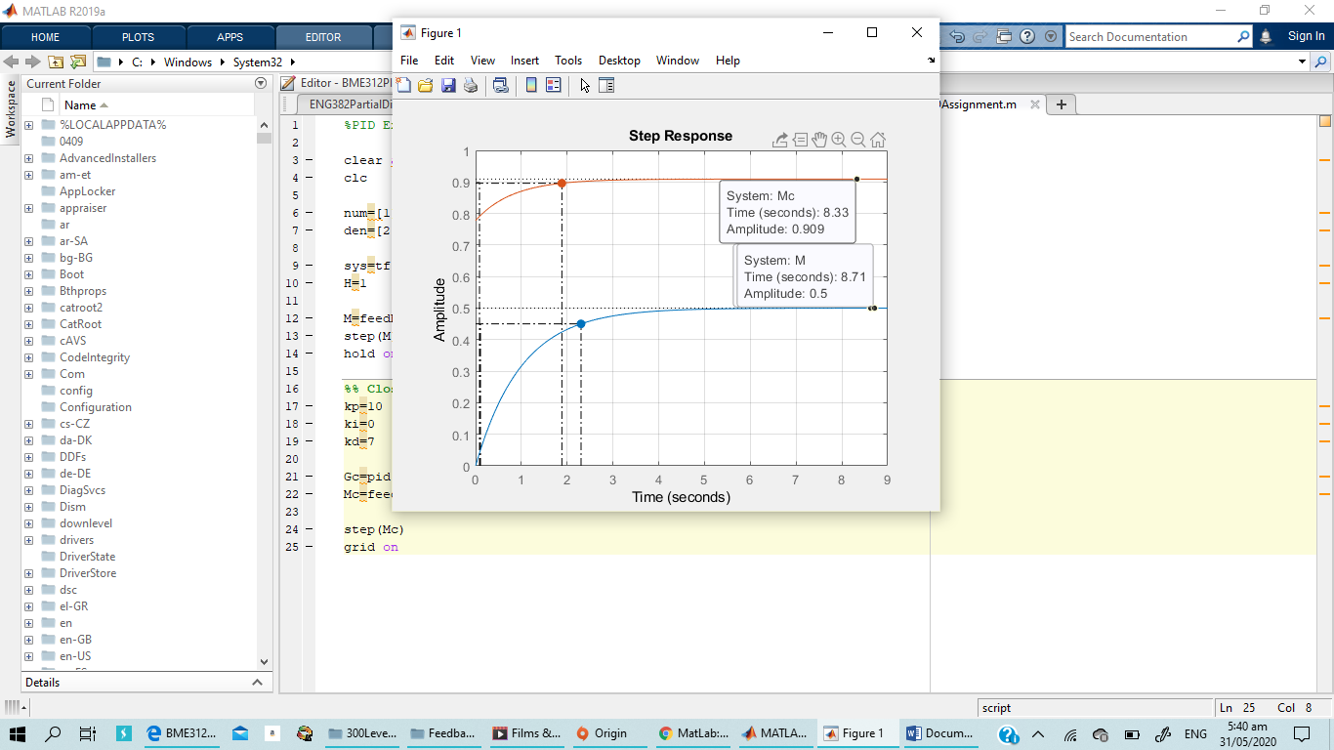

clear all
clc

num=[1];
den=[2 1];

sys=tf(num, den)
H=1; %tf of 1

M=feedback(sys,H) %Open Loop it takes the feedback command as G/1+GH
step(M)
hold on

%% Closed Loop Response
kp=30;
ki=2;

Gc=pid(kp,ki)
Mc=feedback(Gc*sys, H)

step(Mc)
grid on

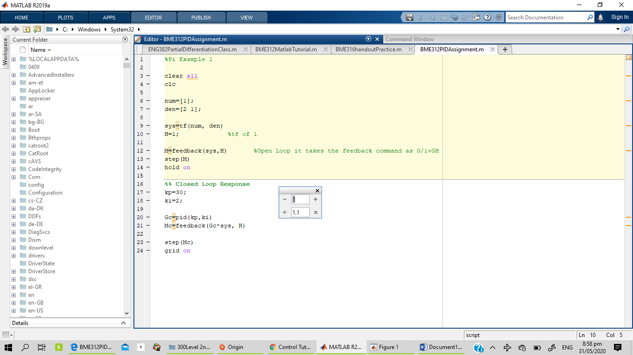
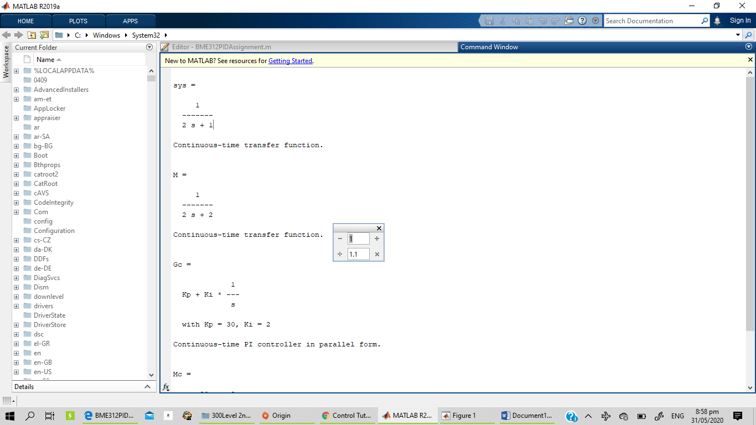
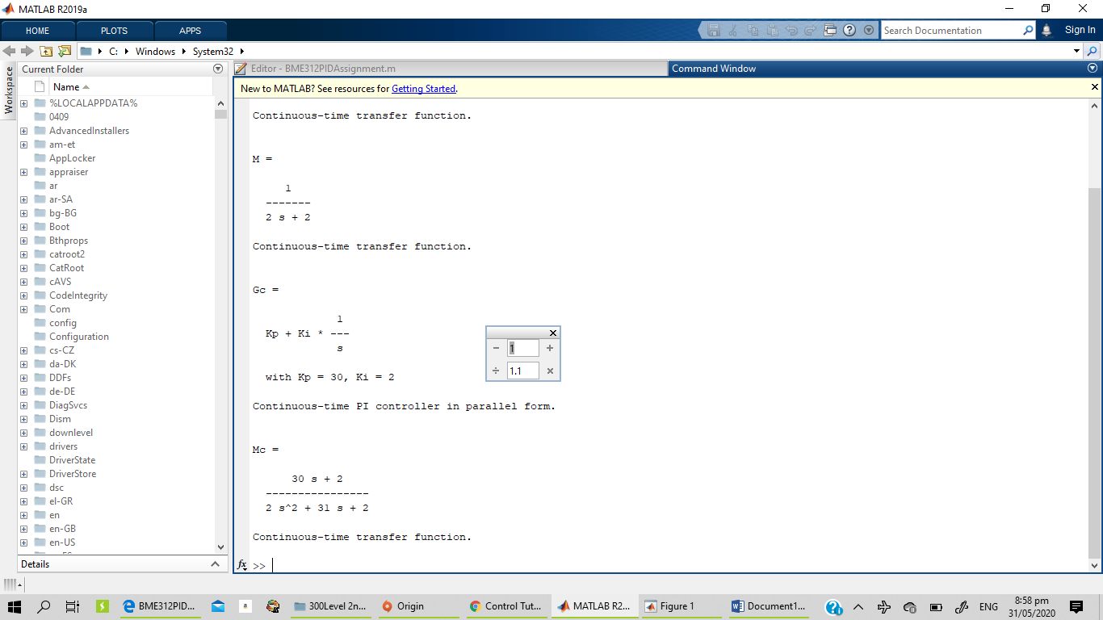
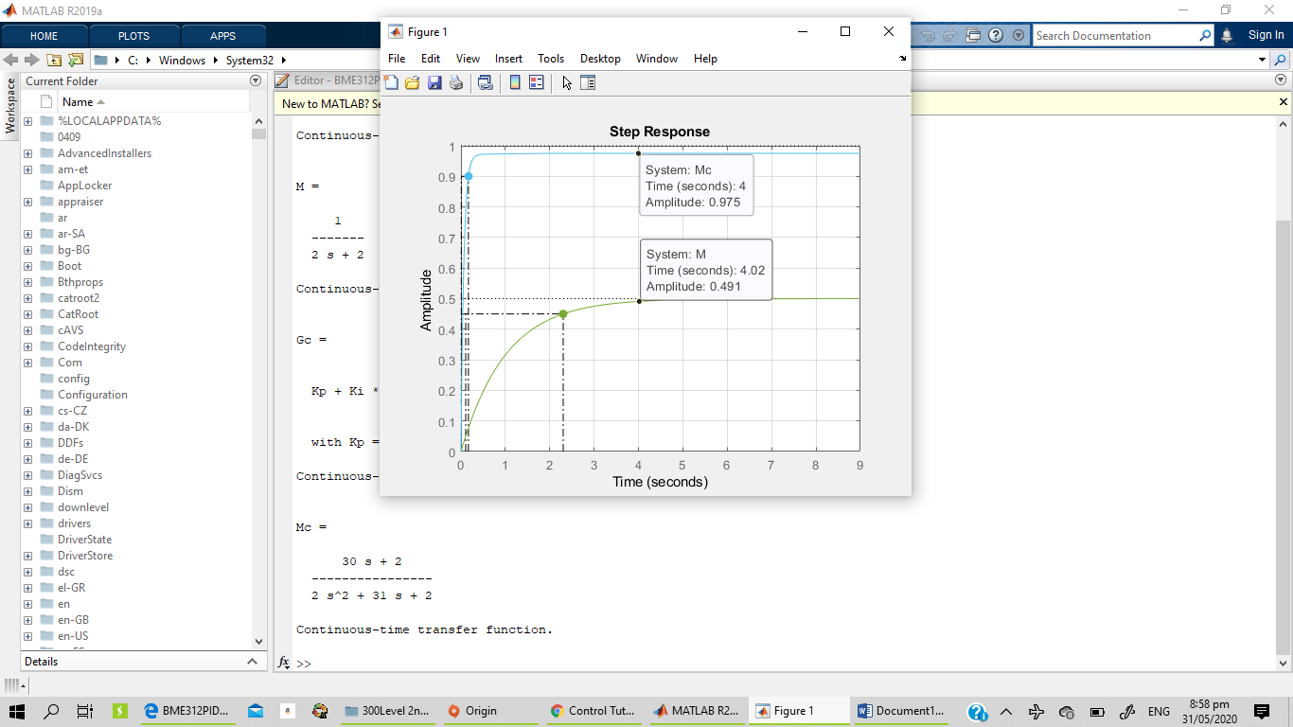

clear all
clc

num=[1];
den=[2 1];

sys=tf(num, den)
H=1; %tf of 1

M=feedback(sys,H) %Open Loop it takes the feedback command as G/1+GH
step(M)
hold on

%% Closed Loop Response
kp=3;

Gc=pid(kp)
Mc=feedback(Gc*sys, H)

step(Mc)
grid on

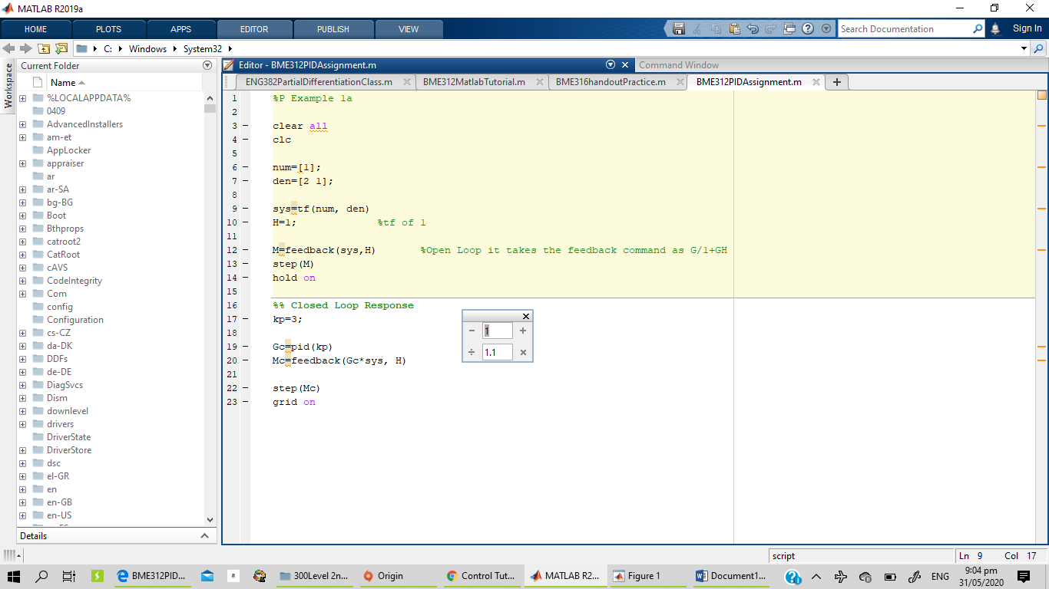
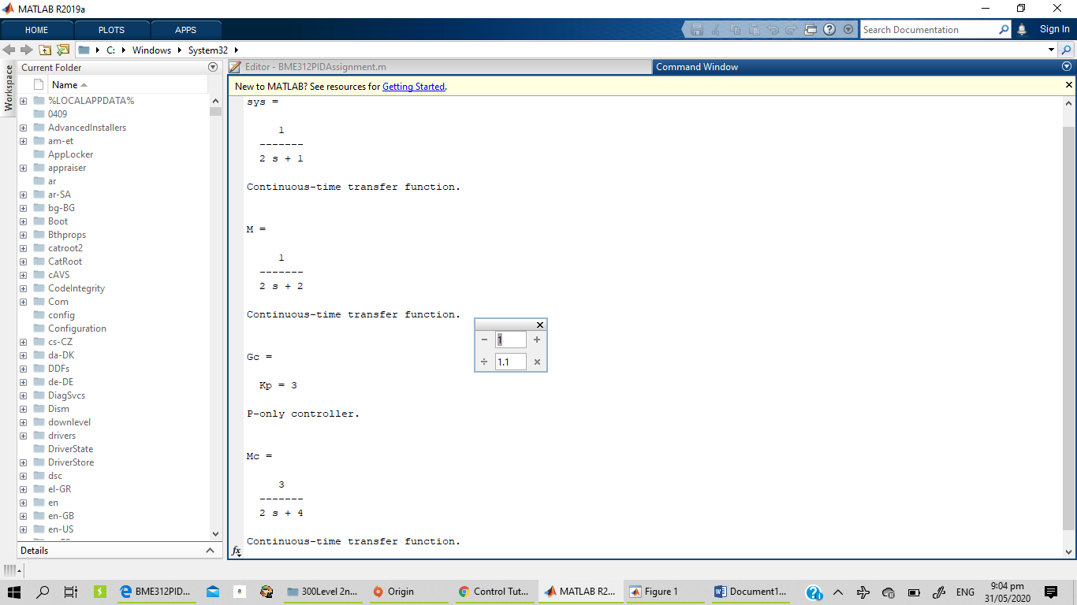
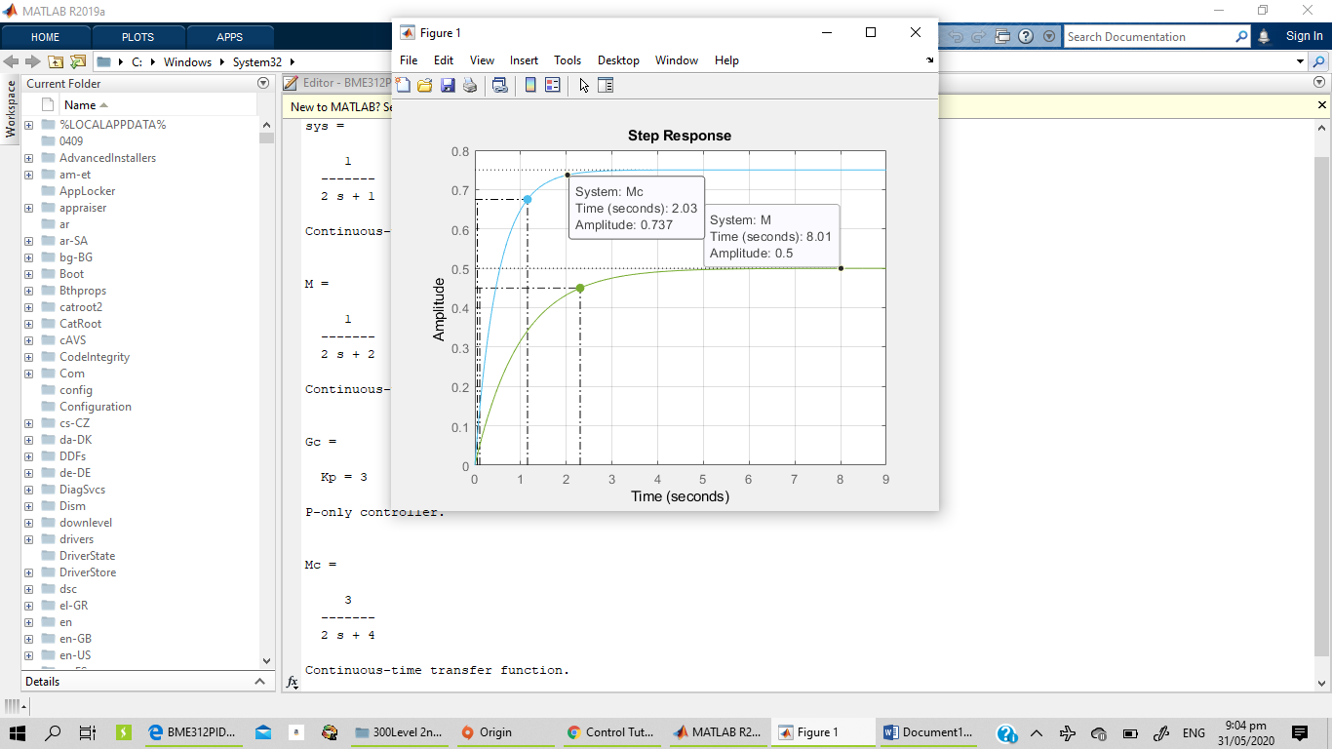

%PID Example 1b

clear all
clc

num=[2]
den=[1 12 9]

sys=tf(num, den)
H=1 %tf of 1

M=feedback(sys,H) %Open Loop it takes the feedback command as G/1+GH
step(M)
hold on

%% Closed Loop Response
kp=11
ki=0
kd=3

Gc=pid(kp,ki,kd)
Mc=feedback(Gc*sys, H)

step(Mc)
grid on

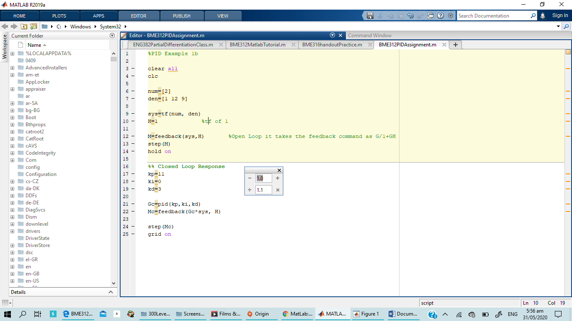
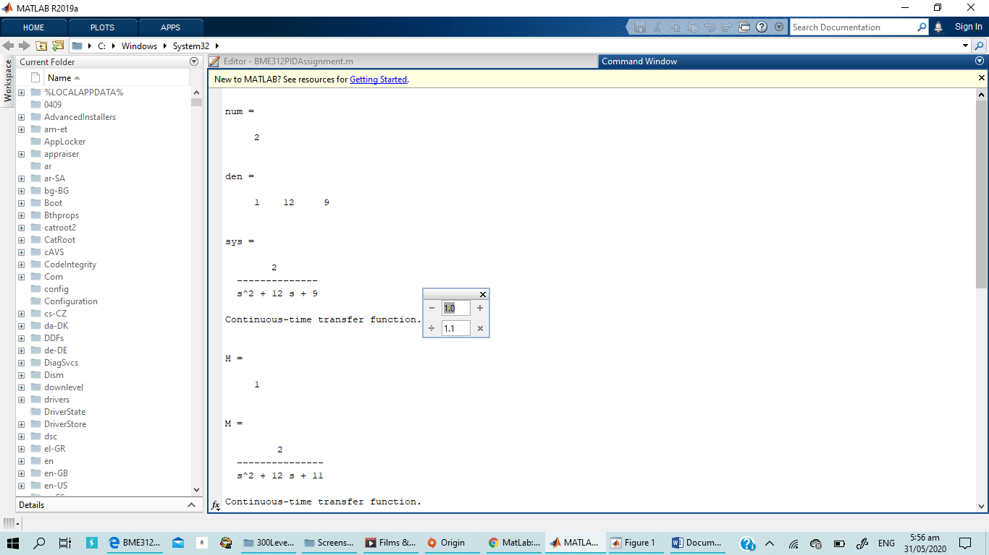
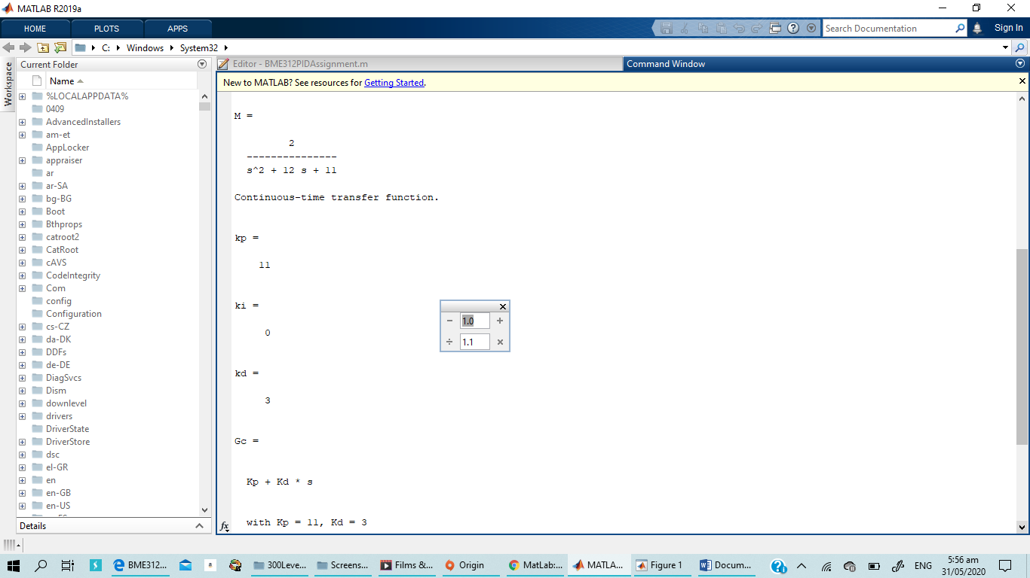
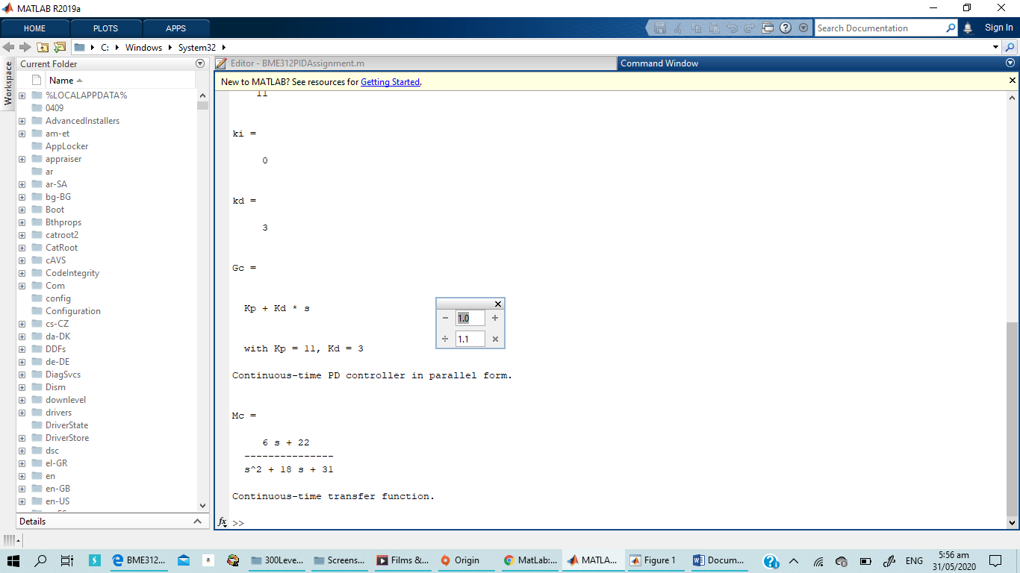
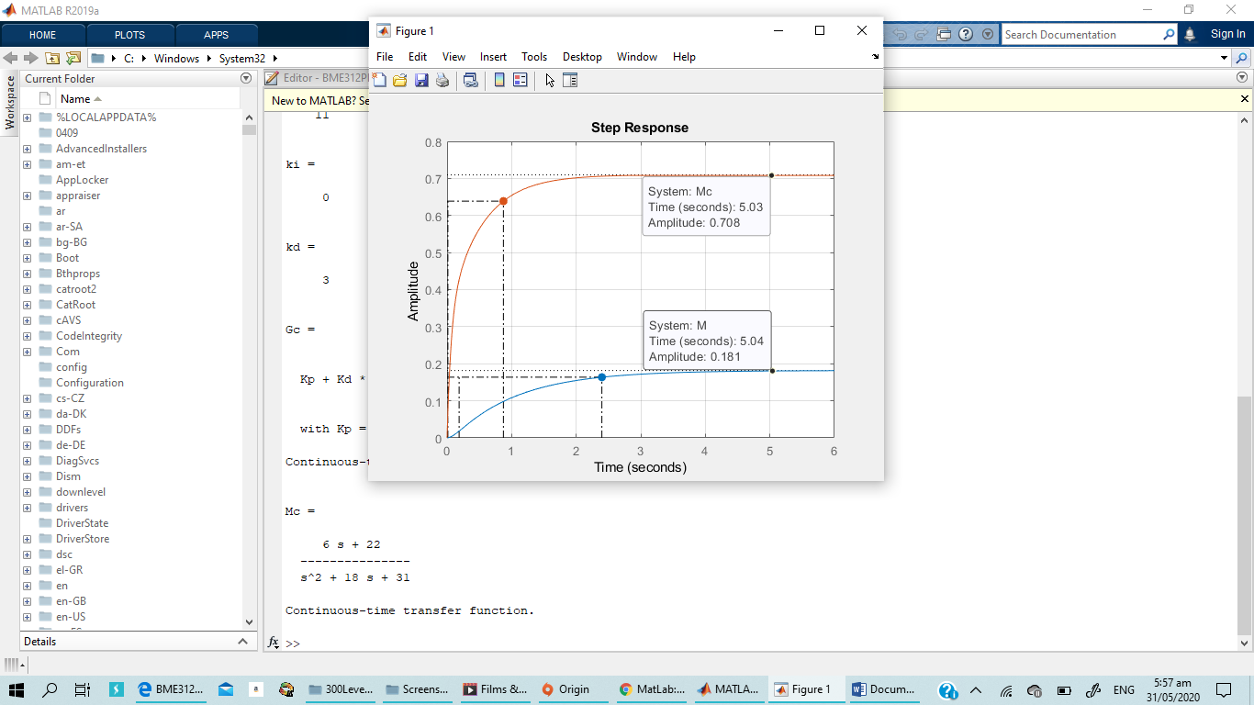

%Pi Example 1b

clear all
clc

num=[2]
den=[1 12 9]

sys=tf(num, den)
H=1 %tf of 1

M=feedback(sys,H) %Open Loop it takes the feedback command as G/1+GH
step(M)
hold on

%% Closed Loop Response
kp=7
ki=2

Gc=pid(kp,ki)
Mc=feedback(Gc*sys, H)

step(Mc)
grid on

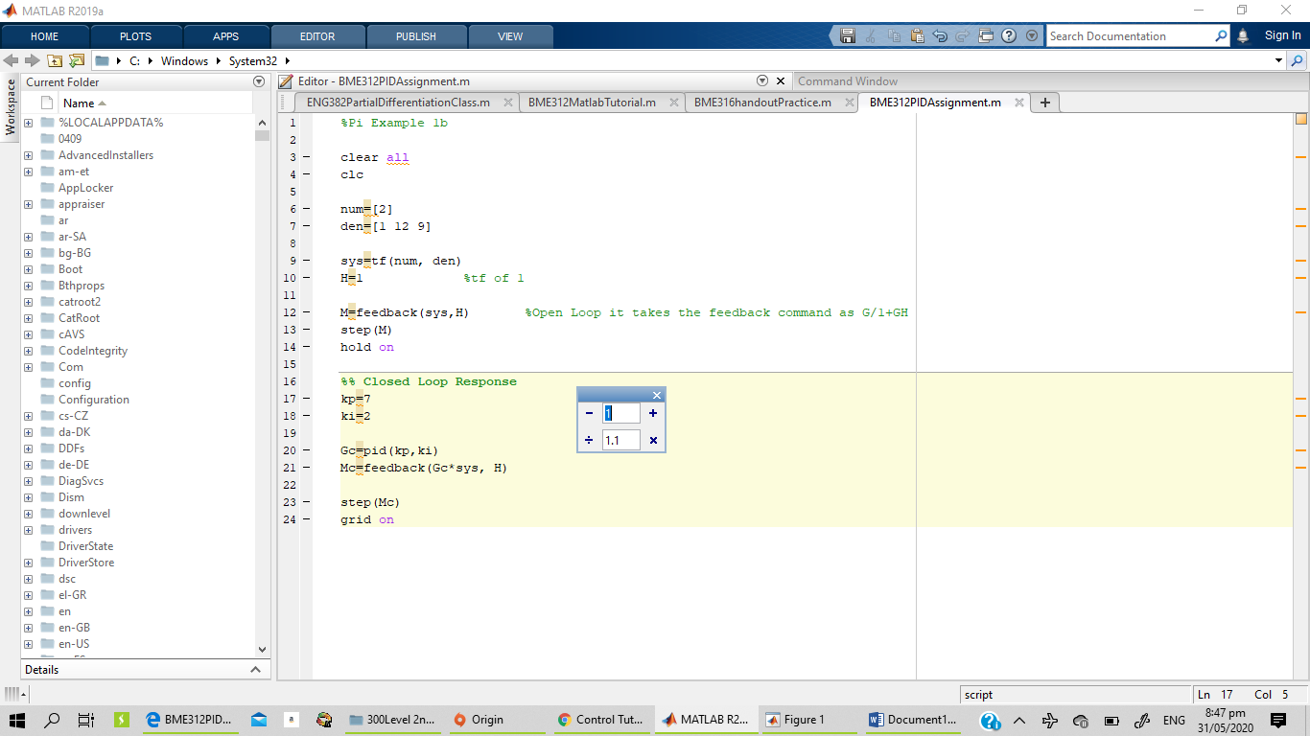
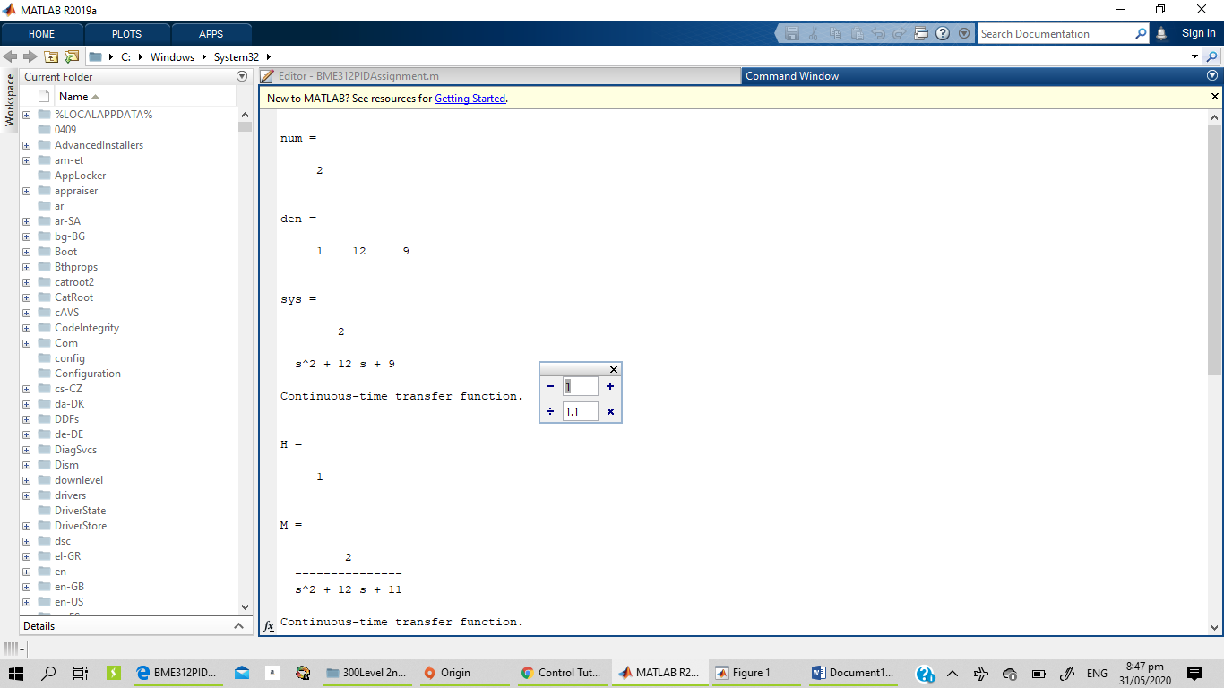
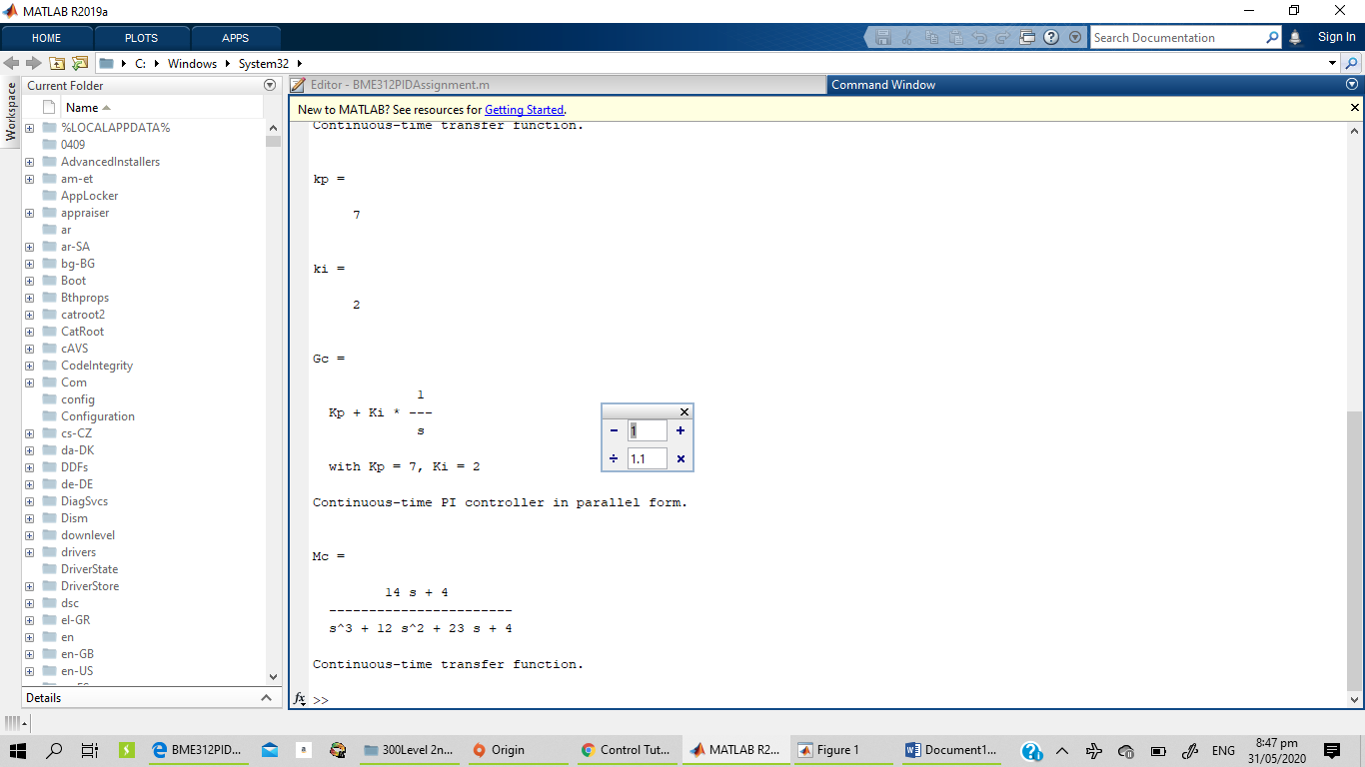
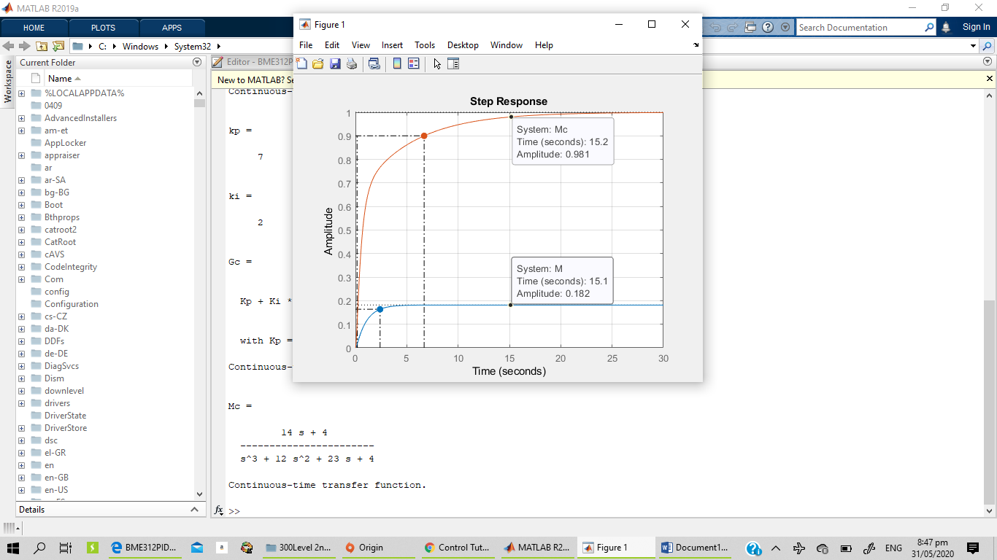

%P Example 1b

clear all
clc

num=[2]
den=[1 12 9]

sys=tf(num, den)
H=1 %tf of 1

M=feedback(sys,H) %Open Loop it takes the feedback command as G/1+GH
step(M)
hold on

%% Closed Loop Response
kp=7

Gc=pid(kp)
Mc=feedback(Gc*sys, H)

step(Mc)
grid on

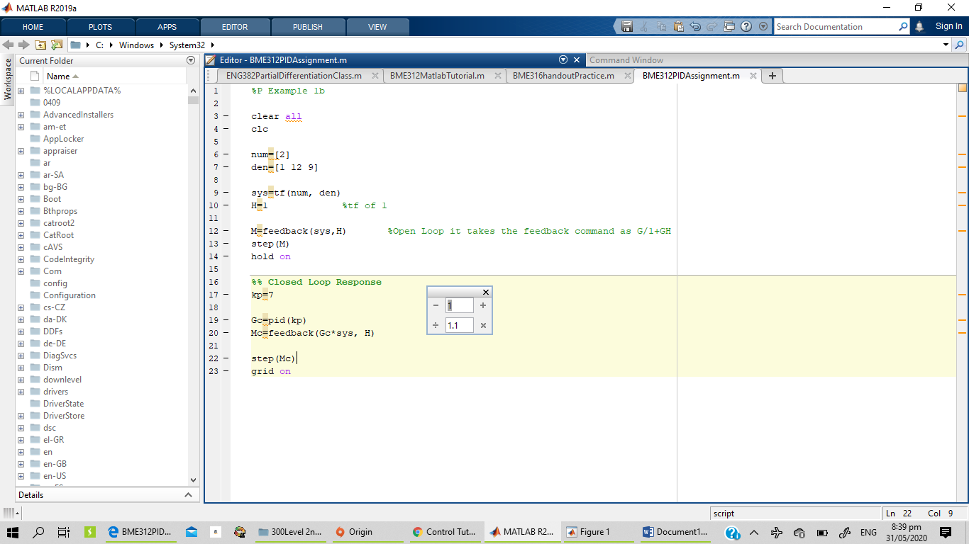
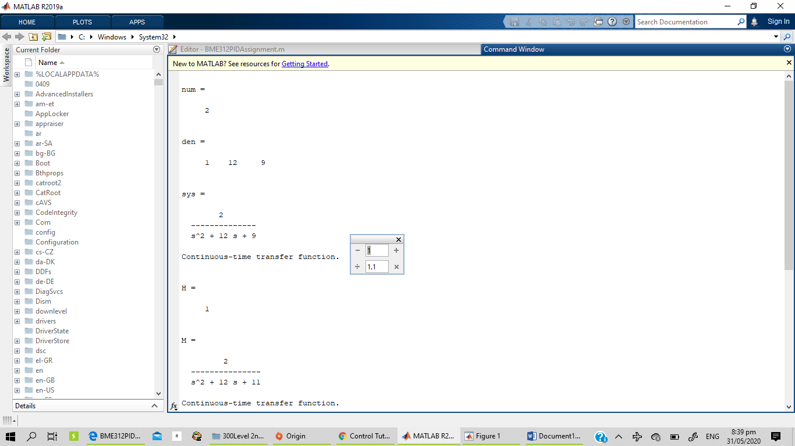
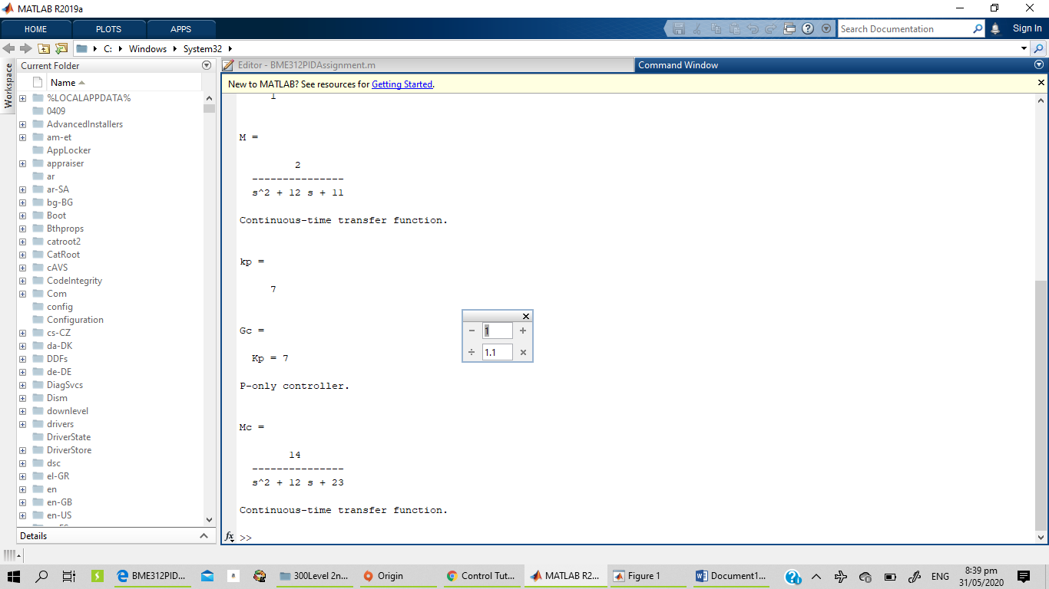

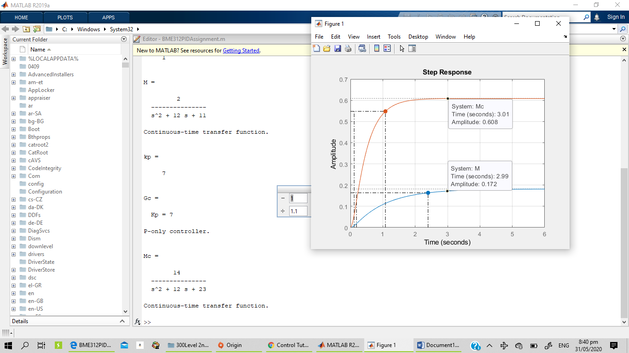

%PID Example 1c

clear all
clc

num=[1]
den=[1 14 49]

sys=tf(num, den)
H=1 %tf of 1

M=feedback(sys,H) %Open Loop it takes the feedback command as G/1+GH
step(M)
hold on

%% Closed Loop Response
kp=7
ki=0
kd=3

Gc=pid(kp,ki,kd)
Mc=feedback(Gc*sys, H)

step(Mc)
grid on

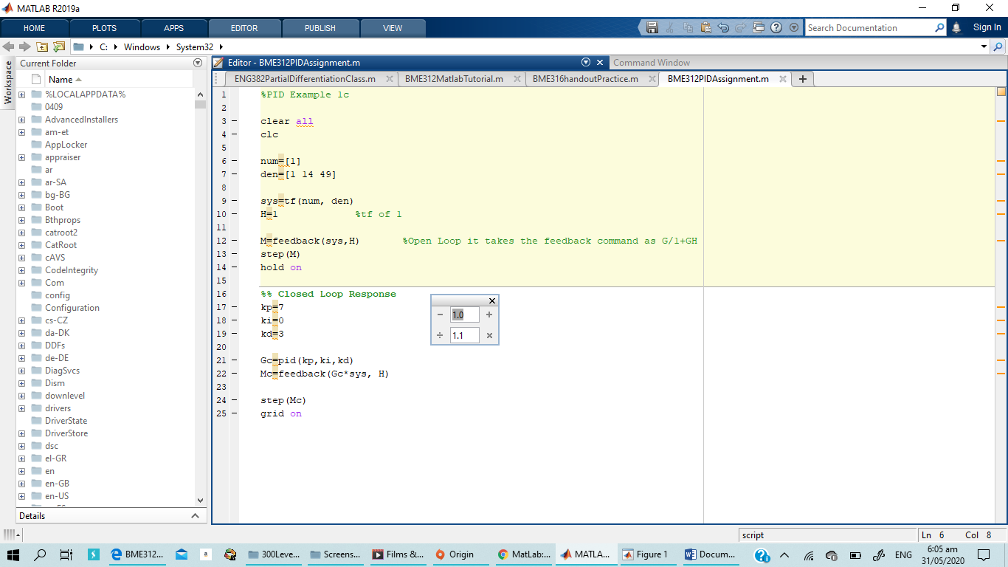
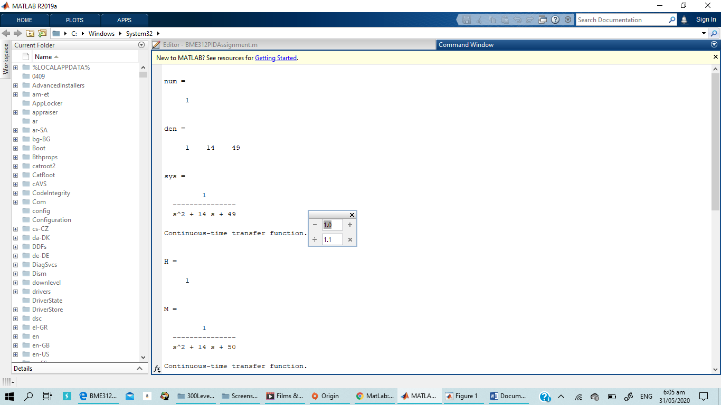
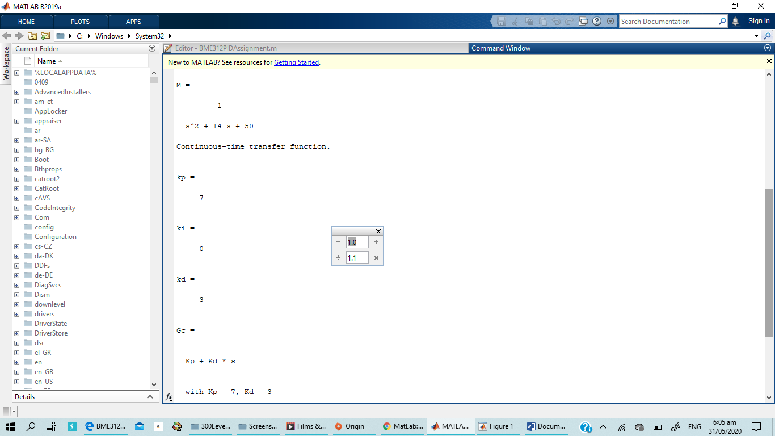
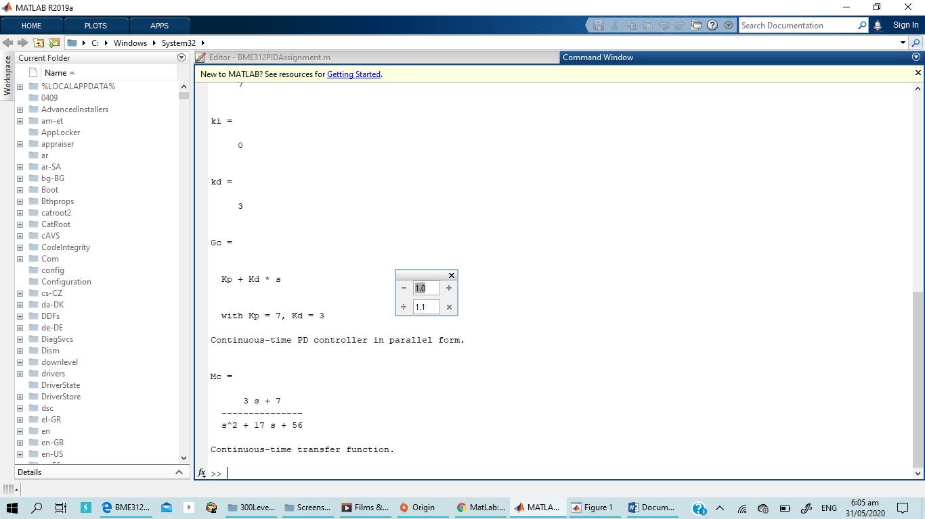
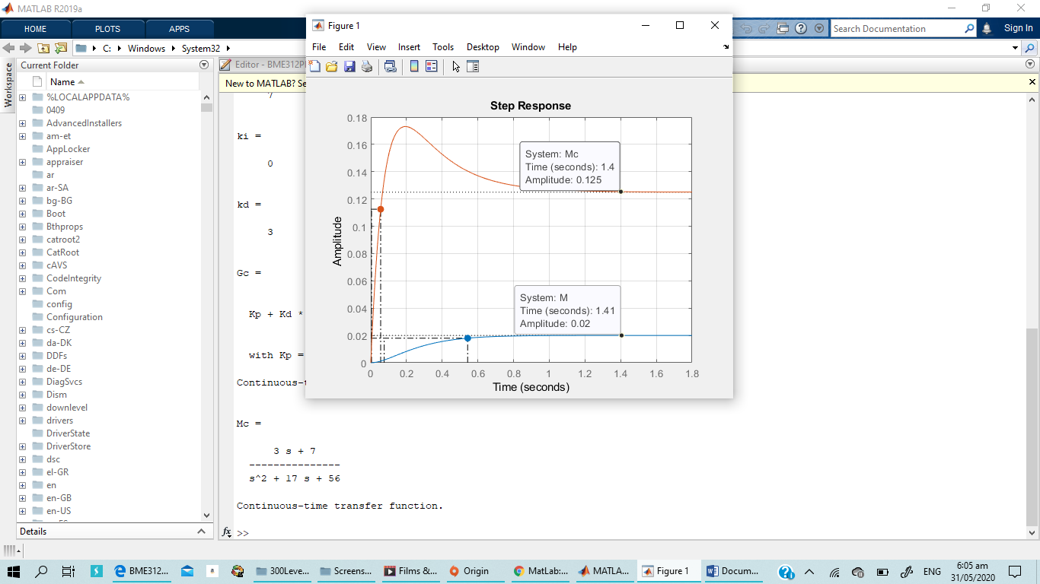

%PI Example 1c

clear all
clc

num=[1]
den=[1 14 49]

sys=tf(num, den)
H=1 %tf of 1

M=feedback(sys,H) %Open Loop it takes the feedback command as G/1+GH
step(M)
hold on

%% Closed Loop Response
kp=4
ki=1

Gc=pid(kp,ki)
Mc=feedback(Gc*sys, H)

step(Mc)
grid on

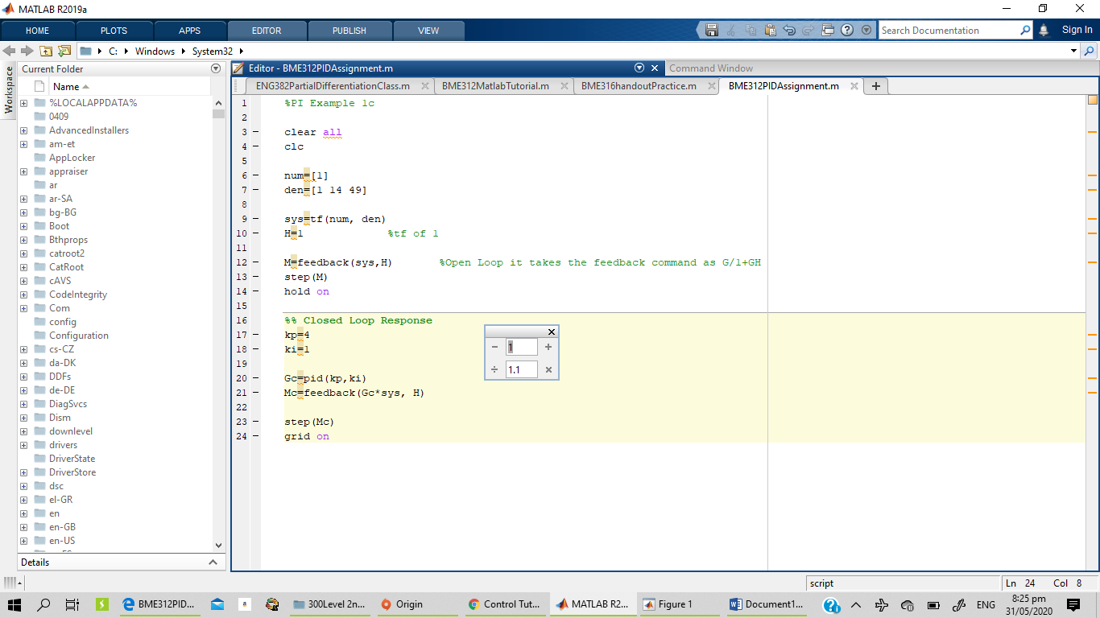
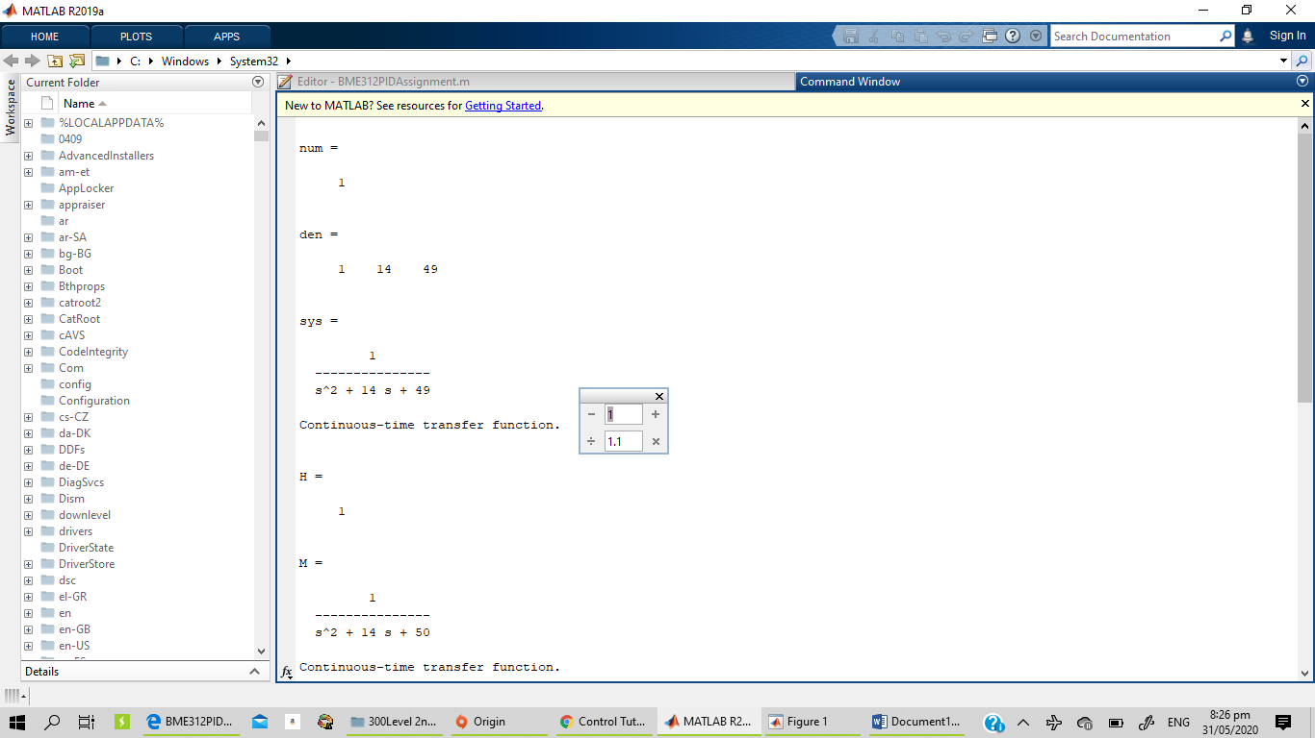
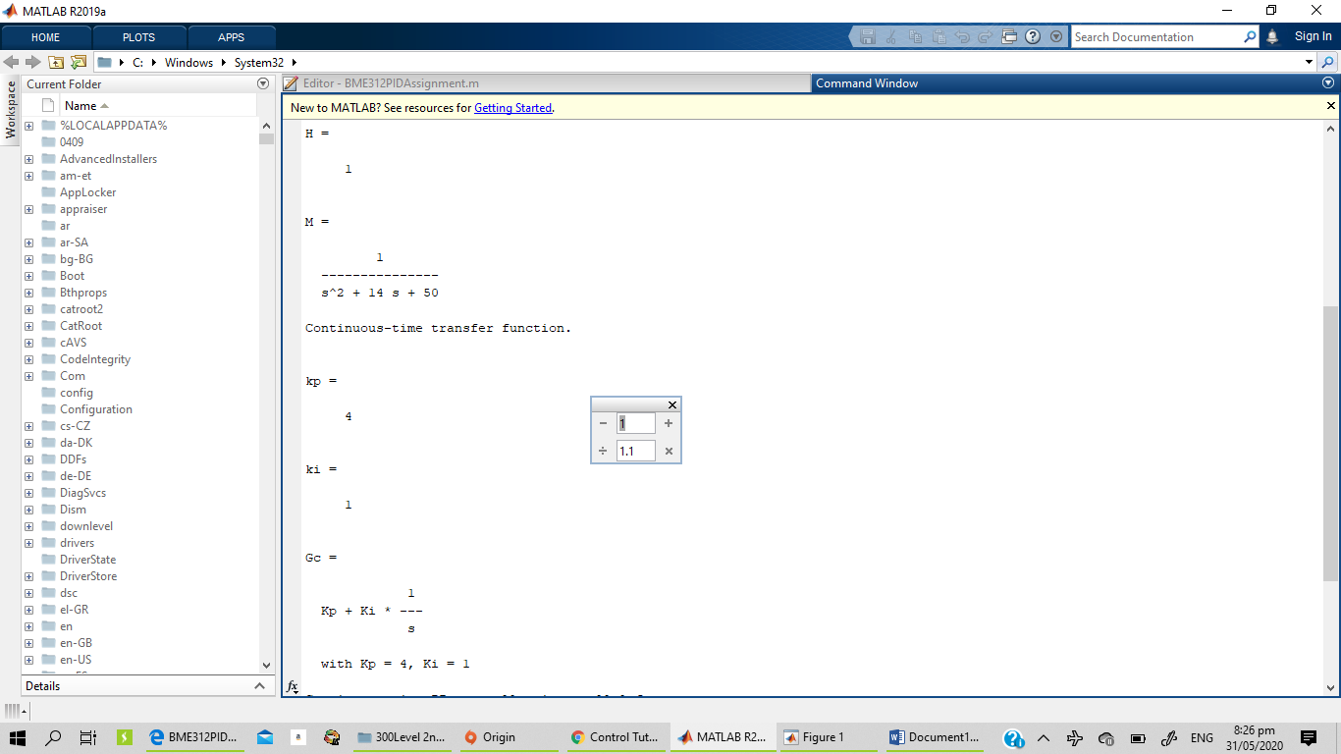
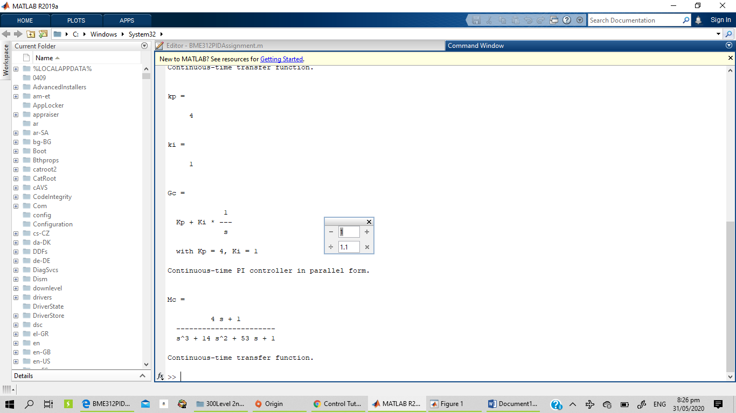
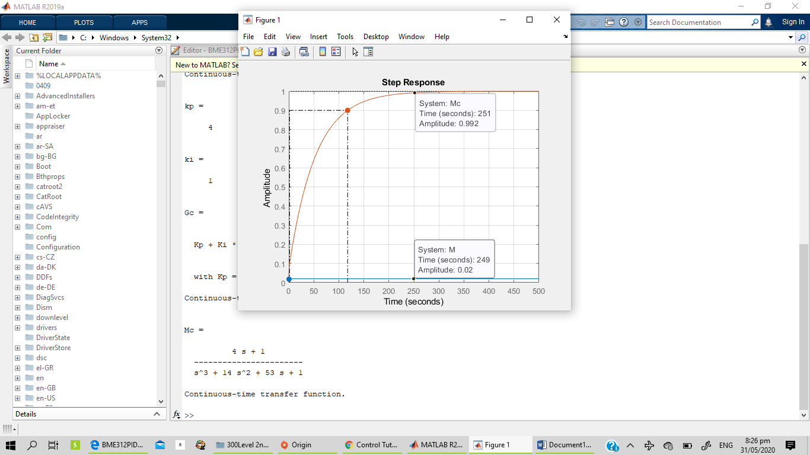

%P Example 1c

clear all
clc

num=[1]
den=[1 14 49]

sys=tf(num, den)
H=1 %tf of 1

M=feedback(sys,H) %Open Loop it takes the feedback command as G/1+GH
step(M)
hold on

%% Closed Loop Response
kp=7

Gc=pid(kp)
Mc=feedback(Gc*sys, H)

step(Mc)
grid on

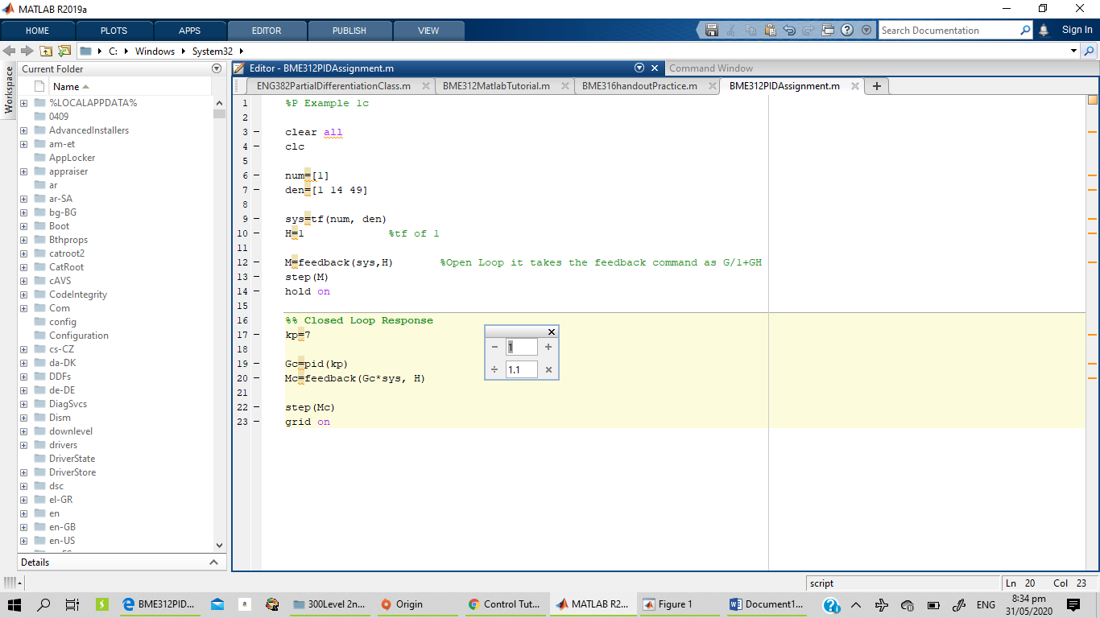
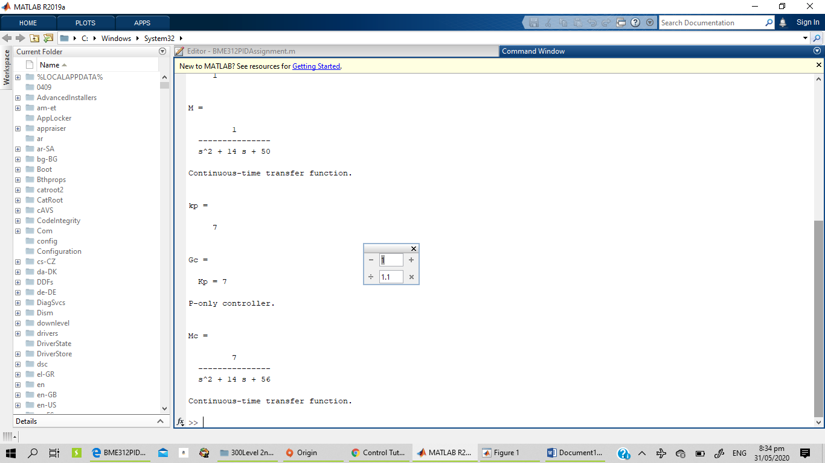
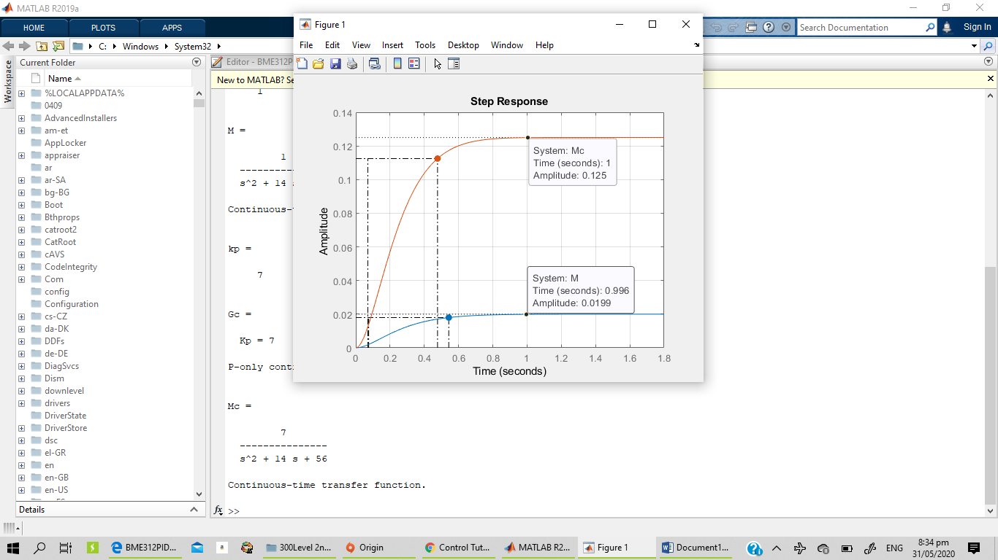

OBSERVATION

- I observed that during my simulation the increase of kp, ki, kd in the simulation changes the graph
- During the PID simulation, I observed that increasing in kp can make it get to overshoot

QUESTION 2
SIMC Tuning Method
%SIMC TUNING Question 2a

clear all
clc

num=[1]
den=[17 2]
theta=3
sys=tf(num, den, 'InputDelay', theta) %InputDelay, to specify delays at the inputs
P0 = tf(num,den)
step(P0,'b',sys,'r')

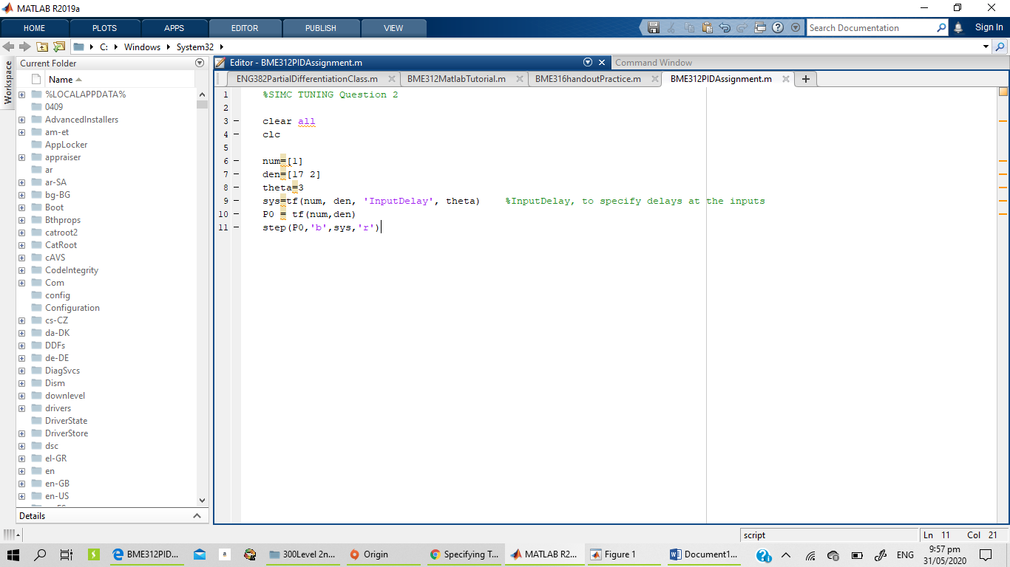
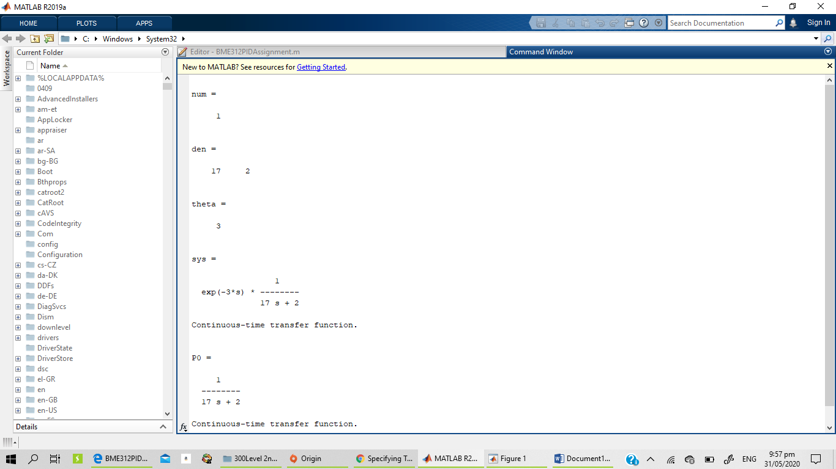

%SIMC TUNING Question 2b

clear all
clc

num=[2]
den=[5 1]
theta=2
sys=tf(num, den, 'InputDelay', theta) %InputDelay, to specify delays at the inputs
P0 = tf(num,den)
step(P0,'b',sys,'r')

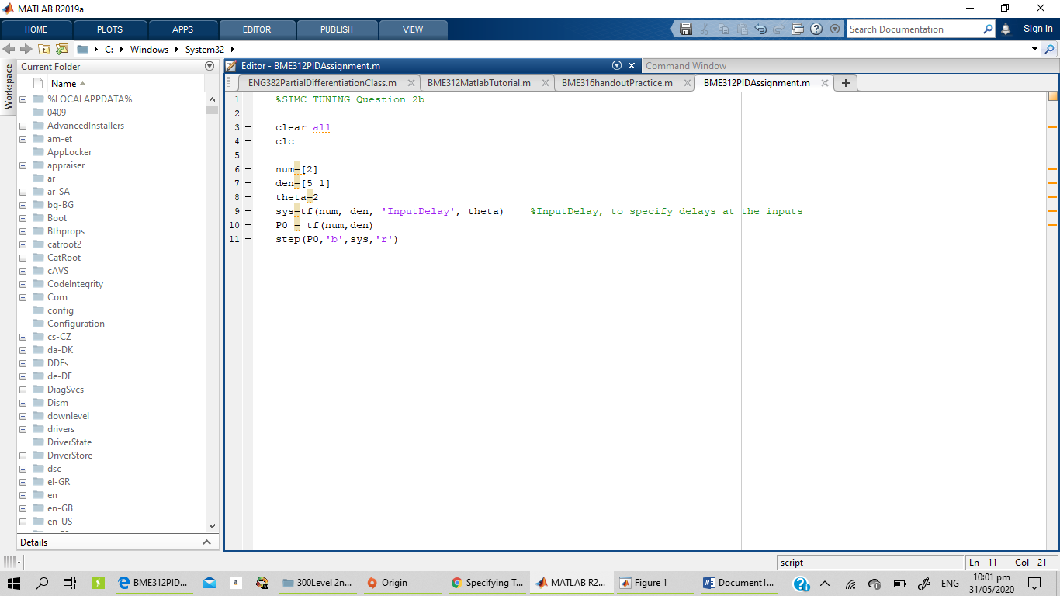
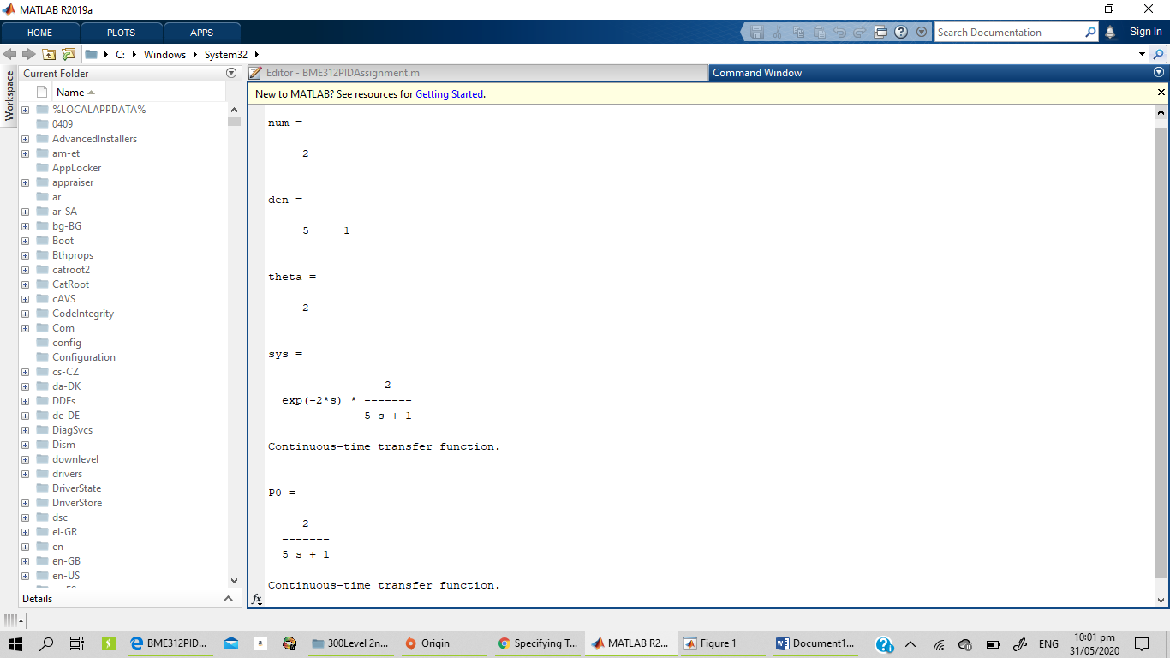
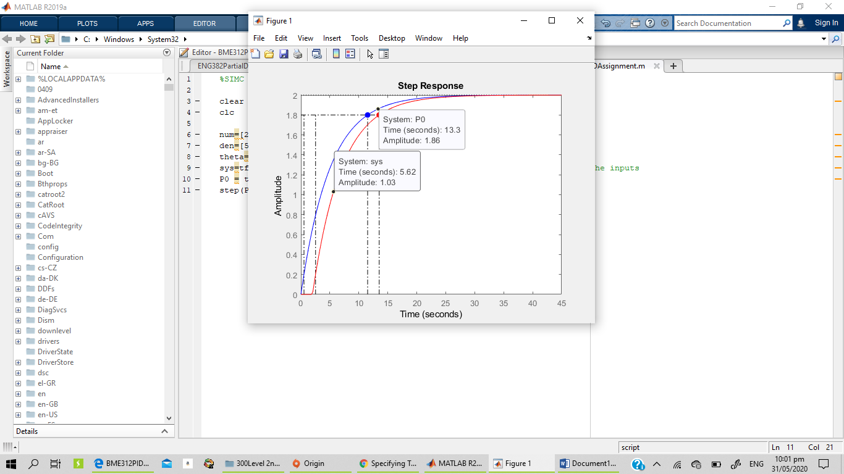

OBSERVATION
- I observed that the rising time between the two are different

