NAME: OYEBOADE Rukayah Kiitan
MATRIC NO: 17/ENG08/004
DEPARTMENT: Biomedical Engineering
COURSE CODE: BME312
COURSE TITLE: Biological Systems Control and Modelling

Example 1.- Transfer function
Q= (0.1)/((s^2)+(0.17*s)+0.006) ;
den= [1 0.17 0.006];
roots(den)
num=[0.1]
[r,p]=residue(num,den)

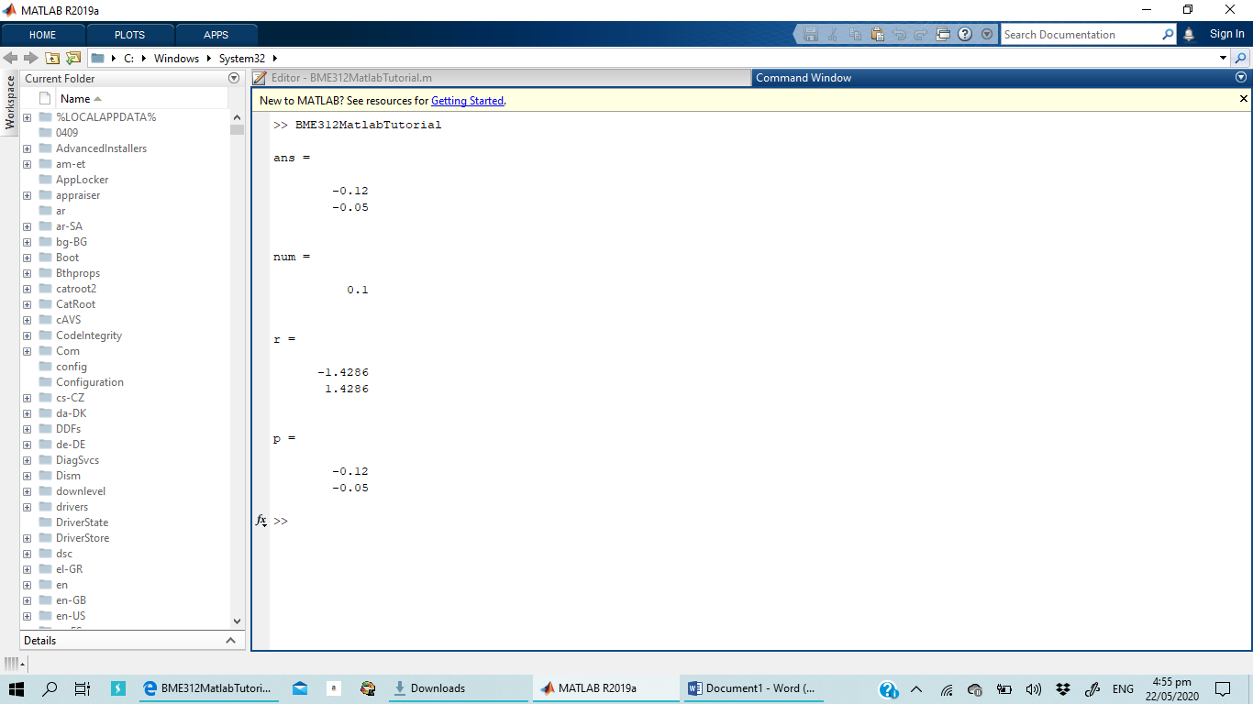

Example 2.-Transfer Function
Q= (0.1)/((s^2)+(0.17*s)+0.006) ;
den= [1 0.17 0.006];
roots(den)
num=[0.1];
[r,p]=residue(num,den);
t=0:0.1:250;
y=(1.4286*exp(-0.12*t))+(1.4286*exp(-0.05*t));
plot(t,y)

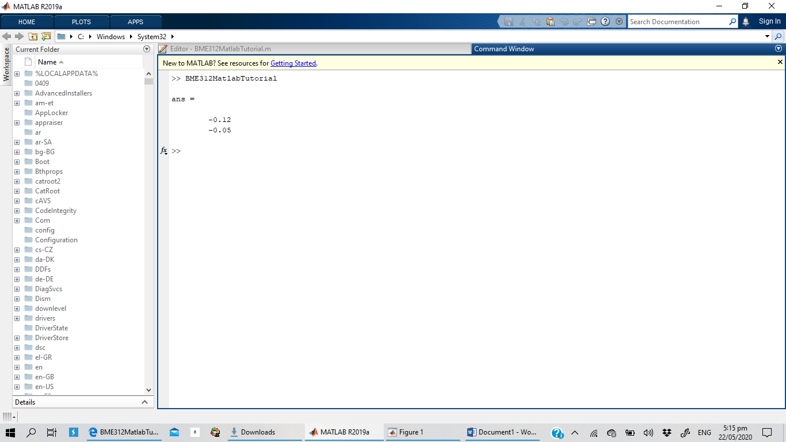
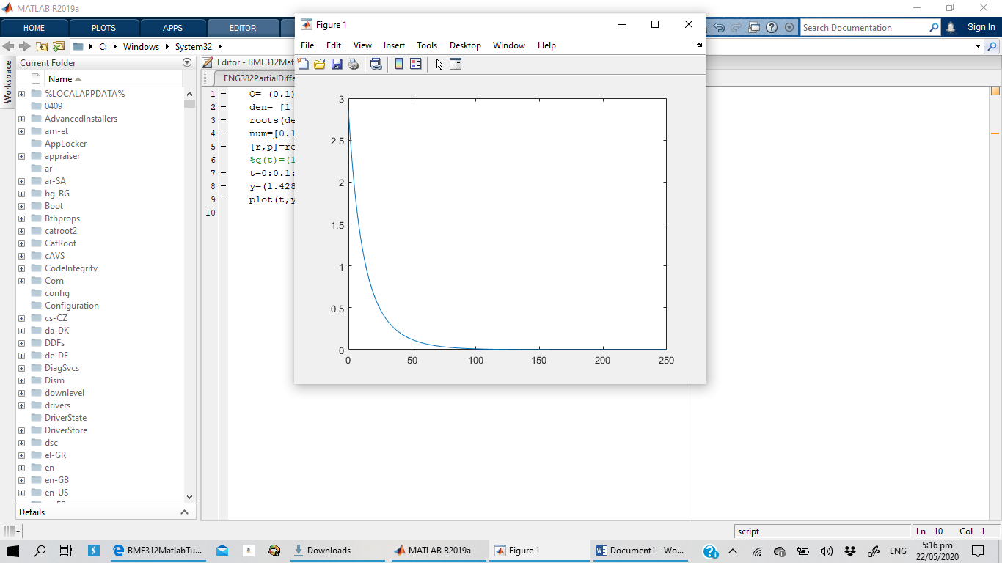

Example 3- Step Response (Transfer Function)
Q= 6/((2*s^3)+(2*s^2)+s);
den= [2 3 1 0 ];
num=[6];
[r,p]=residue(num,den)
t=0:0.1:15;
y=6+(6*exp(-t))-(12*exp(-0.05*t));
plot(t,y)

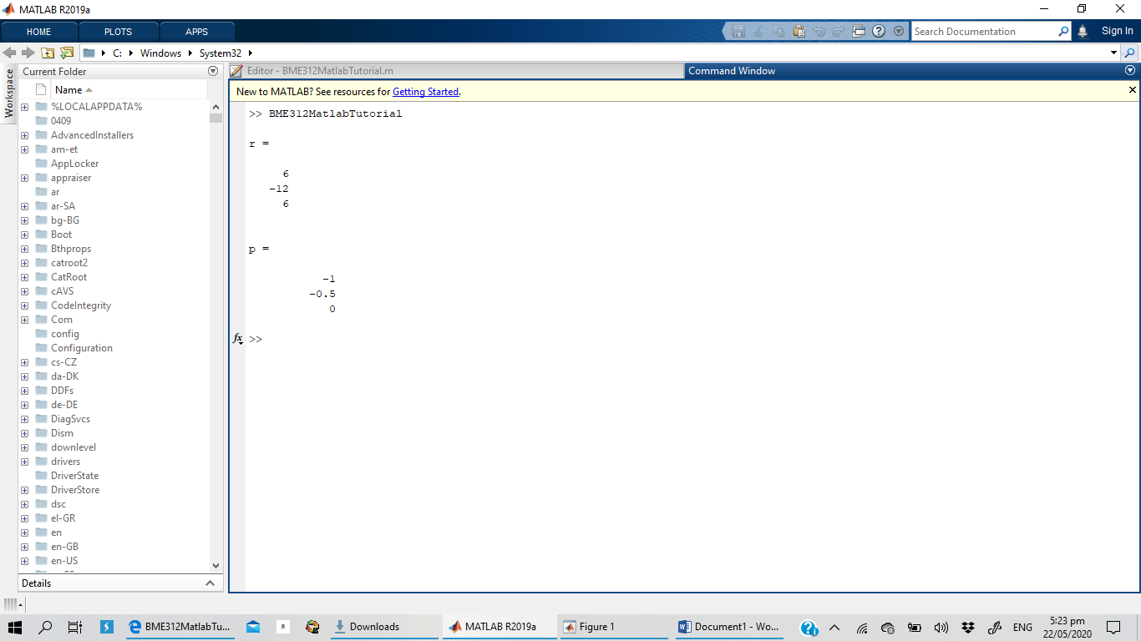
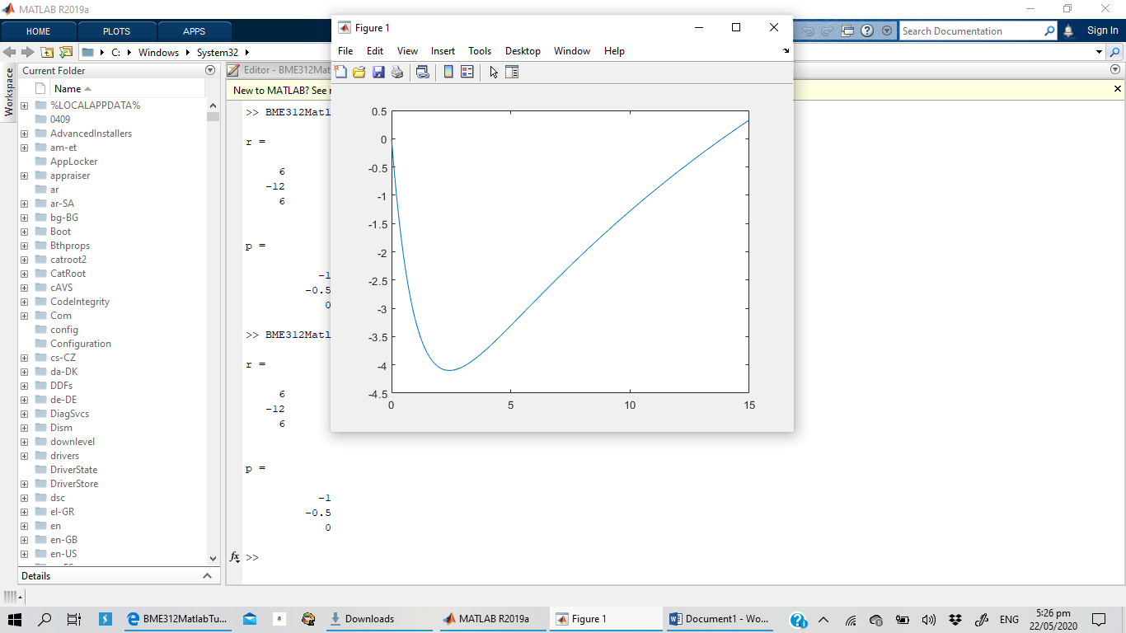

Using second Code
Q= 6/((2*s^3)+(3*s^2)+s);
den= [2 3 1 0 ];
num=[6];
[r,p]=residue(num,den)
s=tf('s')
G=6/((2*s^2)+(3*s)+1)
step(G,15)
impulse(G,15)
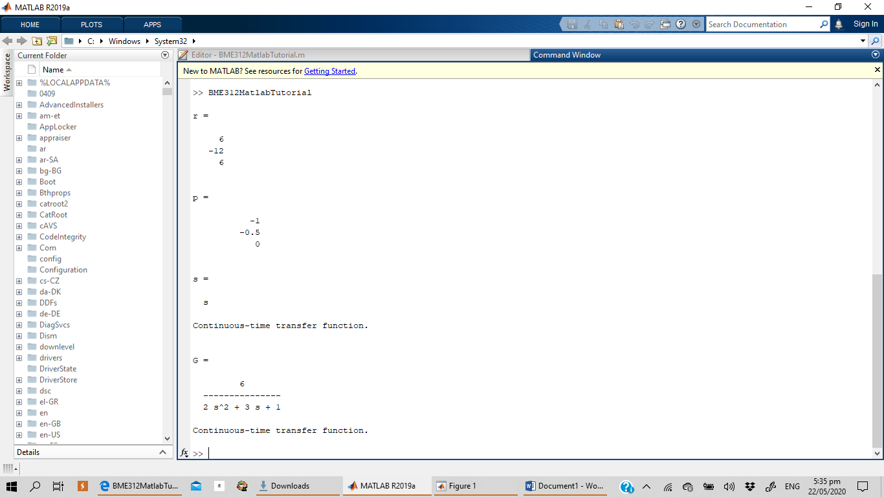
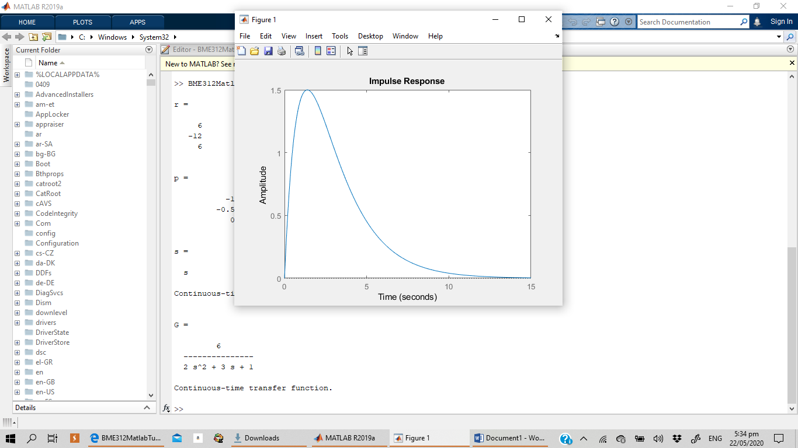

Example 4- Compartmental Model
syms s VT VA VL UFR KTA KTL KA KL
VA = KTA/((s+KA)*VT);
VL= KTL/((s+KL)*VT);
eq=VT==((KA/(s+KTA+KTL))*VA)+ ((KL/(s+KTA+KTL))*VL)-((1/(s+KTA+KTL))*UFR);
VT= solve(eq,VT);
G= VT/UFR;
G=collect(G);
pretty(G);
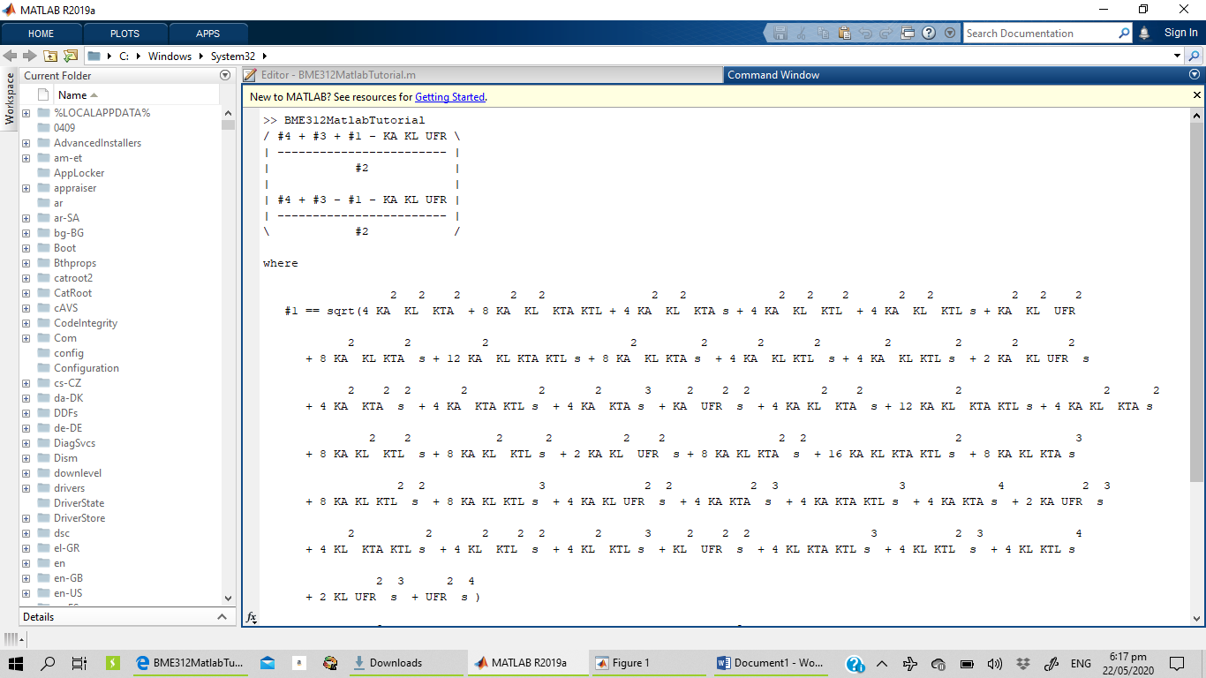
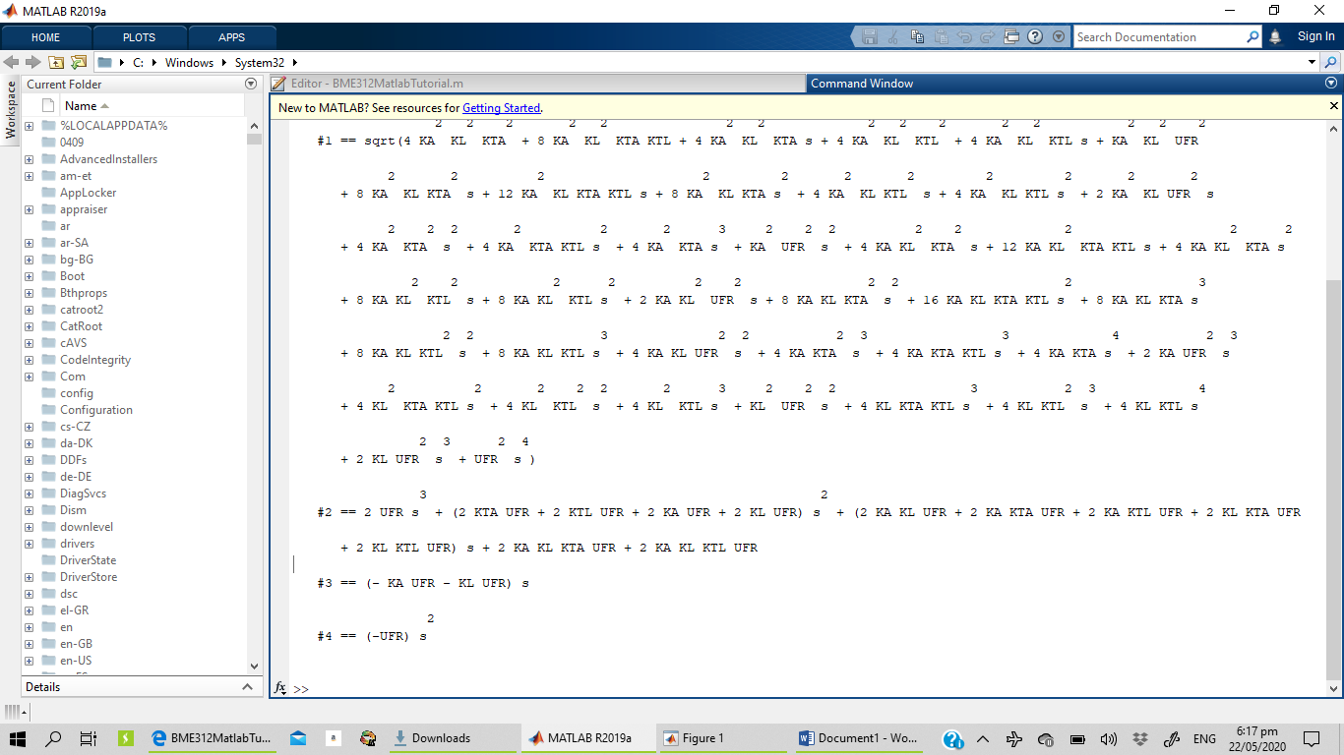

Example 5
syms s VT VA VL UFR KTA KTL KA KL
VA = KTA/((s+KA)*VT);
VL= KTL/((s+KL)*VT);
eq=VT==((KA/(s+KTA+KTL))*VA)+ ((KL/(s+KTA+KTL))*VL)-((1/(s+KTA+KTL))*UFR);
VT= solve(eq,VT);
G= VT/UFR;
G=collect(G);
pretty(G);
G=subs(G, [KA, KL, KTA, KTL], [0.15, 0.25, 0.33, 0.25]);
[numGs, denGs]=numden(G);
numG=sym2poly(numGs);
denG=sym2poly(denGs);
G= tf(numG,denG);
G=minreal(numG,denG);
ZerosG=zero(G);
polesG=pole(G);
p2map(G);
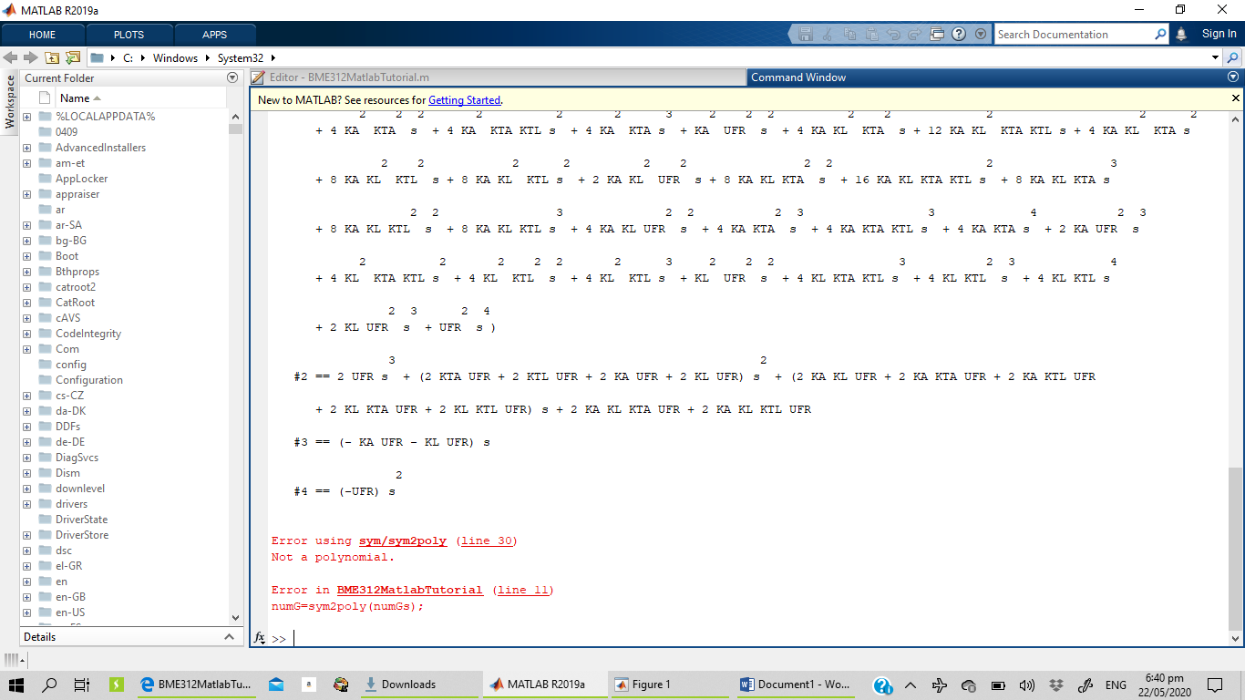

%CODE DID NOT RUN!!!!

Example 5.
K=2;
m= (K*G)/((K*G)-1);
%M=minreal(m);
display(m)
[ir,t]=impulse(m);
sr=step(m,t);
figure
plot(t,ir,'b',t,sr,'r')
axis tight
legend({'impulse response','step response'},'location','Best')
xlabel('time')
ylabel('V_T(t)')

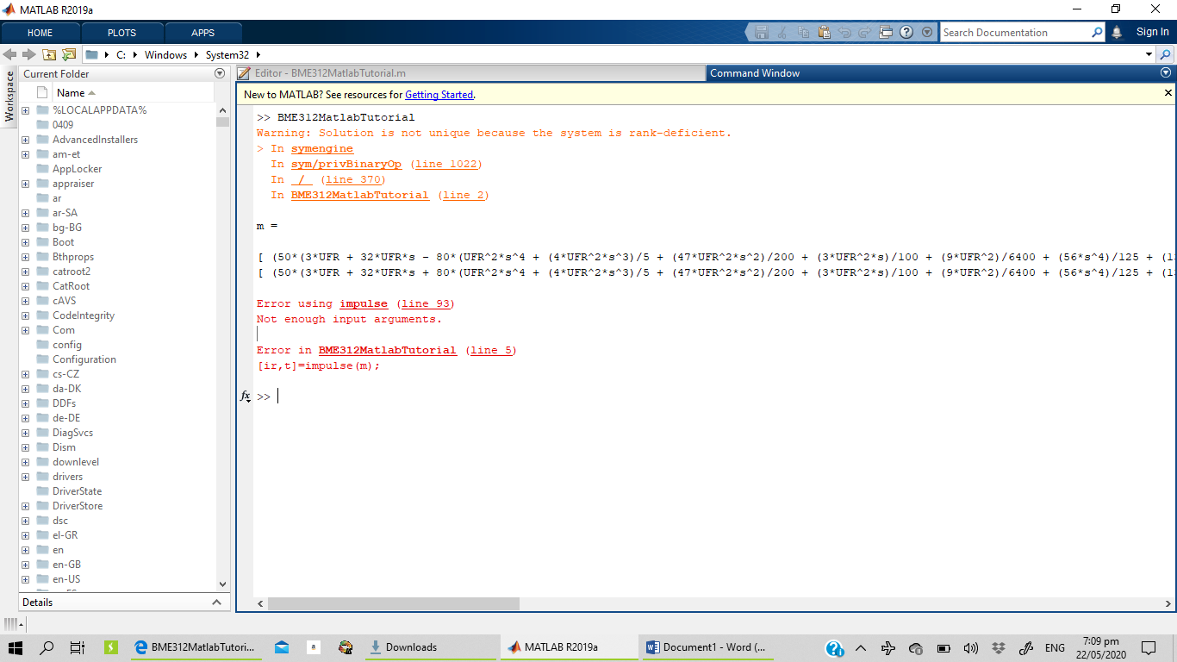

Example 6- Drug Administration
syms t tp
dc_dt=diff(c,t);
tp=solve(dc_dt==0,t);
pretty(tp);
cp=subs(c,t,tp);
pretty(cp);
D0=500;
Vd=10;
par.D0=D0;
par.Vd=Vd;
par.tp=8;
par.cp=30;
x=fsolve(x, absEstimRateEquations(x,par), [2,1]);
ka=x(1);
ke=x(2);
display(ka);
functionF= absElimRateEquation(x, par);
ka= x(1);
ke=x(2);
Vd=par.vd;
tp=log(ka/ke)/(ka-ke);
A= (D0*ka)/(Vd*(ka-ke));
cp=(A*exp(-ke*tp))-(A*exp(-ka*tp));
eq1=tp-par.tp;
eq2=cp-par.cp;
F=[eq1 eq2];

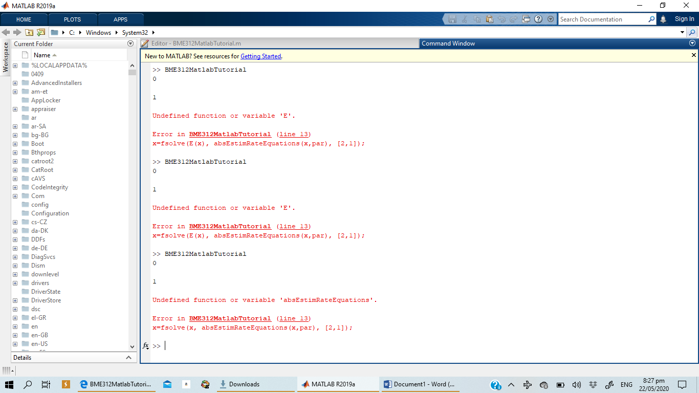

%DID NOT RUN

