PID TUNING ASSIGNMENT
NWANKWO CHUKWUERIKE MARK
17/MHS01/205
BIOMEDICAL ENGINEERING

ZIEGLAR-NICHOLS OPEN-LOOP TUNING RULE

clear all
clc

num=[1]
den=[2 1]

sys=tf(num, den)
H=1

M=feedback(sys,H)
step(M)
hold on

kp=15
ki=4
kd=9

Gc=pid(kp,ki,kd)
Mc=feedback(Gc*sys, H)

step(Mc)
grid on

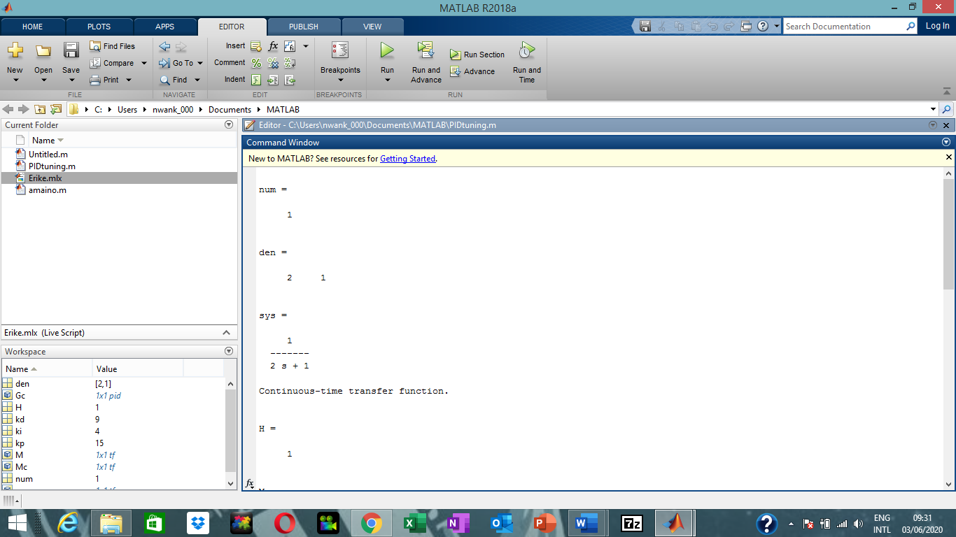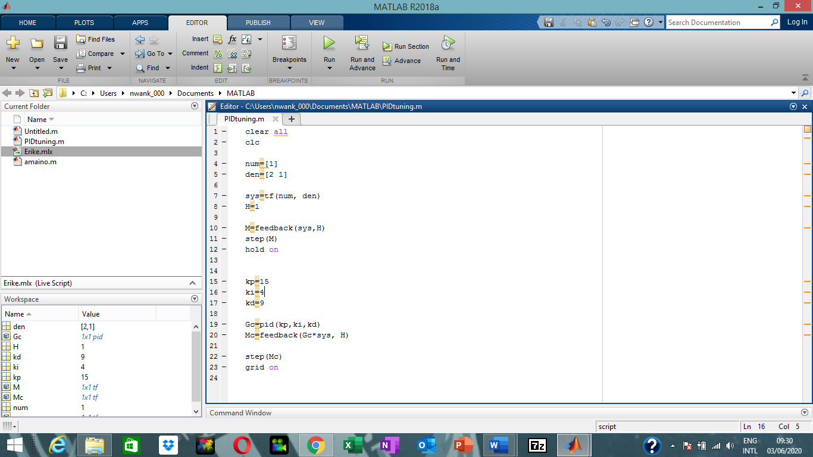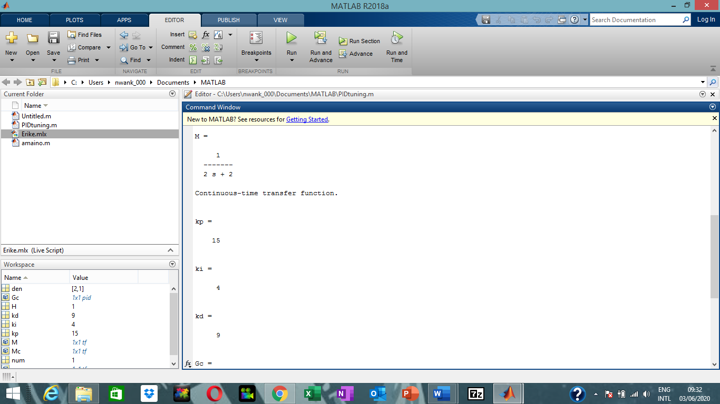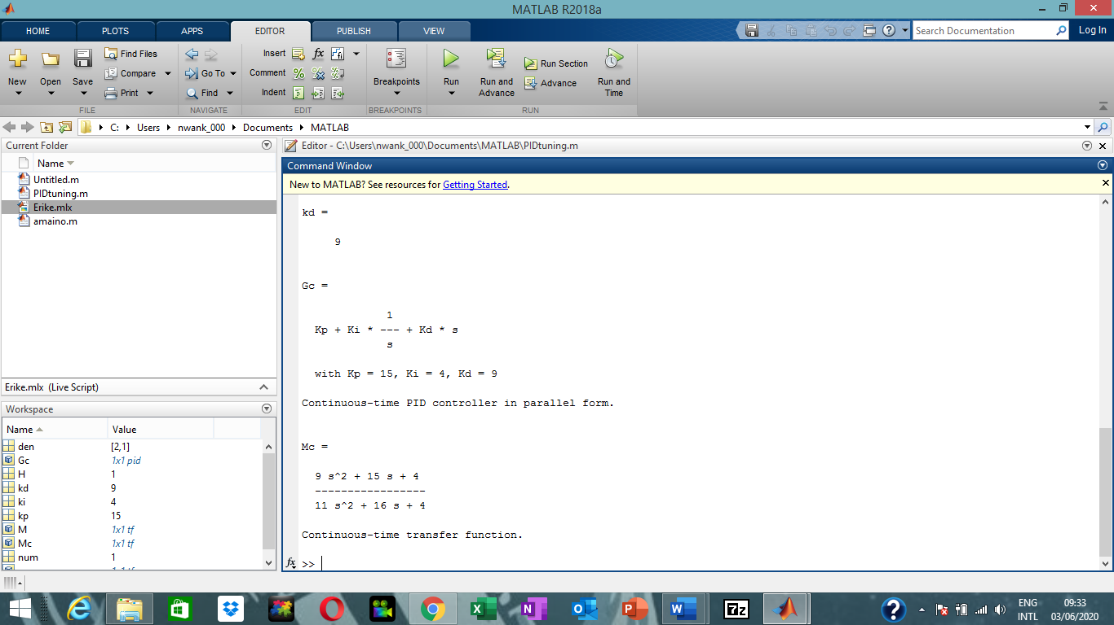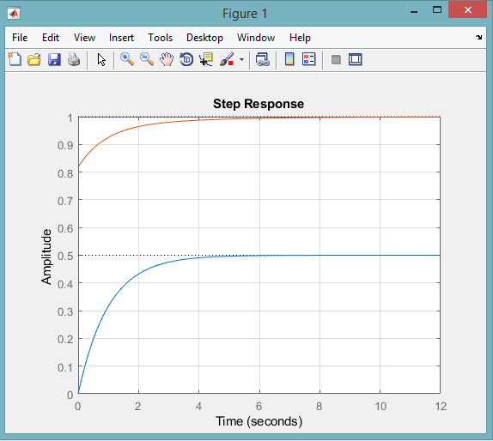

clear all
clc

num=[1];
den=[2 1];

sys=tf(num, den)
H=1;

M=feedback(sys,H)
step(M)
hold on

kp=30;
ki=2;

Gc=pid(kp,ki)
Mc=feedback(Gc*sys, H)

step(Mc)
grid on
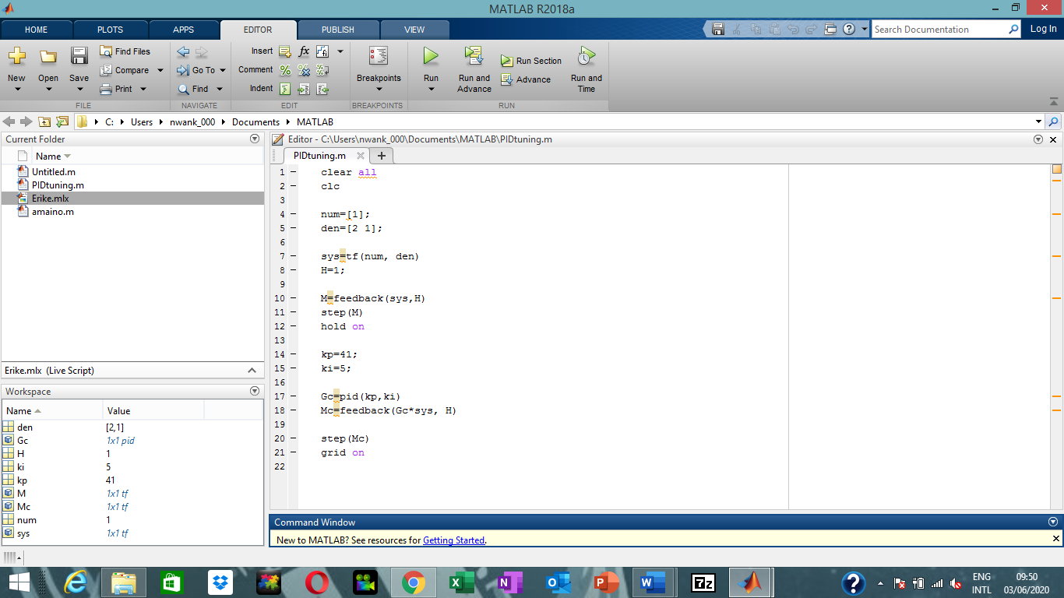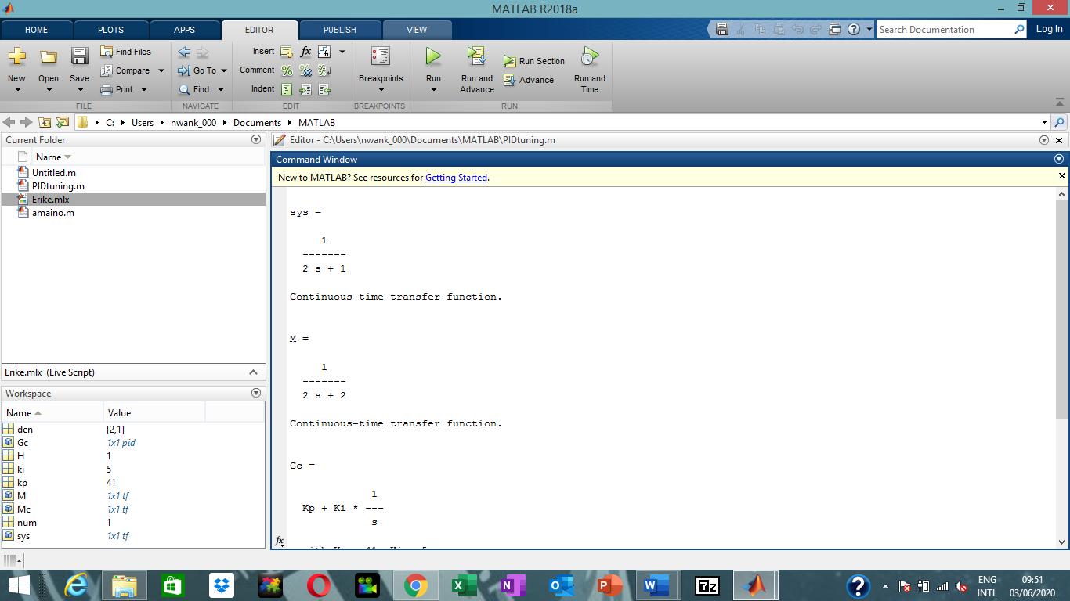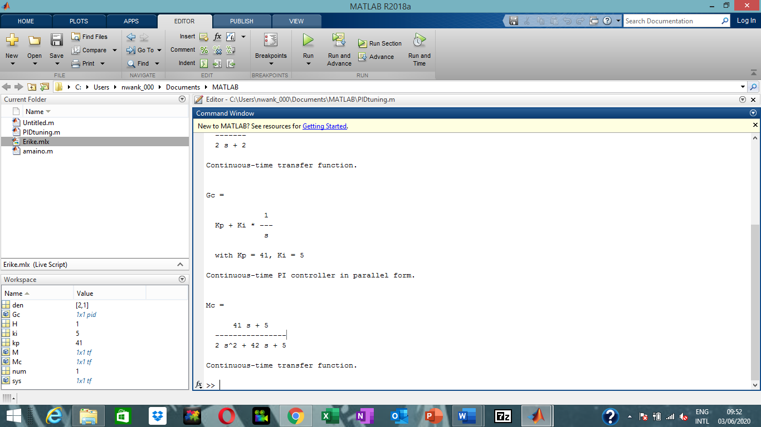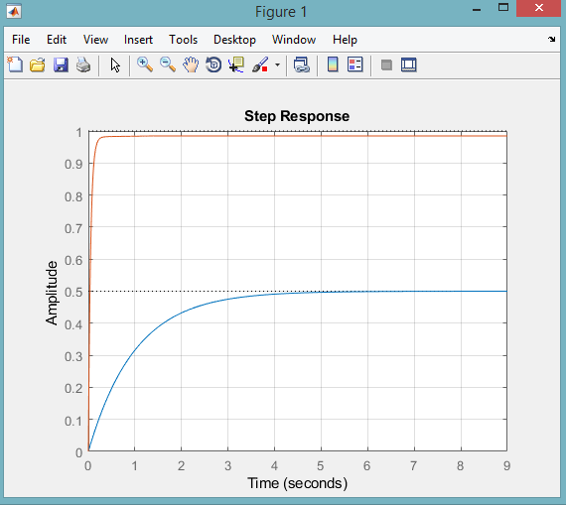

clear all
clc

num=[1];
den=[2 1];

sys=tf(num, den)
H=1;

M=feedback(sys,H)
step(M)
hold on

kp=5;

Gc=pid(kp)
Mc=feedback(Gc*sys, H)

step(Mc)
grid on

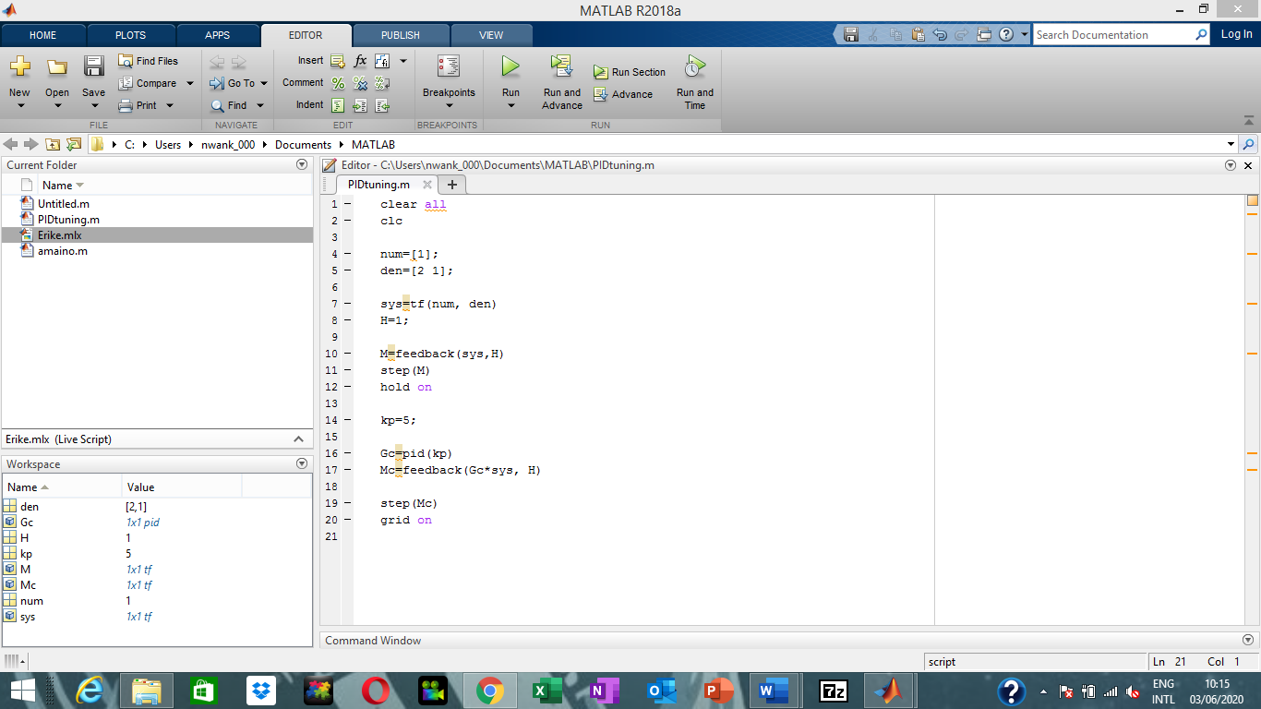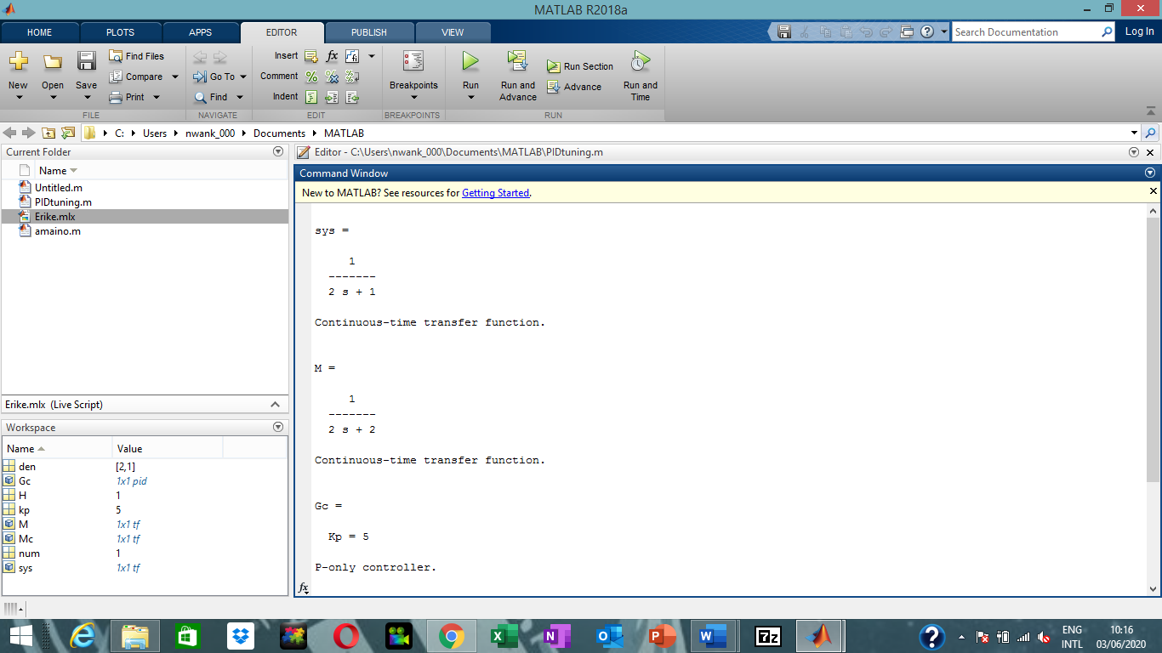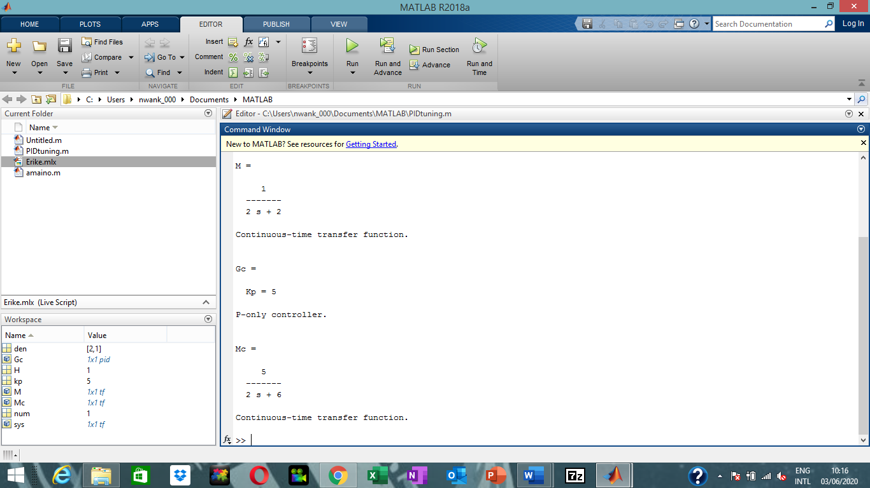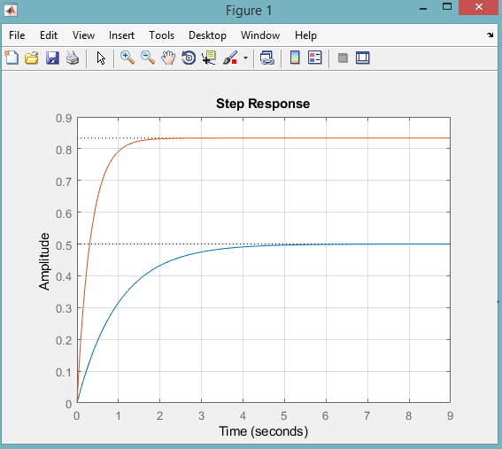

clear all
clc

num=[2]
den=[1 12 9]

sys=tf(num, den)
H=1

M=feedback(sys,H)
step(M)
hold on

kp=10
ki=2
kd=6

Gc=pid(kp,ki,kd)
Mc=feedback(Gc*sys, H)

step(Mc)
grid on

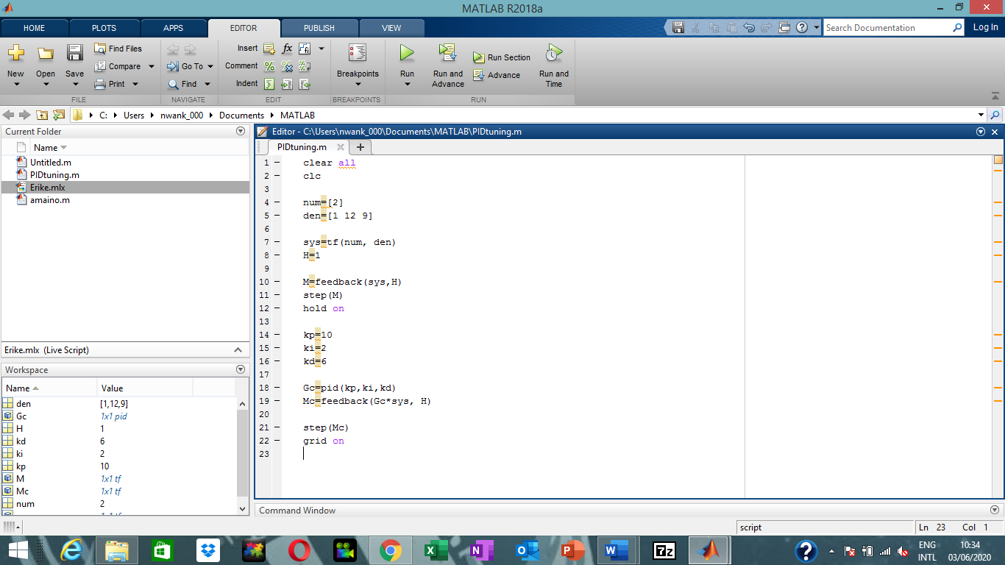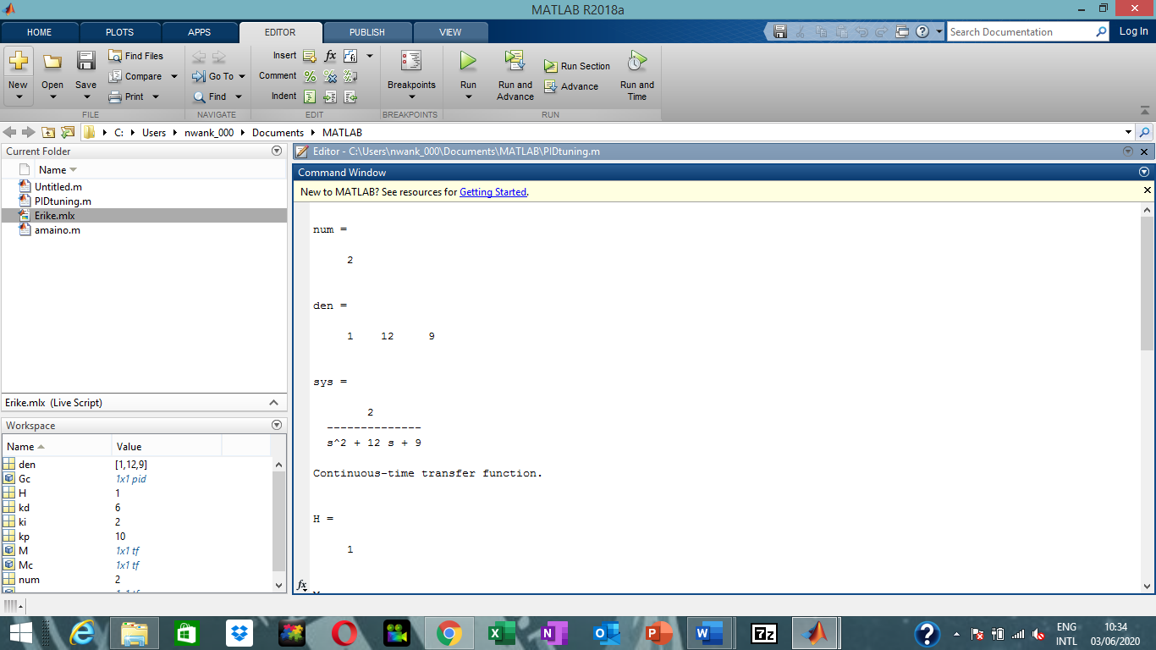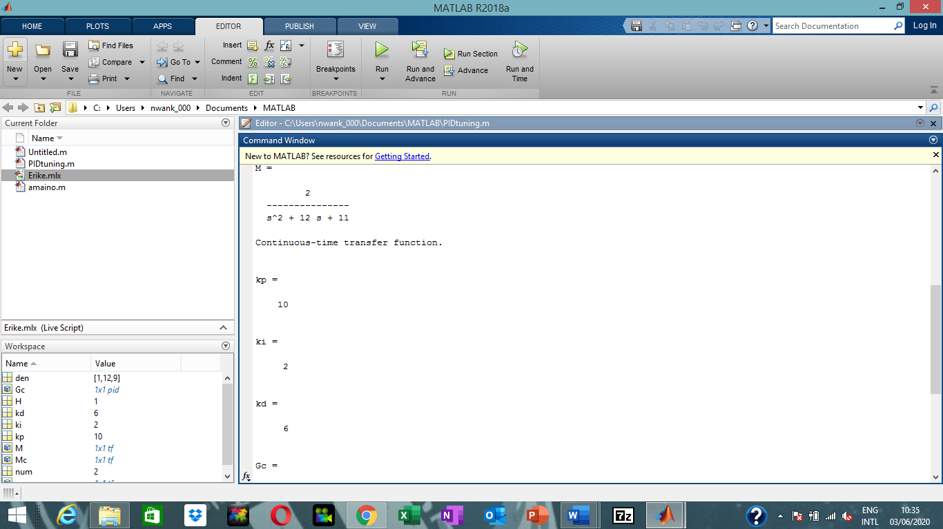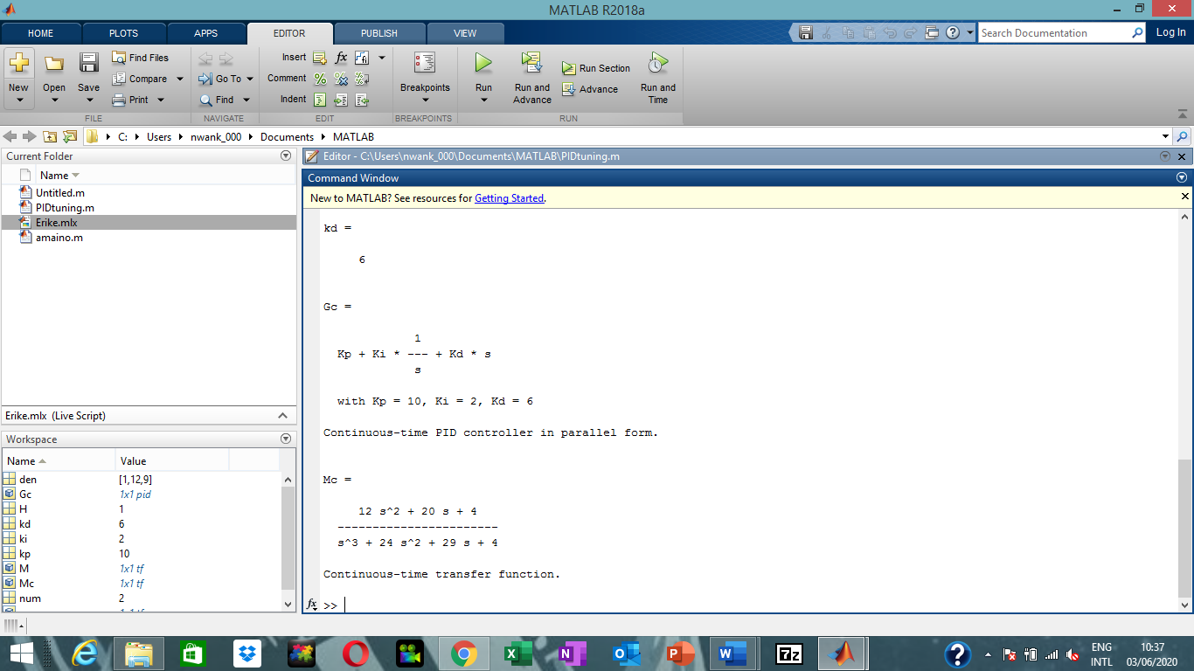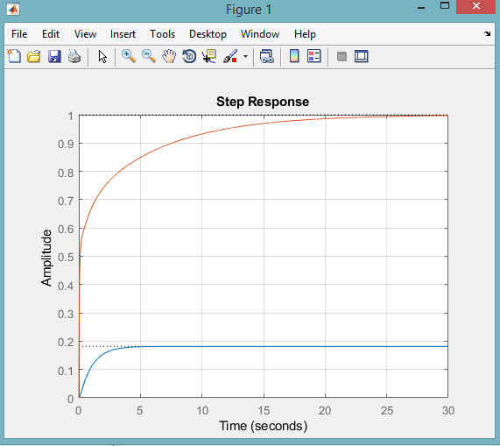

clear all
clc

num=[2]
den=[1 12 9]

sys=tf(num, den)
H=1

M=feedback(sys,H)
step(M)
hold on

kp=9
ki=3

Gc=pid(kp,ki)
Mc=feedback(Gc*sys, H)

step(Mc)
grid on

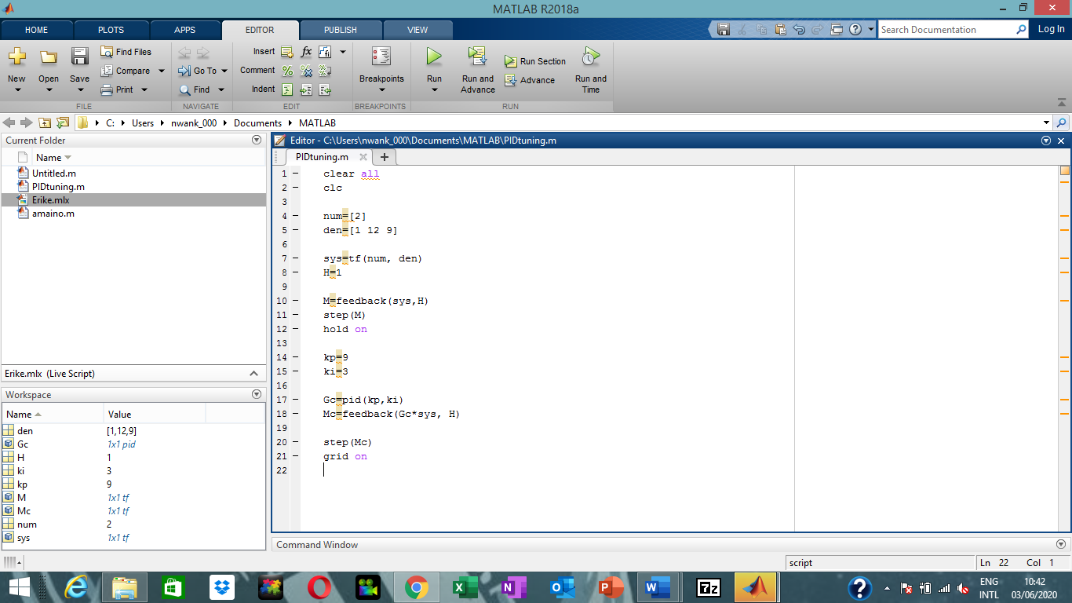
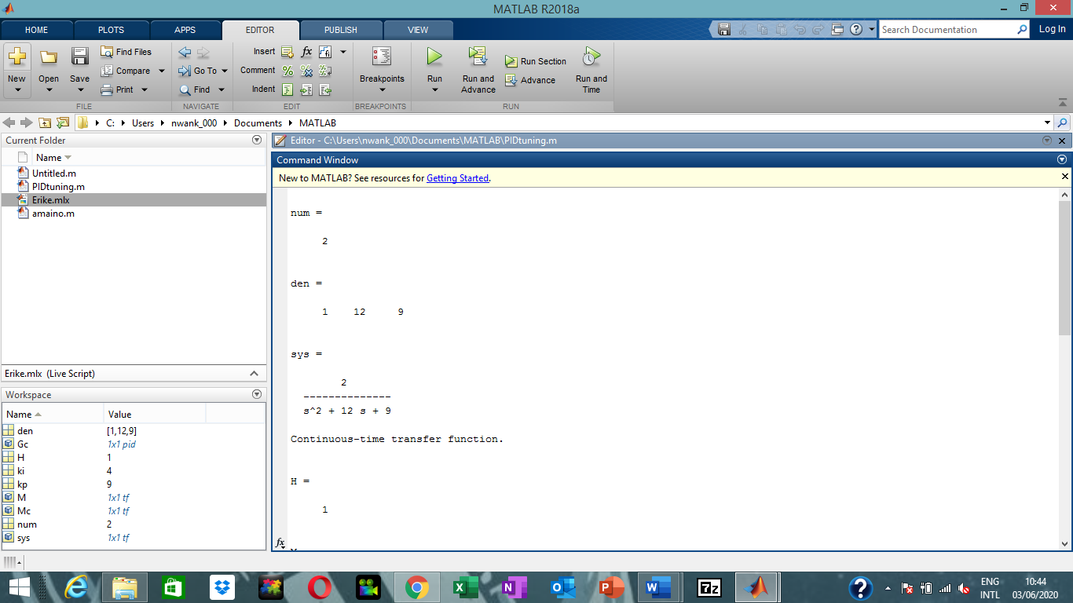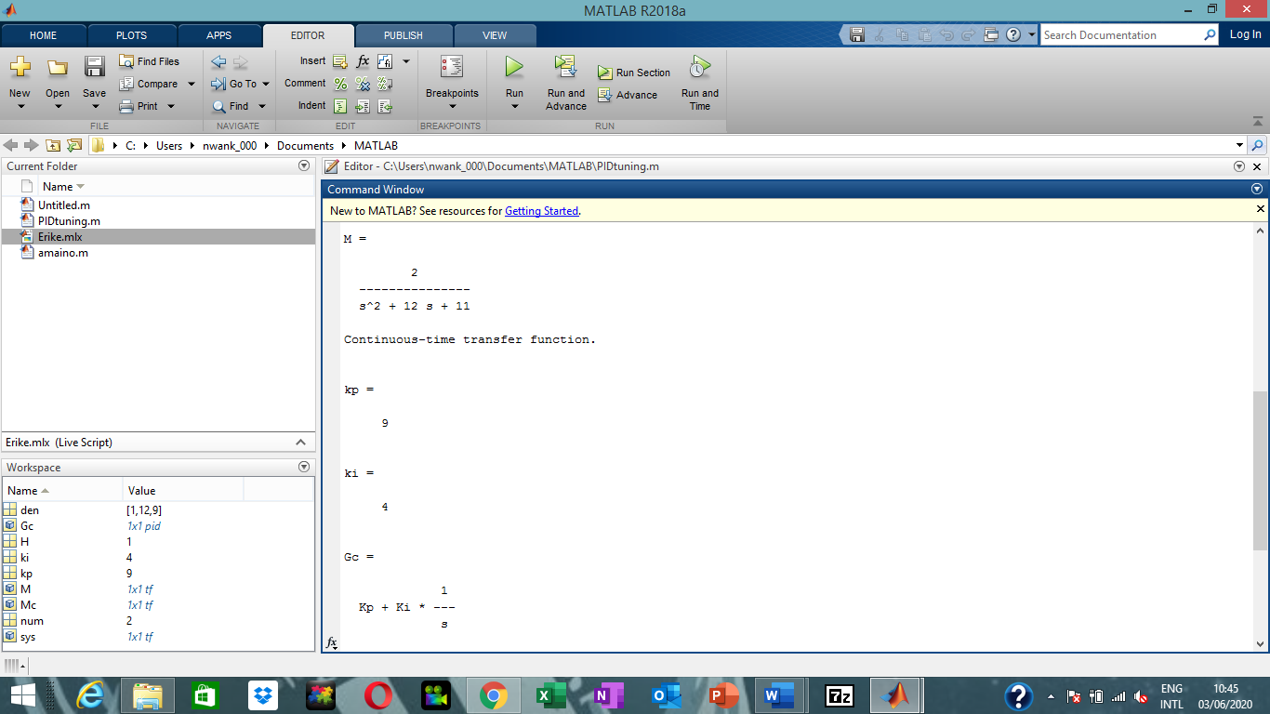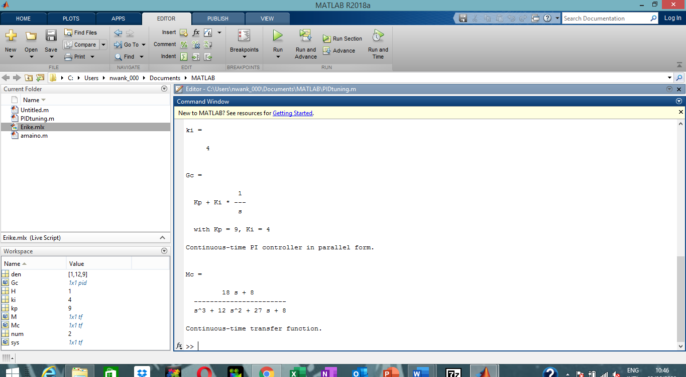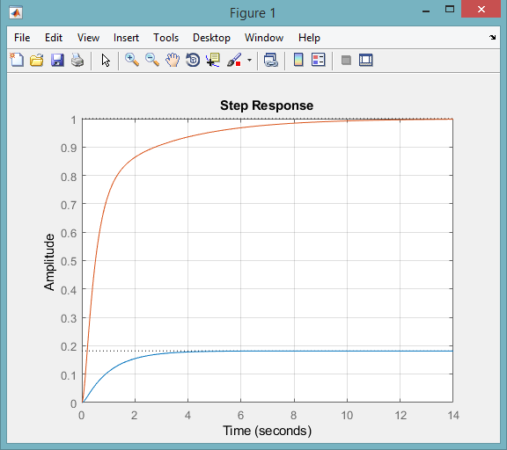

clear all
clc

num=[2]
den=[1 12 9]

sys=tf(num, den)
H=1

M=feedback(sys,H)
step(M)
hold on

kp=8

Gc=pid(kp)
Mc=feedback(Gc*sys, H)

step(Mc)
grid on
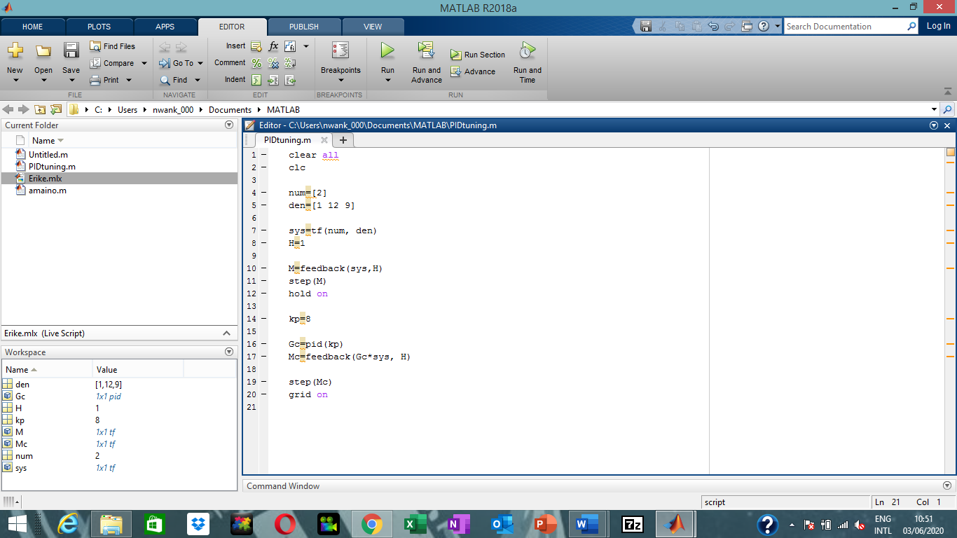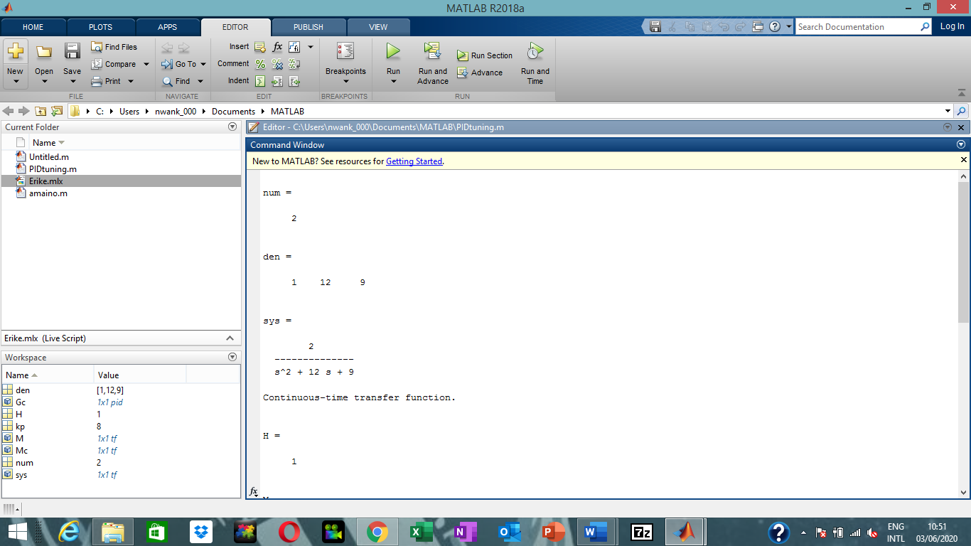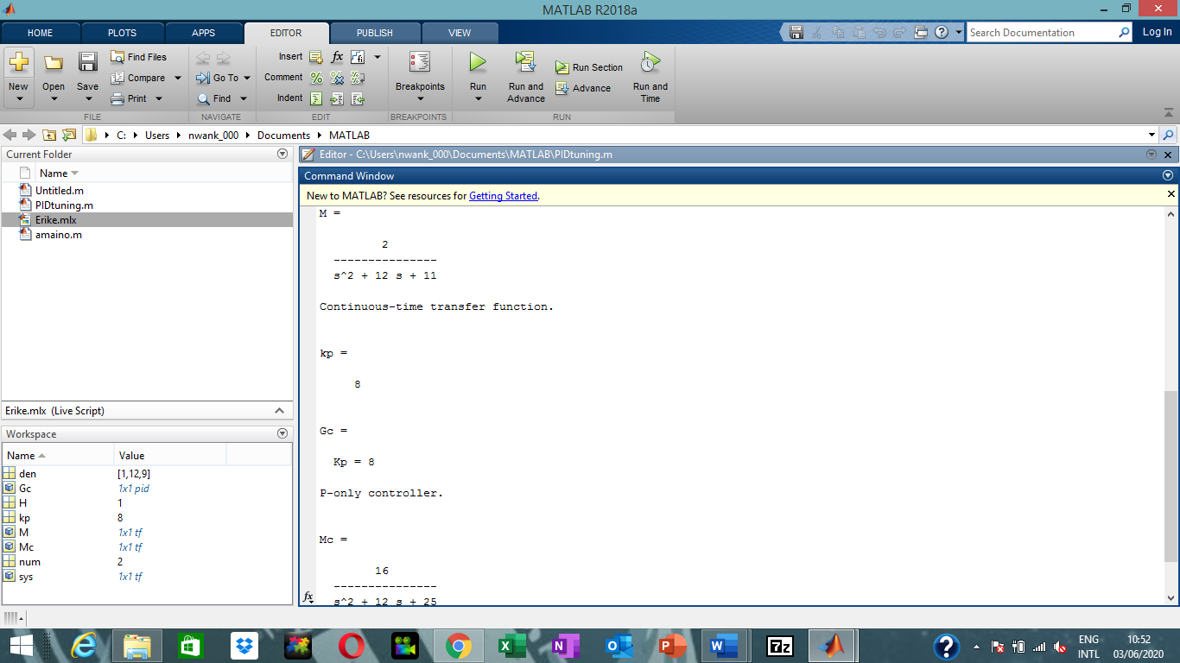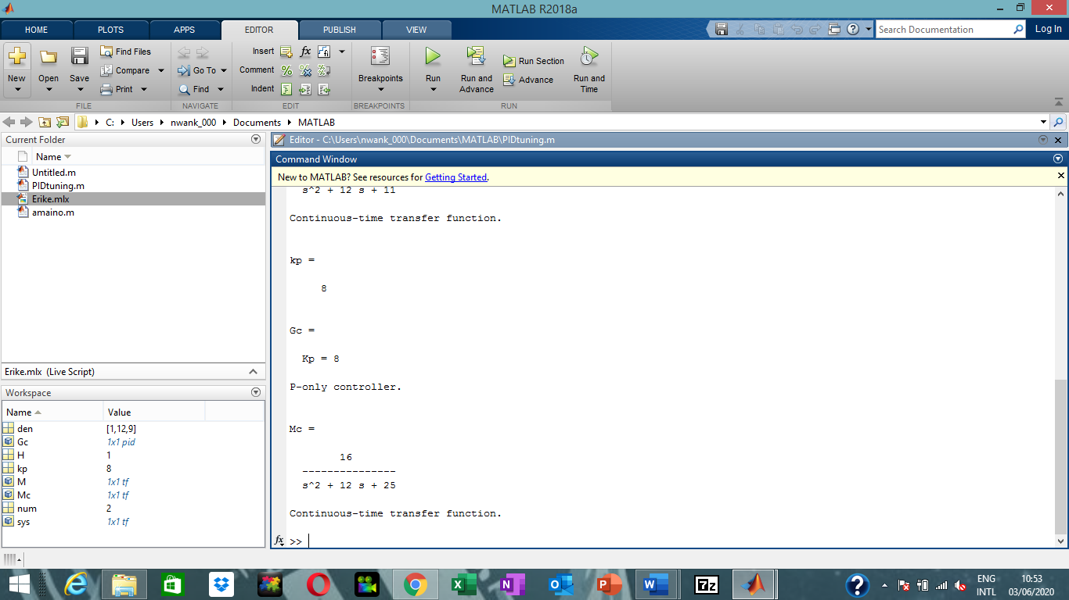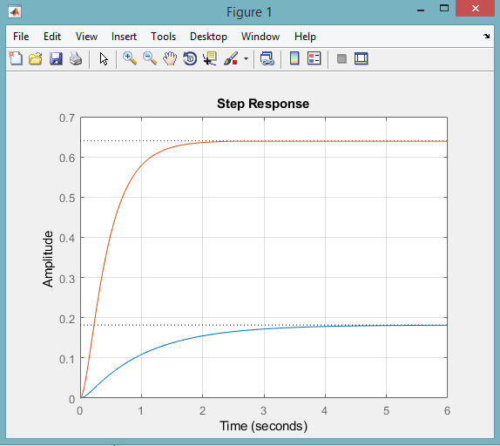

clear all
clc

num=[1]
den=[1 14 49]

sys=tf(num, den)
H=1

M=feedback(sys,H)
step(M)
hold on

kp=8
ki=0
kd=4

Gc=pid(kp,ki,kd)
Mc=feedback(Gc*sys, H)

step(Mc)
grid on
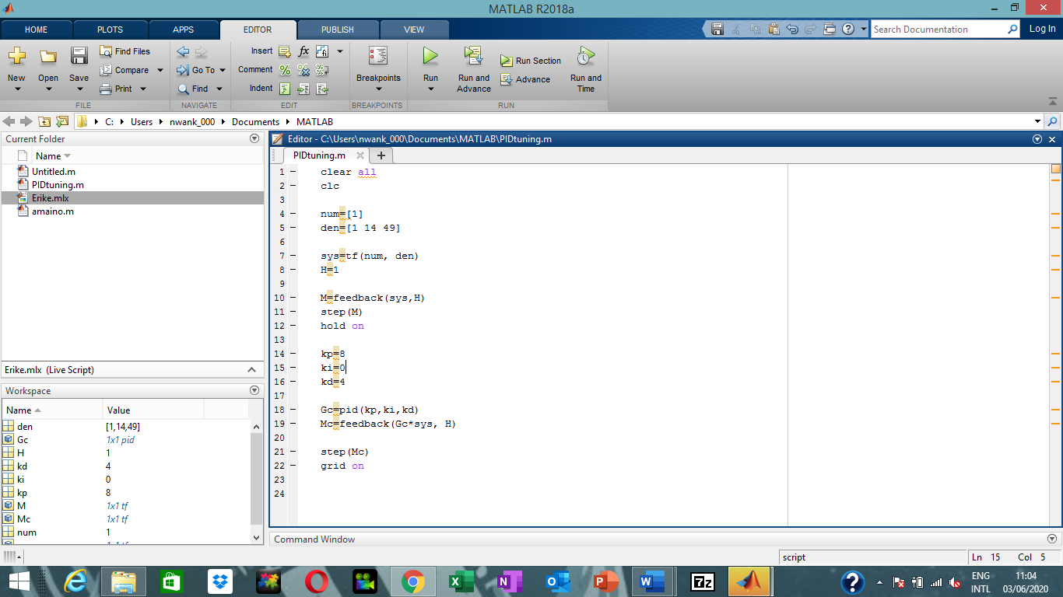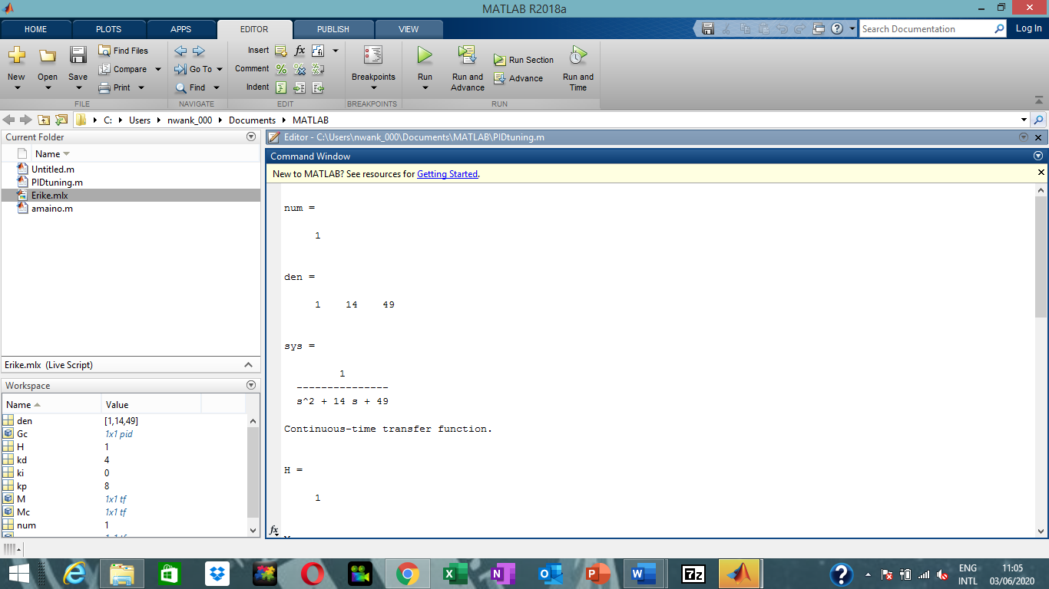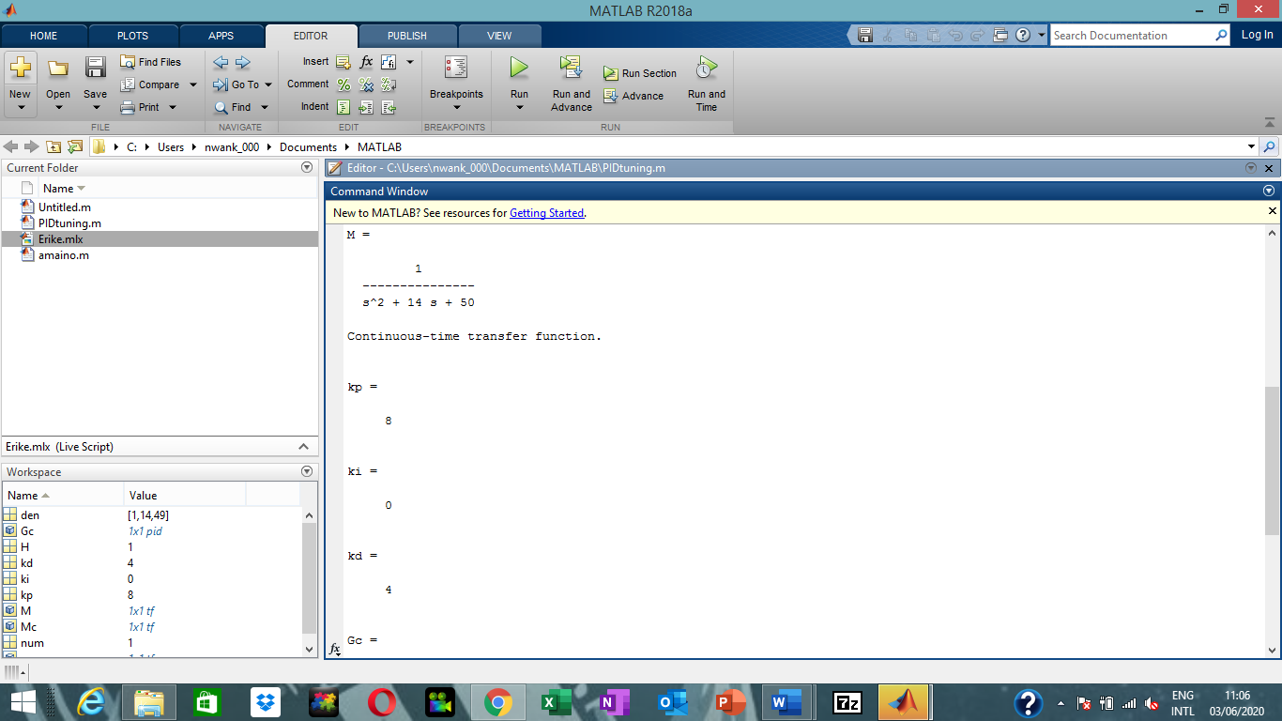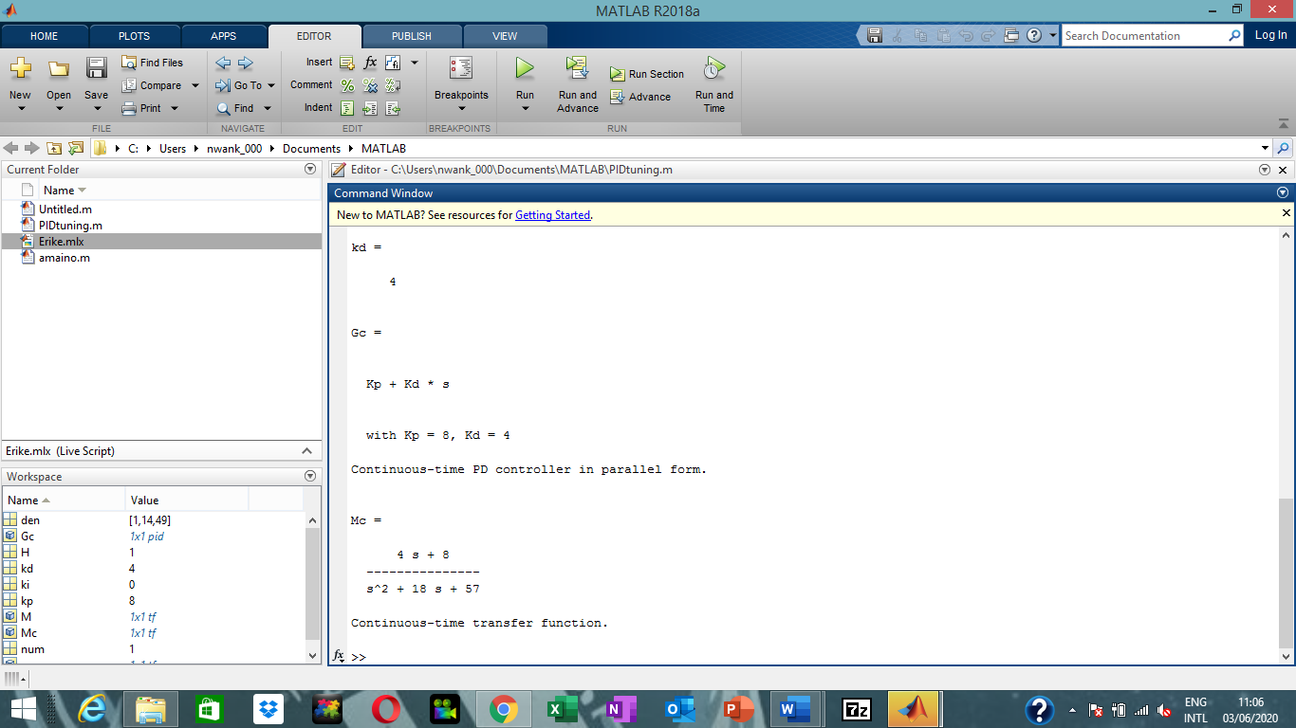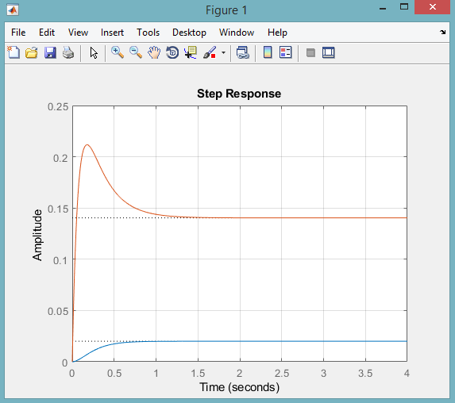

clear all
clc

num=[1]
den=[1 14 49]

sys=tf(num, den)
H=1

M=feedback(sys,H)
step(M)
hold on

kp=6
ki=2

Gc=pid(kp,ki)
Mc=feedback(Gc*sys, H)

step(Mc)
grid on
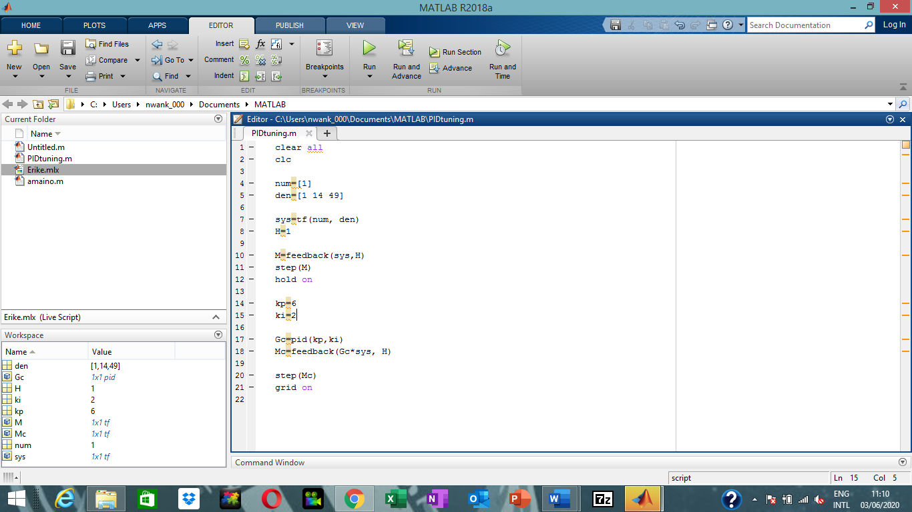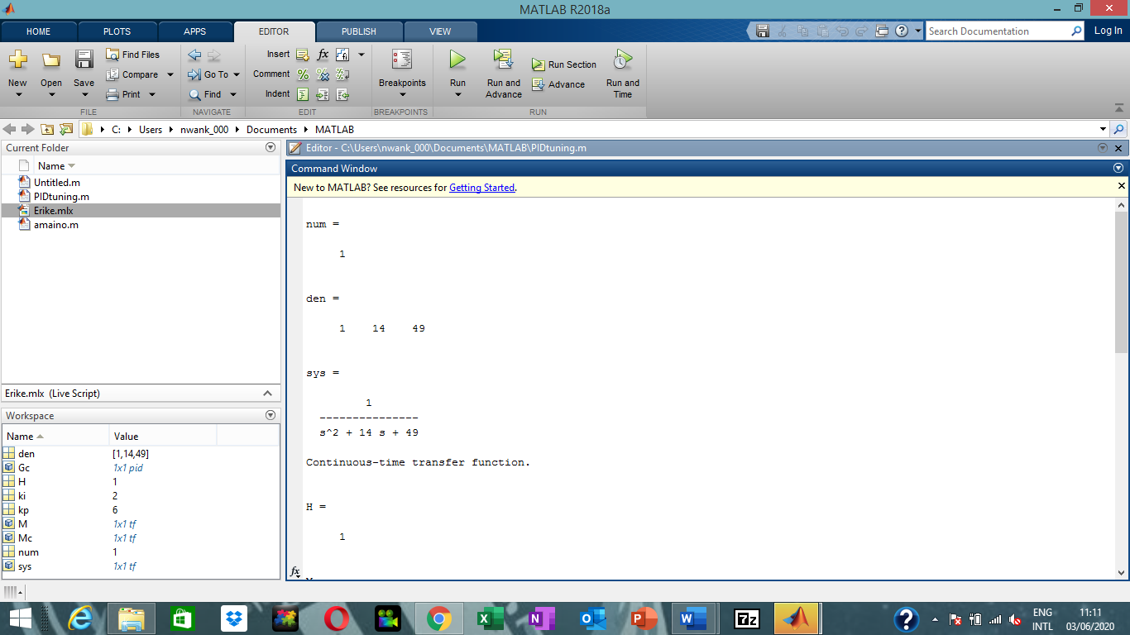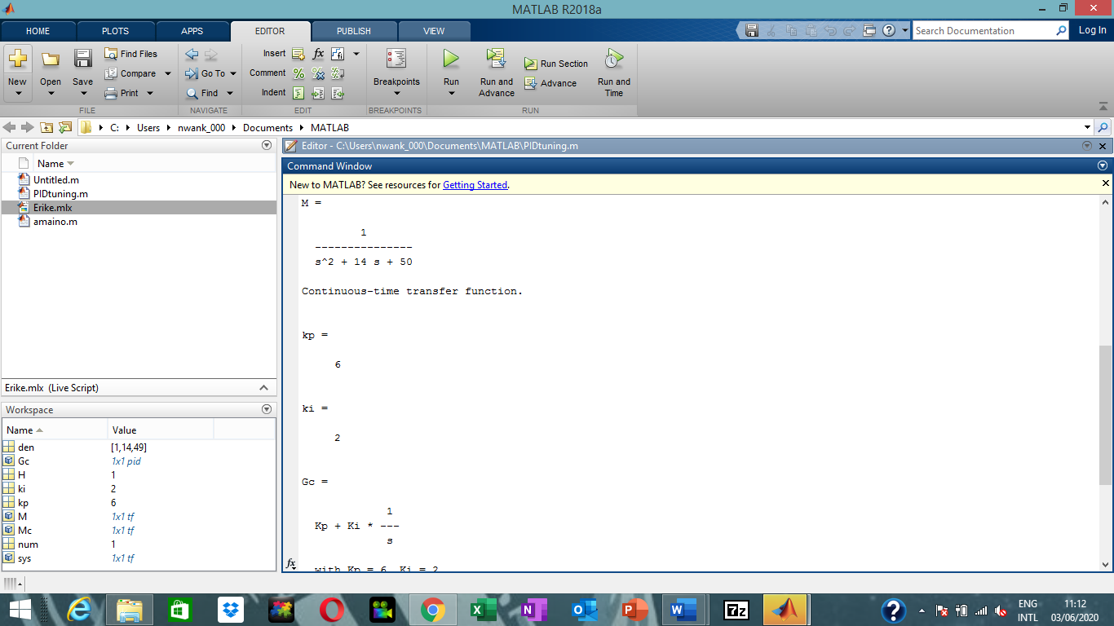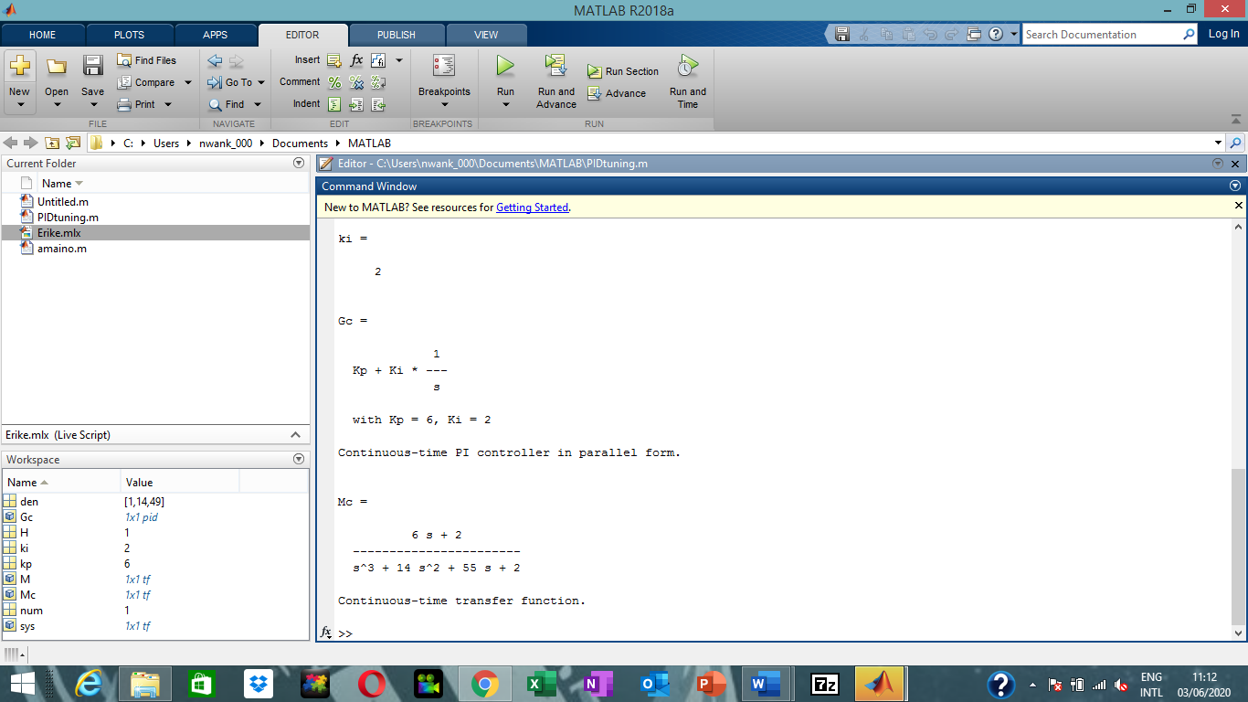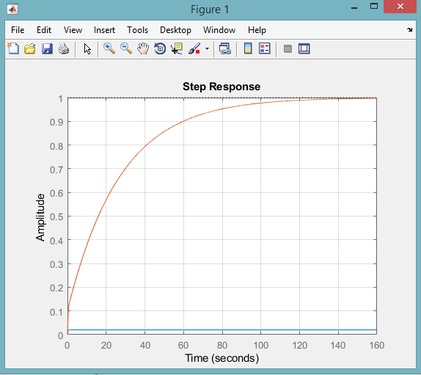

clear all
clc

num=[1]
den=[1 14 49]

sys=tf(num, den)
H=1

M=feedback(sys,H)
step(M)
hold on

kp=9

Gc=pid(kp)
Mc=feedback(Gc*sys, H)

step(Mc)
grid on
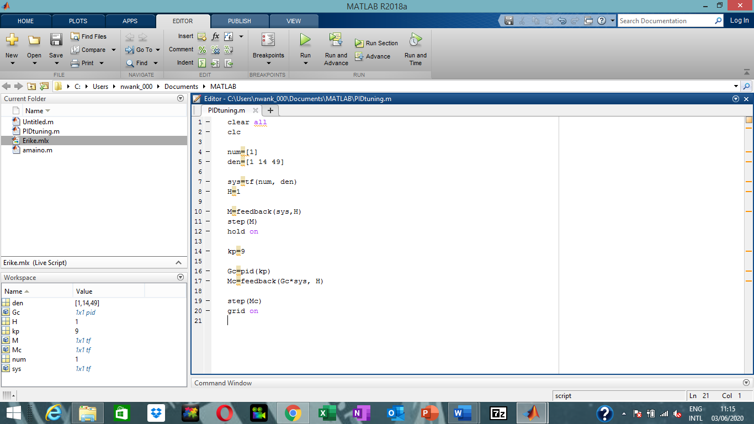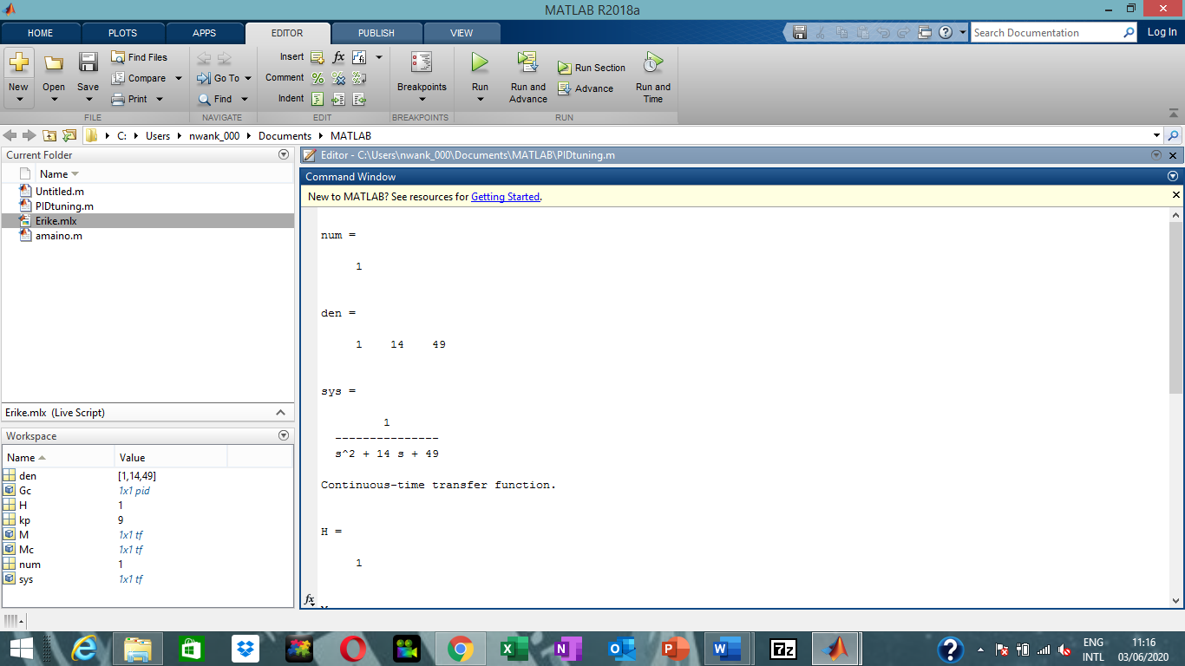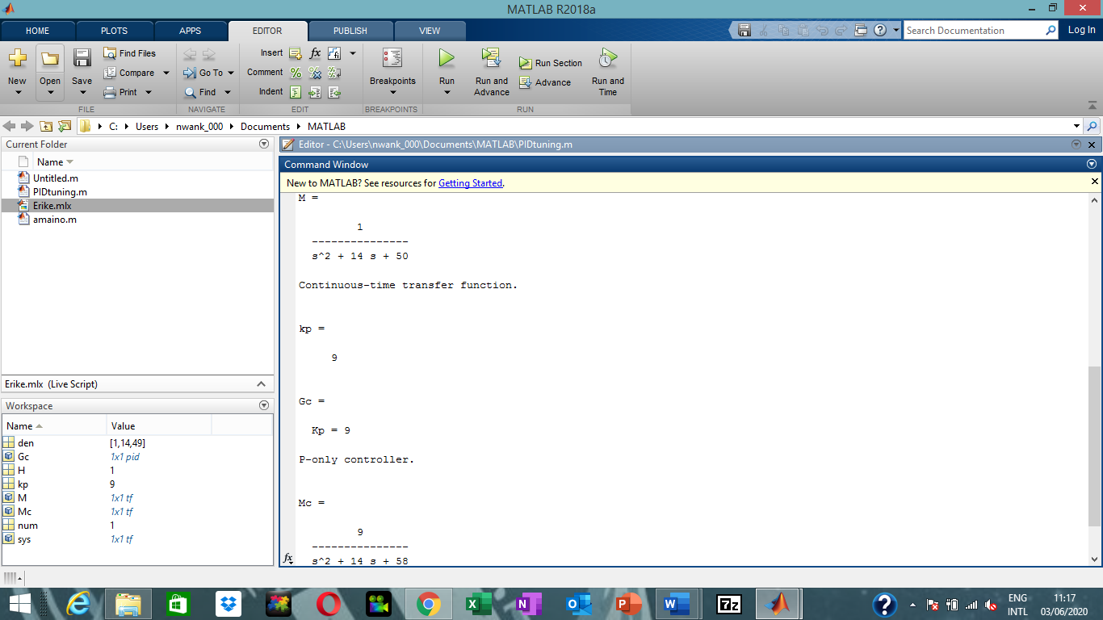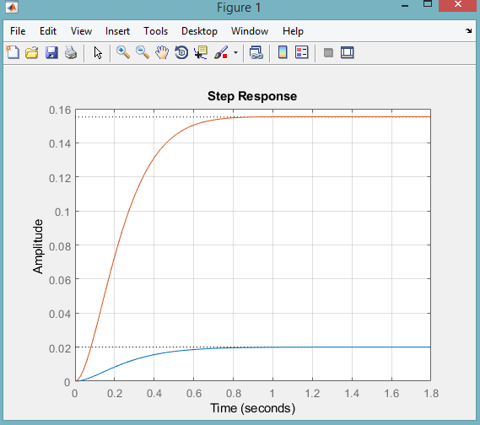

Observation:
In the PID increasing kp makes it over shoot
Changes in ki,kp,kd values changes the simulation

2) Simc tuning method

clear all
clc

num=[1]
den=[17 2]
theta=3
sys=tf(num, den, 'InputDelay', theta)
P0 = tf(num,den)
step(P0,'b',sys,'r')

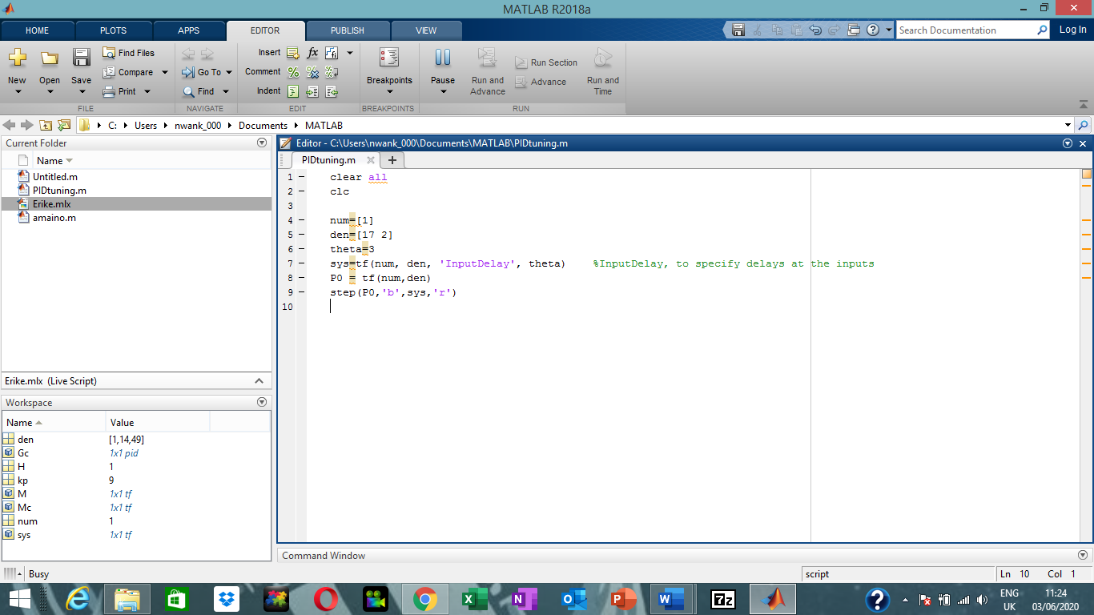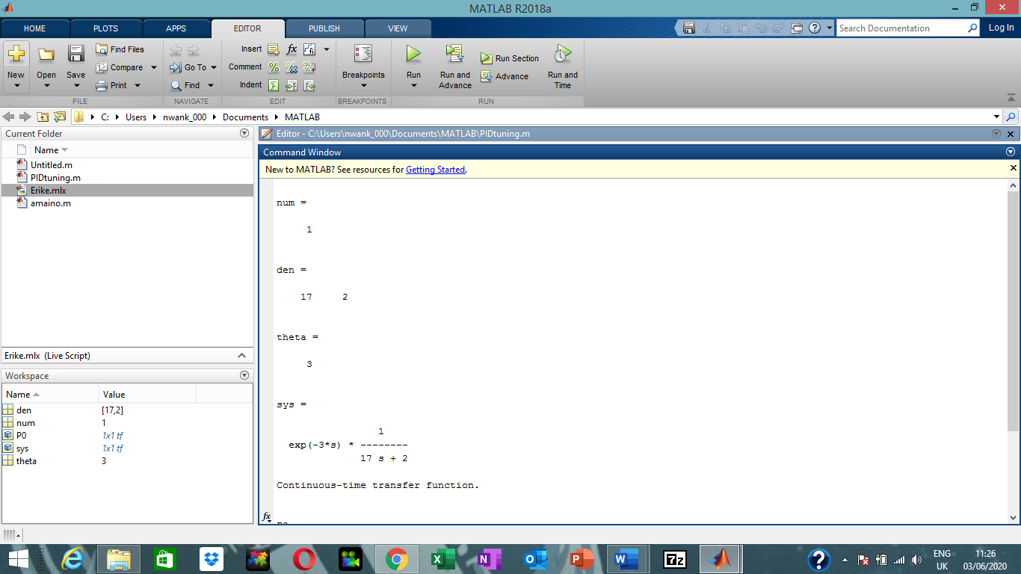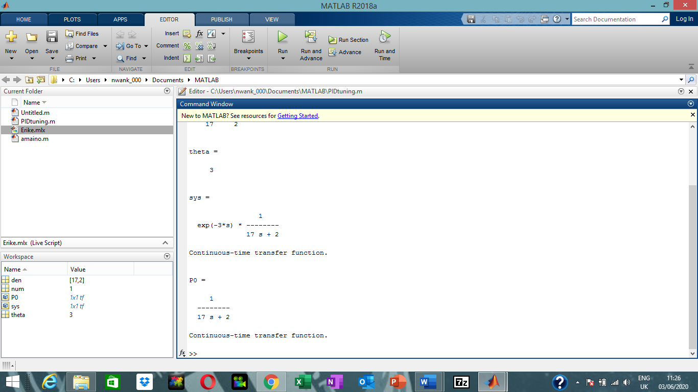

clear all
clc

num=[2]
den=[5 1]
theta=2
sys=tf(num, den, 'InputDelay', theta)
P0 = tf(num,den)
step(P0,'b',sys,'r')

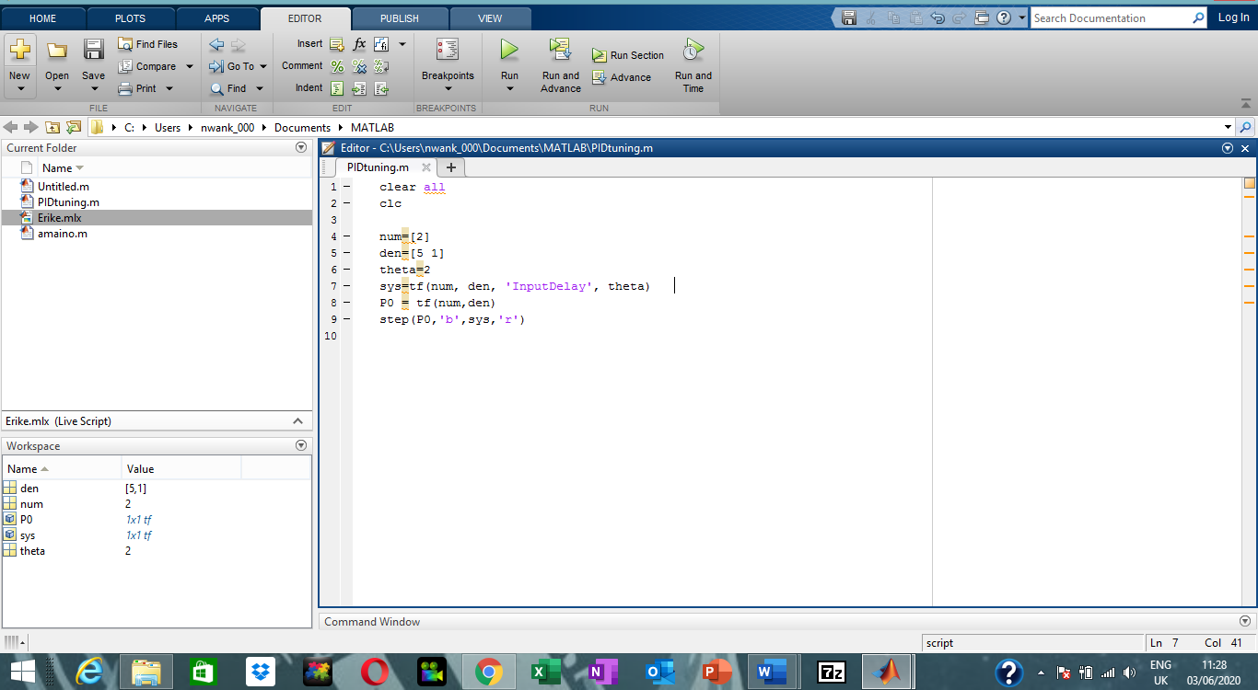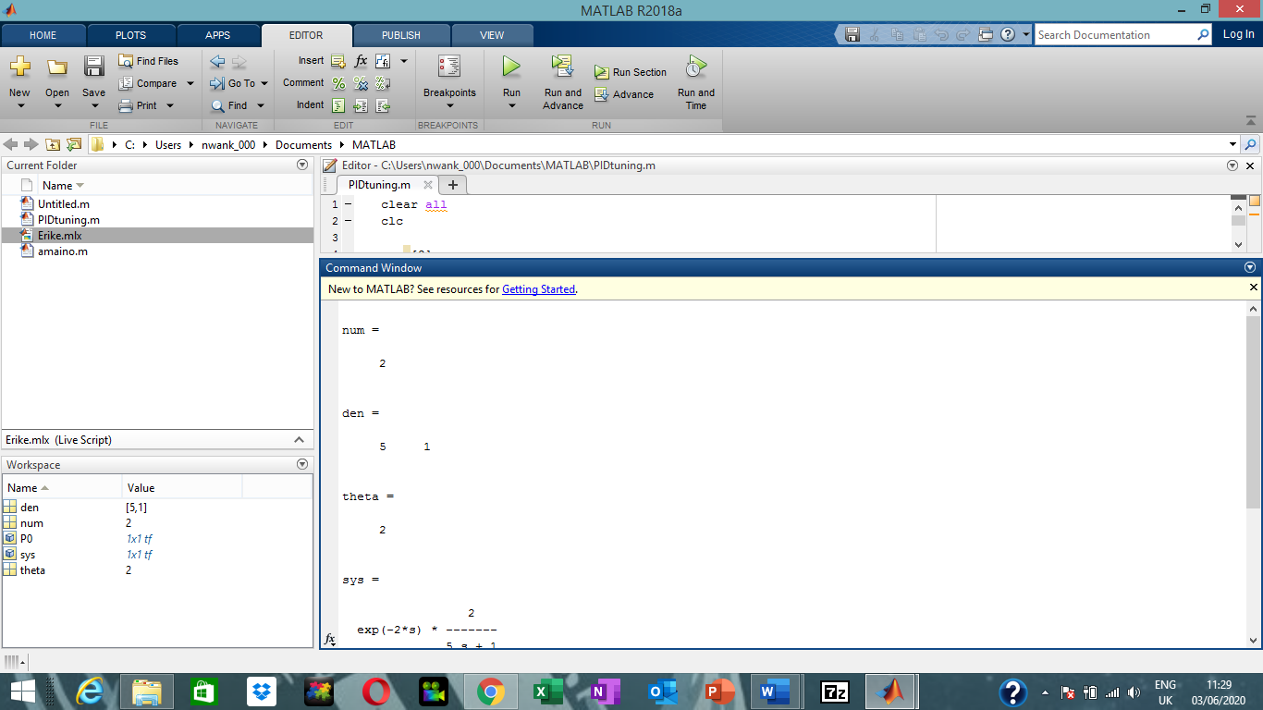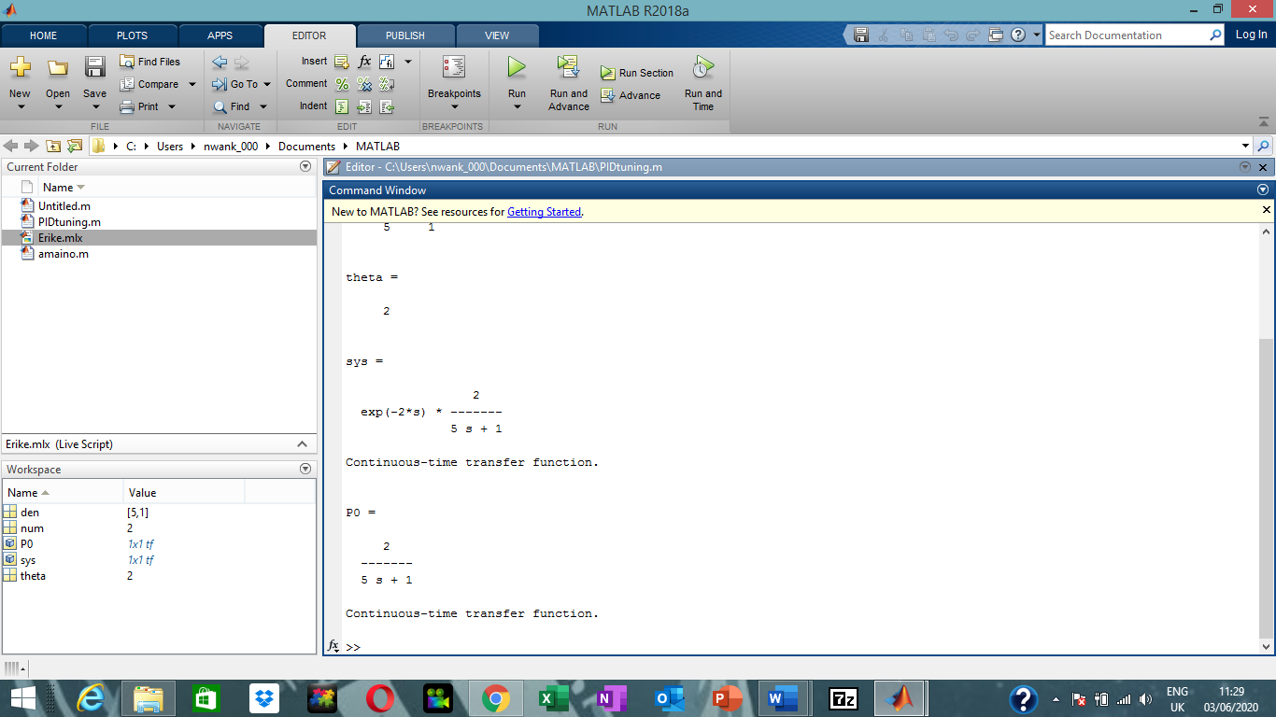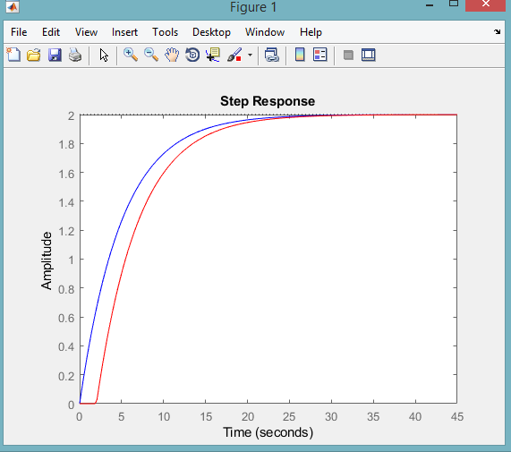
Observation:
There is difference in rising time

