GREEN GRACE IGBOGI

18/MHS07/021

PHARMACOLOGY

PHS 212 ASSIGNMENT
Special senses II

Question
Write short notes on any 2 eye defects

- Astigmatism
Astigmatism is a common vision condition that causes blurred vision. It occurs when the cornea (the clear front cover of the eye) is irregularly shaped or sometimes because of the curvature of the lens inside the eye.
An irregularly shaped cornea or lens prevents light from focusing properly on the retina, the light-sensitive surface at the back of the eye. As a result, vision becomes blurred at any distance. This can lead to eye discomfort and headaches.
Astigmatism frequently occurs with other vision conditions like myopia (nearsightedness) and hyperopia (farsightedness). Together these vision conditions are referred to as refractive errors because they affect how the eyes bend or "refract" light.
There are many causes to astigmatism. It can be hereditary and is usually present from birth. It can decrease or increase over time.
A comprehensive optometric examination will include testing for astigmatism. If necessary, your optometrist can provide eyeglasses or contact lenses that correct the astigmatism by altering the way light enters the eyes.
Another option for treating astigmatism is a corneal procedure called orthokeratology (ortho-k). In this painless, noninvasive procedure, the patient wears a series of specially designed rigid contact lenses to gradually reshape the curvature of the cornea.
Laser surgery can also treat some types of astigmatism. The laser changes the shape of the cornea by removing a small amount of eye tissue.
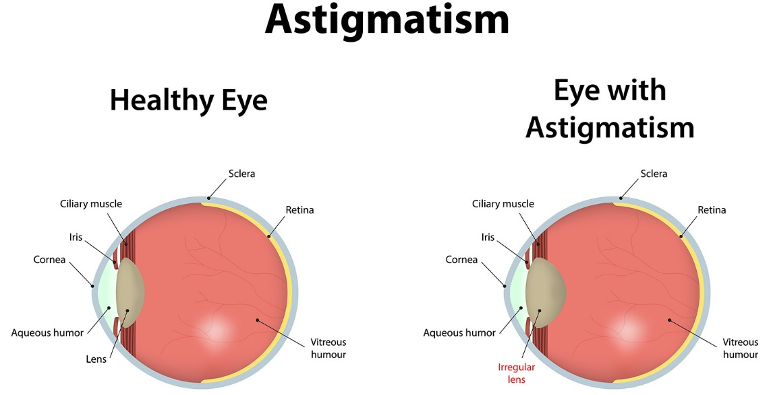

What causes astigmatism?
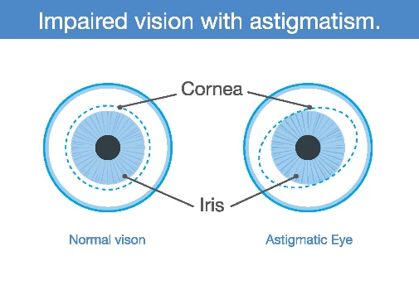
The curvature of the cornea and lens bends the light entering the eye in order to focus it precisely on the retina at the back of the eye. In astigmatism, the surface of the cornea or lens has a somewhat different curvature.
the surface of the cornea is shaped more like a football instead of round like a basketball, the eye is unable to focus light rays to a single point. Vision becomes out of focus at any distance.
In addition, the curvature of the lens inside the eye can change, resulting in an increase or decrease in astigmatism. This change frequently occurs in adulthood and can precede the development of naturally occurring cataracts.
Sometimes astigmatism may develop following an eye injury or eye surgery.
Astigmatism also occurs due to a relatively rare condition called keratoconus in which the cornea becomes progressively thinner and cone-shaped. This results in a large amount of astigmatism, which causes poor vision that cannot be clearly corrected with eyeglasses. People with keratoconus usually need contact lenses for clear vision and eventually may need a corneal transplant.

How is astigmatism diagnosed?
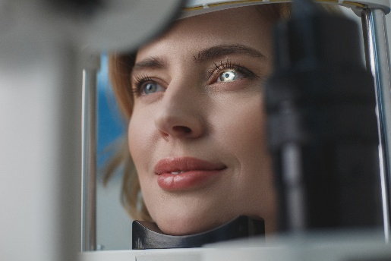
An optometrist can diagnose an astigmatism through a comprehensive eye examination. Testing for astigmatism measures how the eyes focus light and determines the power of any optical lenses needed to improve vision. This examination may include:
- Visual acuity-When you read letters on a distance chart, you are measuring your visual acuity. Visual acuity is given as a fraction (for example, 20/40). The top number is the standardized testing distance (20 feet) and the bottom number is the smallest letter size read. A person with 20/40 visual acuity would have to get within 20 feet to read a letter that should be seen clearly at 40 feet. Normal distance visual acuity is 20/20.
- Keratometry/Topography-A keratometer is the primary instrument used to measure the curvature of the cornea. By focusing a circle of light on the cornea and measuring its reflection, it is possible to determine the exact curvature of that area of the cornea's surface. This measurement is particularly critical in determining the proper fit for contact lenses. A corneal topographer, which is gaining use, generates a contour map of the cornea and provides even more detail of the cornea's shape.
- Refraction-Using an instrument called a phoropter, your optometrist places a series of lenses in front of your eyes and measures how they focus light. This is performed using a handheld lighted instrument called a retinoscope or an automated instrument that evaluates the approximate focusing power of the eye. Based on your responses, the power is then refined to determine the lenses that allow the clearest vision. Despite improved technology, patient input remains integral in determining vision needs.

- Presbyopia

Presbyopia is an age-related condition that causes blurred near vision. It typically starts at around age 40 and affects everyone, even those who've never had vision problems before.
When presbyopia begins, people will squint or hold reading materials at arm's length to help their eyes focus. Eye strain, headache and fatigue are common symptoms of presbyopia.
Most experts believe presbyopia is caused by changes to the lens inside the eye. As people age, the lens becomes harder and less elastic, making it more difficult for the eye to focus on close objects.
For centuries presbyopia was corrected with the use of bifocal eyeglasses. Today there are many ways to correct presbyopia with eyeglasses, contact lenses and surgery.

Contact Lenses for Presbyopia
People in the early stages of presbyopia, called emerging presbyopes, are often unpleasantly surprised by the new difficulty in seeing up close, especially if they've never had vision problems before. In addition, many are unhappy about the idea of wearing bifocal glasses.
Fortunately, bifocal contact lenses are now available in many soft and GP lens designs. Similar to bifocal eyeglasses, bifocal contacts have two prescriptive powers for distance and near vision. Multifocal contact lenses are also available with additional variations in power to correct near, intermediate, and far vision.

Mono vision is another contact lens option for correcting presbyopia, where one eye wears a near vision lens, and the other eye wears a distance vision lens. Your eyes automatically focus properly depending on the visual situation.
Contact lenses wearers can also use a distance lens in both eyes, and then wear reading glasses for close-up work.

