GEY 402
- MORPHOLOGICAL CLASSIFICATION OF POLLEN AND SPORES

In general the spores of bacteria, fungi, algae and protists are rarely preserved but those of terrestrial plants are very common fossils. Terrestrial plants produce extremely resistent spores and pollen which are easily transported by wind and water. Most fossil spore and pollen grains are studied in a dispersed state and this is the fundamental basis upon which Hyde and Williams (1944) initially proposed the term Palynology. The initial meaning has now been expanded to include all acid-resistant organic microfossils. Spores are produced by the so-called "lower plants" or cryptogams, and within this group the pteridophytic vascular plants and bryophytes (mosses, liverworts and hornworts) are the most commonly studied. Pollen of seed plants, both angiosperme and gymnosperms increasingly dominate palynological assemblages of Mesozoic and younger nonmarine deposits
The earliest terrestrial plants are recorded from the late Silurian, and these were homosporous (all spores produced are of the same kind). By the end of the Devonian heterospory had appeared, this still involves dispersal by spores only but both microspores (held in a microsporangium) and megaspores (held in a megasorangium) are produced. Both these forms of plants relied on water (or at least damp conditions) to allow transport of the spermatozoid to the egg. The earliest gymnosperms appear in the very latest Devonian and rapidly become diverse and important during the Carboniferous. The angiosperms did not appear untill the early Cretaceous and diversified rapidly from the mid Cretaceous.
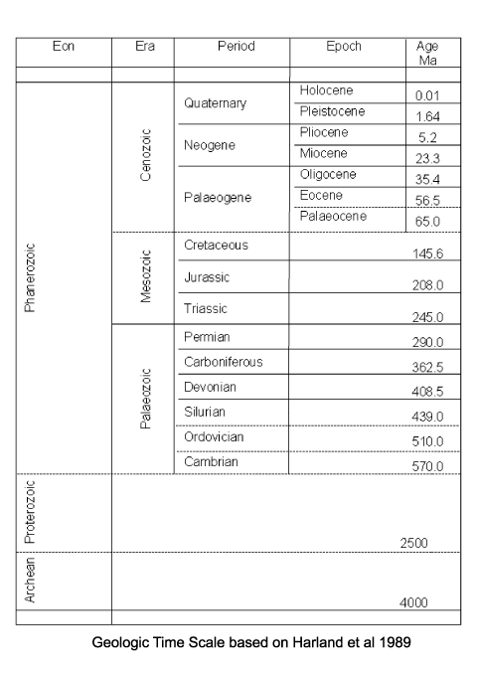
The fact that spores and pollen are normally retrieved from their host sediments as disjunct entities, separate from the original parent plant means that their natural affinities are often obscure. The free sporing plants including the Bryophyta e.g. mosses and liverworts, and the Pteridophytes which, although not a natural classification, encompassess all the seedless vascular plants, including the palaeontologicaly important ferns and fern allies, are primarité classified using the gross morphology, wall structure and the type of wall sculpture, if present. The important feature of homospory in terms of the fossil record is the four fold division involved in spore production, this takes the form of either a tetrahedra which gives a trilete spore or a tetragon which gives a monolete spore. The trilete and monolete marks imparted on the individual spores are the marks where each of the spore tetrad once abutted each other.
Classification of pollen, like that of spores is based on the morphological trends observed among various groups of fossils which may be primarily but not entirely reflections of evolution within the groups of plants which produced the pollen. It should also be remembered that higher plants have charcteristics of reproduction which permit them to utilise modes of evolution unavailable to animals. Because of their relatively simple genetic systems plants may utilise hybridisation and self fertilisation. The early gymnosperms produce prepollen, differentiated from true pollen by germination from the proximal rather than the distal side. Recent gymnosperms may produce very distinctive saccate pollen, i.e. pollen with one, two or rarely three air sacs attached to a central body (colpus) or monosulcate pollen as in the cycads and ginkgos. The angiosperms produce pollen with the greatest morphological variation, but typicaly with either a tricolpate or monosulcate form.

- The aim of paleoenvironmental analysis, or paleoecology, is to reconstruct the biological, chemical, and physical nature of the environment at the collection site at the time of deposition, based on the rock's paleontological record. Information can be reconstructed for depositional environments, paleobathymetry, positions of ancient shorelines, paleoclimate, degree of oxygenation of the bottom water and sediment, and salinity of the waters
Stratigraphy is the science of interpreting and describing layers and strata of sediments. Commonly these layers are levels of sedimentary rock, but stratigraphy can also include the study of non-ossified sediments, like those in stream beds and lake bottoms, of inclusions such as volcanic ash and lava, and even the study of different layers of human occupation. Sediment usually forms distinct strata with the most recent layers on top and, although they may be folded by continental drift, interrupted by inclusions and slippages, and even metamorphosized into other forms of rock, as long as these strata can be untangled and interpreted, scientists can perform stratigraphic analyses. The processes of sedimentation—including the presence of certain types of fossils—provide scientists with valuable clues about the age of the earth and its history. These principles are thus valuable for many different types of scientist, ranging from prospecting geologists to city planners to archaeologists and paleontologists studying human and animal history and prehistory.

