- -Methanoic acid
-Pentan-1,5- dioic acid
-Butanoic acid
Ethanedioic acid
-Hexanoic acid
-Hexa-4-enoic acid
2.) Physical Appearance: Most carboxylic acids are solid at room temperature but from C1 to C2 are liquid and anhydrous carboxylic acids freeze at temperature below room temperature.
Boiling Point: The boiling point increases with increase in carbon atom. Aromatic carboxylic acids are crystalline in nature and have high melting points than their corresponding aliphatic counterparts.
Solubility: C1 to C4 are soluble in water due to the presence of hydrogen bonds, but with in increase in relative molecular mass makes it more of a hydrocarbon so they are soluble in inorganic compounds.
3.) Industrial preparations:
From Carbon(ii) oxide: this is proceeded with adding of pressure to the reaction of carbon(ii) oxide and hot aqueous sodium hydroxide. The free carboxylic acid then is released with the reaction with tetraoxosuphate (vi) acid.
From ethanol: Ethanoic oxide is produced through this reaction which is called liquid phase air oxidation of 5% solution of ethanal to athanoic acid using manganite(ii) ethanoate as a catalyst
4.) Oxidation: The oxidation of primary alcohols is a common method for the synthesis of carboxylic acids: RCH2OH → RCOOH. This requires a strong oxidizing agent, the most common being chromic acid (H2CrO4), potassium permanganate (KMnO4), and nitric acid (HNO3). Aldehydes are oxidized to carboxylic acids more easily (by many oxidizing agents), but this is not often useful, because the aldehydes are usually less available than the corresponding acids. 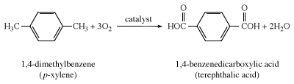
Hydrolysis of acid derivatives: The easiest acid derivatives to hydrolyse are acyl chlorides, which require only the addition of water. Carboxylic acid salts are converted to the corresponding acids instantaneously at room temperature simply on treatment with water and a strong acid such as hydrochloric acid Carboxylic esters, nitriles, and amides are less reactive and typically must be heated with water and a strong acid or base to give the corresponding carboxylic acid. If a base is used, a salt is formed instead of the carboxylic acid, but the salt is easily converted to the acid by treatment with hydrochloric acid.
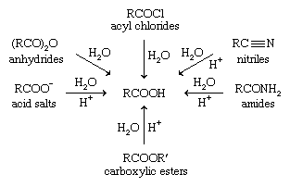
5.) Reduction:
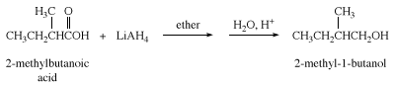
Esterification:
