ASSIGNMENT

NAME: OFEIMUH OSAREMEN YEMBETT

MATRIC: 18/SMS04/069

DEPT: MEDIA AND COMMUNICATION STUDIES

LECTURER: MS IKE

Course: CMS 304 FOREIGN CORRESPONDENCE AND NEWS AGENCY

ASSIGNMENT: ANSWER THE TWO QUESTIONS

Question 1
How is the portrayal of the Global South by the Global North news organisations/media? (You can get news stories to support your claim) 10 Marks.
The North–South divide is a socio-economic and political division of Earth popularized in the late 20th century and early 21st century. Examples of countries of the Global North include the United States, Canada, almost all the European countries, Israel, Cyprus, Japan, Singapore, South Korea, Australia, and New Zealand. The Global South however is made up of Sub-Saharan Africa, Latin America and the Caribbean, Pacific Islands, and the developing countries in Asia, including the Middle East. The North is mostly correlated with the Western world and the First World, plus much of the Second World, while the South largely corresponds with the Third World and Eastern world.
The Global South's often discussed struggle is to be equally represented in the media compared to the North. When looking at media coverage of developing countries, a generalized view has developed through Western media. Negative images and coverage of the poverty are frequent in the mass media when talking about third world countries. This common coverage has created a dominant stereotype of the Global South. The 'South' is characterized by socioeconomic and political backwardness, measured against Western values and standards. Mass media's role often compares the Global South to the North and is thought to be an aid in the divide.
The popular stereotypes of Africa in Western media have essentially turned the continent into a one-story issue. There are hardly any positive stories about Africa except stories of war, danger, darkness, violence, poverty, disease, and hopelessness. Michira (2002) stated that Africa is often portrayed as a homogenous entity comprising uncivilized and heathen peoples who are culturally, intellectually, politically, and technically backward or inferior. Several studies – both old and fairly recent – have confirmed that Western media does portray Africa in a negative light. Schraeder and Endless (1998), for instance, investigated the portrayal of Africa by The New York Times between 1955 and 1995 and found that “73 percent of all articles provided negative images of African politics and society”. To back up this finding a recent feature online article about Nigeria carried out by the BBC, explored the issue of cultism in our tertiary institutions.
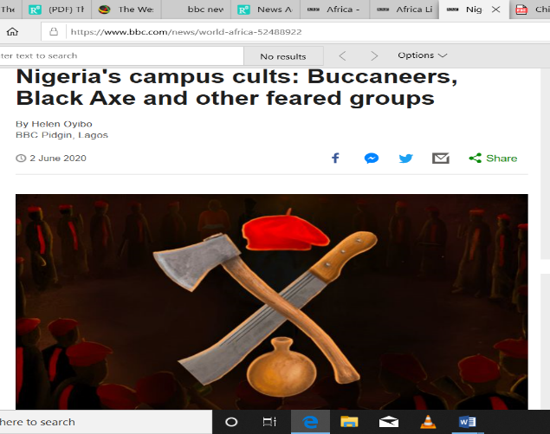
The choice of images is very detrimental as the use of the cutlass and a machete in the first image connotes violence, which fits into the narrative of how Africa is often portrayed

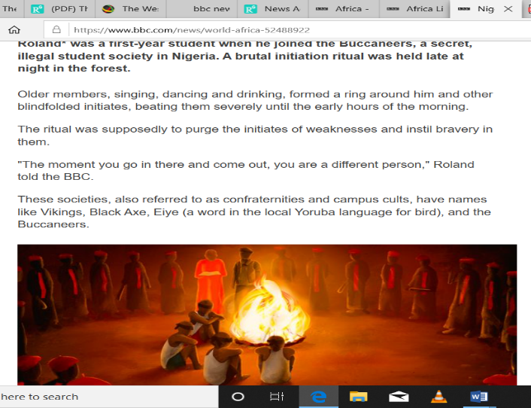
In the second image you see what represents youths circling around a fire in what seems to be an initiation this also portrays a very primitive image of African society.
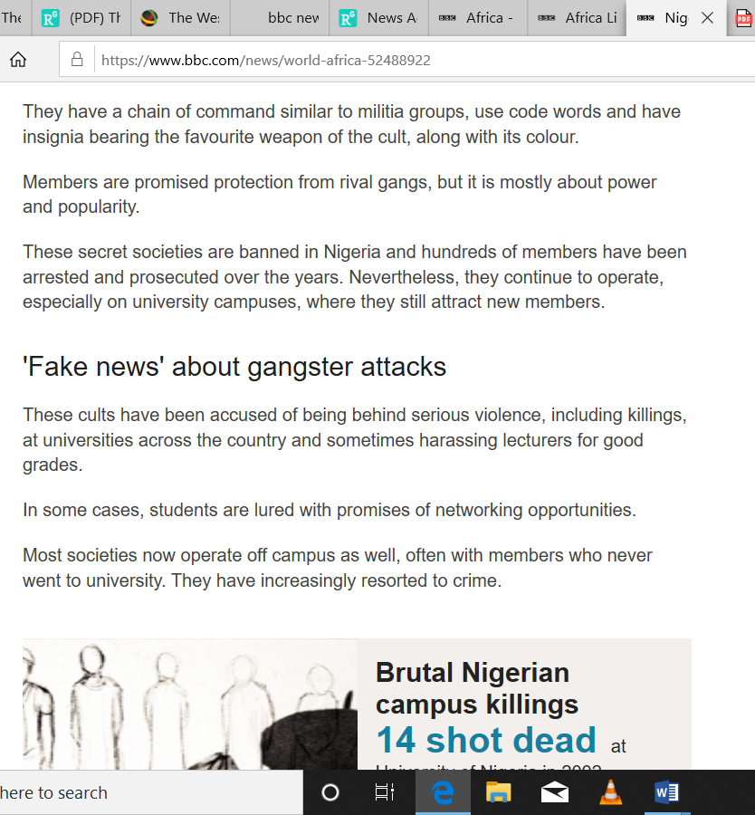
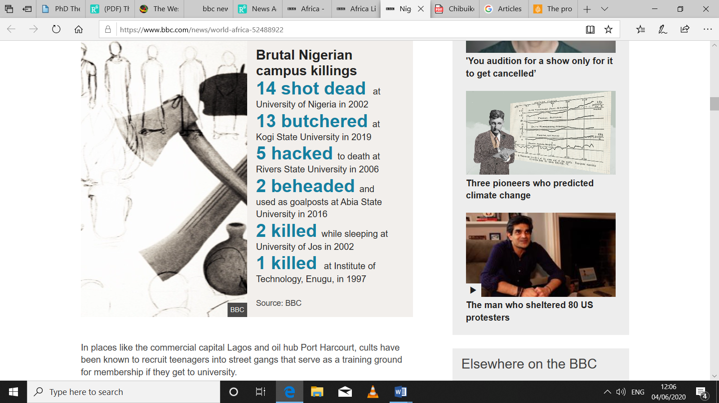

The article is a feature length piece that at no point paints a positive outlook of the Nigerian university but solely highlights the cultism and gang issue which although rightly should be scrutinised and steps taken to resolve, is also prevalent in the UK and other western countries.
The reader of this article is left with the impression that all university students in Nigeria are members of a cult in one way or another and once again paints a negative image of Nigerian and by extension African society as violent and disorganised.
The article can be found on the BBC News, Africa page https://www.bbc.com/news/world-africa-52488922.

Question 2
What are the challenges a foreign correspondent is likely to face in these times, especially with Corona Virus, Racism and all other fears in view? Proffer the solutions you think will overcome the challenges you raise (10marks)
A foreign correspondent is journalist who reports and files stories from a foreign country. He or she can work for a newspaper, television or radio station. As such a foreign correspondent is a brave journalist who is required to travel abroad leaving their comfort zone in pursuit of news to be reported back to their media house in their home country. Being a foreign correspond is rightly seen as a lucrative job because of the benefits and often the most talented, resourceful reporters are selected for this role. However, as I am about to reveal there are numerous challenges facing foreign correspondents.
- Political instability in their host country
Political instability undoubtedly affects the operations of foreign correspondent. In a stable political environment, foreign correspondence will be given room to thrive and gather stories. However, in a situation of political upheaval, even local reporters find it difficult to go about their job despite being citizens of their countries. So one can imagine just how much more challenging the operation of foreign correspondence will be affected because as the political powers jostle for position, they do not want interference or what they may deem as nosy foreign reporters reporting back to their nations the situation unraveling in their assigned nation and tarnishing the reputation of either a political party or a candidate. During this times foreign correspondents are always at a very great risk and they can be arrested, detained or asked to leave the country of assignment during political problem as was the case during the great uprising in Libya and Egypt.
During the recent impeachment scandal surrounding American President Donald Trump, he grew particularly hostile towards foreign reporters and often labelled them and their respective media houses as perpetrators of “fake news”. This is particularly damaging to the reporter in question and may cause him/her to suffer a lack of confidence and demotivation when reporting such stories. As the foreign correspondent may face prejudice from supporters of Donald Trump who don’t take the time to research for themselves whether the news reported by the correspondent was in fact “fake”. An example was the BBC’s Jon Sopel being sarcastically branded “another beauty” by Donald Trump in a fake news rant in 2018.

In China since President Xi Jinping came to power in 2013, China has forced out nine foreign journalists, either through outright expulsion or by non-renewal of visas. A report also found that a majority of journalist 82% said they had experienced interference, harassment or violence while reporting in China over the past year. This is surely due to increased scrutiny of the Chinese government handling of the Coronavirus crisis which is rumoured to have its root in the Chinese city of Wuhan.

Solution:
The issue of foreign correspondents being caught up in political instability can be resolved by having strong support by their media organization and their home government. In a case where, a reporter from Nigeria is sent on an assignment by one of our media houses, e.g. Channels, TVC etc. and is caught up in political instability the media house should reaffirm their support for their journalist by issuing strong defensive statements to enhance the reporter’s credibility if wrongly labelled as a perpetrator of fake news or by hiring security operatives to ensure the safety of their reporter. In a situation where a reporter is unlawfully or wrongly detained by the security forces of the country he/she is reporting in, the reporters home government and embassy in the country where they were detained should use all available efforts to secure the release of the journalist. This is because foreign correspondents are in essence ambassadors of their home nation and if the journalist is not freed, it sets a terrible precedent for sending future foreign correspondents into that country and could damage relations between the journalist nation and the country where they are imprisoned.

- Cultural Issues (Racism)
Understanding the culture and the racial tolerance of the people of the country of assignment is very important. A foreign correspondent will do better in a familiar cultural environment. Many foreign correspondents sent to countries with poor race relations or where there is simply a lack of multi-ethnicity can face negative stereotypes or racism. In Asian countries like China, Japan, North and South Korea, a majority of the population simply aren’t used to seeing people of darker skin and get most of their experiences from movies. Hence sending, an African or Indian person will inevitably pose its own challenges. Some of the racism may not be outright or overt, but these reporters may find it harder to get on public transport, have difficulty persuading locals or witnesses to give them interviews and in cases where the racism is overt and out in the open, such incidents can lead to both physical and psychological damage for the reporter involved. A foreign correspondent who wakes up each day with a fear of being stereotyped or abused because they don’t fit in will most likely be unable to do their job to the fullest (reporting few and poor quality stories) and in the worst case scenario may even request to be reassigned which would put off other colleagues from replacing him/her.
Incidentally racism is a trending topic worldwide after the death of George Floyd in the United States. Unfortunately, another “George Floyd” incident could happen with a foreign reporter sent to do his job being killed by law enforcement or facing police brutality simply because of the colour of his skin. A recent example was where Mexican American reporter Omar Rodrigues was arrested in Minnesota live on camera whilst reporting for Fox news the protest of the George Floyd killing whilst incidentally another white Fox news reporter and his crew in a nearby location was left undisturbed.
Solution:
In resolving the issue of culture and race in foreign correspondence I believe it is of great importance the reporter is proficient in the language spoken in the country of assignment as otherwise this will definitely a strong cultural barrier. Locals are less likely to want to associate with a foreigner that does not speak their language and such a reporter may be labelled as ignorant or disrespectful. Foreign correspondents must therefore have at least a working knowledge of the language of the country of assignment. This can be acquired while in school or working as a cub reporter.
In order to avoid disrespecting the culture of the country of assignment, a foreign reporter should carry out extensive reading about the country. They can also learn by living in the country of assignment in order to be accustomed to the food they eat, their dos and don’ts.

- Travel restrictions
In this recent climate of coronavirus and as countries become increasingly nationalistic, foreign correspondents will be severely hit. Many countries have closed their borders to foreign airplanes and so journalist simply won’t be able to reach their country of assignment due to travel restrictions. As the blame-game between countries over coronavirus continues it is the reporters already posted that bear the consequences. Just recently, China has expelled at least 13 American journalists in the biggest crackdown of its kind in recent memory, a move that Beijing called “self-defence” for restrictions placed on Chinese state media representatives in the US.
Solution:
To deal with this issue, media houses should either wait till travel restrictions are lifted before posting their Foreign correspondents, or liaise with the respective countries embassy to arrange special flights. For those already posted, they should ensure that their work visa is still valid and in cases where it is nearing expiration liaise with the embassy or interior ministry of their country of assignment for a renewal.
In the case of foreign reporters who are posted in countries where there is lockdown or quarantine, they should utilise social media, in particular the Zoom App, which allows video conferencing in order to relay back to their media houses the ongoing events in their country of assignment.

- Cost of Operation
Several media organisations have shut down foreign bureaus and recalled their international correspondents because of the economic circumstances. In Nigeria the Covid-19 pandemic is rumoured to push Nigeria into a recession. This means media houses will likely seem to cut cost and may not be willing to send reporters abroad in search of news, for fear of not being able to finance them appropriately. This is likely to be the case for other countries and their news organisations also. To compound matters, the rise of citizen journalism has now made it easy without foreign correspondents. The advent of social media and envious contributions by citizen journalists, bloggers and local stringers, the coverage of foreign news in the western media has not come to a total end. The glorious institution of foreign correspondence is losing the battle for its survival to economic meltdown.
Solution:
I propose in light of the economic climate, that foreign correspondents are still very much needed as citizen journalist and the social cannot be trusted to provide quality, unbiased news unlike actual professional journalist. Media houses that are less hit by the Covid-19 pandemic should not end the institution of foreign correspondent but rather encourage it in this time when fake news is on the rise around the world. It is foreign correspondents that give us insight into how other nations are dealing with the pandemic so they are still as essential as ever.

