NAME: AFOLABI OMOLOLA JOY

DEPARTMENT: MEDIA AND COMMUNTICATION STUDY

COURSE CODE: CMS304

DATE: JUNE 05TH OF 2020

Global Northern countries are those nations that are economically developed such as the USA, UK, CANADA, western European nations and developed parts of Asian
Global Southern are those that are less economically developed such as nations in Africa and some parts of Asia, Non-western, undeveloped.
The global South is not doing well during the pandemic
China’s Racism Is Wrecking Its Success in African
The expulsion of Africans from their homes in southern China is causing a diplomatic storm.
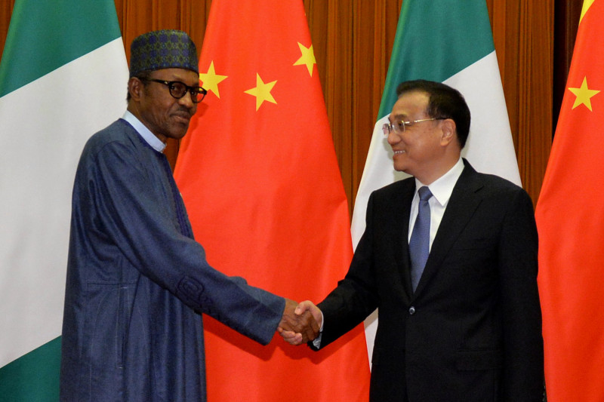
Nigerian President Muhammadu Buhari shakes hands with Chinese Premier Li Keqiang before their meeting in Beijing.
Over the past week, hundreds of African migrant workers, traders, and students in the southern city of Guangzhou, home to Asia’s largest African diaspora, were tossed out onto
the street—some by their landlords, some by hotel managers, and some by local officials. Those evicted, mostly Igbo Nigerians, insisted that they had paid their rent, had valid visas and the right paperwork, and had no contact with anybody infected with COVID-19. Meanwhile, many others were forced into a 14-day quarantine and random testing without getting their test results. Tony Mathias, an Ugandan exchange student, told Agence France-Presse: “I’ve been sleeping under the bridge for four days with no food to eat. … I cannot buy food anywhere. No shops or restaurants will serve me.”
Over the past two decades, China and Africa have become inextricably entwined. China has built roads and railways across Africa and is the biggest trading partner for the entire continent. Eighty percent of Nigeria’s bilateral debt is owed to China. About 60 percent of foreign direct investments to Ethiopia came from China in 2019. China has repeatedly stressed the importance of China-Africa alliances based on “mutual prosperity.” Yet these partnerships face irrevocable disruption if the Chinese government continues to downplay deeply rooted racial prejudices and dismisses the international outrage concerning the treatment of African migrant workers and students in China.
The events of April 10 are part of the response to growing Chinese fear of a re-emergence of coronavirus infection but also build on long-standing hostility toward Africans in China. Anti-African feelings in China go back decades, including riots aimed at Africans in 1988-1989 in Nanjing. In Chinese media, Africans are often characterized as backward or primitive and blackness as unattractive. Virulent racism common on social media is largely unchecked by censors, including claims that Africans are rapists, drug dealers, or AIDS carriers.
Those prejudices have led to a string of incidents amid coronavirus-induced paranoia. On April 4, reports of an infected Nigerian man attacking a Chinese nurse went viral, unleashing a slew of online trolls demanding the cleansing of a city they claimed was “littered with blacks.” Three days later, four Nigerians tested positive for the virus after having been seen eating together at a local restaurant. These reports sparked widespread fear that Africans were the primary cause of recent upticks in coronavirus cases.
African expats were left at the mercy of xenophobic attitudes and heavy-handed enforcement. “They are accusing us of having the virus,” Tobenna Victor, an evicted
Nigerian student, told the BBC. A viral post shows McDonald’s staff in a restaurant in Guangzhou holding a sign that says: “We’ve been informed that from now on black people are not allowed to enter the restaurant.” Rumors quickly circulated that “300,000 black people in Guangzhou were setting off a second epidemic,” and even though public officials later debunked that myth, the damage to domestic perceptions in China had been done.
Video evidence of these mistreatments has sparked international outrage. A dozen African countries have summoned their Chinese ambassadors to explain the “inhumane treatment being meted out.” A coalition of African ambassadors in Beijing delivered a letter to China’s foreign minister demanding an immediate end to all discrimination. Moussa Faki Mahamat, the chairman of the African Union Commission, also expressed his “extreme concern.” Moses Kuria, a vocal member of the Kenyan Parliament, took a more aggressive stance, calling for the immediate removal of all Chinese nationals in Kenya.
Rhetoric in the African press was just as intense. The front page of the Daily Nation, Kenya’s biggest newspaper, led with the headline “Kenyans in China: Rescue Us From Hell.” Similar news stories were found in the Nigerian, Ghanaian, and Ugandan press. The hashtag #ChinaMustExplain quickly trended on Twitter, as users expressed their anger and frustration. However, many people on Chinese social media praised the forcible expulsions and mistreatments as responsible steps to “stemming the spread of virus by Africans.”
China’s response has been to deny that any problem exists. Last Thursday, Foreign Ministry spokesman Zhao Lijian responded by stressing that China treats “all foreign nationals equally.” On Saturday, the Chinese Embassy in Zimbabwe urged critics not to “sensationalize isolated incidents.” The Global Times, a state-controlled English-language newspaper, dismissed the situation in Guangzhou as a “Western trap to stir enmity,” all the while reaffirming China’s impartiality. Yet as more and more videos of African mistreatment emerge, China’s stance of innocence is harder to maintain.
Some measures have been taken. McDonald’s has apologized for the Guangzhou store’s refusal to serve black people, ordering the halt of any discrimination. Chinese volunteers banded together to raise money, connecting African migrants with hotels that accept foreign guests and even offering counseling services. Zhao, the spokesman, also stressed that Chinese citizens should end all racist remarks and that the government will indiscriminately provide accommodations for all foreigners. Yet Zhao did not specifically address allegations of forced evictions, lack of testing results, and other discriminatory actions. As of now, no formal apology has been offered.
This article is written by Celine Sui is a United States-based independent scholar and freelance journalist focused on Sino-African relations.
This shows how the global north disrespect and discrimination the global north.

2. CHALLENGES OF FOREIGN CORRESPONDENTS
a. Aside from having to deal with the issues during the COVID-19 pandemic such as lack of access to sources and poor internet services when working from home, they are experiencing harassment and stigma as they attempt to provide information about the virus to their communities. The minister of the Interior has permitted journalists to continue operating during the Coronavirus. Some of the foreign correspondents have been experiencing stigma and discrimination. Family members or the community members says they are the ones going out meeting with so many people and they believe that they could easily get infected and also infect them at home and the community at large.
The foreign correspondents we need personal protective equipment so they can so their jobs safely. They also need funding to continue to provide information to the public about preventative measures and the status of the virus.

b. Another biggest challenge in reporting the Coronavirus is that mains roads and ways are blocked by security forces, they have to for several hours to get to the office, or for interviewing health sources, they wastes a lot of there time.
With the shutdown of business that income from advertising that the station relies on has been almost completely lost. Although the local government has asked media outlets to help with raising awareness about Covid-19 prevention measures, they have not provided economic support to do so.
The pandemic crisis is also an information crisis, and journalists are the first responders.

