GEY 402 ASSIGNMENT
BY

OGBONNA BENITA CHINYERE
16/SCI14/009

SUBMITTED TO THE DEPARTMENT OF GEOLOGY, AFE BABALOLA UNIVERSITY

JUNE 2020

1. MORPHOLOGICAL CLASSIFICATION OF POLLENS AND SPORES
BRIEF INTRODUCTION
SPORES are reproductive haploid structures that is adapted for dispersal and surviving for extended periods of time in unfavorable conditions. Spores form part of the lifecycles of many plants, algae, fungi and some protozoans. A chief difference between spores and seeds as dispersal units is that spores have very little stored food resources compared with seeds. Spores are usually haploid and unicellular and are produced by meiosis in the sporophyte. Once conditions are favorable. The spore can develop into a new organism using miotic division, producing a multicellular gametophyte, which eventually goes on to produce gametes.
POLLENS are produced from the microspore mother cells, but female spores are produced by megaspore mother cells. Pollen grains have two outer coats extine and intine and female spores do not have the extine or intine. Pollens are dispersed by various mechanisms, but female spores are retained within the ovary. Pollens are found inside the pollen sac, and female spores are found inside the ovule. In other words, all pollens are spores, but not all spores are pollens.

CLASSIFICATION
The fact that spores and pollen are normally retrieved from their host sediments as disjunct entities, separate from the original parent plant means that their natural affinities are often obscure. The free sporing plants including the Bryophyta e.g. mosses and liverworts, and the Pteridophytes which, although not a natural classification, encompasses all the seedless vascular plants, including the paleontologically important ferns and fern allies, are primarily classified using the gross morphology, wall structure and the type of wall sculpture, if present. The important feature of homospory in terms of the fossil record is the four-fold division involved in spore production, this takes the form of either a tetrahedra which gives a trilete spore or a tetragon which gives a monolete spore. The trilete and monolete marks imparted on the individual spores are the marks where each of the spore tetrad once abutted each other.
Classification of pollen, like that of spores is based on the morphological trends observed among various groups of fossils which may be primarily but not entirely reflections of evolution within the groups of plants which produced the pollen. It should also be remembered that higher plants have characteristics of reproduction which permit them to utilize modes of evolution unavailable to animals. Because of their relatively simple genetic systems plants may utilize hybridization and self-fertilization. The early gymnosperms produce prepollen, differentiated from true pollen by germination from the proximal rather than the distal side. Recent gymnosperms may produce very distinctive saccate pollen, i.e. pollen with one, two or rarely three air sacs attached to a central body (colpus) or monosulcate pollen as in the cycads and ginkgos. The angiosperms produce pollen with the greatest morphological variation, but typically with either a tricolpate or monosulcate form.
NPC CLASSIFICATION
- NPC is an artificial system of classification of pollen and spore based on the three features of aperture only. i.e. number, position, and character.
- Erdtman and Straka (1961) proposed NPC classification and palynologists all over the world accepted it.
- According to NPC system each pollen grain has an arithmetic cardinal number consisting of three digits.
- The first digit reveals the absence or presence of aperture, and when present it mentions the total number of aperture(s) present in a pollen grain.
- The second digit illustrates the position of apertures(s), i.e. distal, proximal, and latitudinal, meridional, equatorial etc.
- The microspores reveal the position of aperture(s) with full clarity when they are in tetrad.
- The third digit explains the character of an aperture, i.e. circular/oval or elongated, simple or compound etc. ‘N’ from number, ‘P’ from position and ‘C’ from character of aperture compose the NPC classification.
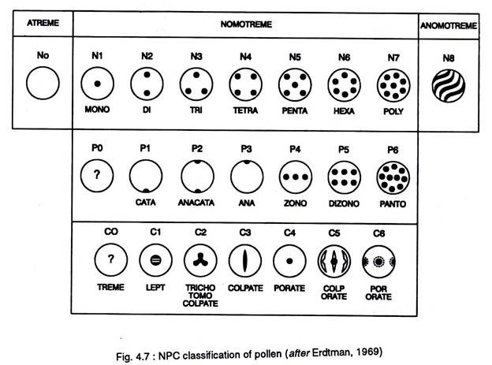
NPC classification of pollens and spores
CLASSIFICATION OF APERTURE BASED ON NUMBER
- In NPC system ‘N’ denotes the number of aperture(s) present in a pollen grain.
- The pollen number (N) groups are of nine types. The grain without aperture is named “Atreme” and is designated as No. Depending upon the number of apertures.
- The types of pollen are Monotreme (N1) with one aperture, Ditreme (N2) with two apertures; Tritreme (N3) with three apertures, Tetratreme (N4) with four apertures, Pentatreme (N5) with five apertures, Hexatreme (N6) with six apertures and Polytreme (N7) having more than six apertures. Irregularly arranged spiral apertures over the surface of the pollen irrespective of their number are designated as ‘Anomotreme’ (N8).
- There are pollen grains where apertures are absent.
- Such pollen grains are termed as inaperturate or Atreme and they are placed in N0 group.
CLASSIFICATION OF APERTURE BASED ON POSITION
- In NPC system ‘P’ denotes the position of aperture in a pollen grain and spore.
- The position may be proximal, distal, and equatorial.
- On the basis of the position (P) of apertures, pollen is categorized into seven groups (P0 to P6).
- In ‘Catatreme’ (P1) pollen aperture is in proximal face, while in ‘Anatreme’ (P3) it is in distal face.
- The pollen is designated as Anacatatreme’ (P2) where apertures are both in proximal and distal faces.
- One aperture with its center occurs at the proximal pole. The other aperture with its center occurs on the distal pole.
- The distal part is the face of a pollen grain and spore that faces outward, i.e. away from the center of tetrad and opposite the proximal part.
- The pollen grains are referred to as ‘Zonotreme’ (P4), when the apertures are located on the equatorial zone.
- The equator is the part of a pollen grain or spore that runs midway between the proximal and distal poles and perpendicular to polar axis.
- ‘Dizonotreme’ (P5) are like Zonotreme, but with two rows of apertures on the equatorial region.
- The apertures occur parallel to equator.
- In ‘Pantotreme’ (P6), apertures are globally distributed all over the pollen surface. As a rule, Pantotreme pollen grains are spheroidal.
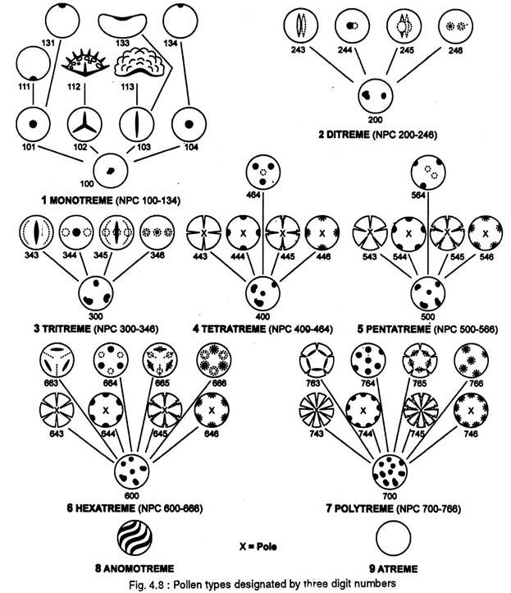

CLASSIFICATION OF APERTURES BASED ON CHARACTER
- In NPC system ‘C’ denotes the character of an aperture in a pollen grain and spore.
- The character groups of pollen and spore are seven and they are mentioned as C0 to C6.
- C0 groups have apertures whose character cannot be established with certainty.
- C1 groups of pollen and spore have leptoma (Greek leptoma means thin place).
- Leptoma is a thin area, aperture like and functions like an aperture.
- Pollen grains having one leptoma are termed as monlept.
- The leptoma may occur on either proximal or distal face of a pollen grain and spore and accordingly termed as catalept and analept.
- C2 groups are Trichotomocolpate (Gr. Tricha, in three parts; tome, cut; kolpos, depression, furrow).
- Trichotomocolpate is a three branched aperture, the branches of which are more than two times longer than breadth.
- Trichotomocolpate pollen and spores having aperture on proximal face are termed as Trilete.
- The group C3 has colpate grains.
- The group C4 comprises porate pollen grains.
- The group C5 comprises colporate pollen.
- The group C6 comprises pororate pollen.
Based on NPC classification, each pollen type is designated by using a three-digit number. The first digit denotes the number of apertures, for example, 100 is assigned to monotreme, 200 to Ditreme, 300 for Tritreme, 400 for Tetratreme, 500 for Pentatreme, 600 for Hexatreme, 700 for Polytreme, and 8 for Anomotreme and 9 for Atreme.
The second digit denotes the position of the aperture, e.g. 010 to proximal aperture, 030 for distal aperture, 040 for equatorial aperture, 060 for global aperture. The third digit denotes the characters of the aperture, e.g., 002 for trilete, 003 for colpate, 004 for porate, 005 for colporate. Therefore, the number 112 is assigned to trilete grains, similarly 133 to monosulcate grains, 343 to tricolpate and 345 to tricolporate grains, etc.

2. APPLICATIONS OF POLLENS AND SPORES IN GEOSCIENCES
- PALEOBOTANY: In the research of plants and their origins, palynologists have an important foothold in the study of past environmental systems, or paleo environments. In studying spores and pollens of preserved species samples, palynologists can reveal many details about different eco systems, especially marine environments. With palynology, one can determine such environmental characteristics as water depth, temperature and salinity. This is important in learning more about past wildlife and how it has evolved.
- PALYNOLOGY AND HYDROLOGY: These two classes of scientific study come together to serve one another well. Hydrology is a broad field that can involve, though is not exclusively related to, determining the presence and source of sediment in water, the flow of that water in an above or underground system, and determining pollutants within a water sample. This works together with palynology, in determining the presence of specific types of material within a water source including pollen, spores, or specific minerals and sediments, which can help develop palynology research more fully.
- FORENSIC SCIENCE: On a much more recent chronological level, palynology is also beneficial to criminal investigators in revealing the history of evidence based on pollen and spore traces. For example, pollen samples found on an object could reveal to a palynologist the potential location this object was in contradiction to where it was found. Most commonly, this is applied in homicide cases in investigating body disposal. As a result, palynology can bring an irrefutable dimension to the criminal justice system.
- BIOLOGICAL RESEARCH: The versatility of palynology as a field is most adequately illustrated in the many research opportunities it provides. Pollen and spores can reveal so much about the origins of a large number of things. One common example is honey. An immense amount of research is being done to use palynology to investigate the biological origin of honey.
- While botanical information from them may be limited, fossil spores and pollen have proved exceptionally useful as biostratigraphic indices. They are particularly valuable in freshwater environments, in evaporitic deposits and situations where marine and freshwater facies interdigitate.
- Pollen is used to manipulate plant traits. Cross-pollination is the process of fertilization between similar plants to improve them. Creating plants resistant to pests or dehydration or increasing crop production are a few changes made through cross-pollinating. Pollen can also be used by archeologists to determine what ancient civilizations used for food.
- Pollen can spread with the wind or through interaction with insects. The outer wall of the pollen grain is strong to prevent damage during transport. The inner layer is similar to an ordinary plant cell. Microscopic in size, pollen grains are not visible individually to the eye. Clumps of pollen can be seen on insects that move from plant to plant. Only 10 percent of plants spread pollen without the help of insects.
- Pollen grains are exploited in basic research, because pollen is representing a generation and a haploid (gametophyte) plant can be made from single pollen. They are also used for commercial purposes as health food support as well as medicine. Pollen grains are also responsible to cause human allergy.

