NAME: CHUKWUMA EZINNE CHIRONMA
MATRIC NO: 16/SCI14/003
DEPARTMENT: GEOLOGY
ASSIGNMENT TITLE: 1. DISCUSS THE MORPHOLOGICAL CLASSIFICATION OF POLLENS AND SPORES.
2. EXPLAIN AND HIGHLIGHT THE VARIOUS APPLICATIONS OF POLLENS AND SPORES IN GEOSCIENCES.

1. DISCUSS THE MORPHOLOGICAL CLASSIFICATION OF POLLENS AND SPORES.
INTRODUCTION
The fact that spores and pollen are normally retrieved from their host sediments as disjunct entities, separate from the original parent plant means that their natural affinities are often obscure. The free spore plants including the Bryophyta e.g. mosses and liverworts, and the Pteridophytes which, although not a natural classification, encompassess all the seedless vascular plants, including the paleontologically important ferns and fern allies, are primarily classified using the gross morphology, wall structure and the type of wall sculpture, if present. The important feature of homospory in terms of the fossil record is the four-fold division involved in spore production, this takes the form of either a tetrahedral which gives a trilete spore or a tetragon which gives a monolete spore. The trilete and monolete marks imparted on the individual spores
CLASSIFICATION
Classification of pollen, like that of spores is based on the morphological trends observed among various groups of fossils which may be primarily but not entirely reflections of evolution within the groups of plants which produced the pollen. Because of their relatively simple genetic systems plants may utilize hybridization and self-fertilization. The early gymnosperms produce prepollen, differentiated from true pollen by germination from the proximal rather than the distal side. Recent gymnosperms may produce very distinctive saccate pollen, i.e. pollen with one, two or rarely three air sacs attached to a central body (colpus) or monosulcate pollen as in the cycads and ginkgos. The angiosperms produce pollen with the greatest morphological variation, but typicaly with either a tricolpate or monosulcate form.
MORPHOLOGY OF POLLEN AND PORES
Pollen grains of gymnosperms are generally distinguished on the basis of their shape, subspherical with or without vesicles or sacci. Conifer pollen grains are often characterized by a pair of sacci and are designated as bisaccate. The size range of gymnosperm pollen is variable, ranging from about 10 mm in simple forms to about 200 mm for large bisaccate taxa. The pollen grains of angiosperms have a great morphological diversity. They are identiﬁed on the basis of their geometry (spherical, oblate, prolate) and on the type of aperture, circular (pore) or elongate (colpus), the number and distribution of apertures, and the ornamentation.
Morphology of Pollen and spores
1.Polarity: The Polar Axis is the straight line between the distal and proximal poles of a pollen grain or a spore. The orientation of polarity is an important criterion in identification and description of pollen grains, as apertural position is of primary phylogenetic and functional significance.
Pollen grains can therefore be:
- Isopolar: the proximal and distal faces of the exine are alike
- Heteropolar: the distal and proximal faces of the exine are different, either in shape, ornamentation or apertural system.
- Subisopolar: the proximal and distal faces are slightly different

2. Symmetry: Spores and pollen are either symmetric or asymmetric
Symmetric ones can be:
- Radially symmetric: with two or more vertical planes of symmetry
- Bilaterally symmetric: with a single, principal plane of symmetry
Asymmetric ones can be:
- Non- Fixiform: without fixed shape
- Fixiform: with fixed shape
Asymmetrical grains have no plane of symmetry. They are rare in occurrence.

3. Shape: The shape of the pollen grains varies from species to species. Shape of the grains is found to be useful in spore/pollen identification. However, the shape may vary considerably within one grain type or even within one species. Pollen grains and spores are often described by the shape (non-angular and angular) of their outline both in polar and equatorial views.
The shape of pollen grains and spores can be:
- Prolate: the polar axis is longer than the equatorial diameter
- Oblate: the polar axis is shorter than the equatorial diameter
- Spheroidal: the polar axis and the equatorial diameter are approximately equal
4. Aperture: The aperture is a specialized thin region of the spore/pollen wall that is generally different in ornamentation and/or in structure
Apertures can be in the form of:
- Pori (pores)
- Colpi/Sulci (furrows)
- Grains with pori are called Porate
- Grains with colpi/sulci are called Colpate/Sulcate
- Grains with combined colpus and porus are called Colporate
5. Size: Pollen grains show a great variety in their sizes. Smallest pollen grains of about 5 x 2.4 µm is noted in Myosotis palustris and some members of Boraginaceae, while the largest pollen grains (> 200 µm in diameter) are observed in Curcurbitaceae, Nyctaginaceae and Orectanthe ptaritepuiane (Abolbodaceae). In taking measurements of size the length of polar axis (PA), equatorial diameter (ED) and sometimes equatorial breadth (EB) are considered in bilateral grains. In radially symmetrical pollen grains the PA and the greatest ED can be measured in equatorial view, while the EB can be measured in polar view only. It is also necessary to measure exine elements, taking into consideration the thickness of exine, sexine/nexine thickness ratio and the thickness of the exine projections greater than 0.5 µm if any.

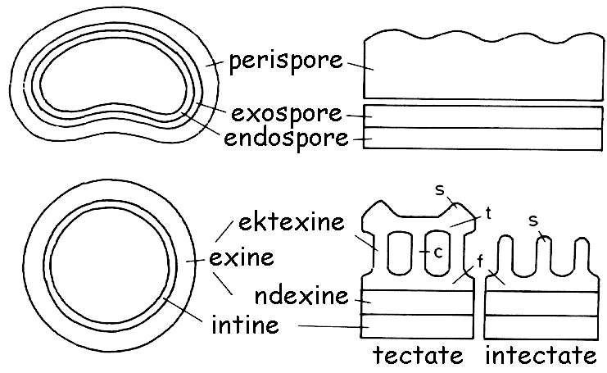

Cross-section of the cell wall (structure) of a pollen grain and a spore.

2. APPLICATIONS OF POLLENS AND SPORES IN GEOSCIENCES
INTRODUCTION
While botanical information from them may be limited, fossil spores and pollen have proved exceptionally useful as bio-stratigraphic indices. They are particularly valuable in freshwater environments, in evaporitic deposits and situations where marine and freshwater facies interdigitate. The field is associated with the plant sciences as well as with the geologic sciences, notably those aspects dealing with stratigraphy, historical geology, and paleontology.
The study of Pollen and spores using fresh or non-fossilized samples have also been useful in establishing a geologic relative age distribution of sediments or strata Palynological analysis therefore is of practical application to petroleum exploration and to other geologic research involving subsurface sediments and structures.
Now that we have established the primary evidence types, we need to look at precisely what it is that palynology can tell us. There is a wealth of information available for many disciples. It's one of the scientific tools for a cross-disciplinary approach to geoscience.
VARIOUS APPLICATIONS OF POLLENS AND SPORES IN GEOSCIENCE
Pollen and spores can be applied in;
- Geology
- Paleo-environmental studies
- Geo-engineering
- Geo-archeology
- Biostratigraphy and Geochronology
- Paleo-ecology and climate changes
- Organic Palynofacies studies
- Geothermal alteration studies
- Forensic palynology

- Geology: The oil industry first noticed the benefits of palynology as a commercial application for identifying pockets of oil. Certain microfossils survive better in certain types of rock and those that are correlated regularly with oil pockets is a great way of prospecting for new pockets, they are abundant in certain types of rock so they act as a great indicator. They may also be used for dating rocks, as most of the rocks in which these fossils are found are sedimentary, meaning they were once a river or sea bed - much like how pollen, spores and dinoflagellates survive today.
- The Paleo-environment: Climate change is largely concerned today with how human activity is changing the environment. In the distant past, climate change was overwhelmingly a natural process subject to all the natural forcing that we know about now and despite that much of the discussion is on anthropogenic climate change, it is important to know the difference as well as understand what factors drive natural processes. In order to understand how we might be affecting the climate, and what effect such elements as greenhouse gases affect the global and local environments, land and sea, we can say with certainty that it is necessary to look to the distant past, periods of cold and warm. How did the changes of the past affect plant and animal life? What were the knock-on effects? Local extinctions? Invasive species? How did the glacial retreat affect the topography and vegetation? For example, we have a good chronology of the retreat of the glaciers in Quebec and how tree species changed as the climate altered.
- Geoengineering/geo-archaeology: As well as looking at how natural processes affect the climate, we also use the evidence to look at how human action has changed the topography over time. With 250,000 years of human history, there is much about our prehistoric past we still do not know as really only organic material will survive under certain circumstances, therefore the record is limited even though we have learnt so much from what we do have. Palynology has many applications in archaeology, and pollen analysis has been core to tracking the spread of the Neolithic Revolution for example, particularly for selective breeding of plants such as wheat, barley and other grains. In Bohemia, where conditions have been poor in the past, researchers have been able to draw up a 5000-year long vegetation history through pollen studies alone.
- Biostratigraphy and geochronology: Geologists use palynological studies such as pollens and spores in biostratigraphy to correlate strata and determine the relative age of a given bed, horizon, formation or stratigraphic sequence.
- Paleoecology and climate change: Pollen and spores can be used to reconstruct past vegetation (land plants) and marine and freshwater phytoplankton communities, and so infer past environmental (paleo-environmental) and paleo-climatic conditions.
- Organic palynofacies studies, which examine the preservation of the particulate organic matter and palynomorphs provides information on the depositional environment of sediments and depositional paleo-environments of sedimentary rocks.
- Geothermal alteration studies examine the color of palynomorphs such as pollens and spores, extracted from rocks to give the thermal alteration and maturation of sedimentary sequences, which provides estimates of maximum paleo-temperatures.
- Limnology studies: Freshwater palynomorphs and animal and plant fragments, including the prasinophytes and desmids (green algae) can be used to study past lake levels and long term climate change.
- Forensic palynology: the study of pollen and other palynomorphs for evidence at a crime scene.
- Archaeological Palynology: examines human uses of plants in the past. This can help determine seasonality of site occupation, presence or absence of agricultural practices or products and plant-related activity areas within an archaeological context. Bonfire Shelter is one such example of this application.
REFERENCES
- http://www.flmnh.ufl.edu/pollen/whatispalynology.htm
- http://www.palynology.org/what-is-palynology
- http://www.palynology.org/pollen
- http://www.bioone.org/doi/abs/10.1080/01916122.2011.629523
- http://www.palynology.org/spores
- http://www.palynology.org/palynology-principles-applications
- https://www.utexas.edu/courses/denbow/labs/palynology.htm
- Moore, P.D., et al. (1991), Pollen Analysis (Second Edition). Blackwell Scientific Publications. ISBN 0-632-02176-4
Traverse, A. (1988), Paleopalynology. Unwin Hyman ISBN 0-04-561001-0

