NAME: CHUKWUMA EZINNE CHIRONMA
MATRIC NO: 16/SCI14/003
DEPARTMENT: GEOLOGY
ASSIGNMENT TITLE: 1. DISCUSS THE MORPHOLOGICAL CLASSIFICATION OF POLLENS AND SPORES.
2. EXPLAIN THE STRATIGRAPHICAL AND PALEO-ENVIRONMENTAL APPLICATIONS OF POLLEN AND SPORES IN SEDIMENTARY AND PETROLEUM GEOLOGY.
1. DISCUSS THE MORPHOLOGICAL CLASSIFICATION OF POLLENS AND SPORES.
INTRODUCTION
The fact that spores and pollen are normally retrieved from their host sediments as disjunct entities, separate from the original parent plant means that their natural affinities are often obscure. The free spore plants including the Bryophyta e.g. mosses and liverworts, and the Pteridophytes which, although not a natural classification, encompassess all the seedless vascular plants, including the paleontologically important ferns and fern allies, are primarily classified using the gross morphology, wall structure and the type of wall sculpture, if present. The important feature of homospory in terms of the fossil record is the four-fold division involved in spore production, this takes the form of either a tetrahedral which gives a trilete spore or a tetragon which gives a monolete spore. The trilete and monolete marks imparted on the individual spores
CLASSIFICATION
Classification of pollen, like that of spores is based on the morphological trends observed among various groups of fossils which may be primarily but not entirely reflections of evolution within the groups of plants which produced the pollen. Because of their relatively simple genetic systems plants may utilize hybridization and self-fertilization. The early gymnosperms produce prepollen, differentiated from true pollen by germination from the proximal rather than the distal side. Recent gymnosperms may produce very distinctive saccate pollen, i.e. pollen with one, two or rarely three air sacs attached to a central body (colpus) or monosulcate pollen as in the cycads and ginkgos. The angiosperms produce pollen with the greatest morphological variation, but typicaly with either a tricolpate or monosulcate form.
MORPHOLOGY OF POLLEN AND PORES
Pollen grains of gymnosperms are generally distinguished on the basis of their shape, subspherical with or without vesicles or sacci. Conifer pollen grains are often characterized by a pair of sacci and are designated as bisaccate. The size range of gymnosperm pollen is variable, ranging from about 10 mm in simple forms to about 200 mm for large bisaccate taxa. The pollen grains of angiosperms have a great morphological diversity. They are identiﬁed on the basis of their geometry (spherical, oblate, prolate) and on the type of aperture, circular (pore) or elongate (colpus), the number and distribution of apertures, and the ornamentation.
Morphology of Pollen and spores
1.Polarity: The Polar Axis is the straight line between the distal and proximal poles of a pollen grain or a spore. The orientation of polarity is an important criterion in identification and description of pollen grains, as apertural position is of primary phylogenetic and functional significance.
Pollen grains can therefore be:
- Isopolar: the proximal and distal faces of the exine are alike
- Heteropolar: the distal and proximal faces of the exine are different, either in shape, ornamentation or apertural system.
- Subisopolar: the proximal and distal faces are slightly different

2. Symmetry: Spores and pollen are either symmetric or asymmetric
Symmetric ones can be:
- Radially symmetric: with two or more vertical planes of symmetry
- Bilaterally symmetric: with a single, principal plane of symmetry
Asymmetric ones can be:
- Non- Fixiform: without fixed shape
- Fixiform: with fixed shape
Asymmetrical grains have no plane of symmetry. They are rare in occurrence.

3. Shape: The shape of the pollen grains varies from species to species. Shape of the grains is found to be useful in spore/pollen identification. However, the shape may vary considerably within one grain type or even within one species. Pollen grains and spores are often described by the shape (non-angular and angular) of their outline both in polar and equatorial views.
The shape of pollen grains and spores can be:
- Prolate: the polar axis is longer than the equatorial diameter
- Oblate: the polar axis is shorter than the equatorial diameter
- Spheroidal: the polar axis and the equatorial diameter are approximately equal
4. Aperture: The aperture is a specialized thin region of the spore/pollen wall that is generally different in ornamentation and/or in structure
Apertures can be in the form of:
- Pori (pores)
- Colpi/Sulci (furrows)
- Grains with pori are called Porate
- Grains with colpi/sulci are called Colpate/Sulcate
- Grains with combined colpus and porus are called Colporate
5. Size: Pollen grains show a great variety in their sizes. Smallest pollen grains of about 5 x 2.4 µm is noted in Myosotis palustris and some members of Boraginaceae, while the largest pollen grains (> 200 µm in diameter) are observed in Curcurbitaceae, Nyctaginaceae and Orectanthe ptaritepuiane (Abolbodaceae). In taking measurements of size the length of polar axis (PA), equatorial diameter (ED) and sometimes equatorial breadth (EB) are considered in bilateral grains. In radially symmetrical pollen grains the PA and the greatest ED can be measured in equatorial view, while the EB can be measured in polar view only. It is also necessary to measure exine elements, taking into consideration the thickness of exine, sexine/nexine thickness ratio and the thickness of the exine projections greater than 0.5 µm if any.

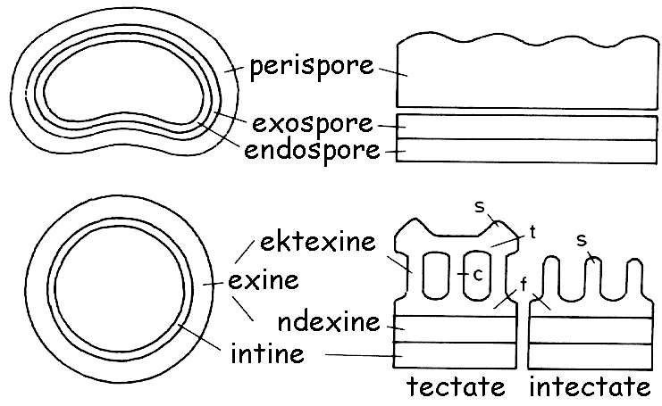

Cross-section of the cell wall (structure) of a pollen grain and a spore.

3. EXPLAIN THE STRATIGRAPHICAL AND PALEO-ENVIRONMENTAL APPLICATIONS OF POLLEN AND SPORES IN SEDIMENTARY AND PETROLEUM GEOLOGY.
STRATIGRAPHICAL APPLICATIONS OF POLLEN AND SPORES IN SEDIMENTARY AND PETROLEUM GEOLOGY
Pollen and spores are important group of micro fossils and in general are important in petroleum geology. The evaluation of microfossils such as pollen and spores is imperative for setting up detailed stratigraphic subdivisions. pollen extracted from a deposit can be used radiocarbon dating.
Pollen and spores can be used in Biostratigraphy and geochronology. Geologists use palynological studies in biostratigraphy to correlate strata and determine the relative age of a given bed, horizon, formation or stratigraphical sequence. Fossilized pollen was first discovered in a coal thin section, because pollen and spores have the tendency of being dragged along with migrating petroleum through porous rocks.
The oil industry is credited with demonstrating the usefulness of pollen and spores in the study of stratigraphic sequences of rocks and the potential for oil and gas exploration. Because palynomorphs are resistant to decomposition and are produced in great abundance, their recovery from rocks and sediments via special and careful chemical treatments is possible and provides scientists with information needed to describe plant life of past ages. By describing the sequence of selected palynomorphs through the rock layers of Earth, stratigraphers (scientists who study the rock layers of the earth), are able to correlate rocks of the same age and may therefore locate and correlate layers that contain oil or natural gas. Certain microfossils survive better in certain types of rock and those that are correlated regularly with oil pockets is a great way of prospecting for new pockets, they are abundant in certain types of rock so they act as a great indicator. They may also be used for dating rocks, as most of the rocks in which these fossils are found are sedimentary, meaning they were once a river or sea bed - much like how pollen, spores and dinoflagellates survive today. The study of palynology such as pollen and spores can be utilized in helping to determine petroleum source rocks, forecasting target strata for further exploration, and providing a scientific basis for petroleum prospect evaluation and exploration.
The role of palynology in the exploration for oil is essentially comparable to that of any other branch of paleontology. The economic value of this relatively modern scientific field to the petroleum industry may be increased and hastened by avoiding some of the pitfalls which plagued micropaleontology in its earlier years of application. Information should be developed simultaneously on the biology, ecology and stratigraphy of these organisms.
Palynologists now being trained should be encouraged to develop their knowledge of both geologic and biologic fundamentals. Research in this field should be sponsored by industry, as well as by universities and government agencies, in both its own research laboratories and in private or university labs. The areas of this research should include: studies of the distribution and preservation of palynomorphs in modern sediments; relative significance of living assemblages or transported entities to other types of organisms with which they are found; development of methods and programs for mechanical classification of these micro-fossils and analysis, evaluation, storage and retrieval of data concerning them; improvement of techniques for separating these fossils from the rocks; development of environmental information by the study of types and conditions of preservation, origin and significance of reworked fossils, relative percentages of spores and pollen to other organisms, and characteristics of their role in sedimentation.
PALEO-ENVIRONMENTAL APPLICATIONS OF POLLEN AND SPORES IN SEDIMENTARY AND PETROLEUM GEOLOGY.
Pollens and spores can be used in studying past climates and environment by indenting the plants. Pollens and spores tells us little or much about the environment of deposition and can be applied in paleo-environmental interpretation for a drilling process. The advantage of pollen and spores over other fossils is their widespread distribution, they can be found in either terrestrial freshwater, saltwater or estuary sources of sedimentary rocks.
Pollen and spores provides evidence of stratigraphical correlation through biostratigraphy and paleo-environmental reconstruction, one common and lucrative application of palynology is in oil and gas exploration.
Climate change is largely concerned today with how human activity is changing the environment. In the distant past, climate change was overwhelmingly a natural process subject to all the natural forcing, that we know about now and despite that much of the discussion is on anthropogenic climate change, it is important to know the difference as well as understand what factors drive natural processes. In order to understand how we might be affecting the climate, and what effect such elements as greenhouse gases affect the global and local environments, land and sea, we can say with certainty that it is necessary to look to the distant past periods of cold and warm. How did the changes of the past affect plant and animal life? What were the knock-on effects? Local extinctions? Invasive species? How did the glacial retreat affect the topography and vegetation? For example, we have a good chronology of the retreat of the glaciers in Quebec, and how tree species changed as the climate altered.

