NAME: AGADA EMMANUELLA NKEM
MATRIC NO: 18/MHS06/007
DEPARTMENT: MEDICAL LABORATORY SCIENCE
COURSE CODE: BCH 202
COURSE TITLE: CLINICAL BIOCHEMISTRY AND XENOBIOTICS
Answer
1. Structure of ATP, GDP, CDP, UTP, DNA
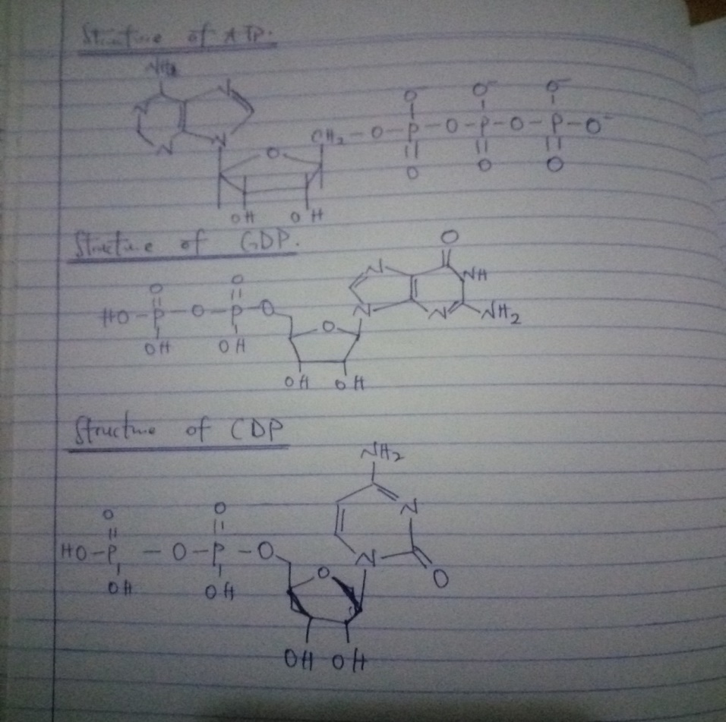
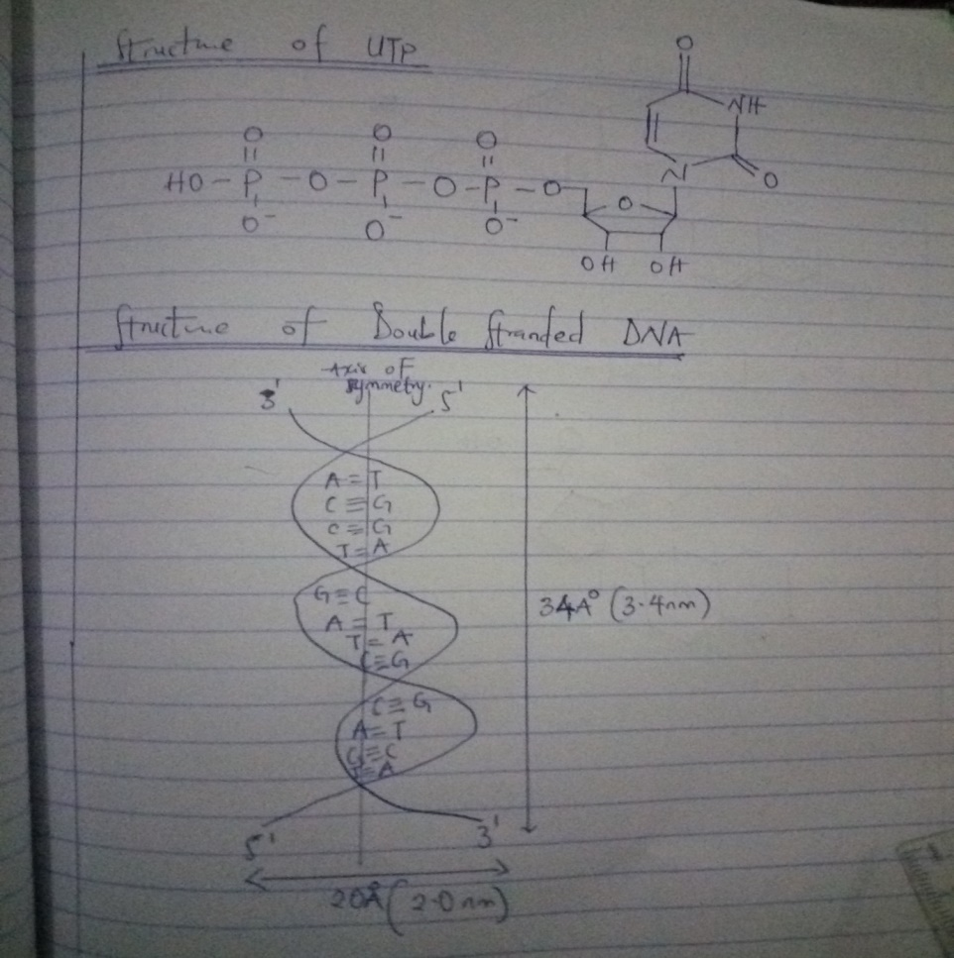
2. Differences between DNA and RNA.
DNA | RNA
1) contains deoxyribose sugar | Contains ribose sugar
2) contains all nitrogenous bases except uracil | Contains all bases except thymine
3) DNA is double stranded | RNA is single stranded
4) DNA is present in nucleus and small in mitochondrion | RNA is present in cytoplasm and small in nucleolus.
5) DNA is stable under alkaline conditions | RNA is not stable under alkaline conditions

3. Biosynthesis of calcitriol
Calcitriol or bioactive vitamin D is a steroid hormone that has been known for its important role in regulating body levels of calcium and phosphorus. Calcitriol is produced in the cells of a proximal tubles of the nephron in the kidneys by the action of 25-hydroxyvitamin D3 1-alpha hydroxylase, mitochondrial oxygenase and an enzyme which catalyses the hydroxylation of 25- hydroxycholecalciferol in the 1-alpha position. The activity is stimulated by PTH.
Calcitriol is also produced outside the kidney in small amounts by many tissues including placenta and activated macrophages. When the drug alfacalcidol is used, 25-hydroxylation in the liver will produce calcitriol as the active metabolite. This will produce greater effects than other vitamin D precursors in patients with kidney disease who have loss of renal 1-alpha-hydroxylase.
4. Coenzymes are organic non protein additional components bounded loosely to enzymes for their optimum activity.
Coenzyme form of Riboflavin: Flavin adenine dinucleotide (FAD) and Flavin mononucleotide (FMN)
5. Characteristic components of nucleotides and nucleoside units on RNA
In RNA, the components of nucleoside units found are; Purine bases- Adenine and Guanine, Pyrimidine bases- Cytosine and Uracil and Pentose sugar found is a ribose sugar.
While the components of nucleotide units of RNA found are Pentose sugar, D- ribose sugar, purine bases, Cytosine, Uracil and phosphate group. It is a combination of nucleoside unit of RNA and a phosphate group, for example; A nucleoside diphosphate e.g. ADP and A nucleoside triphosphate, e.g. ATP.
6. Structure of cholesterol and cortisol
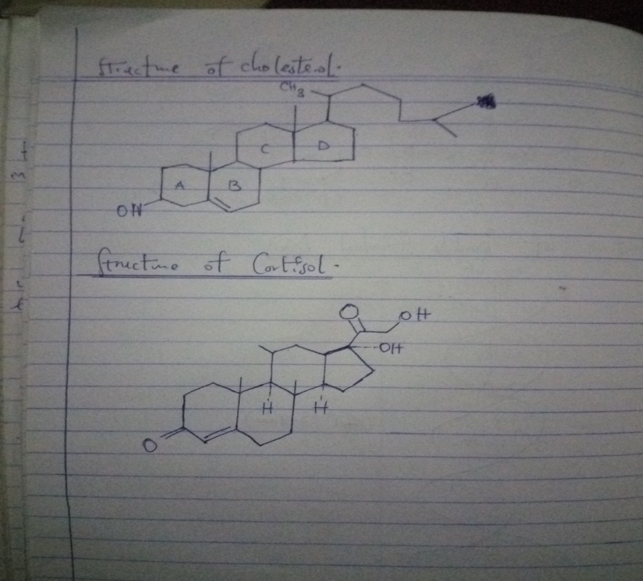
7. Vitamins are organic nutrients taken in small quantities for biochemical functions, cannot be synthesized in the body but must be supplied by diet. They are divided into two groups;
1) Fat soluble: which include Vitamin A, Vitamin D, Vitamin E, Vitamin K.
2) Water soluble: which include B complex vitamins- Thiamine B1, Riboflavin B2, Niacin B3, Pantothenic B5, Pyridoxine B6, Biotin, Folic acid, Cobalamin B12 and Vitamin C. Metabolism of folic acid to its active form
Folic acid
Folate reductase NADPH + H+ NADP+

Dihydrofolate (DHF)
Folate reductase NADPH + H+ NADP+
Tetrahydrofolate (THF)
8. Glycolipids
Glycolipids as their name implies, are sugar containing lipids. They consist of alcohol sphingosine. The amino group of sphingosine is esterified by a fatty acid and one or more sugar units are attached to the hydroxyl group of sphingosine. Glycolipids are widely distributed in every tissue of the body, particularly in nervous tissue such as brain.
It is divided into four forms:
1) Cerebrosides
2) Sulfatides
3) Globosides
4) Gangliosides.
Structure of glycolipids
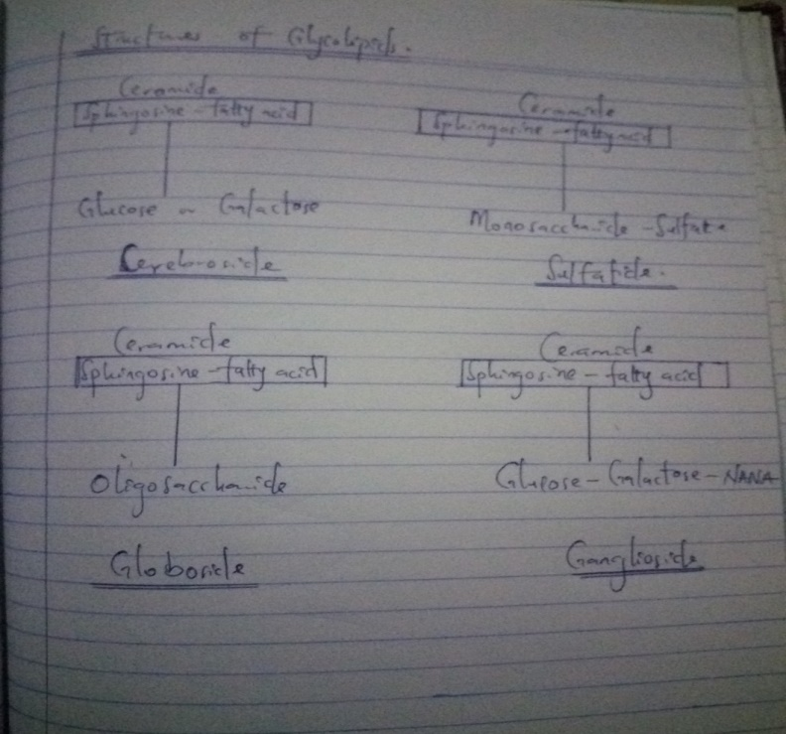

9. Cell is the basic fundamental unit of life. It is the structural and functional unit of all living organism. There are two forms of cell: Prokaryotic and Eukaryotic. The prokaryotic cells are formed in simple organisms while the eukaryotic cells are formed in higher organisms.
The cell can be divided into three parts: Cytoplasm, Cell membrane and Cell Organelles. The Cell membrane defines the periphery of the cell contents from the environment; the cytoplasm is the internal volume of the cell enclosed by the plasma membrane. It is composed of aqueous solution called cytosol and the organelles.
Cell organelles and their functions include;
1) Nucleus: most prominent and important. All cells contain nucleus except RBC. The DNA is stored in the nucleus and DNA synthesis takes place in the nucleus.
2) Endoplasmic reticulum: is the interconnected network of tubular and flat vesicular structures in the cytoplasm. It forms the link between nucleus and cell membrane by connecting the cell membrane at one end and the outer membrane of the nucleus at the other end. Rough ER functions in the biosynthesis of protein.
3) Mitochondria: is the power house of the cell. It functions include; ATP synthesis, site for tricarboxylic acid cycle, fatty acid oxidation, oxidative phosphorylation, part of urea cycle and part of heme synthesis.
4) Lysosomes: Intracellular digestion of macromolecules and hydrolysis of nucleic acid, protein, glycosaminoglycans, glycolipids, sphingolipids.
5) Golgi apparatus: Post-transcriptional modification and sorting of proteins and export of proteins.
6) Nucleolus: Synthesis of rRNA and formation of ribosomes.

