OLAKADA BLESSING NYIMENKA
17/SMS04/043
CMS 304

Over the last 20 years, journalism scholars have criticized Western media for their reporting of Africa. Scott recently argued in this journal that this criticism has become taken for granted to the point of becoming a “myth”. This article constitutes the first academic response to Scott and revisits empirically what we think we know best about Western media coverage of Africa. It identifies and assesses three claims about this coverage, namely that it systematically (1) refers to “darkness” and “tribalism”; (2) it presents Africa as a homogenous entity; and (3) that it relies predominantly on Western sources. The corpus includes 282 articles published across eight British and French newspapers (2007–2012). The textual analysis—complemented by interviews with correspondents—finds that the claims that coverage systematically refers to “tribalism” and “darkness”, treats Africa as a country and relies pre-dominantly on Western voices are not empirically supported. Nonetheless, it reveals that processes of conflation are at stake, and that the framing of African voices is impacted by a linguistic bias linked to peculiar perceptions of African political leadership. The article concludes that the critical ethos of postcolonial critique is best served by transparent and nuanced interpretation of textual data.
The first thing to notice about how Africa is portrayed by the media is that it generally is not. Studies of major internationally focused Western (US, UK, French) news outlets (newspapers and TV) have found that Africa tends to account for roughly 6% to 9% of the total amount of international news; in Japanese news, this drops to two to 3%. Even if we generously assume that 20% of the news is focused on international events (it rarely rises above 15%), that still means that at best, less than 2% of coverage in a Western newspaper will be about Africa. That does not leave a lot of room to portray Africa in all its diversity.
It surely comes as no surprise to anyone that what little coverage of Africa there is, it tends to be of the negative variety. News in general displays a tendency for negativity, as the truism “If it bleeds, it leads” would suggest. Journalists have long spoken of a coups-and-earthquakes approach to covering the world outside (to quote the title of a book by Mort Rosenblum). But the tendency appears to be more pronounced regarding news of the African continent. A study of US television news found more than 60% of news of Africa focused on conflicts, terrorism, disasters, disease and other tragedies. A study of Japanese newspapers found 70% of coverage of Africa to be negative — more negative than that of any other continent. Even within news about conflicts, the more positive aspect of peacemaking is less likely to be covered for conflicts in Africa than it is for conflicts in the Middle East.
This is not to say that African conflicts are actively pursued by the media. African conflicts are in fact woefully underrepresented by the news media compared to other continents and regions. And as Kenneth Dowler rightly points out, it may well be that the “If it bleeds, it leads” notion holds true for the media, but “it really depends on who is bleeding.” Conflicts occurring in Europe or the Middle East inevitably attract vastly greater amounts coverage than African conflicts do. In a similar vein, a Western victim of a kidnapping or killing by an armed group in Africa is far more likely to be covered than an African victim.
This cannot simply be written off as a case of media based at “home” focusing on “our” people from the perspective of nationality. One cannot help but come to the conclusion that race (and/or socioeconomic status) is also playing a role in the determination of newsworthiness. In a situation in which no US citizens are involved, for example, a French citizen kidnapped in North Africa will attract US media coverage where a kidnapped Ethiopian citizen will not.

US President Donald Trump’s alleged remarks questioning why the US should take in immigrants from what he apparently called “shithole countries” — those comprising Africa, along with Haiti and El Salvador — have been met with indignation around the world and sparked a discussion on issues of race and racism, and on the deficiencies of the current US head of state. But perhaps it is also high time for a discussion on the role of the media in creating such negative images in people’s minds regarding immigrants from Africa and the continent from which they come.
Africa is the world’s second-largest continent, one covered in a wide range of landscapes, from grassy highlands, jungles, savannahs and deserts, to vast lakes and rivers, snow-topped mountains, lush valleys and canyons. It is also the second-most populous continent, being home to more than 1.2 billion people living in a variety of urban, semi-rural and rural settings. The continent is divided politically into at least 55 states, and a great many more ethnic and linguistic groups. It is indeed true that much of the continent suffers from poverty, but there is also a large middle class and pockets of opulence. There is agriculture, and there is industry. Africa is host to a number of deadly armed conflicts, but violence is largely confined within limited regions, and many of its countries have not experienced armed conflict since their independence more than half a century ago. To call Africa diverse is a vast understatement.
People from the continent occupy all walks of life — they are farmers, builders, office workers, computer programmers, fashion designers, doctors. Regardless of their circumstances, people from Africa, just like people from any continent and just like Donald Trump, tend to devote their energies to the pursuit of a better life for themselves and their families. The fact that it seems at all necessary to have to make a point of spelling out the diversity of the continent and the basic nature of human existence speaks volumes about the degree to which the entire continent of Africa and its billion inhabitants seem to be all too often reduced to a single crude stereotype or, in this case, into a single derogatory adjective.
But considering how “Africa” is portrayed in the news media — the prime (if not only) source of information for much of the outside world about the continent — it should perhaps come as little surprise that Africa does tend to be perceived in such a stereotypical manner.
The article concludes that the critical ethos of postcolonial critique is best served by transparent and nuanced interpretation of textual data.

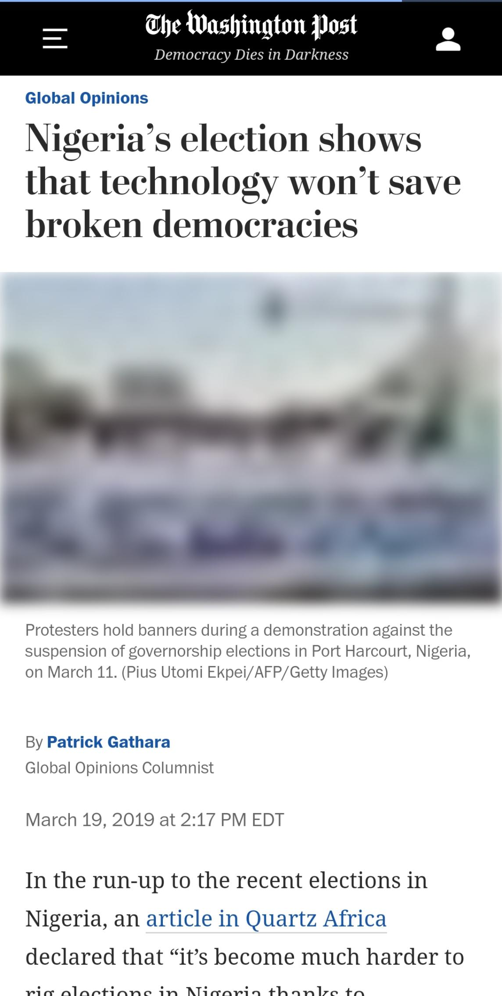
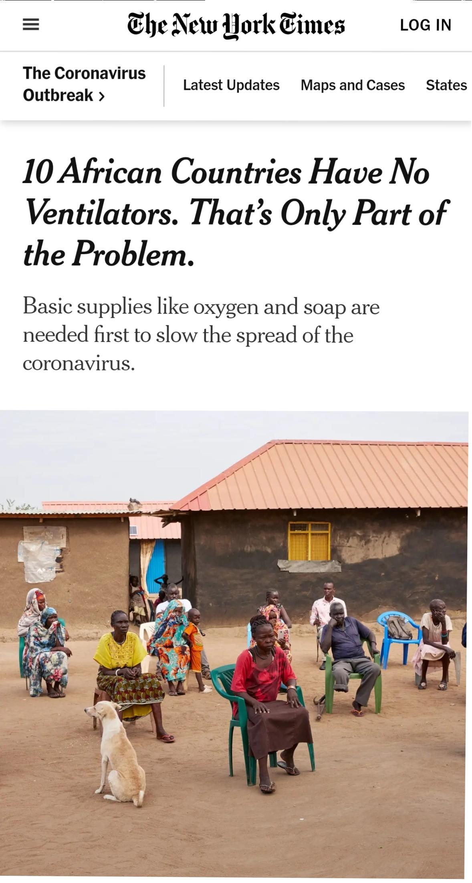

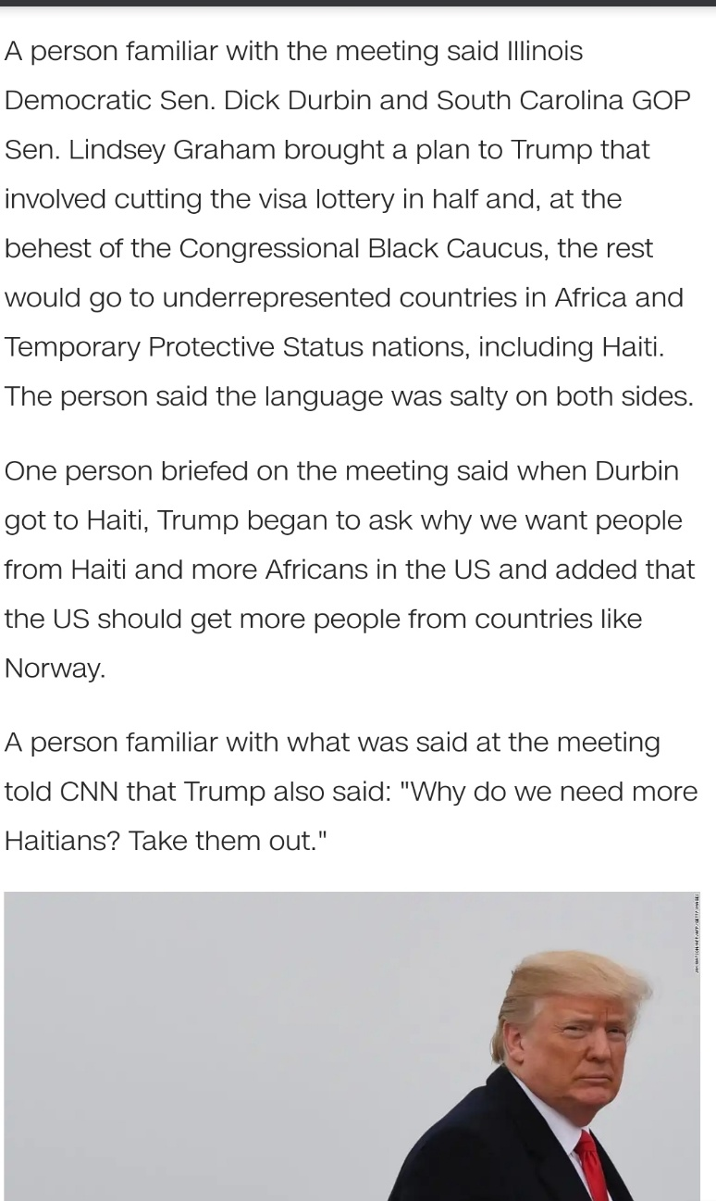
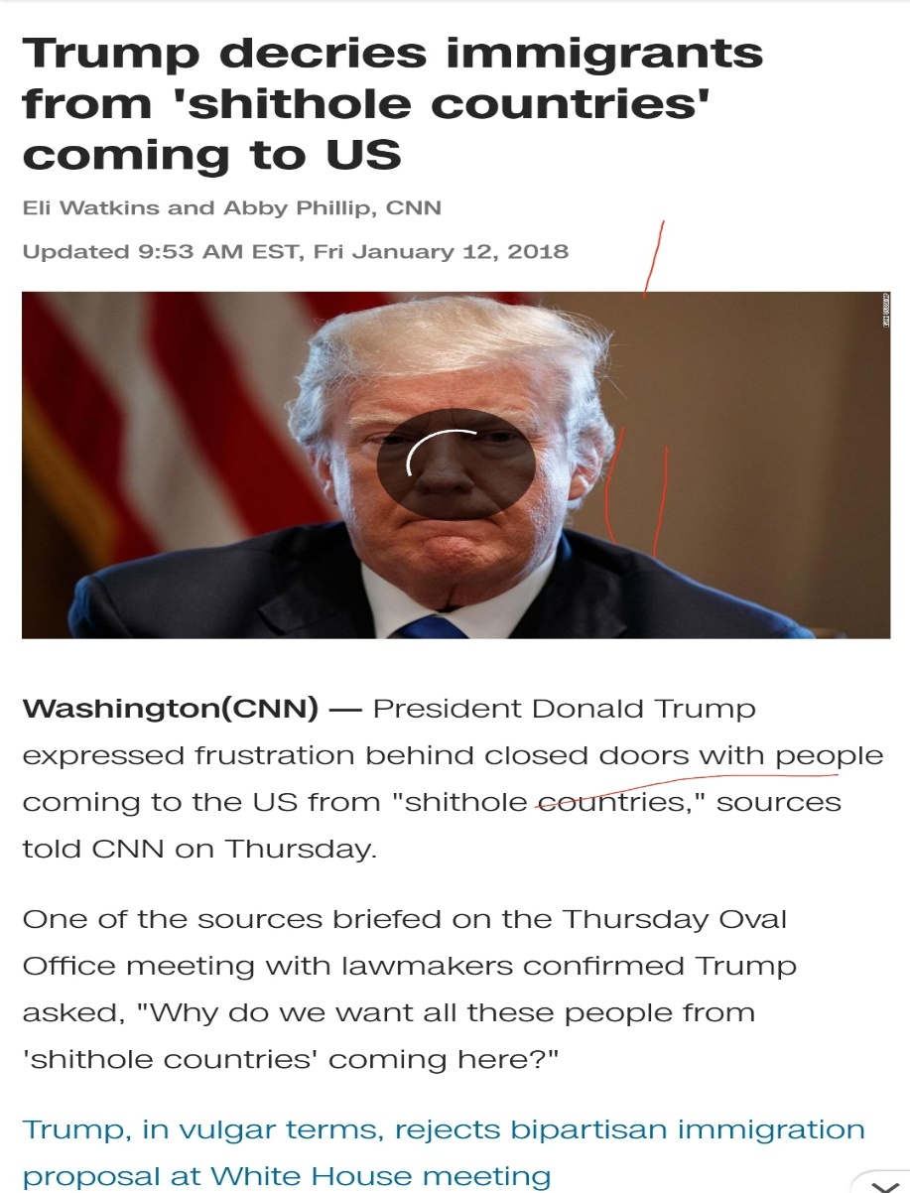
2. What are the challenges a foreign correspondent is likely to face in these times, especially with Corona Virus, Racism and all other Fears in view? Proffer the solutions you think will overcome the challenges you raise.

A foreign correspondent is a journalist who is responsible for reporting news from another country. This may mean covering anything from wars to politics to living conditions and attitudes in this country. "Foreign correspondents do all kinds of work," says Maria Trombly.
Challenges of Foreign correspondence
Foreign correspondence is the reportage and filing of new stories by a Journalist known as a foreign correspondent (who works for a media organization) from a foreign country. A Foreign correspondent is a journalist who sends news reports and commentary from a foreign country for publication or broadcast. His is an agent who contributes reports to a newspaper, radio or television, from a remote, often distant location. The foreign correspondent is stationed in a foreign country. Challenges are the part of every job and journalism is not escaped from it. This profession invites maximum number of challenges and a correspondent has to take them as part of his/her occupation. According to a famous journalist, “the biggest challenge for a today’s journalist is to survive”. Foreign correspondence, even from a layman’s perspective has a lot of challenges especially because the Journalist has to leave his/her own country for another country that he/she is not familiar with. The challenges of foreign correspondence are:
· The cost of operation has risen, not only as a result of economic meltdown but also because of the advent of new technology. The media organizations have to make sure they do not get out of business as a result of citizen Journalism, which has come to stay. The economic situation all over the world has made many countries call back their foreign correspondent and close down news bureaus. The advent of new media technology has even made it easier for the extent of foreign correspondence. These new technologies, made it possible that correspondents are not sent abroad, before news information are gotten from reliable sources. Reporters can now sit in the comfort of the newsroom, access the internet and gather necessary information. The technological progress over the past years has enabled large parts of the general public to access and afford new ways of interaction and communication via the internet’s new intelligent web services and fast broadband connections. Personal digital assistance (PDA); in form of Androids, Smartphone, Tablets, etc. is also not encouraging media houses and agencies to send foreign correspondents on assignments. This is because individuals are now becoming citizen journalists, providing user generated content and relegating to the ground the function of the foreign correspondent. A media organization or agency, that is not buoyant financially, might find it difficult to send foreign correspondents on assignment because money is needed for transportation, accommodation, feeding and other things that will keep the foreign correspondent going.
· The problem of language barrier, which is very common but can be avoided. Being a foreign correspondent means you report happenings in countries outside your country. The language in this foreign country is most definitely different from what is spoken in your own country; this may pose as a challenge to the foreign correspondence. This is why foreign correspondents need to possess a bilingual skill. The foreign correspondent should at least have a working knowledge of the language of the country of assignment. Foreign correspondence should learn international languages that will give him/her edge during an assignment and also make it easy to interact with people in the country of assignment. Languages can be learn in school or prior to an assignment while on the job.
· Wars, disputes and ripple are major challenges faced by foreign correspondents and why many upcoming communication students avoid foreign journalism and journalism as a whole. Countries are made up of people with different perspectives and ideologies on issues. These differences when not well managed results to dispute and if not still curbed, may result to wars. During situations like these, foreign correspondents and reporters in general are injured, maimed or killed. Correspondence have to take protective measures while reporting wars because, it might entail reporting from the war front.
Foreign correspondents often have to visit places which are badly struck by natural calamities like floods, heavy snowfall, volcanoes, etc,. In order to keep the authorities alert,of the affected area towards the welfare and rescue mission of the people, foreign correspondents have to visit the worst hit areas as well. This could also pose a serious threat to their lives as well. In some unfortunate accidents, foreign correspondents have suffered injuries while covering stories in dangerous places.
Foreign correspondence is also followed by assignments, like covering a war zone, communal riots, and infiltrations in borders, civil wars and much more perilous coverage. The spread of insecurity in a country not only threatens the lives the people of that place, but foreign correspondents also become their targets. Many terrorist organizations do not hesitate to kill them; they accuse journalists for supporting the government authorities and security forces. Sometimes these consequences can turn fatal.
Foreign correspondence are also held hostage and detained during conflicts between the countries. It is really traumatic and sometimes situations can become extremely dangerous for the captured media professional/s.
· The foreign correspondent is also faced with cultural challenges. The foreign correspondent if not conversant with the culture of his place of assignment will have problems. The culture of the place of assignment of the foreign correspondent is usually different from that of his/her country. The correspondent has to learn the culture of the people; the dress sense, what they eat, different seasons in the country, courtesy among the people, their way of live, the laws of the land (dos and don’ts) and the language and it’s usage. To know all these, the correspondence must read extensively. Foreign correspondents at times find it difficult to eat some types of food in their place of assignment; at times they break some rules not knowing they are breaking them. The correspondence also has to take note of the seasons so as to bring the appropriate clothing. For example if a reporter is sent from Nigeria and assumes the weather of Nigeria is similar to that of New York’s, he will probably have to freeze and develop cold. Some things that are accepted one country may not be accepted in other countries, things might be much more different in the place of assignment of the correspondent. This is why it is important to study the culture of the host country. A foreign correspondent must have a knowledge and appreciation of the history of the region concerned. So much news today evolves from events, decisions or incidents from years back and which puts things in context. You must be conversant with history to be able to analyze events with real authority and thus boost your credibility as someone who knows what he/she is talking about. It is certainly the case for print reporters, who are expected also to write lengthy analytical pieces and features about developments and what they all mean.
· Political instability is another problem faced by a foreign correspondent. When there is political instability in a country, a correspondent will not be able to carry out his assignment effectively. He might even be sent back to his country. A foreign correspondent might not be able to carry out in his country of assignment when there is political upheaval.
Many western countries have “freedom of the press” but not all the countries give this right to their media professionals. In many countries media does not have freedom to speech and journalists (foreign correspondent) have to adhere with the set norms before writing or publishing a story, else they have to face dire consequences. This is called self-censorship. The foreign correspondent is often oppressed by the governments of his place of assignment. The foreign correspondent in some countries is not supposed to show any videos which could malign the government for violating human rights and taking innocent lives and creating havoc. The foreign correspondent also has some roles to play. He has to have a thorough knowledge of various political philosophy operation in his place of assignment i.e. should know the difference between capitalism which is operated in U.S and western Europe and communism a variance of socialism still practiced in China, Cuba of North Korea. He should have the knowledge of authoritarianism, fascism and totalitarianism, which are almost stale. The knowledge of these philosophies will help the correspondent know what step to take in case of any situation. He should have a wide knowledge of the constitution of his country of assignment. The constitution is the primary law upon which a country is governed. This will also save him the trouble of asking too many questions about the political parties because the constitution gives the reporter access to the conduct of political parties in his country of assignment.
· The foreign correspondence should have knowledge of the economy of his country of assignment. At times foreign correspondence makes the mistake of reporting wrong figures. He should be familiar with economic terms like inflation, and its effect on the economy, the lives of the citizens and the causes of the inflation, demand, supply, deficit, budget and deflation. To do this the correspondent has to maintain contact with experts on the field. He should be able to interpret data, charts and graphs.
· Another challenge of foreign correspondence is that the correspondence will require additional training to master other skills. The Job of a foreign correspondent requires him to have other skills aside reporting. The old days when a Television foreign correspondent was nothing more than a reporter who telexed, faxed or later emailed his/her copy once or twice a day and did nothing else, leaving the cameraman to handle the pictures, are over. Today's foreign correspondent is on duty 24 hours a day and has to be versatile with technology and in some cases do everything. However, despite all intense challenges in foreign correspondence some foreign correspondent are determined to do their jobs with full dedications and nothing could deter them.

