NAME: FAGBUYI AKINTOMIWA
DEPARTMENT: CIVIL ENGINEERING
MATRIC NO.:19/ENG03/009
COURSE CODE: CHM 102
CARBOXYLIC ACID

    - HCOOH – Methanoic Acid
    - HOOCCH₂CH₂CH₂COOH – Pentan-1,5,dioic acid
    - CH₃CH₂CH₂COOH – Bentanoic acid
    - HO₂C-CO₂H – Ethanedioic acid
    - CH3(CH₂)₄COOH – Hexanoic acid
    - CH₃CH=CHCH₂CH₂COOH – Hex-4-enoic acid

    - PHYSICAL APPEARANCE: All aliphatic carboxylic acids from C₁ to C₁₀ are liquids at room temperature. While other carboxylic acids are solid at room temperature although anhydrous carboxylic acid freezes to an ice like solid below the room temperature.
    - BOILING POINT: The boiling point of the carboxylic acid increases with increasingly relative molecular mass. Aromatic carboxylic acids are crystalline solids and have higher melting points than their aliphatic counterparts of comparable relative molecular mass.
    - SOLUBILITY: Lower molecular mass Carboxylic acids that has up to four carbon atoms in their molecules are soluble in water, this largely due to their ability to form hydrogen bonds with water molecules.

    - FROM ETHANAL: Ethanoic acid is obtained commercially by the liquid phase air-oxidation of 5% solution of ethanol to ethanoic acid using Manganite (II) Ethanoate catalyst.
    - FROM CARBON (II) OXIDE: Methanoic acid (formic acid) is produced by adding Carbon (II) Oxide under pressure to hot aqueous solution of sodium hydroxide. The free carboxylic acid is liberated by careful reaction with Tetraoxosulphate(VI)Acid (H₂SO₄).

    - OXIDTION OF PRIMARY ALCOHOLS: It can be used to prepare Carboxylic acids using the usual oxididzing agents (i.e KMnO₄ or K₂Cr₂O₇) in acidic solution.
[O], excess acid/ KMnO₄ [O]
RCH₂OH RCHO RCOOH
    - CARBONATION OF GIGNARD REAGENT: Aliphatic Carboxylic acids are obtained by bubbling Carbon (IV) Oxide into the Grignard reagent and then hydrolyzed with dilute acid.
(C₂H₃)₂O H₂O/dil.
Acid
RMgBr + CO₂ RCOOMgBr RCOOH + MgBrOH

    - REDUCTION OF CARBOXYLIC ACID TO PRIMARY ALCOHOL: Carboxylic acids are difficult to reduce by catalytic hydrogenation or dissolving metals but Lithium Tetrahydridoaluminate (III) and diborance form intermediate compounds with the acids which liberate the alcohol on hydrolysis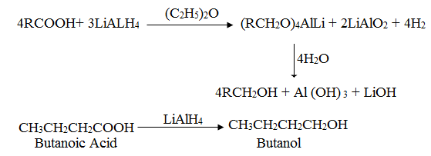
    - DECARBOXYLATION: This involves removal of the carboxyl group from the acid to give a hydrocarbon or its derivative.
- THERMAL DECARBOXYLATION: Carboxylic acids with a strong electron attracting group e.g. –COOH,-CN,NO₂, C=O, decarboxylate readily on heating to 100-150ºC while others decarboxylate when their salts are heated with soda lime.
fuse
CH₃CH₂CH₂COONa + NaOH CH₃CH₂CH₃+Na₂CO₃
    - ESTERIFICATION OF CARBOXYLIC ACID: in the presence of strong acid catalyst, carboxylic acids react with alcohols to form esters.

CH₃CH₂CH₂COOH + CH₃CH₂CH₂OH CH₃CH₂CH₂COOCH₂CH₂CH₃ + H₂O
H⁺

