GEY 402 ASSIGNMENT
BY

OGBONNA BENITA CHINYERE
16/SCI14/009

SUBMITTED TO THE DEPARTMENT OF GEOLOGY, AFE BABALOLA UNIVERSITY

JUNE 2020

1. MORPHOLOGICAL CLASSIFICATION OF POLLENS AND SPORES
BRIEF INTRODUCTION
SPORES are reproductive haploid structures that is adapted for dispersal and surviving for extended periods of time in unfavorable conditions. Spores form part of the lifecycles of many plants, algae, fungi and some protozoans. A chief difference between spores and seeds as dispersal units is that spores have very little stored food resources compared with seeds. Spores are usually haploid and unicellular and are produced by meiosis in the sporophyte. Once conditions are favorable. The spore can develop into a new organism using miotic division, producing a multicellular gametophyte, which eventually goes on to produce gametes.
POLLENS are produced from the microspore mother cells, but female spores are produced by megaspore mother cells. Pollen grains have two outer coats extine and intine and female spores do not have the extine or intine. Pollens are dispersed by various mechanisms, but female spores are retained within the ovary. Pollens are found inside the pollen sac, and female spores are found inside the ovule. In other words, all pollens are spores, but not all spores are pollens.

CLASSIFICATION
The fact that spores and pollen are normally retrieved from their host sediments as disjunct entities, separate from the original parent plant means that their natural affinities are often obscure. The free sporing plants including the Bryophyta e.g. mosses and liverworts, and the Pteridophytes which, although not a natural classification, encompasses all the seedless vascular plants, including the paleontologically important ferns and fern allies, are primarily classified using the gross morphology, wall structure and the type of wall sculpture, if present. The important feature of homospory in terms of the fossil record is the four-fold division involved in spore production, this takes the form of either a tetrahedra which gives a trilete spore or a tetragon which gives a monolete spore. The trilete and monolete marks imparted on the individual spores are the marks where each of the spore tetrad once abutted each other.
Classification of pollen, like that of spores is based on the morphological trends observed among various groups of fossils which may be primarily but not entirely reflections of evolution within the groups of plants which produced the pollen. It should also be remembered that higher plants have characteristics of reproduction which permit them to utilize modes of evolution unavailable to animals. Because of their relatively simple genetic systems plants may utilize hybridization and self-fertilization. The early gymnosperms produce prepollen, differentiated from true pollen by germination from the proximal rather than the distal side. Recent gymnosperms may produce very distinctive saccate pollen, i.e. pollen with one, two or rarely three air sacs attached to a central body (colpus) or monosulcate pollen as in the cycads and ginkgos. The angiosperms produce pollen with the greatest morphological variation, but typically with either a tricolpate or monosulcate form.
NPC CLASSIFICATION
- NPC is an artificial system of classification of pollen and spore based on the three features of aperture only. i.e. number, position, and character.
- Erdtman and Straka (1961) proposed NPC classification and palynologists all over the world accepted it.
- According to NPC system each pollen grain has an arithmetic cardinal number consisting of three digits.
- The first digit reveals the absence or presence of aperture, and when present it mentions the total number of aperture(s) present in a pollen grain.
- The second digit illustrates the position of apertures(s), i.e. distal, proximal, and latitudinal, meridional, equatorial etc.
- The microspores reveal the position of aperture(s) with full clarity when they are in tetrad.
- The third digit explains the character of an aperture, i.e. circular/oval or elongated, simple or compound etc. ‘N’ from number, ‘P’ from position and ‘C’ from character of aperture compose the NPC classification.
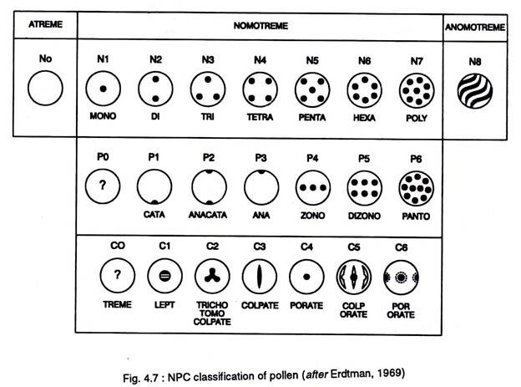
NPC classification of pollens and spores
CLASSIFICATION OF APERTURE BASED ON NUMBER
- In NPC system ‘N’ denotes the number of aperture(s) present in a pollen grain.
- The pollen number (N) groups are of nine types. The grain without aperture is named “Atreme” and is designated as No. Depending upon the number of apertures.
- The types of pollen are Monotreme (N1) with one aperture, Ditreme (N2) with two apertures; Tritreme (N3) with three apertures, Tetratreme (N4) with four apertures, Pentatreme (N5) with five apertures, Hexatreme (N6) with six apertures and Polytreme (N7) having more than six apertures. Irregularly arranged spiral apertures over the surface of the pollen irrespective of their number are designated as ‘Anomotreme’ (N8).
- There are pollen grains where apertures are absent.
- Such pollen grains are termed as inaperturate or Atreme and they are placed in N0 group.
CLASSIFICATION OF APERTURE BASED ON POSITION
- In NPC system ‘P’ denotes the position of aperture in a pollen grain and spore.
- The position may be proximal, distal, and equatorial.
- On the basis of the position (P) of apertures, pollen is categorized into seven groups (P0 to P6).
- In ‘Catatreme’ (P1) pollen aperture is in proximal face, while in ‘Anatreme’ (P3) it is in distal face.
- The pollen is designated as Anacatatreme’ (P2) where apertures are both in proximal and distal faces.
- One aperture with its center occurs at the proximal pole. The other aperture with its center occurs on the distal pole.
- The distal part is the face of a pollen grain and spore that faces outward, i.e. away from the center of tetrad and opposite the proximal part.
- The pollen grains are referred to as ‘Zonotreme’ (P4), when the apertures are located on the equatorial zone.
- The equator is the part of a pollen grain or spore that runs midway between the proximal and distal poles and perpendicular to polar axis.
- ‘Dizonotreme’ (P5) are like Zonotreme, but with two rows of apertures on the equatorial region.
- The apertures occur parallel to equator.
- In ‘Pantotreme’ (P6), apertures are globally distributed all over the pollen surface. As a rule, Pantotreme pollen grains are spheroidal.
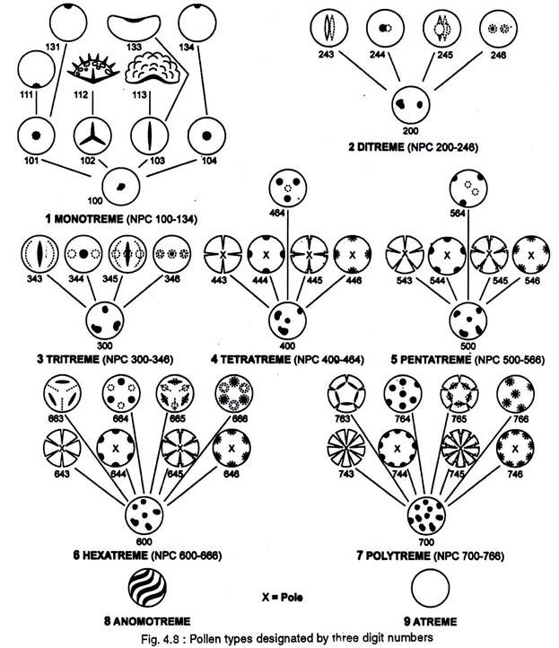

CLASSIFICATION OF APERTURES BASED ON CHARACTER
- In NPC system ‘C’ denotes the character of an aperture in a pollen grain and spore.
- The character groups of pollen and spore are seven and they are mentioned as C0 to C6.
- C0 groups have apertures whose character cannot be established with certainty.
- C1 groups of pollen and spore have leptoma (Greek leptoma means thin place).
- Leptoma is a thin area, aperture like and functions like an aperture.
- Pollen grains having one leptoma are termed as monlept.
- The leptoma may occur on either proximal or distal face of a pollen grain and spore and accordingly termed as catalept and analept.
- C2 groups are Trichotomocolpate (Gr. Tricha, in three parts; tome, cut; kolpos, depression, furrow).
- Trichotomocolpate is a three branched aperture, the branches of which are more than two times longer than breadth.
- Trichotomocolpate pollen and spores having aperture on proximal face are termed as Trilete.
- The group C3 has colpate grains.
- The group C4 comprises porate pollen grains.
- The group C5 comprises colporate pollen.
- The group C6 comprises pororate pollen.
Based on NPC classification, each pollen type is designated by using a three-digit number. The first digit denotes the number of apertures, for example, 100 is assigned to monotreme, 200 to Ditreme, 300 for Tritreme, 400 for Tetratreme, 500 for Pentatreme, 600 for Hexatreme, 700 for Polytreme, and 8 for Anomotreme and 9 for Atreme.
The second digit denotes the position of the aperture, e.g. 010 to proximal aperture, 030 for distal aperture, 040 for equatorial aperture, 060 for global aperture. The third digit denotes the characters of the aperture, e.g., 002 for trilete, 003 for colpate, 004 for porate, 005 for colporate. Therefore, the number 112 is assigned to trilete grains, similarly 133 to monosulcate grains, 343 to tricolpate and 345 to tricolporate grains, etc.

2. STRATIGRAPHICAL AND PALEOENVIRONMENTAL APPLICATIONS AND SIGNIFICANCE OF POLLENS AND SPORES IN SEDIMENTARY AND PETROLEUM GEOLOGY
Most pollen grains consist of three distinct parts. The central cytoplasmic part is the source of nuclei responsible for fertilization. The other parts constituting the wall of the grain are an inner layer, the intine, and an outer layer, the exine. The intine consists, at least in part, of cellulose or hemicellulose. The outer and most durable layer, the exine, is very resistant to disintegration; treatment with intense heat, strong acids, or strong bases has little effect upon it. The constituents of the exine have been termed sporopollenins. The internal parts of the pollen grain are easily broken down, whereas the exine layer, and thus the general form of the pollen grain, is easily preserved in various kinds of sediments; the quality of preservation may vary with different environments.
Because of their high resistance to decay, their widespread dispersal by wind and water, and their abundant production by plants, pollen grains are very commonss constituents of geologic sediments, both recent and ancient. Because of these features, pollen grains have provided much information on the origin and geologic history of terrestrial plant life. Additionally, given their remarkably symmetrical structure and surface patterns, fresh and preserved pollen grains are readily recognizable under the microscope. Characteristics such as the exine sculpturing and the size and number of apertures through which the pollen tubes grow are useful as taxonomic tools. The structure of a pollen grain is oftentimes so distinctive that in some cases species may be identified by pollen grains alone. Nearly all angiosperm and gymnosperm plant families and many genera can be identified solely by their pollen grains. The study of pollen and spores is known as palynology.
SIGNIFICANCE OF POLLENS AND SPORES IN PETROLEUM GEOLOGY
Pollens and spores in the oil industry is a stratigraphic tool especially useful in the study of rocks deposited in continental, coastal, and shallow-marine settings.
Pollen and spore analyses are used mainly for chronostratigraphic correlations, paleoenvironmental studies, and the evaluation of potential source rocks. The integration of palynology with other geoscience disciplines, such as sedimentology, geophysics, geochemistry, and Petro physics, is needed for geological modeling and petroleum system studies, which in turn are essential for planning and developing better exploration strategies and for optimizing reservoir exploitation. This also will enhance detection of hydrocarbon accumulation in subtle traps and permit better prediction of the lateral variability in quality of reservoir rock than is achievable only with the classical litho-seismic stratigraphic approach, thereby leading to increased oil reserves.
The study of fossil flora record of sedimentary rocks has diverse range of applications in geology including biostratigraphy, geochronology (to correlate strata and determine the relative age of a bed, horizon, formation or stratigraphic sequence), paleoecology and climate change, organic palynofacies studies, geothermal alteration studies (to examine the color of palynomorphs extracted from rocks to give the thermal alteration and maturation of sedimentary sequences). This is especially true because the floristic component of layered rocks occurs in high abundance permitting the use of only little amount of sample and statistical analysis.
APPLICATION OF POLLENS AND SOPORES IN STRATIGRAPHY AND STRATIGRAPHY
Pollens and spores offer a plethora of applications in the study of the evolution of life, relative dating (biostratigraphy), paleobiology, paleoenvironment, paleogeography, paleoclimatology, and geological resources (hydrocarbon production). Because acid dissolution of a rock or sediment sample is a chemically selective process, the resulting organic residue is usually composed of a broad variety of material of plant and animal origin within the same sample. It is not uncommon to recover marine palynomorphs from terrestrial settings by erosion and redeposition of older marine rocks, and terrestrial palynomorphs can be transported by air and water into nearshore marine settings.
Pollen and spores represent the most important group of microfossils in terrestrial settings. Beside scolecodonts, they differ from any other palynomorph group as they do not represent individual organisms, but rather reproductive structures produced during the life cycle of plants. Spores (Playford and Dettemann, 1996) are produced by cryptogams (the so-called lower plants), which include bryophytes (mosses, liverworts, and hornworts) and pteridophytic vascular plants (ferns, lycopsids, and Methods in Paleopalynology and Palynostratigraphy 131 horsetails).

Pollen (Jarzen and Nichols, 1996), on the other hand, is produced by seed plants, the
gymnosperms (conifers and older relatives) and angiosperms (flowering plants). Because terrestrial plants are affixed to their substratum, their reproduction and dispersion relies on the propagation of pollen and spores, which are produced in vast numbers and released into the environment, traveling widely and rapidly in wind and/or water, and eventually settling on the surface of the land and on water bodies, including places where preservation is most likely, such as at the bottom of ponds, lakes, rivers, and oceans. The fact that they are very resistant, microscopic, produced in large numbers, and disseminated over large areas makes them an ideal biostratigraphic group. The outer wall of pollen and spores (the exine), is made of sporopollenin, one of the most resistant and chemically inert biopolymers. Whereas pollen and spores are mostly produced by land plants (embryophytes), it is not uncommon to recover them from nearshore marine deposits where they may be transported by river systems into estuaries and coastal lagoons. The broad range of dispersal of pollen and spores make terrestrial to marine correlation possible, and is one of their most valuable biostratigraphic functions.

Pollen and spores are also useful paleoecological and paleoenvironmental markers when they can be linked to a parent plant, and when the ecology of that parent plant is known.
pollen and spores are referred to using the term miospores, sporomorphs, or sometimes sporopollen in the Chinese literature. Spores appear very early in the fossil record, associated with the colonization of land by the first terrestrial plants. The oldest known forms of spore like bodies are called crypto spores, from the Middle Cambrian (500 million years old, Strother, 2016). The first trilete spores appear in the late Ordovician.
Whereas palynological evidence is the oldest indication for the existence of true land plants, the first fossils of macroscopic land plants, the Cooksoniales, is recorded later during the Middle Silurian (!425 million years,). The temporal disconnects or delay between the first appearance of a plant group in the palynological record and its later appearance as macrofossils is a recurrent observation in the rock record. This delay can be simply explained by a taphonomical bias, as pollen and spores offer a better preservation potential than the presumably small and delicate parent plants. Although some crypto spores resemble the spores of modern bryophytes (Gray, 1985; Richardson, 1992; Renzaglia et al., 2015), their botanical affinity is still highly debated. Nonetheless, they remain of great use for biostratigraphy and correlation of early Paleozoic terrestrial and nearshore marine deposits (Richardson, 1996; Streel and Loboziak, 1996; Loboziak et al., 2004). Just as paleontologists have subdivided the Phanerozoic into three major eras, the Paleozoic, Mesozoic, and Cenozoic, each representative of revolutions in faunal assemblages, introducing the next revolution initiated by the emergence of the gymnosperms (conifers, cycadophytes, pteridospermaphytes, Caytoniales, etc.) and their associated corte`ge of pollen grains during the late Carboniferous (Clayton, 1996; Owens, 1996;). One of the notable characteristics of the late Paleozoic floras is the appearance of taeniate (¼ striated) pollen near the end of the Carboniferous, which persists up to the end of the Triassic (Warrington, 1996a,b; Playford and Dino, 2004). The last floral revolution is marked by the first significant appearance of angiosperms (flowering plants) in the early Cretaceous and a rapid diversification from the mid-Cretaceous (Batten and Koppelhus, 1996; Batten, 1996a; Frederiksen, 1996;).
Pollen and spores are retrieved from and isolated in sediments, disconnected from their parent plants, meaning that their natural affinities are often obscure. The principle of anatomical connection (e.g., extracting pollen from a fossilized cone or flower), or the use of modern analogues (comparison with extant plants), can help to elucidate the botanical relationship of specific pollen and spores taxa. As is common in paleobotany, where organs are preserved individually and disconnected rather than in the form of entire organisms, a paranomenclatural system based on form taxa has been developed, similar to the way that vertebrate paleontology has its own naming conventions for ichnotaxa and ootaxa. Potoni!e developed an informal, artificial classification of spores and pollen based on morphological traits, called the turmal system. The problem of identifying parent plants has led to major differences in methods employed for Quaternary (palynology) and pre-Neogene (paleopalynology). In the former, almost all taxa recorded are from extant species, whereas Methods in Paleopalynology and Palynostratigraphy 133 in the latter, the taxa are almost invariably extinct. Thus palynologists use natural genera and species whereas paleopalynologists use form taxa, and many use the turmal system, especially for Paleozoic and Mesozoic taxa. In a similar way, palynologists use a very different approach to palynostratigraphy. Quaternary dating and correlation strongly rely on relative abundance counts (formally called pollen analysis, and represented in a pollen diagram) and the recognition of changing climate indicated by shifts in marker species, whereas studies in deep time traditionally rely on the description of the first and last occurrence of taxa (originations and extinctions) in the stratigraphic record (albeit the benefit of using relative abundance counts is being acknowledged.

