NWOSU NYIMENKA ISAAC
18/MHS02/121
PHYSIOLOGY
ASTIGMATISM : Astigmatism is a common vision problem caused by an error in the shape of the cornea. With astigmatism, the lens of the eye or the cornea which is the front surface of the eye, has an irregular curve. This can change the way light passes, or refracts, to your retina. This causes blurry, fuzzy or distorted vision. Farsightedness and nearsightedness are the two other types of problems with the way light to the retina. Farsightedness is called hyperopia while Nearsightedness is called myopia.
The two main types of astigmatism are corneal and lenticular. A corneal astigmatism happens when the cornea is misshapen. A lenticular astigmatism happens when the lens is misshapen.
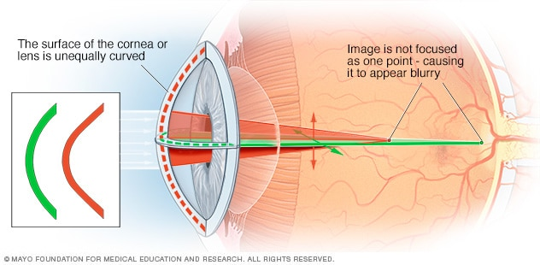
CAUSES;
It is not known what causes astigmatism, but genetics is a big factor. Its often present at birth, but it may develop later in life. It may also occur as a result of an injury to the eye or after surgery. Astigmatism occurs when the cornea or lens is curved more in one direction, either horizontally, vertically or diagonally.
Astigmatism may occur in children or adults. The risk of developing astigmatism may be higher if you have some of the following :
. A family history of astigmatism or the other eye disorders such as keratoconus (degeneration of the cornea)
. Scarring and thinning of your cornea
. Excessive farsightedness, which creates blurry vision at a distance.
SYMPTOMS
. Difficulty seeing at night
. Eyestrain or discomfort
. Squinting
. Eye irritation
. Headaches
. Blurred or distorted vision
HOW TO CORRECT ASTIGMATISM:
Options to correct astigmatism usually can be corrected with eyeglasses, contact lenses or refractive surgery.
Refractive surgery is one of the less common astigmatism treatment options, however , since it is a laser procedure that changes the shape of your eyes, it comes with risks associated with most laser surgeries
PRESBYOPIA
Presbyopia is a condition associated with the aging of the eye that results in progressively worsening ability to focus clearly on close objects. It is a normal part of the aging process, it occurs due to hardening of the lens of the eye, causing the eye to focus on the light behind rather than on the retina when looking at close objects . it is a type of refractive error along with nearsightedness, farsightedness and astigmatism.
Diagnosis is by an eye examination.
Treatment is typically with eye glasses. The eye glasses used have higher focusing power in the lower portion of the lens. Off the shelf reading glasses may be sufficient for some. Contact lenses may be occasionally used
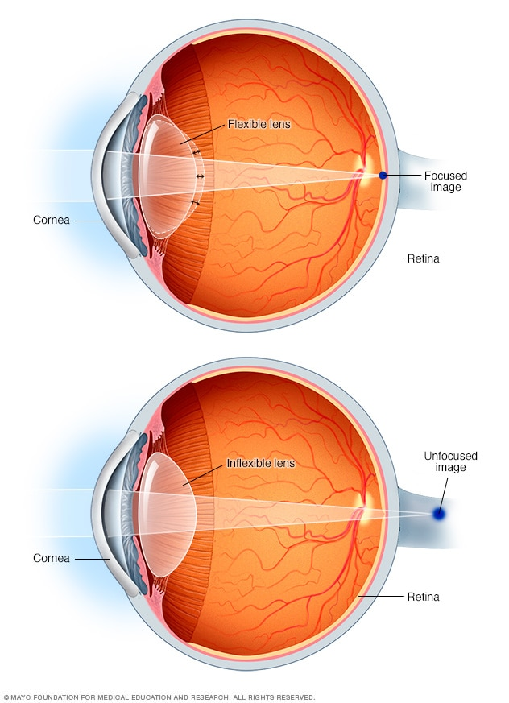
CAUSES;
It is caused by the hardening of the lens of your eye. As the lens becomes less flexible, it can no longer change shape to focus on close up images. As a result, these images appear out of focus.
SIGNS AND SYMPTOMS;
The most common symptoms of presbyopia occur around age 40 for most people. The symptoms typically involve the gradual deterioration in your ability to read or work up close.
. Difficulty reading fine prints, particularly in low light conditions
. Blurred vision at normal reading distance
. Headaches or fatigue
. Eyestrain
. Needing brighter light when reading or doing close work
. Squinting
RISK FACTORS
. Age
. Other medical conditions
. Drugs

