Name: James Vivian Chidera
Matric no: 18/MHS02/096
Department: Nursing science
Course title: Physiology
1. Write short notes on any two-eye defect.
An eye defect is the partial or total loss of sight without pathology of the eye caused by disease of optic nerve or retina or brain.
There are various types of eye defects, which includes
1. Myopia or NEARSIGHTED
2. Hyperopia or FARE-SIGHTED
3. Astigmatism
4. Presbyopia
1. Myopia or NEARSIGHTED
It is a condition in which close objects appear clearly, but far ones don’t.
Myopia is the most common cause of impaired vision in people under 40.. people with myopia experiences difficulty in reading high way signs.
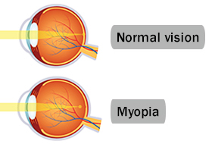
Short sight occurs when light coming from distant objects is 'overfocused', so that the point of focus is in front of the retina. It occurs because either the eyeball is too long, or because the cornea is too curved. Despite maximum flattening of the lens, the eye is not able to focus the light rays further back and on to the retina.
Light coming from near objects requires a stronger focusing activity anyway, so in myopia light from near objects is more likely to be focused in the right place.
People with short sight are not able to see distant objects clearly. Short sight or near sight mean exactly what the terms suggest. You are sighted (you can see), near (short) distance objects. Near objects (for example, when reading a book) can often be seen well. This is because when looking at near objects, the light rays come into the eye going slightly outwards. These will focus further back in the eye than light rays that come in straight from distant objects.
Types of myopia includes:
1. High myopia
2. Degenerative myopia
High myopia: It’s a more serious form of the condition, where the eyeball grows more than it is supposed to and becomes very long front to back. Besides making it hard to see things at a distance, it can also raise your chance of having other conditions like a detached retina, cataracts, and glaucoma.
Degenerative myopia: Also called pathological or malignant myopia, it is a rare type you usually inherit from your parents. Your eyeball gets longer very quickly and causes severe myopia, usually by the teenage or early adult years. This type of myopia can get worse far into adulthood. Besides making it hard to see things at a distance, you may have a higher chance of having a detached retina, abnormal blood vessel growth in the eye (choroid neovascularization), and glaucoma.
Symptoms of myopia
People usually first notice myopia in their teenage years, when they may experience headaches and it becomes apparent that other people can see distant objects better than they do. This may come as a shock to a young person who has forgotten that they used to see more clearly as a child. Such a teenager may be amazed at the clarity of the world after they get their first lens prescription – often they were unaware that the human eye is capable of functioning that well. Other clues that a person may be developing nearsightedness include the need to squint to see clearly, frequent blinking and eye rubbing. A person who is nearsighted may also hold books close to read.
Myopia almost never worsens rapidly. Some diseases, like diabetes, can make nearsightedness develop faster, but underlying diseases more commonly cause trouble at the back of the eye. This makes it hard for an adult to notice if their prescription needs changing. The only way to be sure is to get regular eye tests.
Myopia can lead to poor performance at school. If a student's grades start dropping off around age 10 or 12, there's a chance eyesight is involved, although certainly plenty of other factors can cause 12-year-olds to have problems at school.
Among adults, severe myopia can cause disability, primarily by preventing driving. This can usually be corrected.
A person may also notice:
- Headaches
- Squinting
- Eye strain
- Eye fatigue when you try to see objects more than a few feet away
- Children with myopia often have trouble reading the blackboard at school.

Treatment and Prevention
There are three possible treatments for myopia: glasses, contact lenses, and eye surgery. For less severe myopia, corrective glasses or contact lenses may only need to be used for certain activities, such as driving. Glasses can correct all vision errors, including hyperopia (farsightedness), myopia, and astigmatism. Bifocal lenses are particularly useful for older people with poor vision at long range and very close range. Looking through the upper lens helps long-range vision, while looking through the lower helps close-range vision.
Contact lenses can also correct these problems. Compared to glasses, these offer a larger field of corrected vision. Lenses with high correction factors (i.e., those made to correct very poor vision) are liable to be thicker and heavier than lenses that correct for less severe cases of myopia, and some people find them uncomfortable. This is particularly true of lenses that correct for astigmatism. Soft lenses are taking the place of hard and gas-permeable versions, as they're more comfortable and easier to adjust to, though they may be harder to clean. Disposable contact lenses, which can be worn and then thrown away, are also a popular option. Wearing lenses makes people somewhat more prone to eye infection. This risk can be minimized by cleaning them according to instructions, throwing away disposables on time, and never sleeping with the lenses in.
Eye surgery can also correct these problems. Eye surgery can improve a person’s vision so much that he or she may no longer need to wear glasses or contacts. The most common procedures for myopia are:
- Photo refractive keratectomy: Also called PRK, this surgery uses a laser to sculpt the middle layer of your cornea. That flattens the cornea’s curve and lets light rays focus closer to or on your retina.
- LASIK : This is the most common surgery for myopia. The surgeon uses a laser or another tool to create a thin flap on the top layer of your cornea. He sculpts the cornea with another laser and moves the flap back into place.
2. Hyperopia or FARE-SIGHTED
It is a vision condition in which nearby objects are blurry. It is a common vision condition in adults.
Hyperopia, or farsightedness, is a common vision problem, affecting about a fourth of the population. People with hyperopia can see distant objects very well, but have difficulty focusing on objects that are up close. The condition is sometimes referred to as "hypermetropia" rather than hyperopia.

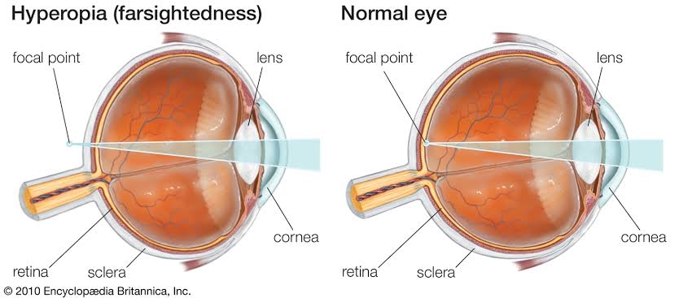
As hyperopia results from the visual image being focused behind the retina, it has two main causes:
- Low converging power of eye lens because of weak action of ciliary muscles
- Abnormal shape of the cornea
Far-sightedness is often present from birth, but children have a very flexible eye lens, which helps to compensate. In rare instances hyperopia can be due to diabetes, and problems with the blood vessels in the retina.

The eyes focus on light rays and send the image of what you’re looking at to your brain. When you’re farsighted, the light rays don’t focus the way they should.
The cornea, the clear outer layer of your eye, and the lens focus images directly on the surface of your retina, which lines the back of your eye. If your eye is too short, or the power to focus is too weak, the image will go to the wrong place, behind your retina. That’s what makes things look blurry.
Types of hyperopia
There are three types of hyperopia: congenital hypermetropia, simple hypermetropia and acquired hypermetropia.
- In congenital hypermetropia one eye is abnormally small. This type of hypermetropia is not common.
- Acquired hyperopia
- Simple hyperopia is
- In congenital hypermetropia one eye is abnormally small. This type of hypermetropia is not common.
- Acquired hyperopia is a very common hyperopia. It usually occurs in those cases in which the lens has been removed after a cataract operation. Hypermetropia may also be acquired after an eye injury, eye disorders such as lens misplaced (aphakia)...
- Simple hyperopia is very common. It is a continuation of childhood hyperopia that has not been detected over time. Most children usually have farsightedness when they are born. As the child grows, the length of the eyeball increases and farsightedness often disappears. If the hyperopia persists in the child, it is called simple hyperopia (one eye has not grown enough). Early detection is very important, because if it is not corrected, it can provoke different pathologies such as strabismus.
Symptoms of Hyperopia
- Trouble focusing on nearby objects
- Headaches
- Blurry vision
- Eye strain
- Fatigue or headache after you do a close-up task such as reading
The main symptom is blurred vision of nearby objects. Most patients with hyperopia, however, are usually asymptomatic in their youth, as they are able to compensate for poor near vision through the accommodative ability of the crystalline lens (the eye’s natural lens whose elasticity enables objects to be focused on). The crystalline lens’s elasticity is lost with age.
Constant movement of the eye’s muscles in young patients can cause symptoms that are not directly related to vision, such as headaches and fatigue, pain or redness of the eye.
Gestures such as rubbing the eyes or wrinkling the forehead on a regular basis may be the first signs of hyperopia.
In the case of children, parents should be particularly attentive to certain symptoms, some of which are not usually associated with vision, such as underachievement at school or the inability to adapt.
If hyperopia in children remains untreated it can cause strabismus (deviation of the eyes) or amblyopia (also known as lazy eye).
Treatments
Hyperopia can easily be corrected by wearing glasses with converging lenses or contact lenses.
Even if the degree of hyperopia is small, correction is still advisable to prevent secondary problems such as headaches or eye irritation.
If the patient prefers not to wear glasses or contact lenses, some corneal refractive surgery techniques are available for patients with a low degree of hyperopia.
Another option is phakic lenses (between the cornea and the crystalline lens), indicated for patients with greater defects. For patients over the age of 40-45, pseudo phakic lenses (replacement of the crystalline lens) can also be a solution.
Refractive surgery to correct hyperopia is particularly delicate and requires an exhaustive evaluation in order to select the best treatment.

