NAME: JIBRIL HALIMA
MATRIC NO: 18/MHS06/033
DEPARTMENT: MEDICAL LABORATORY SCIENCE
COURSE: BCH 202

6. Vitamins are regarded as organic compounds required in the diet in small amounts to perform specific biological functions for normal for normal maintenance of optimum growth and health of the organism.
Vitamins are classified into two; fat soluble vitamins and water soluble vitamins.
Fat soluble vitamins include the four vitamins, namely A, D, E, and K. Their availability in the diet, absorption and transport are associated with fat. They are soluble in fats and oils and also fat solvents. Fat soluble vitamins can be stored in liver and adipose tissue. They are not readily excreted in urine. Excess consumption of these vitamins leads to their accumulation and toxic effects.
Vitamin A
The fat soluble vitamin A, as such is present only in foods of animal origin. However its provitamins carotenes are found in plants. Retinol( vitamin A alcohol), Retinal(vitamin A aldehyde), Retinoic acid(vitamin A acid) are regarded as vitamers of vitamin A.
Vitamin A is necessary for a variety of functions such as vision, proper growth and differentiation, reproduction, and maintenance of epithelial cells.
The daily requirement of vitamin A is expressed as retinol equivalents, RE rather than international units, IU.
1 retinol equivalent= 1microgram retinol
= 3.33 international units of vitamin A activity from retinol
Dietary sources of vitamin A include animal sources such as, liver, kidney, egg yolk, milk, cheese, butter. Fish liver oils are very rich in vitamin A. vegetable sources contain the provitamin A- carotenes. Yellow and dark green vegetables and fruits are good sources of carotenes, e.g carrot, spinach, pumpkins and papaya, mango.
Deficiency manifestation of vitamin A leads to night blindness, xerophthalmia, keratomalacia. Hypervitaminosis A is the excessive consumption of vitamin A that leads to toxicity. The symptoms of hypervitaminosis A include dermatitis, enlargement of liver, skeletal decalcification, tenderness of long bones, loss of hair and joint pains.
Vitamin D is a fat soluble vitamin, it resembles sterols in structure and functions like a hormone. It is also called the sunshine vitamin. Ergocalciferol is formed from ergosterol in plants and cholecalciferol is found in animals. The synthesis of vitaminD3 in the skin is proportional to the exposure to sunlight. Dark skin pigment adversely influences the synthesis of cholecalciferol. Vitamin D is absorbed in the small intestine for which bile is essential. The biologically active form of thitamin is calcitriol obtained from the hydroxylation of cholecalciferol.
The daily requirement of vitamin D is 400 international units or 10mg of cholecalciferol. Dietary sources of this vitamin include fish, fish liver oils, egg yolk. Vitamin D can be provided to the body in three ways,
- Exposure of skin to sunlight for synthesis of vitamin D
- Consumption of natural foods
- By irradiating foods like yeast, meat contain precursors of vitamin D.
Vitamin D deficiency causes rickets in children and osteomalacia in adults
Toxic effects of hypervitaminosis D include demineralization of bone and increased calcium absorption from the intestine. High consumption of vitamin D is associated with loss of appetite, nausea, increased thirst and loss of weight.
Vitamin E also known as tocopherol is a naturally occurring antioxidant. It is essential for normal reproduction in many animals, hence known as antisterility vitamin. Vitamin E is absorbed along with fat in the small intestine. Vitamin E prevents the non-enzymatic oxidations of various cell components by molecular oxygen and free radicals. The element selenium helps in these functions.
Vitamin E increases the synthesis of heme and provides optimal absorption of amino acids from the intestine. Many vegetables oils are rich sources of vitamin E. wheat germ oil, Cotton seed oil, sunflower oil.
Vitamin K is the only fat soluble vitamin with a specific coenzyme function. It is required for the production of blood clotting factors, essential for coagulation. The active forms of this vitamin includes phylloquinone present in plants, menaquinone produced by the intestinal bacteria and menadione. The functions of vitamin K are concerned with blood clotting process. It brings about the post-translational modification of certain blood clotting factors.
Dietary sources are cabbage, cauliflower, tomatoes, spinach. It is also present in egg yolk, meat, liver.
Deficiency symptoms of vitamin K leads to the lack of active prothrombin in the circulation, blood clotting time is increased.
Water soluble vitamins are heterogenous compounds that are soluble in water. Most of these vitamins are readily excreted in urine and they are not toxic to the body. They are not stored in the body. The water soluble vitamins are;
Thiamine is an anti-beri beri vitamin. It has specific coenzyme, thiamine pyrophosphate which is mostly associated with carbohydrate metabolism. The coenzyme thiamine pyrophosphate is connected with the energy releasing reactions in the carbohydrate metabolism. The enzyme, pyruvate dehydrogenase catalyses the irreversible conversion of pyruvate to acetyl CoA. The reaction is dependent on thiamine pyrophosphate.
Thiamine can be obtained from cereals, pulses, oil seeds, nuts and yeasts.
Deficiency manifestation of thiamine results in condition called beri-beri with symptoms such as loss of appetite, weakness, constipation, nausea, peripheral neuropathy. Other deficiency manifestions is Wernicke-Korsakoff syndrome, dry beri beri and wet beri-beri.
Riboflavin through its coenzyme takes part in a variety of cellular oxidation and reduction reactions. The coenzymes of riboflavin are flavin mononucleotide and flavin adenine dinucleotide. Riboflavin through its coenzymes takes part in a variety of cellular oxidation-reduction reactions. The coenzymes of riboflavin are flavin mononucleotide and flavin adenine dinucleotide. The flavin coenzymes participate in many redox reactions responsible for energy production. The functional unit of both the coenzyme is isoalloxazine ring which serves as an acceptor of two hydrogen atoms.
Enzymes that use flavin coenzymes are called flavoproteins. Many flavoproteins contain metal atoms which are known as metalloflavoproteins.
The coenzymes, flavin mononucleotide and flavin adenine dinucleotide are associated with certain enzymes involved in carbohydrate, lipid, protein and purine metabolism.
Dietary requirements of riboflavin are milk, meat, eggs, liver, kidney. Cereals, fruits, vegetables and fish are moderate sources.
Riboflavin deficiency symptoms include cheilosis, fissures at the corners of the mouth, glossitis, tongue smooth and purplish, and dermatitis.
Niacin is also known as pellagra preventive factor of Goldberg. The coenzymes of niacin can be synthesized by the essential amino acid, tryptophan. The coenzymes of niacin are nicotinamide adenine dinucleotide and nicotinamide adenine dinucleotide phosphate which are involved in various oxidation-reduction reactions. The daily requirement of niacin for an adult is 15-20mg and for children, around 10-15mg. Dietary sources include liver, yeast, whole grains, cereals, pulses.
Deficiency manifestation results in pellagra with symptoms such as dermatitis, dementia and death.
Pyridoxine is used to collectively represent the three compounds namely, pyridoxine, pyridoxal and pyridoxamine. The active form of this vitamin is the coenzyme pyridoxal phosphate which takes part in transamination reaction, decarboxylation reaction. The requirement of pyridoxine for an adult is 2-2.2mg/day. Animals sources such as egg yolk, fish, milk, meat are rich in pyridoxine. Pyridoxine deficiency is associated with neurological symptoms such as depression, irritability, nervousness, and mental confusion.
Biotin formerly known as anti-egg white injury factor, is a sulphur containing B-complex vitamin. It directly participates as a coenzyme in the carboxylation reaction. It was shown that the egg white injury in rats and chicks was due to the presence of an anti-vitamin in uncooked egg. Egg white injury factor was identified as a glycoprotein avidin and biotin was called as anti-egg white injury factor. The coenzyme of biotin is biocytin.
Pantothenic acid: it is gotten from the word panthothene. Its active form is coenzyme A, acyl carrier protein(ACP). It functions in reactions of citric acid cycle, fatty acids synthesis, synthesis of cholesterol and utilization of ketone bodies. Deficiency manifestation of this vitamin is burning foot syndrome.
Folic acid: The folic acid has active form called tetra hydro folate and deficiency manifestationis macrocytic anemia/megaloblastic anemia
Cobalamin: the active form is methylcobalamin. Dietary sources of this vitamin is of animal origin they include meat, egg, milk and fish. Deficiency manifestation leads to pernicious anaemia, megaloblastic anemia, and methylmalonic aciduria
And vitamin C active form is ascorbic acid. Humans lack the enzyme gluconolactone hence humans cannot synthesize this vitamins.
Sources of this vitamin are leafy vegetable, fruit especially citrus fruits, strawberries, tomatoes, spinach and potato. They function in collagen synthesis and has antioxidant property. Deficiency manifestation includes scurvy as a result of deficient collagen formation, abnormal bone development and poor wound healing.
Metabolism of Vitamin D to its active form
Biosynthesis of Calcitriol
Vitamin D is a fat soluble vitamin that resembles sterols in structure and functions like a hormone. Cholecalciferol in animals and Ergocalciferol in plants are not biologically active. They are metabolized identically and converted to active forms of Vitamin D.
Cholecalciferol is first hydroxylated at 25th position to 25-hydroxycholecalciferol by a specific hydrolase present in liver. 25-hydroxycholecalciferol is the major storage and circulatory form of vitamin D. kidney possess a specific enzyme 25-cholecalciferol(calciol) 1-hydrolase which hydroxylates 25-hydroxycholecalciferol at position 1 to produce 1,25-hydroxycholecalciferol(1,25-DHCC). 1,25 DHCC contains 3 hydroxyl groups 1,3 and 25 carbon hence referred to as calcitriol. Both the hydrolase enzymes of liver and kidney require cytochrome P450 , NADPH and molecular oxygen for the hydroxylation process.
Calcitriol is the biologically active form of Vitamin D. it regulates the plasma levels of calcium and phosphate

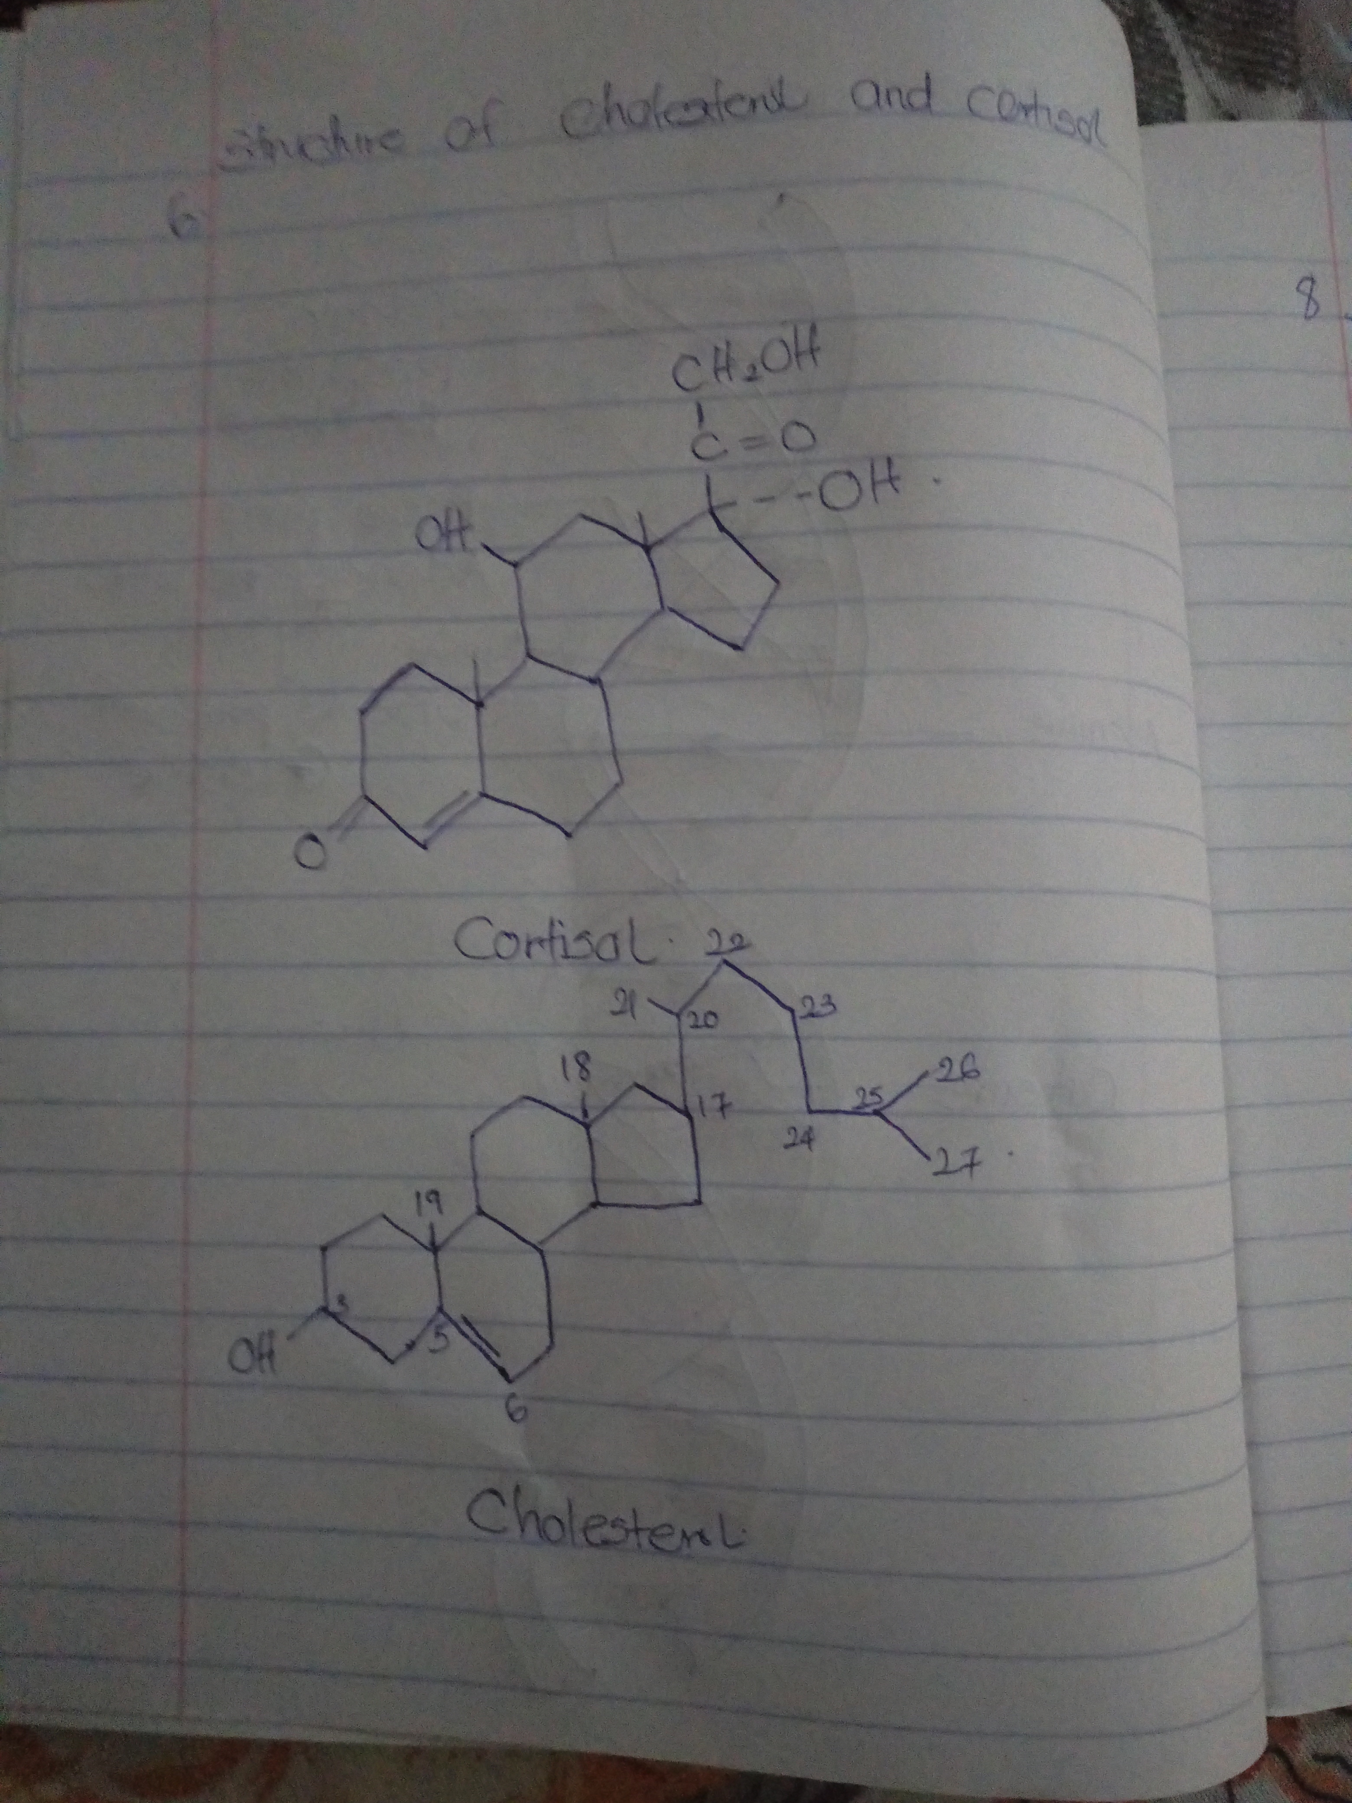

7.

8.Glycolipids are important constituents of cell membrane and nervous tissues. There are various types of glycolipids. They are cerebrosides, and gangliosides. Cerebrosides are the simplest form of glycolipids that contain a ceramide and one or more sugars. Galactocerebrosides and glucocerebroside are the simplest form of glycolipids
Sulfagalactosylceramide is the sulfatide derived form of galactosylceramide.
Gangliosides are predominately found in ganglions and are the most complex form of glycosphingolipids. They are the derivatives of cerebrosides and contain one or more molecules of N-acetylneuramininic acid, the most important sialic acid.

9. Cell is the structural and functional unit of life. It may be also regarded as the basic unit of biological activity. The concept of cell originated from the contributions of Schleiden and Schwann. There are two types of cell based on nuclear membrane; the prokaryotic cell, which lacks well defined nucleus and possess relatively simple structure and eukaryotic cells, possess a well defined nucleus and are more complex in their structure and functions.
The cell consists of well defined subcellular organelles, enveloped by a plasma membrane . the subcellular organelles are briefly described in the following.
Mitochondrion: the mitochondrion are the centres for cellular respiration and energy metabolism.
They are regarded as the power houses of the cell with variable size and shape.
Rough Endoplasmic reticulum: they aid in protein biosynthesis
Smooth endoplasmic reticulum is involved in synthesis of lipids and metabolism of drugs, besides supplying Ca+ for the cellular functions.
Golgi apparatus is responsible for packaging and storing newly synthesized proteins catalysed by the addition of carbohydrates, lipids or sulphate moieties to the proteins.
Lysosomes are regarded as the digestive tract of the cell. They are involved in digestion of cellular substances namely proteins, lipids, carbohydrates and nucleic acids.
Peroxisomes: also known as microbodies, contain an enzyme catalase which protects the cell from toxic effects of peroxides by converting it to water and oxygen molecule.

