NAME: Abejide Motolani Motunrola
DEPARTMENT: Nursing
MATRIC NUMBER: 18/MHS02/003
COURSE: Physiology

ASSIGNMENT QUESTION
Write short notes on any two eye defects

- ASTIGMATISM
Astigmatism is a type of refractive error in which the eye does not focus light evenly on the retina. This results in distorted or blurred vision at any distance. Other symptoms can be including eyestrain, headaches, and trouble driving at night. If it occurs in early life, it can later result in amblyopia. The cause of astigmatism is unclear; however, it is believed to be partly related to genetic factors. The cause of astigmatism isunclea, however it is believed to be partly related to genetic factors. the underlying mechanism involves an irregular curvature of the cornea or abnormalities in the lens of the eyes. Diagnosis is by an eye examination. There are 3 treatment options which are glasses, contact lenses and surgery. Glasses are the simplest. Contact lenses can provide a wider field of vision. Refractive surgery permanently changes the shape of the eye.
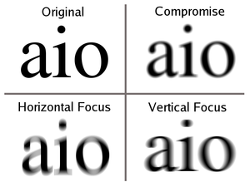
Blur from astigmatic lens at different distances.
Signs and symptoms
Although astigmatism may be asymptomatic, higher degrees of astigmatism may cause symptoms such as blurred vision, double vision, squinting, eye strain, fatigue, or headaches Some research has pointed to the link between astigmatism and higher prevalence of migraine headaches.
. 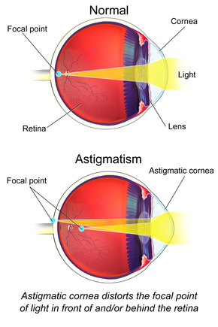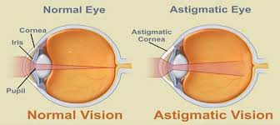
Diagnosis
A number of tests are used during eye examinations to determine the presence of astigmatism and to quantify its amount and axis. A Snellen chart or other eye charts may initially reveal reduced visual acuity. A keratometer may be used to measure the curvature of the steepest and flattest meridians in the cornea's front surface. Corneal topography may also be used to obtain a more accurate representation of the cornea's shape. An autorefractor or retinoscopy may provide an objective estimate of the eye's refractive error and the use of Jackson cross cylinders in a phoropter or trial frame may be used to subjectively refine those measurements. An alternative technique with the phoropter requires the use of a "clock dial" or "sunburst" chart to determine the astigmatic axis and power. A keratometer may also be used to estimate astigmatism by finding the difference in power between the two primary meridians of the cornea. Javal's rule can then be used to compute the estimate of astigmatism.
A method of astigmatism analysis by Alpins may be used to determine both how much surgical change of the cornea is needed and after surgery to determine how close treatment was to the goal. Another rarely used refraction technique involves the use of a stenopaeic slit (a thin slit aperture) where the refraction is determined in specific meridians – this technique is particularly useful in cases where the patient has a high degree of astigmatism or in refracting patients with irregular astigmatism.
Classification
There are three primary types of astigmatism: myopic astigmatism, hyperopic astigmatism, and mixed astigmatism. Cases can be classified further, such as regular or irregular and lenticular or corneal.
Treatment
Astigmatism may be corrected with eyeglasses, contact lenses, or refractive surgery. Glasses are the simplest and safest, although contact lenses can provide a wider field of vision. Refractive surgery can eliminate the need to wear corrective lenses altogether by permanently changing the shape of the eye but, like all elective surgery, comes with both greater risk and expense than the non-invasive options. Various considerations involving eye health, refractive status, and lifestyle determine whether one option may be better than another. In those with keratoconus, certain contact lenses often enable patients to achieve better visual acuity than eyeglasses. Once only available in a rigid, gas-permeable form, toric lenses are now also available as soft lenses.
In older people, astigmatism can also be corrected during cataract surgery. This can either be done by inserting a toric intraocular lens or by performing special incisions (limbal relaxing incisions). Toric intraocular lenses probably provide a better outcome with respect to astigmatism in theses cases than limbal relaxing incisions.
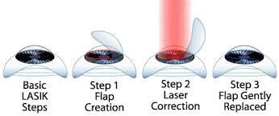

- NEAR-SIGHTEDNESS(MYOPIA)
Near-sightedness, also known as short-sightedness and myopia, is an eye disorder where light focuses in front of, instead of on, the retina. This causes distant objects to be blurry while close objects appear normal. Other symptoms may include headaches and eye strain. Severe near-sightedness is associated with an increased risk of retinal detachment, cataracts, and glaucoma.
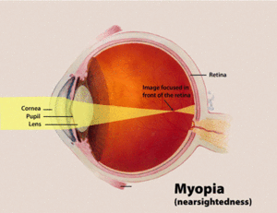Diagram showing changes in the eye with near-sightedness.

Signs and symptoms
A myopic individual can see clearly out to a certain distance (called far point), but everything further becomes blurry. If the extent of the myopia is great enough, even standard reading distances can be affected. Upon routine examination of the eyes, the vast majority of myopic eyes appear structurally identical to nonmyopic eyes. Onset is often in school children, with worsening between the ages of 8 and 15.
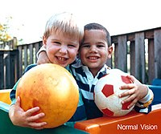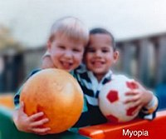
Causes
The underlying cause is believed to be a combination of genetic and environmental factors. Risk factors include doing work that involves focusing on close objects, greater time spent indoors, and a family history of the condition. It is also associated with a high socioeconomic class. A risk for myopia may be inherited from one's parents. Genetic linkage studies have identified 18 possible loci on 15 different chromosomes that are associated with myopia, but none of these loci is part of the candidate genes that cause myopia. Instead of a simple one-gene locus controlling the onset of myopia, a complex interaction of many mutated proteins acting in concert may be the cause. Instead of myopia being caused by a defect in a structural protein, defects in the control of these structural proteins might be the actual cause of myopia. Environmental factors which increase the risk of nearsightedness include insufficient light exposure, low physical activity, near work, and increased year of education. One hypothesis is that a lack of normal visual stimuli causes improper development of the eyeball. Under this hypothesis, "normal" refers to the environmental stimuli that the eyeball evolved to. Modern humans who spend most of their time indoors, in dimly or fluorescently lit buildings which may contribute to the development of myopia. People, and children especially, who spend more time doing physical exercise and outdoor play have lower rates of myopia, suggesting the increased magnitude and complexity of the visual stimuli encountered during these types of activities decrease myopic progression. There is preliminary evidence that the protective effect of outdoor activities on the development of myopia is due, at least in part, to the effect of long hours of exposure to daylight on the production and the release of retinal dopamine. NOTE: Nearsightedness is also more common in children with diabetes, Childhood arthritis, uveitis, and systemic lupus erythematosus.

Types
Various forms of myopia have been described by their clinical appearance:
- Simple myopia: Myopia in an otherwise normal eye, typically less than 4.00 to 6.00 diopters. This is the most common form of myopia.
- Degenerative myopia, also known as malignant, pathological, or progressive myopia, is characterized by marked fundus changes, such as posterior staphyloma, and associated with a high refractive error and subnormal visual acuity after correction. This form of myopia gets progressively worse over time. Degenerative myopia has been reported as one of the main causes of visual impairment.
- Pseudomyopia is the blurring of distance vision brought about by spasm of the accommodation system.
- Nocturnal myopia: Without adequate stimulus for accurate accommodation, the accommodation system partially engages, pushing distance objects out of focus.
- Nearwork-induced transient myopia (NITM): short-term myopic far point shift immediately following a sustained near visual task. Some authors argue for a link between NITM and the development of permanent myopia.
- Instrument myopia: over-accommodation when looking into an instrument such as a microscope.
- Induced myopia, also known as acquired myopia, results from various medications, increases in glucose levels, nuclear sclerosis, oxygen toxicity (e.g., from diving or from oxygen and hyperbaric therapy) or other anomalous conditions. Sulphonamide therapy can cause ciliary body edema, resulting in anterior displacement of the lens, pushing the eye out of focus. Elevation of blood-glucose levels can also cause edema (swelling) of the crystalline lens as a result of sorbitol accumulating in the lens. This edema often causes temporary myopia. Scleral buckles, used in the repair of retinal detachments may induce myopia by increasing the axial length of the eye.
- Index myopia is attributed to variation in the index of refraction of one or more of the ocular media. Cataracts may lead to index myopia.
- Form deprivation myopia occurs when the eyesight is deprived by limited illumination and vision range, or the eye is modified with artificial lenses or deprived of clear form vision. In lower vertebrates, this kind of myopia seems to be reversible within short periods of time. Myopia is often induced this way in various animal models to study the pathogenesis and mechanism of myopia development

Degree

The degree of myopia is described in terms of the power of the ideal correction, which is measured in diopters:

- Low myopia usually describes myopia of −3.00 diopters or less (i.e. closer to 0.00).
- Moderate myopia usually describes myopia between −3.00 and −6.00 diopters. Those with moderate amounts of myopia are more likely to have pigment dispersion syndrome or pigmentary glaucoma.
- High myopia usually describes myopia of −6.00 or more. People with high myopia are more likely to have retinal detachments and primary open angle glaucoma. They are also more likely to experience floaters, shadow-like shapes which appear in the field of vision.

Age at onset
Myopia is sometimes classified by the age at onset:
- Congenital myopia, also known as infantile myopia, is present at birth and persists through infancy.
- Youth onset myopia occurs in early childhood or teenage, and the ocular power can keep varying until the age of 21, before which any form of corrective surgery is usually not recommended by ophthalmic specialists around the world.
- School myopia appears during childhood, particularly the school-age years. This form of myopia is attributed to the use of the eyes for close work during the school years.
- Adult onset myopia
- Early adult onset myopia occurs between ages 20 and 40.
- Late adult onset myopia occurs after age 40.

Treatment
The National Institutes of Health says there is no known way of preventing myopia, and the use of glasses or contact lenses does not affect its progression. There is no universally accepted method of preventing myopia and proposed methods need additional study to determine their effectiveness. Optical correction using glasses or contact lenses is the most common treatment.
Glasses and contacts: corrective lenses bend the light entering the eye in a way that places a focused image accurately onto the retina. The power of any lens system can be expressed in diopters, the reciprocal of its focal length in meters. Corrective lenses for myopia have negative powers because a divergent lens is required to move the far point of focus out to the distance. More severe myopia needs lens powers further from zero (more negative). However, strong eyeglass prescriptions create distortions such as prismatic movement and chromatic aberration. Strongly near-sighted wearers of contact lenses do not experience these distortions because the lens moves with the cornea, keeping the optic axis in line with the visual axis and because the vertex distance has been reduced to zero.
Surgery: Refractive surgery includes procedures which alter the corneal curvature of some structure of the eye or which add additional refractive means inside the eye.
Lasik: In a LASIK pre-procedure, a corneal flap is cut into the cornea and lifted to allow the excimer laser beam access to the exposed corneal tissue. After that, the excimer laser ablates the tissue according to the required correction. When the flap again covers the cornea, the change in curvature generated by the laser ablation proceeds to the corneal surface. Though LASIK is usually painless and involves a short rehabilitation period post-surgery, it can potentially result in flap complications and loss of corneal stability (post-LASIK keratectasia).
Orthokeratology: Orthokeratology or simply Ortho-K is a temporary corneal reshaping process using rigid gas permeable (RGP) contact lenses. Overnight wearing of specially designed contact lenses will temporarily reshape cornea, so patients may see clearly without any lenses in daytime. Orthokeratology can correct myopia upto -6D. several studies shown that Ortho-K can reduce myopia progression also. Risk factors of using Ortho-K lenses include microbial keratitis, corneal edema, etc. Other contact lens related complications like corneal aberration, photophobia, pain, irritation, redness etc. are usually temporary conditions, which may be eliminated by proper usage of lenses.
Intrastromal corneal ring segment: The Intrastromal corneal ring segment (ICRS), commonly used in keratoconus treatment now, was originally designed to correct mild to moderate myopia. The thickness is directly related to flattening and the diameter of the ring is proportionally inverse to the flattening of cornea. So, if diameter is smaller or thickness is greater, resulting myopia correction will be greater.
Alternative medicine: A number of alternative therapies have been claimed to improve myopia, including vision therapy, "behavioural optometry", various eye exercises and relaxation techniques, and the Bates method. Scientific reviews have concluded that there was "no clear scientific evidence" that eye exercises are effective in treating near-sightedness and as such they "cannot be advocated".
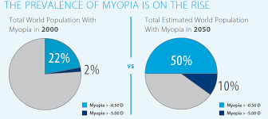

REFRENCE
En.wikipedia.org: https://en.wikipedia.org/wiki/Near-sightedness and https://en.wikipedia.org/wiki/Astigmatism

