18/MHS06/024
Med Lab Sci
BCH 202

Question

1.Draw the structures of the ffg; ATP , GDP, CDP,UTP, double stranded DNA

- ATP
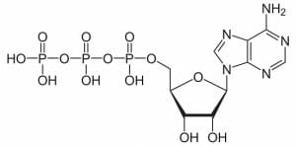

- GDP

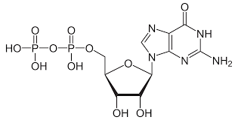

CDP
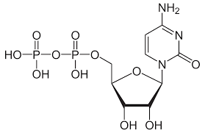
- UTP
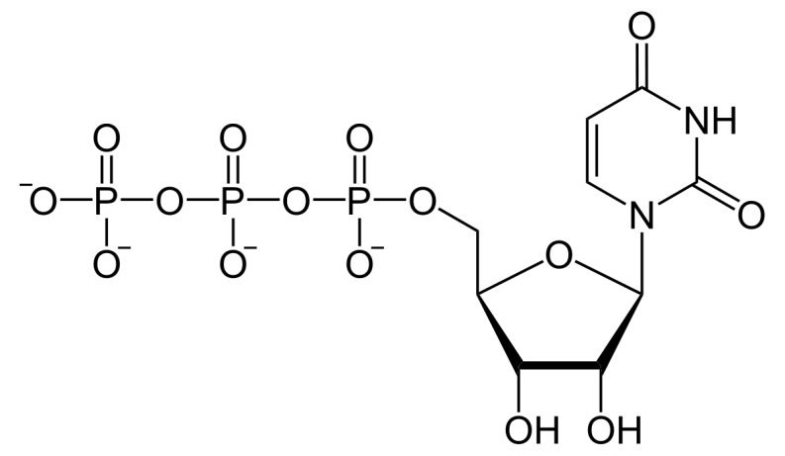
- DOUBLE STRANDED DNA

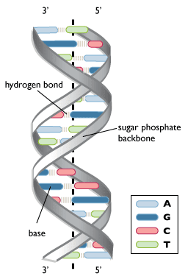

2.Differentiate between DNA and RNA clearly

Main Differences Between DNA and RNA
Comparison | DNA | RNA
Name | DeoxyriboNucleic Acid | RiboNucleic Acid
Function | Long-term storage of genetic information; transmission of genetic information to make other cells and new organisms. | Used to transfer the genetic code from the nucleus to the ribosomes to make proteins. RNA is used to transmit genetic information in some organisms and may have been the molecule used to store genetic blueprints in primitive organisms.
Structural Features | B-form double helix. DNA is a double-stranded molecule consisting of a long chain of nucleotides. | A-form helix. RNA usually is a single-strand helix consisting of shorter chains of nucleotides.
Composition of Bases and Sugars | deoxyribose sugar  phosphate backbone  adenine, guanine, cytosine, thymine bases | ribose sugar  phosphate backbone  adenine, guanine, cytosine, uracil bases
Propagation | DNA is self-replicating. | RNA is synthesized from DNA on an as-needed basis.
Base Pairing | AT (adenine-thymine)  GC (guanine-cytosine) | AU (adenine-uracil)  GC (guanine-cytosine)
Reactivity | The C-H bonds in DNA make it fairly stable, plus the body destroys enzymes that would attack DNA. The small grooves in the helix also serve as protection, providing minimal space for enzymes to attach. | The O-H bond in the ribose of RNA makes the molecule more reactive, compared with DNA. RNA is not stable under alkaline conditions, plus the large grooves in the molecule make it susceptible to enzyme attack. RNA is constantly produced, used, degraded, and recycled.
Ultraviolet Damage | DNA is susceptible to UV damage. | Compared with DNA, RNA is relatively resistant to UV damage.

3.Explain the biosynthesis of calcitriol

The term vitamin D is, unfortunately, an imprecise term referring to one or more members of a group of steroid molecules. Vitamin D₃, also known as cholecalciferol is generated in the skin of animals when light energy is absorbed by a precursor molecule 7-dehydrocholesterol. Vitamin D is thus not a true vitamin, because individuals with adequate exposure to sunlight do not require dietary supplementation. There are also dietary sources of vitamin D, including egg yolk, fish oil and a number of plants. The plant form of vitamin D is called vitamin D₂ or ergosterol. However, natural diets typically do not contain adequate quantities of vitamin D, and exposure to sunlight or consumption of foodstuffs purposefully supplemented with vitamin D are necessary to prevent deficiencies.
Vitamin D, as either D₃ or D₂, does not have significant biological activity. Rather, it must be metabolized within the body to the hormonally-active form known as 1,25-dihydroxycholecalciferol. This transformation occurs in two steps, as depicted in the diagram to the right:
- Within the liver, cholecalciferal is hydroxylated to 25-hydroxycholecalciferol by the enzyme 25-hydroxylase.
- Within the kidney, 25-hydroxycholecalciferol serves as a substrate for 1-alpha-hydroxylase, yielding 1,25-dihydroxycholecalciferol, the biologically active form.
Each of the forms of vitamin D is hydrophobic, and is transported in blood bound to carrier proteins. The major carrier is called, appropriately, vitamin D-binding protein. The halflife of 25-hydroxycholecalciferol is several weeks, while that of 1,25-dihydroxycholecalciferol is only a few hours.

4.write on coenzymes.and the coenzyme form of riboflavin

- COENZYME
A coenzyme is an organic non-protein compound that binds with an enzyme to catalyze a reaction. Coenzymes are often broadly called cofactors, but they are chemically different. A coenzyme cannot function alone, but can be reused several times when paired with an enzyme.An enzyme without a coenzyme is called an apoenzyme. Without coenzymes or cofactors, enzymes cannot catalyze reactions effectively. In fact, the enzyme may not function at all. If reactions cannot occur at the normal catalyzed rate, then an organism will have difficulty sustaining life.When an enzyme gains a coenzyme, it then becomes a holoenzyme, or active enzyme. Active enzymes change substrates into the products an organism needs to carry out essential functions, whether chemical or physiological. Coenzymes, like enzymes, can be reused and recycled without changing reaction rate or effectiveness. They attach to a portion of the active site on an enzyme, which enables the catalyzed reaction to occur. When an enzyme is denatured by extreme temperature or pH, the coenzyme can no longer attach to the active site.
- COENZYME FORM OF RIBOFLAVIN

Riboflavin is a water-soluble B vitamin, also known as vitamin B2. In the body, riboflavin is primarily found as an integral component of the coenzymes, flavin adenine dinucleotide (FAD) and flavin mononucleotide (FMN) .Coenzymes derived from riboflavin are termed flavocoenzymes, and enzymes that use a flavocoenzyme are called flavoproteins .Glutathione reductase is an FAD-dependent enzyme that participates in the redox cycle of glutathione. The glutathione redox cycle plays a major role in protecting organisms from reactive oxygen species, such as hydroperoxides. Glutathione reductase (GR) requires FAD to regenerate two molecules of reduced glutathione from oxidized glutathione. Riboflavin deficiency has been associated with increased oxidative stress , Measurement of GR activity in red blood cells is commonly used to assess riboflavin nutritional status . The erythrocyte glutathione reductase activation coefficient (EGRac) assay assesses riboflavin status by measuring the activity of GR before and after in vitro reactivation with its prosthetic group FAD; EGRac is calculated as the ratio of FAD-stimulated to unstimulated enzyme activity and indicates the degree of tissue saturation with riboflavin. EGRac is thus a functional measure of riboflavin status and has shown to be effective in reflecting biomarker status from severe deficiency to normal status B-complex vitamins
Flavoproteins are involved in the metabolism of several other vitamins: (vitamin B6, niacin, and folate). Therefore, severe riboflavin deficiency may affect many enzyme systems. Conversion of most naturally available vitamin B6 to its coenzyme form, pyridoxal 5'-phosphate (PLP), requires the FMN-dependent enzyme, pyridoxine 5'-phosphate oxidase (PPO) . At least two studies in the elderly have documented significant interactions between indicators of vitamin B6 and riboflavin nutritional status .The synthesis of the niacin-containing coenzymes, NAD and NADP, from the amino acid tryptophan, requires the FAD-dependent enzyme, kynurenine 3-monooxygenase. Severe riboflavin deficiency can decrease the conversion of tryptophan to NAD and NADP, increasing the risk of niacin deficiency. 5, 10-Methylenetetrahydrofolate reductase (MTHFR) is an FAD-dependent enzyme that plays an important role in maintaining the specific folate coenzyme required to form methionine from homocysteine .Along with other B vitamins, higher riboflavin intakes have been associated with decreased plasma homocysteine levels . Increased plasma riboflavin levels have also been associated with decreased plasma homocysteine levels, mainly in individuals homozygous for the C677T polymorphism in the MTHFRgene and in individuals with low folate intake .
.
5.Write on the characteristics components of nucleotides and the nucleoside units on RNA

Nitrogenous base
The nitrogenous base is the central information carrying part of the nucleotide structure. These molecules, which have different exposed functional groups, have differing abilities to interact with each other. As in the image, the idea arrangement is the maximum amount of hydrogen bonds between nucleotides involved. Because of the structure of the nucleotide, only a certain nucleotide can interact with other. The image above shows thymine bonding to adenine, and guanine bonding to cytosine. This is the proper and typical arrangement.
This even formation causes a twist in the structure, and is smooth if there are no errors. One of the ways proteins are able to repair damaged DNA is that they can bind to uneven spots within the structure. Uneven spots are created when hydrogen bonding does not occur between the opposing nucleotide molecules. The protein will cut out one nucleotide, and replace it with another. The duplicate nature of the genetic strands ensures that errors like this can be corrected with a high degree of accuracy.

Sugar
The second portion of the nucleotide is the sugar. Regardless of the nucleotide, the sugar is always the same. The difference is between DNA and RNA. In DNA, the 5-carbon sugar is deoxyribose, while in RNA, the 5-carbon sugar is ribose. This gives genetic molecules their names; the full name of DNA is deoxyribonucleic acid, and RNA is ribonucleic acid.
The sugar, with its exposed oxygen, can bond with the phosphate group of the next molecule. They then form a bond, which becomes the sugar-phosphate backbone. This structure adds rigidity to the structure, as the covalent bonds they form are much stronger than the hydrogen bonds between the two strands. When proteins come to process and transpose the DNA, they do so by separating the strands and reading only one side. When they pass on, the strands of genetic material comes back together, driven by the attraction between the opposing nucleotide bases. The sugar-phosphate backbone stays connected the whole time.

Phosphate Group
The last part of nucleotide structure, the phosphate group, is probably familiar from another important molecule ATP. Adenosine triphosphate, or ATP, is the energy molecule that most life on Earth relies upon to store and transfer energy between reactions. ATP contains three phosphate groups, which can store a lot of energy in their bonds. Unlike ATP, the bonds formed within a nucleotide are known as phosphodiester bonds, because they happen between the phosphate group and the sugar molecule.
During DNA replication, an enzyme known as DNA polymerase assembles the correct nucleotide bases, and begins organizing them against the chain it is reading. Another protein, DNA ligase, finished the job by creating the phosphodiester bond between the sugar molecule of one base and the phosphate group of the next. This creates the backbone of a new genetic molecule, able to be passed to the next generation. DNA and RNA contain all the genetic information necessary for cells to function.

6.Structure of cholesterol and cortisol
CHOLESTEROL
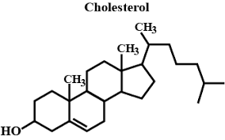
CORTISOL

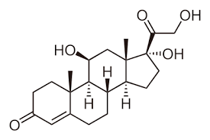

7.Review vitamins and different form, write on metabolism of one known vitamin to its active form

METABOLISM OF VITAMIN B1 TO ITS ACTIVE FORM

Definition
Thiamine, named as the "thio-vitamine" ("sulfur-containing vitamin") is a water-soluble vitamin of the B complex. Its phosphate derivatives are involved in many cellular processes. The best-characterized form is thiamine pyrophosphate (TPP), a coenzyme in the catabolism of sugars and amino acids. Thiamine is used in the biosynthesis of the neurotransmitter acetylcholine and gamma-aminobutyric acid.

Chemical Structure
Vitamin B1

Functions
It is a precursor of Thiamine pyrophosphate

Sources
Thiamin -Linus Pauling Foundation

Deficiency
association between breast cancer and obesity
Regulation of Phosphatidylethanolamine Homeostasis;The Critical Role of CTP:Phosphoethanolamine Cytidylyltransferase (Pcyt2). 2013
Thiamine is an essential cofactor in carbohydrate metabolism and individuals suffering from diabetes and/or metabolic syndrome are generally thiamine deficient.
Pathways
- Thiamine in the polyol pathway
Items
- Beriberi
- Helicobacter Pylori - Virulence Factors
Comments2012-03-31T08:04:33 - Matteo Cucino
Thiamine is a water soluble vitamin which acts as a coenzyme in pyruvic acid and other ketoacids decarboxylation reactions. It is found in foods of plant (wheat germ, cereals, legumes) and animal origin (beef and pork, especially the liver, brain, kidneys and intestines). In the first it is mostly in the free form, while in the latter it can be phosphorylated in both mono and diphosphate.
Its structure is composed of a thiazole ring joined by a methylene link to a pyrimidine ring.
In the intestine, thiamine can be absorbed by a process of active or passive transport by enterocytes, which then release it into the bloodstream in the free or phosphorylated form (thiamine monophosphate). In the tissues it is converted into its active form, thiamine pyrophosphate (TPP), by the enzyme thiamine pyrophosphate synthetase. Since the excess is excreted in the urine, it does not have toxicity.
Thiamine Pyrophosphate
Reactions
The functional part of thiamine pyrophosphate, the thiazole ring, has an acid proton on the carbon atom C2. His detachment produces a carbanion, which is the active species in reactions. The carbanion binds to carbonyl groups, while the thiazole ring is in position to capture electrons, facilitating the reaction.
Pentose phosphate pathway
In some tissues, glucose 6-phosphate is oxidized to pentose phosphate by the pentose phosphate pathway. The electron acceptor is NADP+, which is reduced to NADPH. In the non-oxidative phase of this pathway, the pentose phosphate produced is recycled to glucose 6-phosphate. The enzyme transketolase transfers a two carbon atoms fragment from a ketose donor to an aldose acceptor. The TPP acts as a cofactor, stabilizing the carbanion during the transfer.
Acetyl-CoA synthesis
The pyruvate produced by glycolysis has to be oxidized to acetyl-CoA by the action of the pyruvate dehydrogenase multienzymatic complex. The first part of the transformation is catalyzed by the enzyme E1 (pyruvate dehydrogenase), which requires the intervention of the TPP as a coenzyme. The C1 atom of pyruvate is released as CO2 and the C2 atom is bound to the TPP as a hydroxyethylic group. This is then oxidized to acetate, which continues in the chain of reactions in the complexes E2 and E3, while the TPP, now free again, can start a new cycle.
Citric acid cycle
Acetyl-CoA enters the citric acid cycle, through which it is enzymatically oxidized to CO2. The energy released is stored in the carriers NADH and FADH2. These, oxidizing themselves, give their electrons, through the respiratory chain, to the oxygen. The energy released by this process is used to produce ATP via oxidative phosphorylation.
Thiamine pyrophosphate intervenes in α-ketoglutarate oxidation to succinyl-CoA operated by the α-ketoglutarate dehydrogenase complex. This reaction proceeds in a manner similar to the one catalyzed by pyruvate dehydrogenase complex: the TPP is linked to the first of the three enzymes that compose the complex.
Oxidation of branched chain amino acids
Leucine, isoleucine and valine are not degraded in the liver, but are oxidized in the muscle, adipose tissue, kidney and brain. These tissues have an aminotransferase that is absent in the liver, which converts amino acids into the corresponding ketoacids. Thereafter, the dehydrogenase complex for the branched chain α-ketoacids oxidatively decarboxylates them, producing the respective acyl-CoA and releasing CO2. This complex operates similarly to that of the pyruvate dehydrogenase and α-ketoglutarate dehydrogenase, using thiamine pyrophosphate in the first part of the reaction.

8.glycolipids,its variuod form and structure

- Glyceroglycolipids: a sub-group of glycolipids characterized by an acetylated or non-acetylated glycerol with at least one fatty acid as the lipid complex. ...
- Glycosphingolipids: a sub-group of glycolipids based on sphingolipids.

STRUCTURE

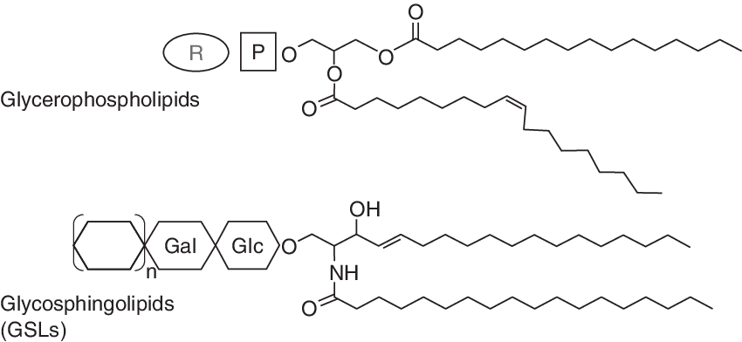

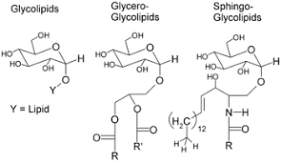
9.Detail write up on cell and functions of important cell organelles
\
CELL

Cells are the basic unit of life. In the modern world, they are the smallest known world that performs all of life’s functions.

.Function of Cells

Scientists define seven functions that must be fulfilled by a living organism. These are:
- A living thing must respond to changes in its environment.
- A living thing must grow and develop across its lifespan.
- A living thing must be able to reproduce, or make copies of itself.
- A living thing must have metabolism.
- A living thing must maintain homeostasis, or keep its internal environment the same regardless of outside changes.
- A living thing must be made of cells.
- A living thing must pass on traits to its offspring.
It is the biology of cells which enables living things to perform all of these functions. Below, we discuss how they make the functions of life possible.

How Cells Work
In order to accomplish them, they must have:
- A cell membrane that separates the inside of the cell from the outside. By concentrating the chemical reactions of life inside a small area within a membrane, cells allow the reactions of life to proceed much faster than they otherwise would.
- Genetic material which is capable of passing on traits to the cell’s offspring. In order to reproduce, organisms must ensure that their offspring have all the information that they need to be able to carry out all the functions of life.All modern cells accomplish this using DNA, whose base-pairing properties allow cells to make accurate copies of a cell’s “blueprints” and “operating system.” Some scientists think that the first cells might have used RNA instead.
- Proteins that perform a wide variety of structural, metabolic, and reproductive functions.
There are countless different functions that cells must perform to obtain energy and reproduce.

- CELL ORGANELLES AND THEIR FUNCTIONS

Organelle | Function | Factory part
Nucleus | DNA Storage | Room where the blueprints are kept
Mitochondrion | Energy production | Powerplant
Smooth Endoplasmic Reticulum (SER) | Lipid production; Detoxification | Accessory production - makes decorations for the toy, etc.
Rough Endoplasmic Reticulum (RER) | Protein production; in particular for export out of the cell | Primary production line - makes the toys聽
Golgi apparatus | Protein modification and export | Shipping department
Peroxisome | Lipid Destruction; contains oxidative enzymes | Security and waste removal
Lysosome | Protein destruction | Recycling and security

