Name: James vivian chidera
Matric no: 18/mhs02/096
Department: Nursing
Course: PHS212

PHYSIOLOGY OF BALANCE

The anatomy of the ear can be a little confusing, especially since the ear is responsible not only for hearing, but also for balance.
There are three components to the ear: the outer ear, the middle ear and the inner ear. All three are involved in hearing but only the inner ear is responsible for balance.
The outer ear is composed of the pinna, or ear lobe, and the external auditory canal. Both structures funnel sound waves towards the ear drum or tympanic membrane allowing it to vibrate. The pinna is also responsible for protecting the ear drum from damage. Modified sweat glands in the ear canal form ear wax.
The middle ear is an air-filled space located in the temporal bone of the skull. Air pressure is equalized in this space via the Eustachian tube which drains into the nasopharynx or the back of the throat and nose. There are three small bones, or ossicles, that are located adjacent to the tympanic membrane. The malleus, incus, and stapes are attached like a chain to the tympanic membrane and convert sound waves that vibrate the membrane into mechanical vibrations of the three bones. The stapes fills the oval window which is the connection to the inner ear.
The inner has two functions; the first is hearing and the second is balance. It is a warren of tubes filled with fluid encased within the temporal bone of the skull. The bony tubes also contain a set of cell membrane lined tubes. The bony tubes are called the bony labyrinth filled with perilymph fluid, which the membranous labyrinth tubes are filed with endolymph. This is where the cells responsible for hearing are located (the hairy cells of Corti.
The bony labyrinth itself has three sections:
- The cochlea is responsible for hearing.
- The semicircular canals have function associated with balance.
- The vestibule which connects the two and contains two more balance and equilibrium related structures, the saccule and utricle.
The final structures of the inner ear are the round window and the eighth cranial nerve (cranial nerve VIII) which is composed of the vestibular nerve (balance) and the cochlear (hearing) nerve.
(*) Now we know that the ear is responsible not only for hearing but also for balance. We’ll be focusing on balance.

BALANCE
Balance is a choreographed arrangement that takes sensory information from a variety of organs and integrates it to tell the body where it is in related to gravity and the earth.
Information from the vestibular system of the inner ear (semicircular canals, the saccule and the utricle) is sent to the brainstem, cerebellum, and spinal cord. Potential balance abnormalities do not require conscious input from the cerebrum of the brain. Abnormal vestibular signals cause the body to try to compensate by making adjustments in posture of the trunk and limbs as well as making changes in eye movement to adjust sight input into the brain.
There are three semicircular canals in the inner ear positioned at right angles to each other like a gyroscope. They are able to sense changes in movement of the body. With such changes, endolymph waves within the canals cause hair cells located within their base to move. Position of the head is sensed by hair cells of the utricle and saccule which is stimulated when the head moves and the relationship to gravity changes.
There is a small dense area of nerve fibers called the macule located in each of the saccule and utricle. The macule of the saccule is oriented vertically while the utricle macule is horizontal. Each macule consists of fine hair bundles which are covered by an otolithic membrane that is jelly-like and covered by a blanket of calcium crystals.
The calcium crystals are the structures that ultimately stimulate the position hairs and provoke nerve impulses created by the position changes and transmit that information to the brain stem and cerebellum.
When your mom tells you, 'It's time to clean your room,' I'm sure you know that you use your ears to hear her. But did you know that her words have to be sent to your brain for interpretation in order for you to understand them? If your ears weren't working with your brain all you would hear would be 'blah blah blah blah blah blah.'
You see, your outer ear, which is the part you can touch, collects sound waves from the world around you, but your brain can't read sound waves, so your ear must change them into a language your brain understands, namely nerve impulses. To do this, your middle ear turns the sound waves into vibrations, which are then passed on to your inner ear. It is your inner ear that uses the vibrations to create nerve impulses that travel to your brain. Creating nerve impulses from the sounds that enter your ear is not the only thing your inner ear does, it also helps you keep your balance.
The semicircular canals of the inner ear help you with balance. This movement of the fluid moves the hairs of the canals, creating nerve impulses that travel up to your brain and let it know that your head is off balance. You don't fall over because your brain tells your muscles to support you.
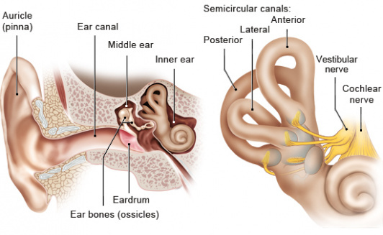Diagram of the vestibular system

WITH THIS WE NOW HAVE A BETTER UNDERSTANDING OF WHAT THE PHYSIOLOGY OF BALANCE IS ALL ABOUT.

