NAME: SAM-OGBONNA ONYINYECHI O.F
MATRIC NO: 18/MHS02/176
DEPARTMENT: NURSING

EYE DEFECTS
Hyperopia or hypermetropia: (farsightedness) This is a defect of vision in which there is difficulty with near vision but far objects can be seen easily. The image is focused behind the retina rather than upon it. This occurs when the eyeball is too short or the refractive power of the lens is too weak. Hyperopia can be corrected by wearing glasses/contacts that contain convex lenses.
A DIAGRAM OF HYPERMETROPIA AND ITS CORRECTION
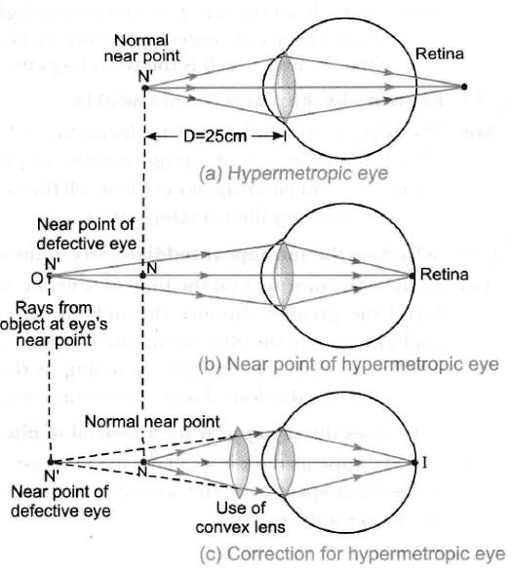

Astigmatism: This defect is when the light rays do not all come to a single focal point on the retina, instead some focus on the retina and some focus in front of or behind it. This is usually caused by a non-uniform curvature of the cornea. A typical symptom of astigmatism is if you are looking at a pattern of lines placed at various angles and the lines running in one direction appear sharp whilst those in other directions appear blurred. Astigmatism can usually be corrected by using a special spherical cylindrical lens; this is placed in the out-of-focus axis.
A DIAGRAM OF ASTIGMATISM AND ITS CORRECTION
