NAME: DICKSON ASELE JAEL

MATRIC NUMBER: 18/MHS02/062

DEPARTMENT: NURSING

COLLEGE: MEDICINE AND HEALTH SCIENCES

COURSE: PHYSIOLOGY

Myopia or Near-Sightedness
Myopia is a defect of vision wherein far-off objects appear blurred and objects near are seen clearly. Since the eyeball is too long or the eye lens’s refractive power is too high; the image forms in front of the retina rather than forming on it. Correction of myopia can happen by wearing glasses/contacts made of concave lenses to help focus the image on the retina.
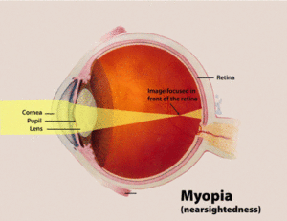
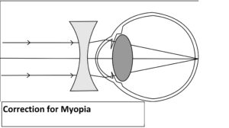

b. Hypermetropia or Longsightedness
Hypermetropia is a defect of vision wherein there is difficulty in viewing objects that are near but one can view far objects easily. Since the eyeball is too short or eye lens’s refractive power is too weak hence the image instead is of being forming upon the retina, its forms behind the retina. Correction of hypermetropia can happen by wearing glasses/contacts containing convex lenses.
