NAME: EKO ELIZABETH ENE
MATRIC NUMBER: 18/MHS02/069
DEPARTMENT: NURSING
COURSE CODE: PHS 212

EYE DEFECTS.
Hyperopia (farsightedness). Hyperopia, which is also known as “farsightedness,” is usually due to either an eyeball that is too short or, occasionally, a lens system that is too weak. In this condition, parallel light rays are not bent sufficiently by the relaxed lens system to come to focus by the time they reach the retina. To overcome this abnormality, the ciliary muscle must contract to increase the strength of the lens. By using the mechanism of accommodation, a farsighted person is capable of focusing distant objects on the retina. If the person has used only a small amount of strength in the ciliary muscle to accommodate for the distant objects, he or she still has much accommodative power left and objects closer and closer to the eye can also be focused sharply until the ciliary muscle has contracted to its limit. In old age, when the lens becomes “presbyopic,” a farsighted person is often unable to accommodate the lens sufficiently to focus even distant objects, much less near objects.
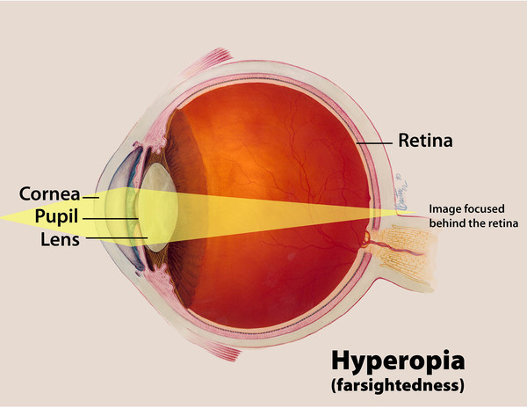

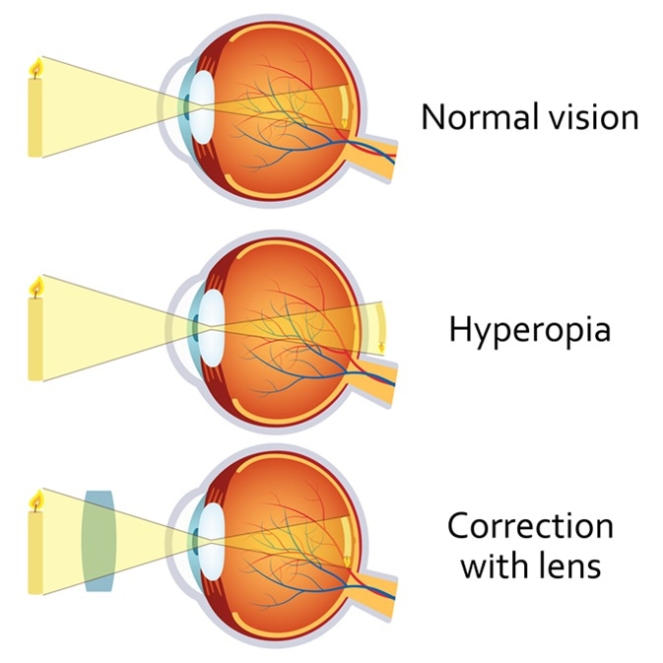
Myopia (Nearsightedness). In myopia, or “nearsightedness” when the ciliary muscle is completely relaxed, the light rays coming from distant objects are focused in front of the retina. This is usually due to too long an eyeball, but can result from too much refractive power in the lens system of the eye.
No mechanism exists by which the eye can decrease the strength of its lens than that which exists when the ciliary muscle is completely relaxed. A myopic person has no mechanism by which to focus distant objects sharply on the retina. However, as an object moves nearer to the person’s eye, it finally gets close enough that its image can focused. Then, when the object comes still closer to the eye, the person can use the mechanism of accommodation to keep the image focused clearly. A myopic person has a definite limiting “far point” for clear vision.
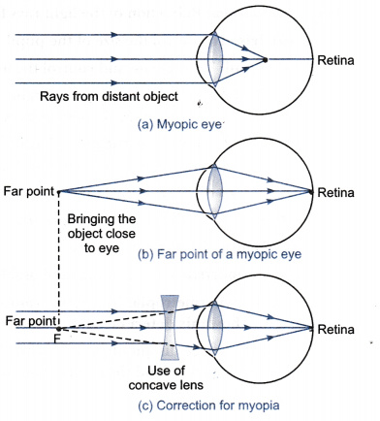
Correction of Myopia and hyperopia by use of lenses.
It will be recalled that light rays passing through a concave lens diverge. If the refractive surfaces of the eye have too much refractive power, as in myopia, this excessive refractive power can neutralized by placing in front of the eye a concave spherical lens, which will diverge rays.
Conversely in a person who has hyperopia-that is, someone who has too weak a lens system-the abnormal vision can be corrected by adding refractive power using a convex lens in front of the eye.
One usually determines the strength of the concave or convex lens needed for clear vision by “trial and error”-that is, by trying first a strong lens and then a stronger or weaker lens until the one that gives the best visual acuity is found.

