NAME: ESAN FAITH
DEPARTMENT: PHARMACOLOGY
MATRIC NUMBER: 18/MHS07/017
COURSE: PHS 212-
PHYSIOLOGY OF BALANCE

The Physiology Of Balance: Vestibular Function: The vestibular system is the sensory apparatus of the inner ear that helps the body maintain its postural equilibrium. The information furnished by the vestibular system is also essential for coordinating the position of the head and the movement of the eyes. There are two sets of end organs in the inner ear, or labyrinth: the semicircular canals, which respond to rotational movements (angular acceleration); and the utricle and saccule within the vestibule, which respond to changes in the position of the head with respect to gravity (linear acceleration). The information these organs deliver is proprioceptive in character, dealing with events within the body itself, rather than exteroceptive, dealing with events outside the body, as in the case of the responses of the cochlea to sound. Functionally these organs are closely related to the cerebellum and to the reflex centres of the spinal cord and brainstem that govern the movements of the eyes, neck, and limbs.
- 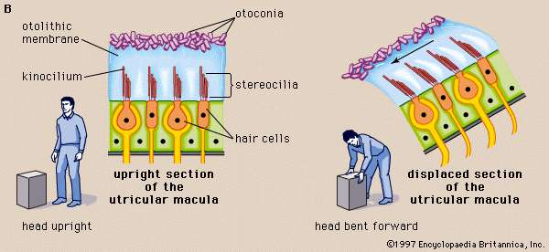
In vertebrates the utricular maculae in the inner ear contain an otolithic membrane and otoconia (particles of calcium carbonate) that bend hair cells in the direction of gravity. This response to gravitational pull helps animals maintain their sense of balance.Encyclopædia Britannica, Inc.
- 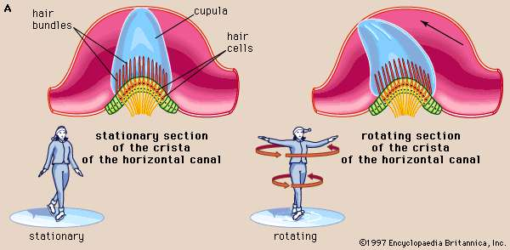
The cristae of the semicircular ducts, which form one of the two sensory organs of balance (the second being the maculae of the utricle and saccule), respond to rotational movements and are involved in dynamic equilibrium.Encyclopædia Britannica, Inc.
Although the vestibular organs and the cochlea are derived embryologically from the same formation, the otic vesicle, their association in the inner ear seems to be a matter more of convenience than of necessity. From both the developmental and the structural point of view, the kinship of the vestibular organs with the lateral line system of the fish is readily apparent. The lateral line system is made up of a series of small sense organs located in the skin of the head and along the sides of the body of fishes. Each organ contains a crista, sensory hair cells, and a cupula, as found in the ampullae of the semicircular ducts. The cristae respond to waterborne vibrations and to pressure changes.
The anatomists of the 17th and 18th centuries assumed that the entire inner ear, including the vestibular apparatus, is devoted to hearing. They were impressed by the orientation of the semicircular canals, which lie in three planes more or less perpendicular to one another, and believed that the canals must be designed for localizing a source of sound in space. The first investigator to present evidence that the vestibular labyrinth is the organ of equilibrium was French experimental neurologist Marie-Jean-Pierre Flourens, who in 1824 reported a series of experiments in which he had observed abnormal head movements in pigeons after he had cut each of the semicircular canals in turn. The plane of the movements was always the same as that of the injured canal. Hearing was not affected when he cut the nerve fibres to these organs, but it was abolished when he cut those to the basilar papilla (the bird’s uncoiled cochlea). It was not until almost half a century later that the significance of his findings was appreciated and the semicircular canals were recognized as sense organs specifically concerned with the movements and position of the head.

DETECTION OF ANGULAR ACCELERATION: DYNAMIC EQUILIBRIUM: Because the three semicircular canals—superior, posterior, and horizontal—are positioned at right angles to one another, they are able to detect movements in three-dimensional space. When the head begins to rotate in any direction, the inertia of the endolymph causes it to lag behind, exerting pressure that deflects the cupula in the opposite direction. This deflection stimulates the hair cells by bending their stereocilia in the opposite direction. German physiologist Friedrich Goltz formulated the “hydrostatic concept” in 1870 to explain the working of the semicircular canals. He postulated that the canals are stimulated by the weight of the fluid they contain, the pressure it exerts varying with the head position. In 1873 Austrian scientists Ernst Mach and Josef Breuer and Scottish chemist Crum Brown, working independently, proposed the “hydrodynamic concept,” which held that head movements cause a flow of endolymph in the canals and that the canals are then stimulated by the fluid movements or pressure changes. German physiologist J.R. Ewald showed that the compression of the horizontal canal in a pigeon by a small pneumatic hammer causes endolymph movement toward the crista and turning of the head and eyes toward the opposite side. Decompression reverses both the direction of endolymph movement and the turning of the head and eyes. The hydrodynamic concept was proved correct by later investigators who followed the path of a droplet of oil that was injected into the semicircular canal of a live fish. At the start of rotation in the plane of the canal, the cupula was deflected in the direction opposite to that of the movement and then returned slowly to its resting position. At the end of rotation it was deflected again, this time in the same direction as the rotation, and then returned once more to its upright stationary position. These deflections resulted from the inertia of the endolymph, which lags behind at the start of rotation and continues its motion after the head has ceased to rotate. The slow return is a function of the elasticity of the cupula itself.
These opposing deflections of the cupula affect the vestibular nerve in different ways, which have been demonstrated in experiments involving the labyrinth removed from a cartilaginous fish. The labyrinth, which remained active for some time after its removal from the animal, was used to record vestibular nerve impulses arising from one of the ampullar cristae. When the labyrinth was at rest there was a slow, continuous, spontaneous discharge of nerve impulses, which was increased by rotation in one direction and decreased by rotation in the other. In other words, the level of excitation rose or fell depending on the direction of rotation.
The deflection of the cupula excites the hair cells by bending the cilia atop them: deflection in one direction depolarizes the cells; deflection in the other direction hyperpolarizes them. Electron-microscopic studies have shown how this polarization occurs. The hair bundles in the cristae are oriented along the axis of each canal. For example, each hair cell of the horizontal canals has its kinocilium facing toward the utricle, whereas each hair cell of the superior canals has its kinocilium facing away from the utricle. In the horizontal canals, deflection of the cupula toward the utricle—i.e., bending of the stereocilia toward the kinocilium—depolarizes the hair cells and increases the rate of discharge. Deflection away from the utricle causes hyperpolarization and decreases the rate of discharge. In superior canals these effects are reversed.

DETECTION OF LINEAR ACCELERATION: STATIC EQUILIBRIUM: The gravity receptors that respond to linear acceleration of the head are the maculae of the utricle and saccule. The left and right utricular maculae are in the same, approximately horizontal, plane and, because of this position, are more useful in providing information about the position of the head and its side-to-side tilts when a person is in an upright position. The saccular maculae are in parallel vertical planes and probably respond more to forward and backward tilts of the head.
Both pairs of maculae are stimulated by shearing forces between the otolithic membrane and the cilia of the hair cells beneath it. The otolithic membrane is covered with a mass of minute crystals of calcite (otoconia), which add to the membrane’s weight and increase the shearing forces set up in response to a slight displacement when the head is tilted. The hair bundles of the macular hair cells are arranged in a particular pattern—facing toward (in the utricle) or away from (in the saccule) a curving midline—that allows detection of all possible head positions. These sensory organs, particularly the utricle, have an important role in the righting reflexes and in reflex control of the muscles of the legs, trunk, and neck that keep the body in an upright position. The role of the saccule is less completely understood. Some investigators have suggested that it is responsive to vibration as well as to linear acceleration of the head in the sagittal (fore and aft) plane. Of the two receptors, the utricle appears to be the dominant partner. There is evidence that the mammalian saccule may even retain traces of its sensitivity to sound inherited from the fishes, in which it is the organ of hearing.

DISTURBANCES OF THE VESTIBULAR SYSTEM The relation between the vestibular apparatus of the two ears is reciprocal. When the head is turned to the left, the discharge from the left horizontal canal is decreased, and vice versa. Normal posture is the result of their acting in cooperation and in opposition. When the vestibular system of one ear is damaged, the unrestrained activity of the other causes a continuous false sense of turning (vertigo) and rhythmical, jerky movements of the eyes (nystagmus), both toward the uninjured side. When the vestibular hair cells of both inner ears are injured or destroyed, as can occur during treatment with the antibiotics gentamicin or streptomycin, there may be a serious disturbance of posture and gait (ataxia) as well as severe vertigo and disorientation. In younger persons the disturbance tends to subside as reliance is placed on vision and on proprioceptive impulses from the muscles and joints as well as on cutaneous impulses from the soles of the feet to compensate for the loss of information from the semicircular canals. Recovery of some injured hair cells may occur.
Routine tests of vestibular function traditionally have involved stimulation of the semicircular canals to elicit nystagmus and other vestibular ocular reflexes. Rotation, which can cause vertigo and nystagmus, as well as temporary disorientation and a tendency to fall, stimulates the vestibular apparatus of both ears simultaneously. Because otoneurologists are usually more interested in examining the right and left ears separately, they usually employ temperature change as a stimulant. Syringing the ear canal with warm water at 44 °C (111 °F) or with cool water at 30 °C (86 °F) elicits nystagmus by setting up convection currents in the horizontal canal. The duration of the nystagmus may be timed with a stopwatch, or the rate and amplitude of the movements of the eyes can be accurately recorded by picking up the resulting rhythmical variations in the corneoretinal direct current potentials, using electrodes pasted to the skin of the temples—a diagnostic process called electronystagmography. An abnormal vestibular apparatus usually yields a reduced response or no response at all.
The vestibular system may react to unaccustomed stimulation from the motion of an aircraft, a ship, or a land vehicle to produce a sense of unsteadiness, abdominal discomfort, nausea, and vomiting. Effects not unlike motion sickness, with vertigo and nystagmus, can be observed in the later stages of acute alcoholic intoxication. Vertigo accompanied by hearing loss is a prominent feature of the periodic attacks experienced by patients with Ménière disease, which, until the late 19th century, was confused with epilepsy. It was referred to as apoplectiform cerebral congestion and was treated by purging and bleeding. Other forms of vertigo may present the otoneurologist with more difficult diagnostic problems.
Since the advent of space exploration, interest in experimental and clinical studies of the vestibular system has greatly increased. Investigators are concerned particularly about its performance when persons are exposed to the microgravity of spaceflight, as compared with the Earth’s gravitational field for which it evolved. Investigations include the growing use of centrifuges large enough to rotate human subjects, as well as ingeniously automated tests of postural equilibrium for evaluating the vestibulospinal reflexes. Some astronauts have experienced relatively minor vestibular symptoms on returning from spaceflight. Some of these disturbances have lasted for several days, but none have become permanent.

