NAME: ABDULRAUF RABIAT
MATRIC NUMBER: 18/MHS02/002
DEPARTMENT: NURSING
PHYSIOLOGY ASSIGNMENT
Discuss the physiology of balance
Write short notes on any two eye defects
Farsightedness
Hyperopia, or farsightedness, is just the opposite – people with it can see clearly far away, but not close up. It is caused by insufficient curvature of the cornea relative to the length of the eyeball. This puts the focal point of the light rays behind the retina instead of on it.
In laser correction, the curvature of the cornea is increased, moving the focal point of the light to the retina and enabling clear vision.
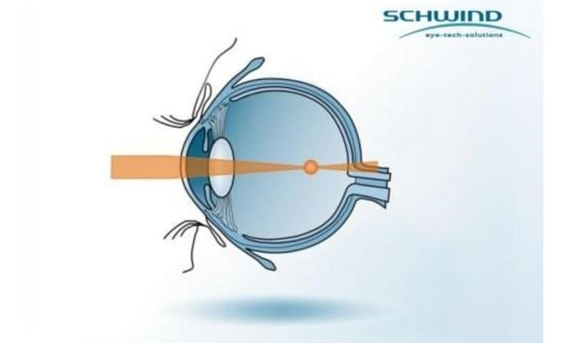
Nearsightedness
Myopia is often called nearsightedness, because people who have it can only see nearby objects in sharp focus. It is caused by too much curvature of the cornea relative to the length of the eyeball. This causes the light rays in the eye to be focused in front of the retina instead of on it.
In laser correction, this curvature is reduced, moving the focal point of the light to the retina and enabling clear vision without corrective lenses.
