OLONIYO SIMILOLUWA GRACE
19/mhs02/132
NURSING SCIENCE
PHYSIOLOGY 212
200LEVEL

WRITE SHORTS NOTES ON TWO EYE DEFECTS

MYOPIA (SHORT SIGHTEDNESS)

Myopia also known as short sightedness . A person with short sightedness would have difficulty reading road signs and seeing distant objects clearly, but will be able to see well for close-up tasks such as reading and computer use . Some signs of myopia are , eye strain and headaches
.
Myopia occurs if the eyeball is too long or the cornea (the clear front cover of the eye) is too curved. As a result, the light entering the eye isn't focused correctly, and distant objects look blurred. many people inherit myopia, or at least the tendency to develop myopia. If one or both parents are nearsighted, there is an increased chance their children will be nearsighted.

Even though the tendency to develop myopia may be inherited, its actual development may be affected by how a person uses his or her eyes. Individuals who spend considerable time reading, working at a computer, or doing other intense close visual work may be more likely to develop myopia.

Generally, myopia first occurs in school-age children. Because the eye continues to grow during childhood, it typically progresses until about age 20. However, myopia may also develop in adults due to visual stress or health conditions such as diabetes.

Myopia may also occur due to environmental factors or other health problems:

Some people may experience blurred distance vision only at night. With "night myopia," low light makes it difficult for the eyes to focus properly. Or the increased pupil size during dark conditions allows more peripheral, unfocused light rays to enter the eye.

People who do an excessive amount of near-vision work may experience a false or "pseudo" myopia. Their blurred distance vision is caused by overuse of the eyes' focusing mechanism. After long periods of near work, their eyes are unable to refocus to see clearly in the distance. Clear distance vision usually returns after resting the eyes. However, constant visual stress may lead to a permanent reduction in distance vision over time.

Symptoms of myopia may also be a sign of variations in blood sugar levels in people with diabetes or may be an early indication of a developing cataract.

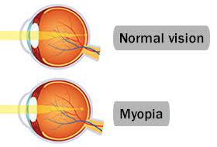
CORRECTION OF MYOPIA

To correct myopia a concave lens is administered to the client

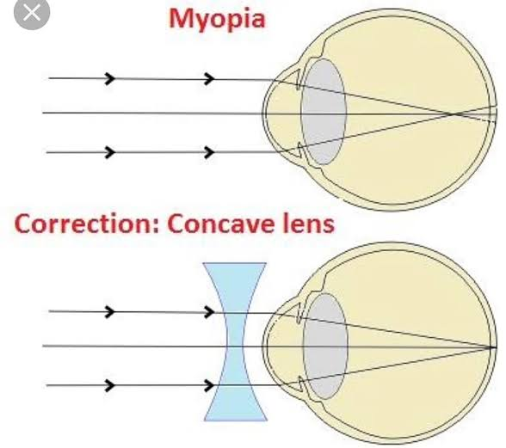

ASTIGMATISM

It is an defect in the eye or in a lens caused by a deviation from spherical curvature, which results in distorted images, as light rays are prevented from meeting at a common focus
Astigmatism is caused by genetics is a big factor. It's often present at birth, but it may develop later in life. It may also occur as a result of an injury to the eye or after eye surgery. Astigmatism often occurs with nearsightedness or farsightedness.
Who is at risk for astigmatism?

Astigmatism can occur in children and adults. Your risk of developing astigmatism may be higher if you have any of the following:

a family history of astigmatism or other eye disorders, such as keratoconus (degeneration of the cornea)
scarring or thinning of your cornea
excessive nearsightedness, which creates blurry vision at a distance
excessive farsightedness, which creates blurry close-up vision
a history of certain types of eye surgery, such as cataract surgery (surgical removal of a clouded lens)

The symptoms of astigmatism may differ in each person. Some people don’t have any symptoms at all. The symptoms of astigmatism include:

blurry, distorted, or fuzzy vision at all distances (up close and far away)
difficulty seeing at night
eyestrain
squinting
eye irritation
headaches

CORRECTION
ASTIGMATISM is corrected by corrective lens

