- Is vitamin C a coenzyme? Justify your answer
Vitamin C is not a coenzyme but performs co- enzymatic functions.Vitamin C functions as a cofactor in many enzymatic reactions in animals (and humans) that mediate a variety of essential biological functions, including wound healing and collagen synthesis. In humans, vitamin C deficiency leads to impaired collagen synthesis, contributing to the more severe symptoms of scurvy.

- Describe the chemistry of phospholipids

Phospholipids are major components of the plasma membrane, the outermost layer of animal cells. Like fats, they are composed of fatty acid chains attached to a glycerol backbone. Unlike triglycerides, which have three fatty acids, phospholipids have two fatty acids that help form a diacylglycerol. The third carbon of the glycerol backbone is also occupied by a modified phosphate group However, just a phosphate group attached to a diacylglycerol does not qualify as a phospholipid. This would be considered a phosphatidate (diacylglycerol 3-phosphate), the precursor to phospholipids. To qualify as a phospholipid, the phosphate group should be modified by an alcohol. Phosphatidylcholine and phosphatidylserine are examples of two important phospholipids that are found in plasma membranes.A phospholipid is an amphipathic molecule which means it has both a hydrophobic and a hydrophilic component. A single phospholipid molecule has a phosphate group on one end, called the “head,” and two side-by-side chains of fatty acids that make up the lipid “tails. ” The phosphate group is negatively charged, making the head polar and hydrophilic, or “water loving.” The phosphate heads are thus attracted to the water molecules in their environment.The lipid tails, on the other hand, are uncharged, nonpolar, and hydrophobic, or “water fearing.” A hydrophobic molecule repels and is repelled by water. Some lipid tails consist of saturated fatty acids and some contain unsaturated fatty acids. This combination adds to the fluidity of the tails that are constantly in motion.The structure of the most common class of phospholipids, phosphoglycerides, is based on glycerol, a three-carbon alcohol with the formula CH 2 OH–CHOH–CH 2 OH. Two fatty acid chains, each typically having an even number of carbon atoms between 14 and 20, attach (via a dual esterification ) to the first and second carbons of the glycerol molecule, denoted as the sn1 and sn2 positions, respectively. The third hydroxyl group of glycerol, at position sn3, reacts with phosphoric acid to form phosphatidate. Common phospholipids, widely distributed in nature, are produced by further reaction of the phosphate group in phosphatidate with an alcohol, such as serine, ethanolamine, choline, glyercol, or inositol. The resulting lipids may be charged, for example, phosphatidyl serine (PS), phosphatidyl inositol (PI), and phosphatidyl glyercol (PG); or dipolar (having separate positively and negatively charged regions), for example, phosphatidyl choline (PC), and phosphatidyl ethanolamine (PE). The term "lecithin" refers to PC-type lipids. A typical phospholipid arrangement is the presence of a saturated fatty acid, such as palmitic or stearic acid, at the sn1 position, and an unsaturated or polyunsaturated fatty acid, such as oleic or arachodonic acid, at sn2 (see Figure 1 for the structure of a phosphoglyceride).Another class of phospholipids is the sphingolipids. A sphingolipid molecule has the phosphatidyl-based headgroup structure described above, but (in contrast to a common phospholipid molecule) contains a single fatty acid

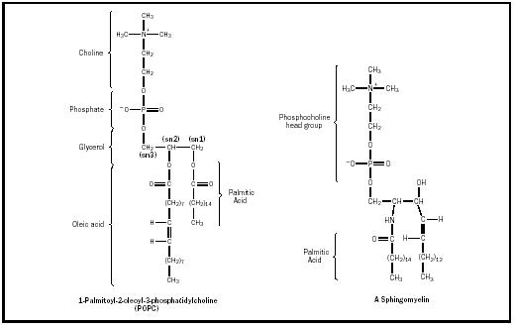

- Differentiate between phospholipids and glycolipids To aid for reading

PHOSPHOLIPIDS | GLYCOLIPIDS
- They are made by four distinguished groups: fatty acid chains, a platform, a phosphate group, and an alcohol attached to the phosphate. | - Glycolipids contain a sugar unit (can be glucose or galactose) instead of a phosphate group.
- Phospholipids provide barriers in cellular membranes to protect the cell, and they make barriers for the organelles within those cells. | - Their role is to maintain the stability of the cell membrane and to facilitate cellularrecognition, which is crucial to the immune response and in the connections that allow cells to connect to one another to form tissues.
- The structure of the phospholipid molecule generally consists of two hydrophobic fatty acid "tails" and a hydrophilic "head" consisting of a phosphate group. The two components are usually joined together by a glycerol molecule. | - The essential feature of a glycolipids is the presence of a monosaccharide or oligosaccharide bound to a lipid moiety. The most common lipids in cellular membranes are glycerolipids and sphingolipids, which have glycerol or a sphingosine backbones, respectively. Fatty acids are connected to this backbone, so that the lipid as a whole has a polar head and a non-polar tail. The lipid bilayer of the cell membrane consists of two layers of lipids, with the inner and outer surfaces of the membrane made up of the polar head groups, and the inner part of the membrane made up of the non-polar fatty acid tails.

