NAME: EKURUME OGHENEMARHO
MATRIC NO: 18/MHS02/071
DEPARTMENT: NURSING SCIENCE
COLLEGE: MEDICINE AND HEALTH SCIENCES
ASSIGNMENT TITLE: SPECIAL SENSES
COURSE TITLE: PHYSIOLOGY
COURSE CODE: PHS 212

QUESTION: DISCUSS THE PHYSIOLOGY OF BALANCE

ANSWER:
THE PHYSIOLOGY OF BALANCE: VESTIBULAR FUNCTION The vestibular system is the sensory apparatus of the inner ear that helps the body maintain its postural equilibrium. The information furnished by the vestibular system is also essential for coordinating the position of the head and the movement of the eyes. There are two sets of end organs in the inner ear, or labyrinth: the semicircular canals, which respond to rotational movements (angular acceleration); and the utricle and saccule within the vestibule, which respond to changes in the position of the head with respect to gravity (linear acceleration). The information these organs deliver is proprioceptive in character, dealing with events within the body itself, rather than exteroceptive, dealing with events outside the body, as in the case of the responses of the cochlea to sound. Functionally these organs are closely related to the cerebellum and to the reflex centres of the spinal cord and brainstem that govern the movements of the eyes, neck, and limbs.
- 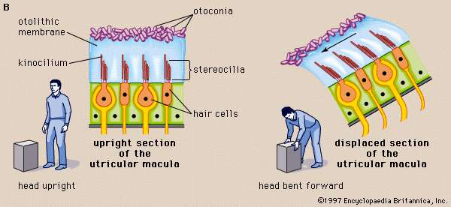
In vertebrates the utricular maculae in the inner ear contain an otolithic membrane and otoconia (particles of calcium carbonate) that bend hair cells in the direction of gravity. This response to gravitational pull helps animals maintain their sense of balance.
- 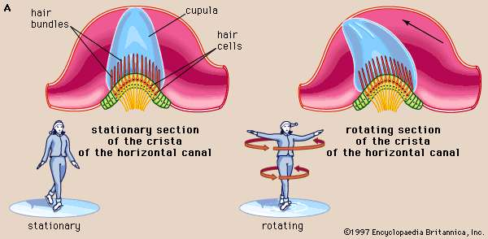
The cristae of the semicircular ducts, which form one of the two sensory organs of balance (the second being the maculae of the utricle and saccule), respond to rotational movements and are involved in dynamic equilibrium.
Although the vestibular organs and the cochlea are derived embryologically from the same formation, the otic vesicle, their association in the inner ear seems to be a matter more of convenience than of necessity. From both the developmental and the structural point of view, the kinship of the vestibular organs with the lateral line system of the fish is readily apparent. The lateral line system is made up of a series of small sense organs located in the skin of the head and along the sides of the body of fishes. Each organ contains a crista, sensory hair cells, and a cupula, as found in the ampullae of the semicircular ducts. The cristae respond to waterborne vibrations and to pressure changes.
The anatomists of the 17th and 18th centuries assumed that the entire inner ear, including the vestibular apparatus, is devoted to hearing. They were impressed by the orientation of the semicircular canals, which lie in three planes more or less perpendicular to one another, and believed that the canals must be designed for localizing a source of sound in space. The first investigator to present evidence that the vestibular labyrinth is the organ of equilibrium was French experimental neurologist Marie-Jean-Pierre Flourens, who in 1824 reported a series of experiments in which he had observed abnormal head movements in pigeons after he had cut each of the semicircular canals in turn. The plane of the movements was always the same as that of the injured canal. Hearing was not affected when he cut the nerve fibres to these organs, but it was abolished when he cut those to the basilar papilla (the bird’s uncoiled cochlea). It was not until almost half a century later that the significance of his findings was appreciated and the semicircular canals were recognized as sense organs specifically concerned with the movements and position of the head.

DISTURBANCES OF THE VESTIBULAR SYSTEM. The relation between the vestibular apparatus of the two ears is reciprocal. When the head is turned to the left, the discharge from the left horizontal canal is decreased, and vice versa. Normal posture is the result of their acting in cooperation and in opposition. When the vestibular system of one ear is damaged, the unrestrained activity of the other causes a continuous false sense of turning (vertigo) and rhythmical, jerky movements of the eyes (nystagmus), both toward the uninjured side. When the vestibular hair cells of both inner ears are injured or destroyed, as can occur during treatment with the antibiotics gentamicin or streptomycin, there may be a serious disturbance of posture and gait (ataxia) as well as severe vertigo and disorientation. In younger persons the disturbance tends to subside as reliance is placed on vision and on proprioceptive impulses from the muscles and joints as well as on cutaneous impulses from the soles of the feet to compensate for the loss of information from the semicircular canals. Recovery of some injured hair cells may occur.
Routine tests of vestibular function traditionally have involved stimulation of the semicircular canals to elicit nystagmus and other vestibular ocular reflexes. Rotation, which can cause vertigo and nystagmus, as well as temporary disorientation and a tendency to fall, stimulates the vestibular apparatus of both ears simultaneously. Because otoneurologists are usually more interested in examining the right and left ears separately, they usually employ temperature change as a stimulant. Syringing the ear canal with warm water at 44 °C (111 °F) or with cool water at 30 °C (86 °F) elicits nystagmus by setting up convection currents in the horizontal canal. The duration of the nystagmus may be timed with a stopwatch or the rate and amplitude of the movements of the eyes can be accurately recorded by picking up the resulting rhythmical variations in the corneoretinal direct current potentials, using electrodes pasted to the skin of the temples—a diagnostic process called electronystagmography. An abnormal vestibular apparatus usually yields a reduced response or no response at all.
The vestibular system may react to unaccustomed stimulation from the motion of an aircraft, a ship, or a land vehicle to produce a sense of unsteadiness, abdominal discomfort, nausea, and vomiting. Effects not unlike motion sickness, with vertigo and nystagmus, can be observed in the later stages of acute alcoholic intoxication. Vertigo accompanied by hearing loss is a prominent feature of the periodic attacks experienced by patients with Ménière disease, which, until the late 19th century, was confused with epilepsy. It was referred to as apoplectiform cerebral congestion and was treated by purging and bleeding. Other forms of vertigo may present the otoneurologist with more difficult diagnostic problems.
Since the advent of space exploration, interest in experimental and clinical studies of the vestibular system has greatly increased. Investigators are concerned particularly about its performance when persons are exposed to the microgravity of spaceflight, as compared with the Earth’s gravitational field for which it evolved. Investigations include the growing use of centrifuges large enough to rotate human subjects, as well as ingeniously automated tests of postural equilibrium for evaluating the vestibulospinal reflexes. Some astronauts have experienced relatively minor vestibular symptoms on returning from spaceflight. Some of these disturbances have lasted for several days, but none have become permanent.

