18/mhs01/225
Long term regulation of mean arterial blood pressure: The long‐term level of arterial pressure is dependent on the relationship between arterial pressure and the urinary output of salt and water, which, in turn, is affected by a number of factors, including renal sympathetic nerve activity (RSNA).
The pulmonary circulation is the portion of the circulatory system which carries deoxygenated blood away from the right ventricle, to the lungs, and returns oxygenated blood to the left atrium and ventricle of the heart.^{[1]} The term pulmonary circulation is readily paired and contrasted with the systemic circulation. The vessels of the pulmonary circulation are the pulmonary arteries and the pulmonary veins. Pulmonary hypertension describes an increase in resistance in the pulmonary arteriesPulmonary embolus is a blood clot, usually from a deep vein thrombosis that has lodged in the pulmonary vasculature. It can cause difficulty breathing or chest pain, is usually diagnosed through a CT pulmonary angiography or V/Q scan, and is often treated with anticoagulants such as heparin and warfarin.Cardiac shunt is an unnatural connection between parts of the heart that leads to blood flow that bypasses the lungs.
The Circle of Willis is the joining area of several arteries at the bottom (inferior) side of the brain. At the Circle of Willis, the internal carotid arteries branch into smaller arteries that supply oxygenated blood to over 80% of the cerebrum.
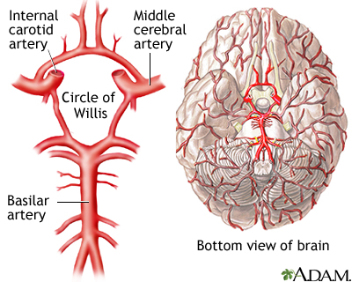

SPLANCHNIC CIRCULATION
The splanchnic circulation comprises the gastric, small intestinal, colonic, pancreatic, hepatic, and splenic circulations. They are arranged in parallel and fed by the celiac artery and the superior and inferior mesenteric arteries.
The resistance arterioles are the primary determinant of vascular resistance in the splanchnic circulation. Neuronal control of the mesenteric circulation is almost entirely sympathetic in origin.

Coronary circulation is the circulation of blood in the blood vessels that supply the heart muscle (myocardium). Coronary arteries supply oxygenated blood to the heart muscle, and cardiac veins drain away the blood once it has been deoxygenated. Because the rest of the body, and most especially the brain, needs a steady supply of.
The cutaneous circulation is the circulation and blood supply of the skin. The skin is not a very metabolically active tissue and has relatively small energy requirements, so its blood supply is different to that of other tissues.
Adjustment that occurs during exercise : changes include large increases in heart rate and cardiac contractility to increase cardiac output, increased rate and depth of respiration which requires enhanced blood flow to respiratory muscles, vasodilation and increased blood flow in the contracting skeletal muscles, and vasoconstriction in the renal. During exercise, carbon dioxide levels (the metabolic waste) rise in arterial blood. Carbon dioxide induces vasodilation in the arteries while the heart rate increases, which leads to better blood flow and tissue perfusion, and better oxygen delivery to the tissues.

