17/MHS01/149
Oghenekaro S. Ifoto

Neurohistology assignment

The spiral organ of corti
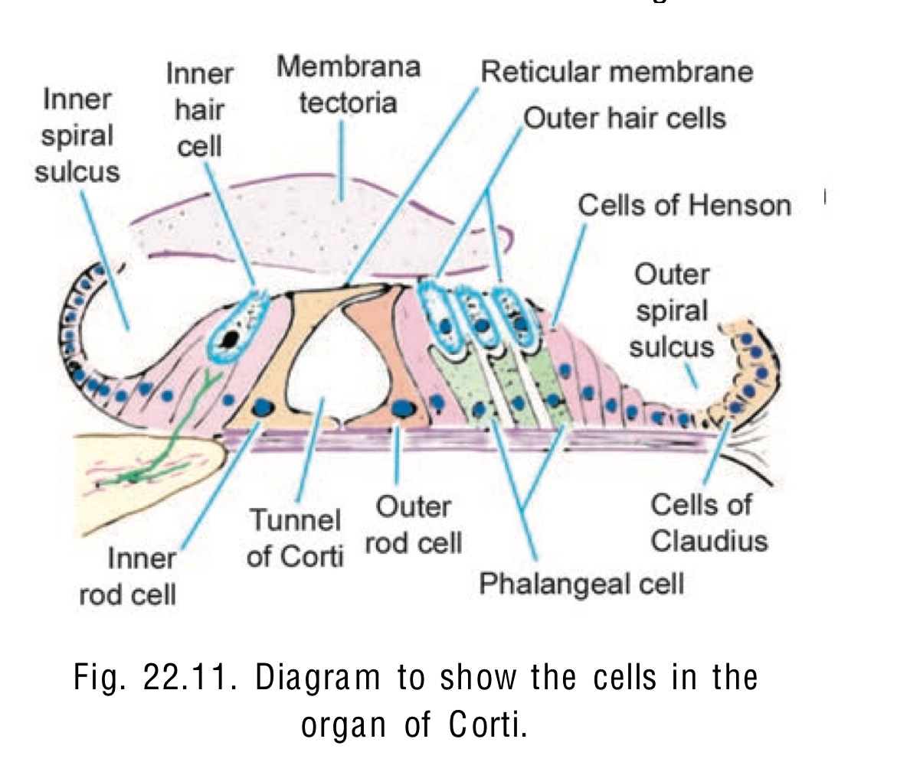
The spiral organ of Corti is so called because (like other structures in the cochlea) it extends in a spiral manner through the turns of the cochlea. In sections it is seen to be placed on The basilar membrane and to be made up of epithelial cells that are arranged in a complicated manner. The cells are divisible into the true receptor cells or hair cells, and supporting elements which are given different names depending on their location. The cells of the spiral organ are covered from above by a gelatinous mass called the membrane tectoria.
From the above diagram it will be clear that the cells of the spiral organ enclose a triangular cavity called the tunnel of Corti (or cuniculum internum). The base of the tunnels lie over the basilar membrane.
It has a sloping inner wall that is formed by internal rod cells; and a sloping outer wall that is formed by external rod cells. To the internal side of the inner rod cells there is a single row of inner hair cells. The inner hair cell is supported by tall cells lining the tympanic lip of the external spiral sulcus. On the outer side of each external rod cell there are three or four outer hair cells. The outer hair cells do not lie directly on the basilar membrane, but are supported by the phalangeal cells (of dieters) which rest on the basilar membrane. To the outer side of the outer hair cells and the phalangeal cells, there are tall supporting cells (cells of Hensen). Still more externally the outer spiral sulcus is lined by cubical cells (cells of Claudius).
A narrow space the cuniculum external intervenes between the outermost hair cells and the cells of Hensen. A third space, the cuniculum medium or space of Nielsen lies between the outer rod cell and the outer hair cells. The spaces are filled with perilymph or cortilymph.

Rod cells
Each rod cell (or pillar cell) has a broad base (or foot plate, or crus) that rests on the basilar membrane; an elongated middle part (rod or scapus); and an expanded upper end called the head or caput.
The bases of the rod cells are greatly expanded and contain their nuclei. The bases of the inner and outer rod cells meet each other forming the base of the tunnel of Corti. The heads of these cells also meet at the apex of the tunnel. Here a convex prominence on the head of the outer rod cell fits into a concavity on the head of the inner rod cell. The uppermost parts of the heads are expanded into horizontal plates called the phalangeal processes. These processes join similar processes of neighbouring cells to form a continuous membrane called the reticular lamina.

Hair cells
The hair cells are so called because their free ‘upper’ or apical ends bear a number of ‘hair’. The hair are really stereocilia.
Each cell is columnar or piriform.
The hair cells are distinctly shorter than the rod cells.
Their apices are at the level of the reticular lamina.
Their lower ends (or bases) do not reach the basilar membrane.
They rest on phalangeal cells.
The apical surface of each hair cell is thickened to form a cuticular plate the edges of which are attached to neighbouring cells.

The outer phalangeal cells and reticular lamina
These are the cells that support the outer hair cells. They lie lateral to the outer rod cells.
Their bases rest on the basilar membrane. Their apical parts have a complicated configuration.
The greater part of the apex forms a cup-like depression into which the base of an outer hair
cell fits. Arising from one side (of the apical part) of the cell there is a thin rod-like phalangeal
process. This process passes ‘upwards’, in the interval between hair cells, to reach the level
of the apices of hair cells. Here the phalangeal process expands to form a transverse plate called the phalanx.
The edges of the phalanges of adjoining phalangeal cells unite with each other to form a membrane called the reticular lamina. (The reticular lamina also receives contributions
from the heads of hair cells).

Membrana Tectoria
The membrana tectoria lies over the internal spiral sulcus and over the hair cells of the
spiral organ. It consists of delicate fibres embedded in a gelatinous matrix. This material is
probably secreted by cells lining the vestibular lip of the limbus lamina spiralis (page 361).
A narrow gap separates the membrana tectoria from the reticular lamina. The stereocilia of
outer hair cells are in contact with the membrana tectoria.

