NAME: TIMOTHY MERCY TEMILOLUWA
MATRICULATION NUMBER: 18/MHS02/183
DEPARTMENT: NURSING
COURSE CODE: PHS 212
TITLE: SPECIAL SENSES
QUESTION: DISCUSS THE SOMATOSENSORY PATHWAYS

DEFINITION:
The somatosensory tracts (also referred to as the somatosensory system or somatosensory pathways) process information about somatic sensations such as pain, temperature, touch, position, and vibration. This information is received through receptors inside or at the surface of the body.
STRUCTURE:
A somatosensory pathway will typically consist of three neurons: primary, secondary, and tertiary.
- In the periphery, the primary neuron is the sensory receptor that detects sensory stimuli like touch or temperature. The cell body of the primary neuron is housed in the dorsal root ganglion of a spinal nerve or, if sensation is in the head or neck, the ganglia of the trigeminal or cranial nerves.
- The secondary neuron acts as a relay and is located in either the spinal cord or the brainstem. This neuron’s ascending axons will cross, or decussate, to the opposite side of the spinal cord or brainstem and travel up the spinal cord to the brain, where most will terminate in either the thalamus or the cerebellum.
- Tertiary neurons have cell bodies in the thalamus and project to the postcentral gyrus of the parietal lobe, forming a sensory homunculus in the case of touch. Regarding posture, the tertiary neuron is located in the cerebellum.
PROCESSING:
The primary somatosensory area of the human cortex is located in the postcentral gyrus of the parietal lobe. The postcentral gyrus is the location of the primary somatosensory area, the area of the cortex dedicated to the processing of touch information. At this location there is a map of sensory space referred to as a sensory homunculus.
A cortical homunculus is the brain’s physical representation of the human body; it is a neurological map of the anatomical divisions of the body. The surface area of cortex dedicated to a body part correlates with the amount of somatosensory input from that area. For example, there is a large area of cortex devoted to sensation in the hands, while the back requires a much smaller area. Somatosensory information involved with proprioception and posture is processed in the cerebellum.
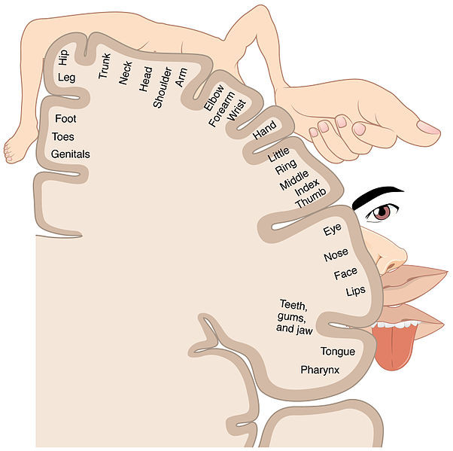
Homunculus: Image representing the cortical sensory homunculus. It shows how the anatomical portions of the body, such as the tongue, elbow, and hip, are mapped out on the homonculus. The surface area of cortex dedicated to a body part correlates with the amount of somatosensory input from that area.
FUNCTIONS:
The somatosensory system functions in the body’s periphery, spinal cord, and the brain.
- Periphery: Sensory receptors (i.e., thermoreceptors, mechanoreceptors, etc.) detect the various stimuli.
- Spinal cord: Afferent pathways in the spinal cord serve to pass information from the periphery and the rest of the body to the brain.
- Brain: The postcentral gyrus contains Brodmann areas (BA) 3a, 3b, 1, and 2 that make up the somatosensory cortex. BA3a is involved with the sense of relative position of neighboring body parts and the amount of effort being used during movement. BA3b is responsible for distributing somatosensory information to BA1 and shape and size information to BA2.
TACTILE SENSATION:
Touch is sensed by mechanoreceptive neurons that respond to pressure in various ways.
- Our sense of touch, or tactile sensation, is mediated by cutaneous mechanoreceptors located in our skin.
- There are four main types of cutaneous mechanoreceptors: Pacinian corpuscles, Meissner’s corpuscles, Merkel’s discs, and Ruffini endings.
- Cutaneous mechanoreceptors are categorized by morphology, by the type of sensation they perceive, and by the rate of adaptation. Furthermore, each has a different receptive field.
PROPRIOCEPTIVE SENSATIONS:
Proprioception refers to the sense of knowing how one’s body is positioned in three-dimensional space
Proprioception is the sense of the position of parts of our body and force being generated during movement.
- Proprioception relies on two, primary stretch receptors: Golgi tendon organs and muscle spindles.
- Muscle spindles are sensory receptors within the belly of a muscle that primarily detect changes in the length of this muscle. They convey length information to the central nervous system via sensory neurons. This information can be processed by the brain to determine the position of body parts.
- The Golgi organ (also called Golgi tendon organ, tendon organ, neurotendinous organ, or neurotendinous spindle) is a proprioceptive sensory receptor organ that is located at the insertion of skeletal muscle fibers into the tendons of skeletal muscle.
SOMATIC SENSORY PATHWAYS:
The somatosensory pathway is composed of three neurons located in the dorsal root ganglion, the spinal cord, and the thalamus.
- A somatosensory pathway will typically have three neurons: primary, secondary, and tertiary.
- The cell bodies of the three neurons in a typical somatosensory pathway are located in the dorsal root ganglion, the spinal cord, and the thalamus.
- A major target of somatosensory pathways is the postcentral gyrus in the parietal lobe of the cerebral cortex.
- A major somatosensory pathway is the dorsal column–medial lemniscal pathway.
- The postcentral gyrus is the location of the primary somatosensory area that takes the form of a map called the sensory homunculus.
MAPPING THE PRIMARY SOMATOSENSORY AREA:
The cortical sensory homunculus is located in the postcentral gyrus and provides a representation of the body to the brain.
- A sensory homunculus is a pictorial representation of the primary somatosensory cortex.
- Somatotopy is the correspondence of an area of the body to a specific point in the brain.
SOMATIC SENSORY PATHWAYS TO THE CEREBELLUM:
The ventral and dorsal spinocerebellar tracts convey proprioceptive information from the body to the cerebellum.
- The main somatosensory pathways that communicate with the cerebellum are the ventral (or anterior) and dorsal (or posterior) spinocerebellar tracts.
- The ventral spinocerebellar tract will cross to the opposite side of the body then cross again to end in the cerebellum (referred to as a double cross). The dorsal spinocerebellar tract does not decussate or cross sides at all through its path.
- The dorsal spinocerebellar tract (also called the posterior spinocerebellar tract, Flechsig’s fasciculus, or Flechsig’s tract) conveys inconscient proprioceptive information from the body to the cerebellum.
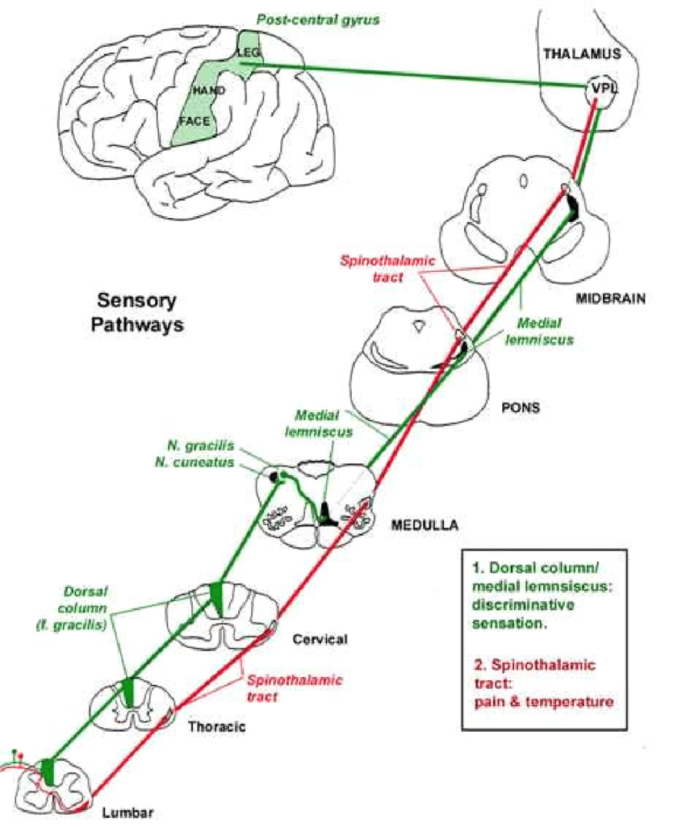
DIAGRAM OF THE SOMATOSENSORY PATHWAY

