NAME: LAWAL AMINAT TEMITOPE
MATRIC NO.: 17/MHS01/177
LEVEL: 300
DEPARTMENT: MEDICINE AND SURGERY
COURSE CODE: ANA 305
ASSIGNMENT TITLE: HISTOLOGY OF SPECIAL SENSES
HISTOLOGY OF ORGAN OF CORTI
The organ of Corti, or spiral organ, is the receptor organ for hearing and it is located in the cochlea. This highly varied strip of epithelial cells allows for transduction of auditory signals into nerve impulses’ action potential. Transduction occurs through vibration of structures in the inner ear causing displacement of cochlear fluid and movement of hair cells at the organ of Corti to produce electrochemical signals.
The organ of Corti is located in the scala media of the cochlea of the inner ear between the vestibular duct and the tympanic duct and is composed of mechanosensory cells known as hair cells. Positioned on the basilar membrane of the organ of Corti are three rows of outer hair cells and one row of inner hair cells. Supporting cells known as Deiters calls or phalangeal cells separate and support these hair cells.
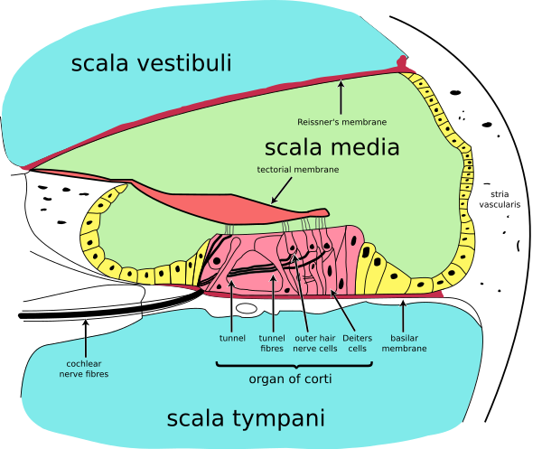
Projecting from the tops of the hair cells are tiny finger-like projections called stereocilia, which are arranged in a graduated fashion with the shortest stereocilia on the outer rows and the longest in the center. This gradation is thought to be the most important anatomic feature of the organ of Corti because it allows the sensory cells to have superior tuning capability.
If the cochlea were uncoiled, it would roll out to be about 33mm long in women and 34mm in men, with about 2.28mm of standard deviation for the population. The base of the cochlea, closest to the outer ear, is stiff and narrow and it is where the high frequency sounds are transduced. The apex of the cochlea is wider and much more flexible and loose and functions as the transduction site for low frequency sounds.
The function of the organ of Corti is to transduce or change auditory signals and minimize the hair cells’ extraction of sound energy. In normal hearing, the majority of auditory signals that reach the organ of Corti in the first place come from the outer ear. Sound waves enter through the auditory canal and vibrate the tympanic membrane which vibrates three small bones called the ossicles. As a result, the attached oval window moves and causes movement of the round window, which leads to displacement of the cochlear fluid. However, the stimulation can also happen via direct vibration of the cochlea from the skull.
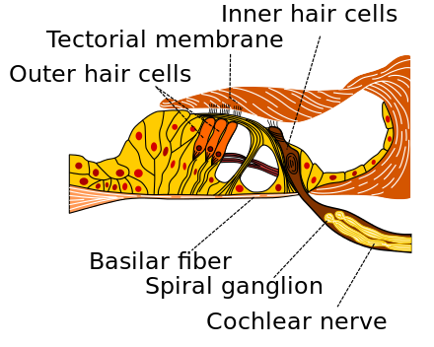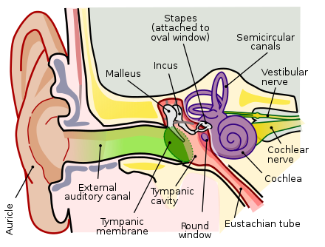
The organ of Corti is surrounded by a potassium-rich fluid called endolymph and it lies on the basilar membrane at the base of the scala media. Under the organ of Corti is the scala tympani and above it, the scala vestibule. Both structures exist in a low potassium fluid called perilymph.
The organ of Corti is also capable of modulating the auditory signal. The outer hair cells can amplify the signal through a process called electromotility where they increae movement of the basilar and tectorial membranes and therefore increase deflection of stereocilia in the inner hair cells.
CLINICAL ANATOMY
- HEARING LOSS: The organ of Corti can be damaged by excessive sound levels, leading to noise-induced impairment. The most common kind of hearing impairment, sensorineural hearing loss, includes as one major cause the reduction of function in the organ of Corti. The active amplification function of the outer hair cells is very sensitive to damage from exposure to trauma from overly-loud sounds or to certain ontoxic drugs. Once outer hair cells are damaged, they do not regenerate, and the result is a loss of sensitivity and an abnormally large growth of loudness in the part of the spectrum that the damaged cells serve.

