NAME: LAWAL AMINAT TEMITOPE
MATRIC NO.: 17/MHS01/177
LEVEL: 300
DEPARTMENT: MEDICINE AND SURGERY
COURSE CODE: PHS 303
ASSIGNMENT TITLE: RENAL PHYSIOLOGY BODY FLUID AND TEMPERATURE REGULATION
QUESTION 1:
PATHOPHYSIOLOGICAL PROCESS OF RENAL FAILURE
Kidney failure, also known as end-stage kidney disease, is a medical condition in which the kidneys are functioning at less than 15% of normal. Kidney failure is classified as either acute kidney failure, which develops rapidly and may resolve; or chronic kidney failure which develops slowly. Acute kidney failure occurs when the kidneys suddenly become unable to filter waste products from the blood. Acute kidney failure, also known as renal failure or kidney injury, develops rapidly, usually in less than a few days. Symptoms may include leg swelling, feeling tired, vomiting, loss of appetite and confusion. Complications of acute and chronic failure include uremia, high blood potassium and volume overload.
Acute kidney injury, also called acute kidney failure, is a rapid, progressive loss of renal function. It is generally characterized by decreased urine production (oliguria). Causes of acute kidney failure include; low blood pressure, blockage of the urinary tract, certain medications, muscle breakdown and hemolytic uremic syndrome. Many people diagnosed with acute kidney failure sometimes require hemodialysis.
Causes of chronic kidney failure include diabetes, high blood pressure, nephritic syndrome and polycystic kidney disease. Chronic kidney failure develops slowly and initially, shows few symptoms.
Symptoms of kidney failure include;
- High levels of urea in the blood which may result in vomiting or diarrhea, nausea, weight loss, nocturnal urination, blood in urine, difficulty in urinating e.t.c.
- A buildup of phosphates in blood that the diseased kidneys cannot filter out resulting in itching, bone damage, muscle cramps.
- Failure of the kidneys to remove excess fluid which leads to swelling of the hands, legs, ankles, feet or face.
- A buildup of potassium in the blood which leads to abnormal heart rhythms and muscle paralysis.
- Polycystic kidney disease.
- Foamy or bubbly urine, excess protein in the blood, darkening of skin e.t.c
Acute kidney failure usually occurs when the blood supply to the kidneys is suddenly interrupted or when the kidneys are overloaded with toxins. Causes of acute kidney failure include accidents, injuries or complications from surgeries. Unlike chronic kidney failure, the kidneys can often recover from acute kidney failure, allowing the person to resume a normal life.
The most common causes of chronic kidney failure are diabetes mellitus and long-term uncontrolled hypertension. Polycystic kidney disease is another well-known cause. Overuse of common drugs such as ibuprofen and acetaminophen can also cause chronic kidney failure.
Chronic kidney failure is measured in five stages, which are calculated using a person’s glomerular filtration rate. Stage 1 chronic kidney failure is mildly diminished renal function, with few overt symptoms. Stages 2 and 3 need increasing levels of supportive care from their medical providers to slow and treat their renal dysfunction. People with stage 4 and 5 kidney failure usually require preparation towards active treatment in order to survive. Stage 5 chronic kidney failure is considered a severe illness and requires some form of renal replacement therapy (dialysis) or kidney transplant whenever feasible.
TREATMENT
The treatment of acute kidney injury depends on the cause. The treatment of chronic kidney failure may include renal replacement therapy: hemodialysis, peritoneal dialysis, or kidney transplant.
QUESTION 2:
TYPES OF DIALYSIS
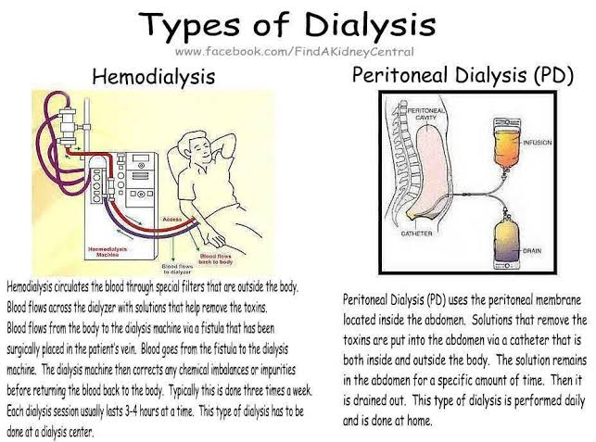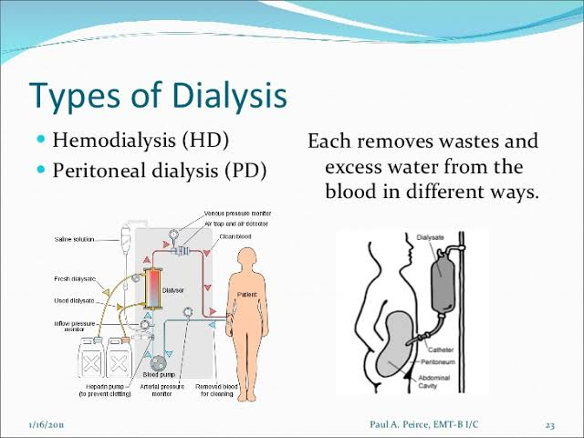
Dialysis is a treatment that filters and purifies the blood using a machine. Dialysis performs the functions of the kidneys if they have failed. Dialysis helps to keep the fluids and electrolytes of the body in balance when the kidneys cannot do their jobs. Dialysis has been used since the 1940s to treat people with kidney problems. The types of dialysis include;
- HEMODIALYSIS: It is the most common type of dialysis. This process uses an artificial kidney (hemodialyzer) to remove waste and extra fluid from the blood. The blood is removed from the body and filtered through the artificial kidney. The filtered blood is then returned to the body with the help of a dialysis machine. To get the blood to flow to the artificial kidney, three entrance points are created. They include;
- Arteriovenous (AV) fistula: It connects an artery and a vein. It is the preferred option.
- AV graft: It is a looped tube.
- Vascular access catheter: It may be inserted into the large vein in the neck.
Both AV fistula and AV graft are designed for long-term dialysis treatments. People who receive AV fistulas are healed and ready to begin hemodialysis two to three months after their surgery. People who receive AV grafts are ready in two to three weeks. Hemodialysis treatments usually last three to five hours and are performed three times per week.
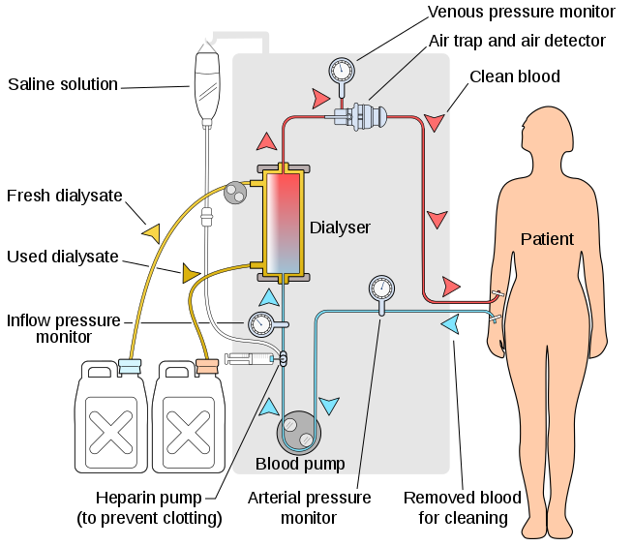
- PERITONEAL DIALYSIS: It involves surgery to implant a peritoneal dialysis catheter into the abdomen. The catheter helps to filter blood through the peritoneum. During treatment, a special fluid called dialysate flows into the peritoneum. The dialysate absorbs waste. It draws waste from the bloodstream and drains it from the abdomen. The process takes a few hours and needs to be repeated four to six times per day. The main types of peritoneal dialysis are;
- Continuous ambulatory peritoneal dialysis (CAPD): The abdomen is filled and drained multiple times each day. This method does not require a machine and must be performed while awake.
- Continuous cycling peritoneal dialysis (CCPD): CCPD uses a machine to cycle fluid in and out of the abdomen. It is usually done at night while sleeping.
- Intermittent peritoneal dialysis (IPD): It is usually performed in the hospital, though it can be performed at home. It uses the same machine as CCPD but the process takes longer.
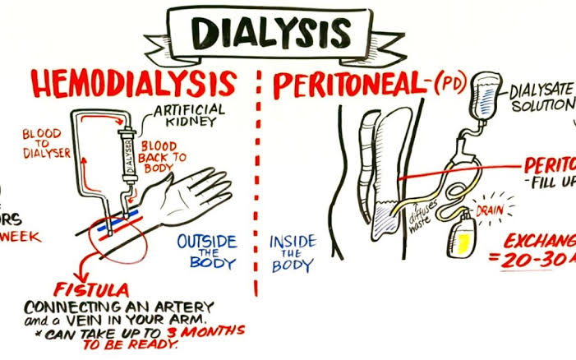
- CONTINUOUS RENAL REPLACEMENT THERAPY: This is used primarily in the intensive care unit for people with acute kidney failure. It is also known as hemofiltration. A machine passes the blood through tubing. A filter then removes waste products and water. The blood is returned to the body, along with replacement fluid. This procedure is performed 12 to 24 hours a day, generally every day.
RISKS ASSOCIATED WITH DIALYSIS
Risks associated with hemodialysis include;
- Low blood pressure.
- Anemia.
- Muscle cramping.
- Difficulty sleeping.
- High blood potassium levels.
- Itching.
- Irregular heartbeat.
- Sudden cardiac death.
- Sepsis.
Risks associated with peritoneal dialysis include;
- Peritonitis (infection of the membrane lining the abdominal wall).
- Abdominal muscle weakening.
- Weight gain.
- Hernia.
- Fever.
- Stomach pain.
- High blood sugar due to the dextrose in the dialysate.
Risks associated with continuous renal replacement therapy include;
- Low blood pressure.
- Infection.
- Hypothermia.
- Weakening of bones.
- Anaphylaxis.

