NAME: Ibironke Boluwatife Omooghelle
MATRIC NO: 17/MHS05/011
HISTOLOGY OF THE EAR
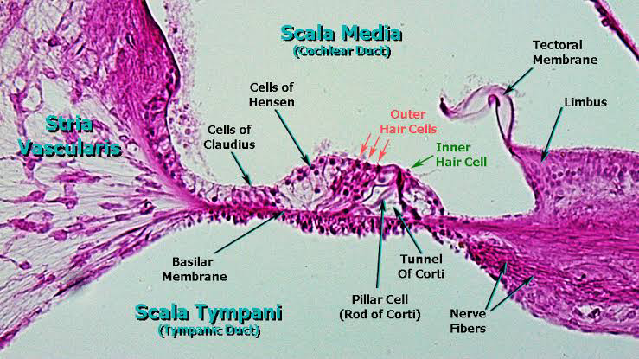
The organ of Corti, or spiral organ, is the receptor organ for hearing and is located in the mammalian cochlea. This highly varied strip of epithelial cells allows for transduction of auditory signals into nerve impulses' action potential.[1] Transduction occurs through vibrations of structures in the inner ear causing displacement of cochlear fluid and movement of hair cells at the organ of Corti to produce electrochemical signals

The organ of Corti consists of two kinds of hair cells and various supporting cells in a complex arrangement (NOTE: you may notice green lipid granules in some of the outer supporting cells, particularly toward the apex of the cochlea, but these support cells can change their mass and volume by altering the amount of lipid in their cytoplasm. The overall effect is a subtle change in the overall geometry of the organ of Corti and thus is a mechanism for fine tuning the sensitivity of the organ, particularly to low frequency sound).
The organ of Corti contains:

1.)The outer hair cells surrounded by outer phalangeal cells. There are three rows of outer hair cells. The apices of these cells and their phalangeal cells are joined together to form the reticular membrane (also called reticular lamina or apical cuticular plate) that separates endolymph in the scala media from underlying corticolymph and perilymph of the scala tympani. Lateral to the outer hair cells and phalangeal cells are other support cells, but you don’t need to worry about knowing their specific types. Note that outer hair cells account for only ~5-10% of the sensory input into the auditory system. The primary function of outer hair cells is actually to contract when stimulated, thus “pulling” on the tectoral membrane thereby stimulating the inner hair cells.

2.)Outer and inner pillar cells outline a triangular shaped tunnel, called the inner tunnel, which is filled with perilymph-like fluid called corticolymph.
3.)The inner hair cells are in a single row close to the inner pillar cells (you may see more than one inner cell nucleus because of the thickness of the section). Note that the inner hair cells account for ~90-95% of the sensory input into the auditory system.

4.)The organ of Corti is overlaid by a gelatinous tectorial membrane (produced and maintained by the columnar cells found atop the spiral limbus just medial to the organ of Corti).

5.)Nerve fibers enter the organ of Corti through openings in a shelf of bone extending from the modiolus like the thread of a screw. The nerve fibers pass between supporting cells to synapse with the hair cells. Compare the innervation and function of the inner vs. outer hair cells.
Loss of OUTER HAIR CELLS in a particular region of the cochlea would result in a “threshold shift” whereby sound of a particular frequency could still be detected (because the inner hair cells are still intact), but it would have to be LOUDER to make up for the fact that there are no outer hair cells to help stimulate the inner hair cells. This type of hearing loss can be compensated by a hearing aid.

Loss of INNER HAIR CELLS in a particular region of the cochlea would result in an almost complete inability to detect specific frequencies regardless of how loud they are. Loss of SPIRAL GANGLION CELLS would have a similar effect since these are the cells that actually project into the CNS. In both cases, the deafness could only be corrected with a cochlear implant.

