HISTOLOGY OF SPECIAL SENSES ASSIGNMENT II
18/MHS01/379
AMOO OLUWANIFEMI MICHAEL
MEDICINE AND SURGERY

ORGAN OF CORTI
The organ of Corti is a specialized sensory epithelium that allows for the transduction of sound vibrations into neural signals. The organ of Corti itself is located on the basilar membrane. The organ of Corti rests on the basilar membrane and contains two types of hair cells: inner hair cells and outer hair cells. Inner hair cells transduce sound from vibrations to neural signals via the shearing action of their stereocilia. Outer hair cells serve a function as acoustic pre-amplifiers which improve frequency selectivity by allowing the organ of Corti to become attuned to specific frequencies, like those of speech or music. The fibrous tectorial membrane rests on top of the stereocilia or the outer hair cells. Mutations in alpha-tectorin, which encodes a protein specific to the tectorial membrane, cause deafness.

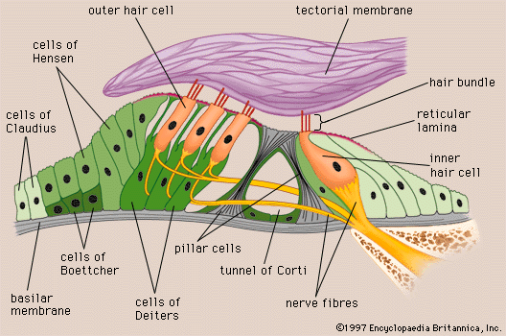
The primary function of the organ of Corti is the transduction of auditory signals. Sound waves enter the ear via the auditory canal and cause vibration of the tympanic membrane. Movement of the tympanic membrane causes subsequent vibrations within the ossicles, the three bones of the middle ear which transfer the energy to the cochlea through the oval window. As the oval window moves, waves transfer to the perilymph fluid inside the scala tympani and then the scala vestibule of the cochlea. When fluid moves through these structures, the basilar membrane (located between the scala media and scala tympani) shifts respectively to the tectorial membrane.
The organ of Corti is an organ of the inner ear contained within the scala media of the cochlea. It resides on the basilar membrane, a stiff membrane separating the scala tympani and scala media. The scala media is a cavity within the cochlea that contains endolymph which has a high (150 mM) K+ concentration. The endolymph helps to regulate the electrochemical impulses of the auditory hair cells. The organ of Corti is composed of both supporting cells and mechanosensory hair cells. The arrangement of mechanosensory cells are into inner and outer hair cells along rows (Figure 1B). There is a single row of inner hair cells and three rows of outer hair cells which are separated by the supporting cells. The supporting cells are also named Dieters or phalangeal cells.
The hair cells within the organ of Corti have sterocilia that attach to the tectorial membrane. Shifts between the tectorial and basilar membranes move these sterocilia and activate or deactivate receptors on the hair cell surface. When cation channels open on the hair cells, potassium ions flow into the hair cells, the cells depolarize, and the depolarization causes voltage-gated calcium channels to open. The calcium influx results in glutamate release from the hair cells onto the auditory nerve. The auditory nerve then sends information about the sound wave to the brain. Inner hair cells function primarily as the sensory organs for audition. They provide input to 95% of the auditory nerve fibers that project to the brain. The stiffness and size of the hair cell arrangement throughout the cochlea enable hair cells to respond to a variety of frequencies from low to high. Cells at the apex to respond to lower frequencies while hair cells at the base of the cochlea (near the oval window) respond to higher frequencies, which creates a tonotopic gradient throughout the cochlea.

