17/MHS01/149
Oghenekaro S. Ifoto
Medicine and surgery
Renal physiology assignment

QUESTION 1 - Discuss the pathophysiological process involves in renal failure

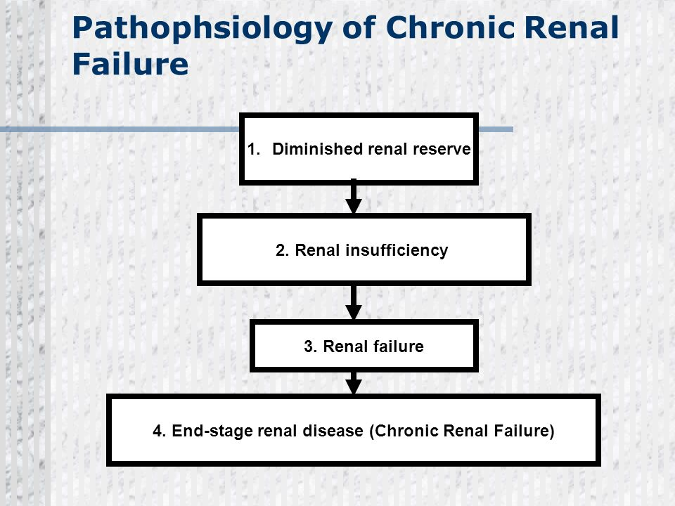

PATHOPHYSIOLOGY OF CHRONIC RENAL FAILURE - Definition
Renal failure pathophysiology: once the loss of nephrons and reduction of functional renal mass reaches a certain point, the remaining nephrons begin a process of irreversible sclerosis that leads to a progressive decline in glomerular filtration rate.
Stages of chronic renal failure are based on the glomerular filtration rate:
The normal glomerular filtration rate is 125cc/min/1.73m
Stage 1: GFR is greater than or equal to 90ml/min/1.73m- kidney damage with normal or increased GFR.
Stage 2: GFR is equal to 60-89mL/min/1.73m. Mild decrease in GFR.
Stage 3: GFR is equal to 30-59 mL/min/1.73m. Moderate decrease in GFR.
Stage 4: GFR is equal to 15 - 29 mL/min/1.73m. Severe decrease in GFR.
Stage 5: GFR is less than 15mL/min/1.73m. Kidney failure.

ACUTE RENAL FAILURE
- Abrupt cessation of activity of the nephrons usually presents initially as a marked fall in urine production (oliguria), which may even be total (anuria).
- This is accompanied by a rapid rise in serum urea and creatinine levels.
- Disturbances of fluid and electrolyte balances soon follow, particularly a rise in the serum potassium level and metabolic acidosis.
CHRONIC RENAL FAILURE
- Progressive retention of nitrogenous metabolites causes a slow rise in serum creatinine levels due to insufficient glomerular filtration.
- Concomitant failure of tubular function produces widespread abnormalities in biochemical homeostasis, including salt and water retention, metabolic acidosis and other electrolyte imbalances, particularly hyperkalaemia.
- Clinical manifestations of full blown Chronic Renal Failure: described under 2 headings:
primary (renal) uraemic manifestations
Secondary (systemic or extra-renal) uraemic manifestations

- PRIMARY URAEMIC MANIFESTATIONS
metabolic acidosis. As a result of renal dysfunction, acid base balance is progressively lost. Excess hydrogen ions and decline in bicarbonate levels in the blood resulting in metabolic acidosis.
The clinical symptoms of metabolic acidosis include: compensatory breathing, hyperkalaemia and hypercalcaemia.
Hyperkalaemia. A decreases glomerular filtration rate results in excessive accumulation of potassium in the blood since potassium is normally excreted mainly in the urine.
Sodium and water imbalance: as glomerular filtration rate declines, sodium and water cannot pass sufficiently into Bowman’s capsule leading to their retention. Release of renin from the juxtaglomerular apparatus further aggravates sodium and water retention.
Hyperuricaemia: decreased glomerular filtration results in excessive accumulation of uric acid in the blood. Uric acid crystals may be deposited in joints and soft tissues resulting in gout.
Azotaemia: the waste products of protein metabolism fail to be excreted resulting in elevation in the blood levels of urea, creatinine, phenols and guanidines causing biochemical abnormality, azotaemia.
- SECONDARY URAEMIC MANIFESTATIONS
ANAEMIA. Decreased production of erythropoietin by diseased kidney results in decline in erythropoiesis and anaemia.
INTEGUMENTARY SYSTEM. The deposit of urinary pigment such as urochrome in the skin causes sallow-yellow colour.
CARDIOVASCULAR SYSTEM. Azotaemia directly induces mucosal ulcerations in the lining of the stomach and intestines. Subsequent bleeding can aggravate anaemia.
SKELETAL SYSTEM. Two major types of skeletal disorders may occur. Osteomalacia and osteitis fibrosa.

END-STAGE KIDNEY
Many kidney diseases, whatever the underlying cause, may progress to chronic renal failure. Macroscopically, the kidneys are usually found to be small and firm with symmetrical thinning of the cortex and poor demarcation of the cortex from the medulla. This condition is known as end-stage kidney. In both gross and histological appearance, there is often little clue to the original renal pathology. In the cortex, the non-functioning or obsolescent glomeruli are replaced by avascular, acellular fibrous material (fibrosis).

Question 2 - With the aid of suitable diagrams discuss the types of dialysis you know

the term dialysis in physiological sense refers to the diffusion of solutes from an area of higher concentration to the area of lower concentration through a semipermeable membrane. This theory has been used to dialyse the blood of patients with renal failure especially those developing uraemia.
TYPES OF DIALYSIS
There are three primary and two secondary types of dialysis:
- hemodialysis (primary)
- peritoneal dialysis (primary)
- hemofiltration (primary)
- hemodiafiltration (secondary)
- intestinal dialysis (secondary)

- Haemodialysis
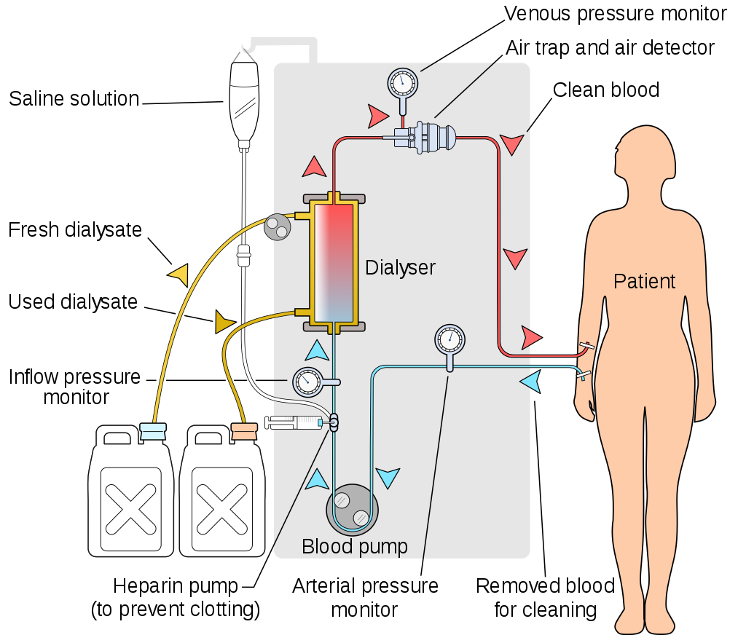

Haemodialysis machine is also called artificial kidney. Haemodialysis is done in a hospitalized patient through intravenous (IV) line for 3-5 hours. During haemodialysis, the patient’s radial artery is connected to the haemodialysis machine. Inside the haemodialysis machine, the blood is passed through a long and coiled cellophane tube immersed in a dialysis fluid. Heparin is used as an anticoagulant while passing the blood through the machine.
Dialyzing fluid. The composition of a dialyzing fluid is similar to that of the plasma, except it is free of waste products like urea, uric acid etc. The fluid contains less amount of sodium, potassium and chloride ions than in the uraemic blood. But the quantity of glucose, bicarbonate and calcium ions are more in the dialyzing fluid than in the uraemic blood.
During haemolysis, the semipermeable cellophane membrane permits the free diffusion of the constituents of plasma except proteins. In this way, the dialysis of a patient’s blood removes the toxic waste products and restores normal electrolyte concentration in the plasma. The dialysed blood is returned back to the patient’s body through a peripheral vein. At a time about 500 mL is passed through the artificial kidney. Haemodialysis is done usually thrice a week in severe uraemia.
Haemodialysis can save the life in many types of acute renal failure. The intermittent haemodialysis may prolong the life of many patients with chronic renal failure, which may lead an active life for many useful years.
The dialysis can partially replace the excretory functions of the kidneys but does not replace the endocrine and metabolic functions.

- Peritoneal dialysis
Peritoneal dialysis is a form of long-term dialysis done by the patients at home or at work. In this type of dialysis, the peritoneum acts as a semipermeable membrane.
Two litres of dialyzing fluid is introduced through an intraperitoneal catheter. It is then kept in the peritoneal cavity for exchange to take place for a period of 15-20 minutes called dwell time. Fluid is then drained out and measured. A strict input and output chart is maintained. The whole procedure constitutes one cycle. It os done at 6 hour intervals (4 cycles/ day), even when the patient is ambulatory or mobile. There is no need for hospitalization. It is useful for young children and old patients with cardiovascular disorders. It prolongs survival in patients with chronic renal failure for many years. Peritoneal dialysis is not very suitable for drug poisoning cases.

- HEMOFILTRATION
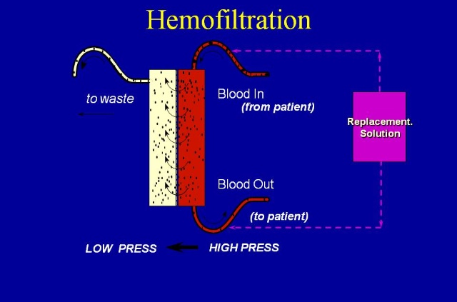
Hemofiltration is a similar treatment to hemodialysis, but it makes use of a different principle. The blood is pumped through a dialyzer or "hemofilter" as in dialysis, but no dialysate is used. A pressure gradient is applied; as a result, water moves across the very permeable membrane rapidly, "dragging" along with it many dissolved substances, including ones with large molecular weights, which are not cleared as well by hemodialysis. Salts and water lost from the blood during this process are replaced with a "substitution fluid" that is infused into the extracorporeal circuit during the treatment.

- HEMODIAFILTRATION
Hemodiafiltration is a combination of hemodialysis and Hemofiltration, thus used to purify the blood from toxins when the kidney is not working normally and also used to treat acute kidney injury (AKI).
In hemodiafiltration, solute removal is achieved across a semi-permeable membrane by CONVECTION AND DIFFUSION - a positive pressure is used to drive water across the membrane and solutes are dragged with the water movement. Larger solutes are removed. Highly pure replacement fluid is infused into the blood line to replace fluid volume and electrolytes.

- INTESTINAL DIALYSIS
In intestinal dialysis, the diet is supplemented with soluble fibres such as acacia fibre, which is digested by bacteria in the colon. This bacterial growth increases the amount of nitrogen that is eliminated in fecal waste.[13][14][15] An alternative approach utilizes the ingestion of 1 to 1.5 liters of non-absorbable solutions of polyethylene glycol or mannitol every fourth hour.

