NAME: MOTAJO OLAKUNLE OLUWATOSIN
MATRIC NUMBER: 17/MHS01/190
DEPARTMENT: MEDICINE AND SURGERY
COURSE: HISTOLOGY OF SPECIAL SENSES AND NEUROHISTOLOGY
COURSE CODE: ANA 305

QUESTION: With the aid of a diagram, write an essay on the histology of an organ of Corti
Answer:
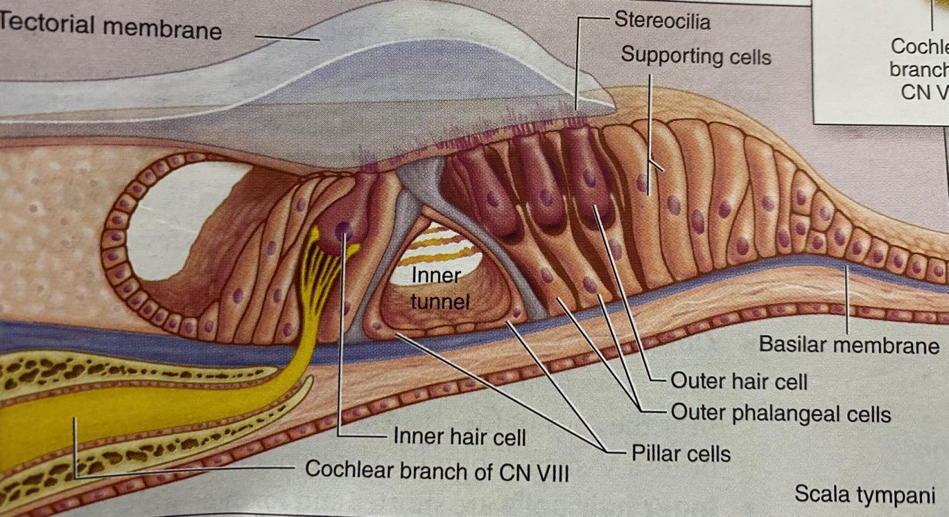
The organ of Corti is a specialized sensory epithelium that allows for the transduction of sound vibrations into neural signals. The organ of Corti itself is located on the basilar membrane. The organ of Corti, or spiral organ, where sound vibrations of different frequencies are detected, consists of hair cells and other epithelial structures supported by the basilar membrane. Here the sensory hair cells have precisely arranged V-shaped bundles of rigid stereocilia, each loses its single larger kinocilium during development. Two major types of hair cells are present:
- Outer hair cells: are about 12,000 in total and they occur in three rows near the saccule, increasing to five rows near the apex of the cochlea. Each columnar outer hair cell bears a V-shaped bundle of stereocilia. Outer hair cells serves as acoustic pre-amplifiers which improve frequency selectivity by allowing the organ of Corti to become attuned to specific frequencies, like those of speech or music.
- Inner hair cells: are shorter and form a single row of about 3500 cells, each with a single linear array of shorter stereocilia. Inner hair cells transduce sound from vibrations to neural signals via the shearing action of their stereocilia.
Both outer and inner hair cells have synaptic connections with afferent and efferent nerve endings, with the inner row of cells more heavily innervated. The cell bodies of the afferent bipolar neurons constitute the spiral ganglion located in the bony core of the modiolus.
Two major types of columnar supporting cells are attached to the basilar membrane in the organ of Corti:
- Inner and outer phalangeal cells: extend apical processes that intimately surround and support the basolateral parts of both inner and outer hair cells and the synaptic nerve endings. The apical ends of phalangeal cells are joined to those of the hair cells by tight zonulae occludens, forming an apical plate across the spiral organ through which the stereocilia bundles project into endolymph.
- Pillar cells: are stiffened by heavy bundles of keratin and outline a triangular space, the inner tunnel, between the outer and inner complexes of hair cells and phalangeal cells. The stiff inner tunnel also plays a role in sound transmission.
On the outer hair cells the tips of the tallest stereocilia are embedded in the gel-like tectorial membrane, an acellular layer that extends over the organ of Corti from the connective tissue around the modiolus. The tectorial membrane consists of fine bundles of collagen (types II, V, IX, and XI) associated with proteoglycans and forms during the embryonic period from secretions of cells lining this region.
Functions of organ of corti
The function of the organ of Corti is to change (transduce) auditory signals and minimise the hair cells’ extraction of sound energy. Also the organ of corti is capable of performing Cochlear Amplification and it does this by modulating the auditory signal. The outer hair cells (OHCs) can amplify the auditory signal through a process called electromotility where they increase movement of the basilar and tectorial membranes and therefore increase deflection of stereocilia in the inner hair cells.
A crucial piece to this cochlear amplification is the motor protein prestin, which changes shape based on the voltage potential inside of the hair cell. When the cell is depolarized, prestin shortens, and because it is located on the membrane of outer hair cells, it then pulls on the basilar membrane and thus increasing how much the membrane is deflected, creating a more intense effect on the inner hair cells. When the cell hyperpolarizes prestin lengthens and eases tension on the inner hair cells which decreases the neural impulses to the brain. In this way, the hair cell itself is able to modify the auditory signal before it even reaches the brain.

