NAME: ABDULAZIZ HALIMAH BOLANLE
LEVEL: 300 LEVEL
MATRIC NO: 17/MHS01/003
NEUROHISTOLOGY ASSIGNMENT: ESSAY ON HISTOLOGY OF CORTI

THE ORGAN OF CORTI
The organ of Corti is a specialized sensory epithelium that allows for the transduction of sound vibrations into neural signals. The organ of Corti itself is located on the basilar membrane. The organ of Corti rests on the basilar membrane and contains two types of hair cells: inner hair cells and outer hair cells. Inner hair cells transduce sound from vibrations to neural signals via the shearing action of their stereocilia. Outer hair cells serve a function as acoustic pre-amplifiers which improve frequency selectivity by allowing the organ of Corti to become attuned to specific frequencies, like those of speech or music. The fibrous tectorial membrane rests on top of the stereocilia or the outer hair cells.

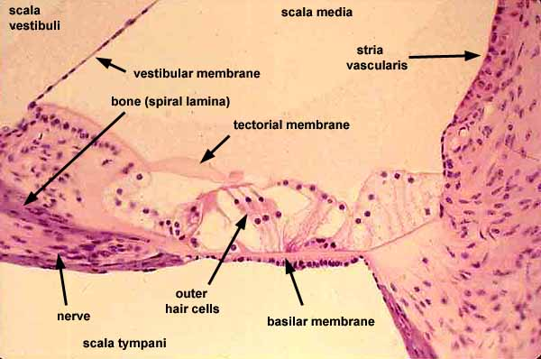
CREDIT: SIU SOM HISTOLOGY

Italian anatomist Alfonso Giacomo Gaspare Corti (1822–1876) discovered the organ of Corti in 1851
The organ of Corti is located in the scala media of the cochlea of the inner ear between the vestibular duct and the tympanic duct and is composed of mechanosensory cells, known as hair cells. Strategically positioned on the basilar membrane of the organ of Corti are three rows of outer hair cells (OHCs) and one row of inner hair cells (IHCs).
Separating these hair cells are supporting cells: Deiters cells, also called phalangeal cells, which separate and support both the OHCs and the IHCs.
Projecting from the tops of the hair cells are tiny finger like projections called stereocilia, which are arranged in a graduated fashion with the shortest stereocilia on the outer rows and the longest in the center. This gradation is thought to be the most important anatomic feature of the organ of Corti because this allows the sensory cells superior tuning capability.
If the cochlea were uncoiled, it would roll out to be about 33 mm long in women and 34 mm in men, with about 2.28 mm of standard deviation for the population.
The cochlea is also tonotopically organized, meaning that different frequencies of sound waves interact with different locations on the structure. The base of the cochlea, closest to the outer ear, is the most stiff and narrow and is where the high frequency sounds are transduced. The apex, or top, of the cochlea is wider and much more flexible and loose and functions as the transduction site for low frequency sounds.^{[7]}
- Organ of Corti consists of different types of cells:
-inner hair cells
-outer hair cells
-Supporting cells

Inner Hair Cell
These cells are specialized in the mechanoelectrical transduction. There are almost 3500 cells disposed in one line along all the basilar membrane. They are connected to type I neuron peripheral fibers of spiral ganglion, these connection are very divergent (10/1). The luminal part of the cell is immerged in endolymph, the basal one is immerged in normal extracellular fluid. The luminal portion is formed by bundles of stereocilia(inner_ear), whose tips are connected by filamentous structures called tip-links.

Outer Hair Cell
These cells are acoustical pre-amplifiers. They are almost 12000, disposed in three parallel lines. These cells are connected to type II amyelinic neurons, the connections are very convergent. They have also an afference from superior olivary nucleus. They have contractile activity.

Supporting Cells
These cells are of four different types: Corti pillars, Hensen cells, Deiters cells and Claudius cells.
Deiters’ cells consist of three parts: 1) the cell body, which forms a cup at the topic face attached to the OHC on the basilar membrane, 2) the straight phalangeal process, extending obliquely and passing two or three OHCs, free of mechanical contact, and 3) the head of the phalangeal process, forming tight junctions with the apical circumference of the OHC at the level of reticular laminar. There are relatively few organelles such as rough endoplasm reticule, lysosomes and mitochondria in the Deiters cell. The round nuclear appears to be of low electronic density.
Consisted of microtubes and microfilaments, the phalangeal process is a prominent structure characteristic of the Deiters’ cell. The complex and yet precisely arranged microfilaments play an important role in the micromechanical aspect of cochlear function. They can transmit mechanical force between cells and coordinate shift of adjacent cells
Hensen’s cells are somewhat column like, upper part wide and lower part narrow. Under electronic microscope, their cytoplasm is thin and endoplasmic reticulum undeveloped, with relatively few mitochondria dispersed in the cytoplasm. The copular part is toward the scala media, with numerous microvilli, which are 0.4–0.6 micrometer long. A characteristic of Hensen’s cell is its phagosomes in the cytoplasm, indicating a function of phagocytosis. Lipid droplets are another morphologic feature of Hensen’s cell and most noticeable at the third and fourth turns of the cochlear. Hensen’s cells at the basal and second turns contain few lipid droplets. The lipid content increase progressively at the second and third turns compared to the basal turn. The distribution of lipid droplets is parallel to the innervation, suggesting their relation to the auditory process. The lipid was observed to be expulsed into the endolymphatic space, which may cause the height of Hensen’s cell to change. This change may modulate the interaction between the tectorial membrane and hair cells to facilitate conduction of mechanical energy.
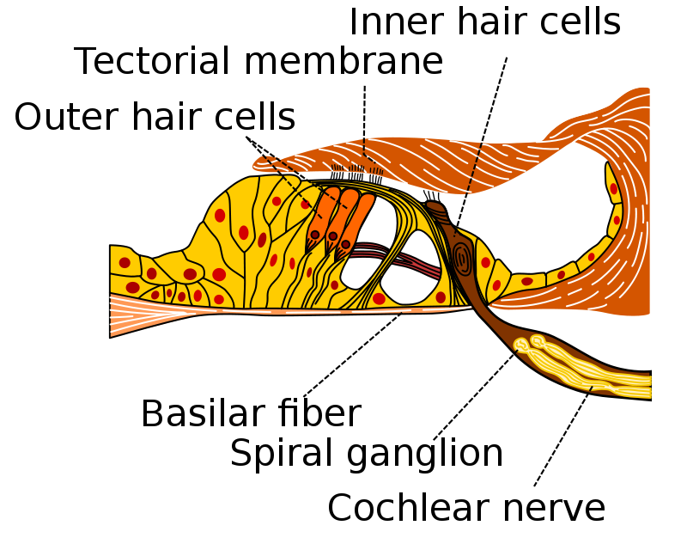
CREDIT: WIKIPEDIA
The function of the organ of Corti is to change (transduce) auditory signals and minimise the hair cells’ extraction of sound energy. It is the auricle and middle ear that act as mechanical transformers and amplifiers so that the sound waves end up with amplitudes 22 times greater than when they entered the ear.
clinical anatomy
The organ of Corti can be damaged by excessive sound levels, leading to noise-induced impairment.
The most common kind of hearing impairment, sensorineural hearing loss, includes as one major cause the reduction of function in the organ of Corti. Specifically, the active amplification function of the outer hair cells is very sensitive to damage from exposure to trauma from overly-loud sounds or to certain ototoxic drugs. Once outer hair cells are damaged, they do not regenerate, and the result is a loss of sensitivity and an abnormally large growth of loudness (known as recruitment) in the part of the spectrum that the damaged cells serve.

