NAME: ESAN FAITH
ANA 202
18/mhs07/017
Pharmacology
Assignment

WHY DO WE HAVE THE PORTAL VEIN OR LIVER RECEIVING MORE BLOOD FROM THE VEIN THAN THE ARTERY ?

In the hepatic portal system, the liver receives a dual blood supply from the hepatic portal vein and the hepatic arteries.
Outline of the blood flow to and from the liver
- The hepatic portal vein supplies 75% of the blood to the liver, while the hepatic arteries supply the remaining 25%.
- Approximately half of the liver’s oxygen demand is met by the hepatic portal vein, and half is met by the hepatic arteries.
- The hepatic portal system connects the capillaries of the gastrointestinal tract with the capillaries in the liver. Nutrient-rich blood leaves the gastrointestinal tract and is first brought to the liver for processing before being sent to the heart.
In the hepatic portal system, the liver receives a dual blood supply from the hepatic portal vein and hepatic arteries. The hepatic portal vein carries venous blood drained from the spleen, gastrointestinal tract and its associated organs; it supplies approximately 75% of the liver’s blood. The hepatic arteries supply arterial blood to the liver and account for the remainder of its blood flow.
Oxygen is provided from both sources; approximately half of the liver’s oxygen demand is met by the hepatic portal vein, and half is met by the hepatic arteries. Blood flows through the liver tissue and empties into the central vein of each lobule. The central veins coalesce into hepatic veins that collect the blood leaving the liver and bring it to the heart.
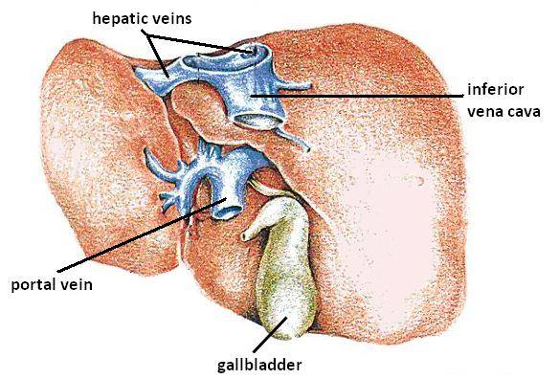
Hepatic veins: An image of a liver with the hepatic veins labeled. They are located in the inferior vena cava.
A portal system is a venous structure that enables blood from one set of capillary beds to drain into another set of capillary beds, without first returning this blood to the heart. The majority of capillaries in the body drain directly into the heart, so portal systems are unusual. The hepatic portal system connects the capillaries of the gastrointestinal tract with the capillaries in the liver. Nutrient-rich blood leaves the gastrointestinal tract and is first brought to the liver for processing before being sent to the heart. Here, carbohydrates and amino acids can be stored or used to make new proteins and carbohydrates.

DISCUSS 5 DISEASES CONDITIONS OF THE LIVER

Hepatitis: Hepatitis is a viral infection of your liver. It causes inflammation and liver damage, making it difficult for your liver to function as it should. All types of hepatitis are contagious, but you can reduce your risk by getting vaccinated for types A and B or taking other preventive steps, including practicing safe sex and not sharing needles. There are five types of hepatitis:
- Hepatitis A is typically spread through contact with contaminated food or water. Symptoms may clear up without treatment, but recovery can take a few weeks.
- Hepatitis B can be acute (short-term) or chronic (long-term). It’s spread through bodily fluids, such as blood and semen. While hepatitis B is treatable, there’s no cure for it. Early treatment is key to avoiding complications, so it’s best to get regular screenings if you’re at risk.
- Hepatitis C can also be acute or chronic. It’s often spread through contact with blood from someone with hepatitis C. While it often doesn’t cause symptoms in its early stages, it can lead to permanent liver damage in its later stages.
- Hepatitis D is a serious form of hepatitis that only develops in people with hepatitis B — it can’t be contracted on its own. It can also be either acute or chronic.
- Hepatitis E is usually caused by drinking contaminated water. Generally, it clears up on its own within a few weeks without any lasting complications.

Fatty liver disease: Fat buildup in the liver can lead to fatty liver disease. There are two types of fatty liver disease:
- alcoholic fatty liver disease, which is caused by heavy alcohol consumption
- nonalcoholic fatty liver disease, which is caused by other factors experts are still trying to understand
Left unmanaged, both types of fatty liver disease can cause liver damage, leading to cirrhosis and liver failure. Diet and other lifestyle changes can often improve symptoms and reduce your risk of complications.

Autoimmune conditions : Autoimmune conditions involve your immune system mistakenly attacking healthy cells in your body. Several autoimmune conditions involve your immune system attacking cells and your liver, including:
- Autoimmune hepatitis. This condition causes your immune system to attack your liver, resulting in inflammation. Left untreated, it can lead to cirrhosis and liver failure.
- Primary biliary cirrhosis (PBC). This results from damage to the bile ducts in your liver, causing a buildup of bile. PBC can lead to eventual cirrhosis and liver failure.
- Primary sclerosing cholangitis. This inflammatory condition causes gradual damage to your bile ducts. They eventually become blocked, causing bile to build up in your liver. This can lead to cirrhosis or liver failure.
- liver to absorb copper instead of releasing it into your bile ducts. Eventually, your liver may become too damaged to store more copper, allowing it to travel through your bloodstream and damage other parts of your body, including your brain.
- Alpha-1 antitrypsin (AT) deficiency occurs when your liver can’t make enough alpha-1 antitrypsin, a protein that helps prevent enzyme breakdowns throughout your body. This condition can cause lung disease as well as liver disease. There’s no cure, but treatment can help.

Cancer: Liver cancers first develop in your liver. If cancer starts elsewhere in the body but spreads to the liver, it’s called secondary liver cancer. The most common type of liver cancer is hepatocellular carcinoma. It tends to develop as several small sports of cancer in your liver, though it can also start as a single tumor. Complications of other liver diseases, especially those that aren’t treated, may contribute to the development of liver cancer.

Cirrhosis
Cirrhosis refers to scarring that results from liver diseases and other causes of liver damage, such as alcohol use disorder. Cystic fibrosis and syphilis may also lead to liver damage and, eventually, cirrhosis. Your liver can regenerate in response to damage, but this process usually results in the development of scar tissue. The more scar tissue that develops, the harder it is for your liver to function properly. In its early stages, cirrhosis is often treatable by addressing the underlying cause. But left unmanaged, it can lead to other complications and become life-threatening.

