NAME: AYENI, Adetola Olufoyeke
MATRIC NO: 17/MHS01/073
COURSE: Histology of Special Senses and Neurohistology
COURSE CODE: ANA 305
ASSIGNMENT TITLE: Histology of the Ear
DATE: 21th June, 2020.

QUESTION: With the aid of diagram, write an essay on the Histology of the Organ of Corti.
- DIAGRAM OF THE ORGAN OF CORTI
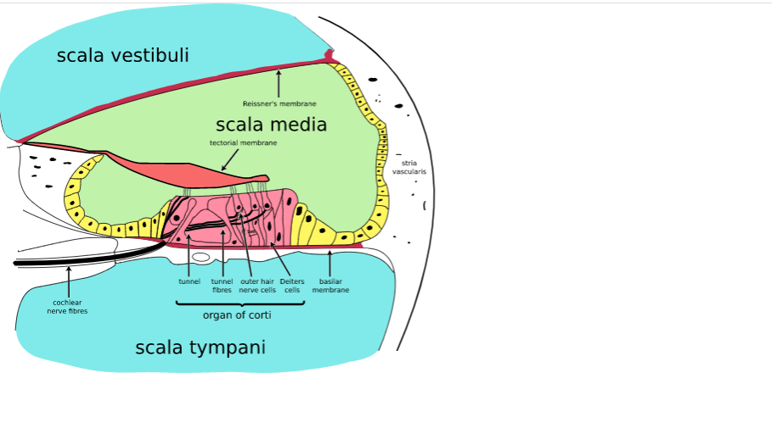
The Diagram of the organ of Corti showing its location between the scala tympani and scala media of the mammalian ear. There is also presence of hair cells, membranes and presence of cochlear nerve.

- INTRODUCTION:
The ear is an organ for hearing and equilibrium. The organ of Corti is the receptor organ for hearing and is located in the mammalian cochlea (cochlear duct) of the ear. It can also be referred to as the Spiral organ. It is a specialized sensory epithelium that allows for the transduction of sound vibrations into neural signals. It consists of hair cells in which vibrations caused by sound waves bend the stereocilia on these hair cells via an electromechanical force. The hair cells convert mechanical energy into electrical energy that is transmitted to the central nervous system via the auditory nerve and facilitate audition.
The organ of Corti in between the scala tympani and the scala media develops after the formation and growth of the cochlear duct. The inner and outer hair cells then differentiate into their appropriate positions and are followed by the organization of the supporting cells.
- FUNCTION:
The primary function of the organ of corti is: The transduction of auditory signals. The organ of Corti responds to sounds.
- STRUCTURE:
The organ of Corti is an organ of the inner ear located within the scala media of the cochlea. It resides on the basilar membrane which is a stiff membrane that separates the scala tympani and the scala media. The scala media is a cavity within the cochlea that contains endolymph which has a high (150mM) K+ concentration. The function of the endolymph is to help regulate the electrochemical impulses of the auditory hair cells.
The organ of Corti is composed of:
I. Supporting cells
II. Mechanosensory cells.
The mechanosensory cells are arranged into inner and outer hair cells along rows. There is also presence of a single row of inner hair cells and three rows of outer hair cells which are separated by the supporting cells. The supporting cells are also named Dieters or phalangeal cells. The three rows of outer hair cells that possess stereocilia (but no kinocilium) on their apical border synapse with the bipolar neurons of the cochlear (spiral) ganglion of CN VIII.
These hair cells within the organ of Corti have stereocilia that is attached to the tentorial membrane. The shifts between the tectorial and basilar membranes move these stereocilia and activate or deactivate receptors on the hair surface. When cation channels open the hair cells, potassium ions flow into the hair cells, the cells depolarize and the depolarization causes voltage-gated calcium channels to open. The calcium influx results in glutamate release from the hair cells onto the auditory nerve. The auditory nerve then sends information about the sound wave to the brain.
- HAIR CELLS:
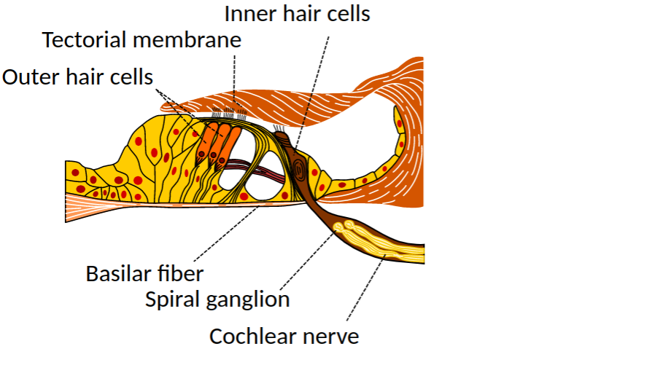
The diagram above indicates the outer and inner hair cells.
The organ of Corti contains several hair cells which are classified into 2.
I. Inner hair cells
II. Outer hair cells.
INNER HAIR CELLS:
They function primarily as the sensory organs for audition. They provide input to 95% of the auditory nerve fibres that project to the brain. The stiffness and size of the hair cells arrangement throughout the cochlear enable hair cells to respond to variety of frequencies from low to high. Cells at the apex to respond to lower frequencies while hair cells at the base of the cochlea (near the oval window) respond to higher frequencies which creates a tonotopic gradient throughout the cochlea.
OUTER HAIR CELLS:
While the inner hair cells are the output center of the cochlea, the outer hair cells are the input center. They receive input from the brain to assist with the modulation of inner hair cell function (i.e., modulating tuning and intensity information). Unlike the regions of the brain, the modulation of inner hair cells by outer hair cells is not electrical nut mechanical. The activation of outer hair cells changes the stiffness of their cell bodies; his manipulates the resonance of perilymph fluid movement within the scala media and it allows for fine-tuning of inner hair cell activation.
These two cells (outer and inner hair cells) are distinctly different in structure but they both have stereocilia on their apical surface. However, the arrangement of stereocilia and their connection to the tentorial membrane are distinctly different. The total number of outer hair cells in the cochlea has been estimated at 12,000 and the number of inner hair cells at 3,500.
NOTE THAT:
• For both types of hair cells, the mechanical bending of the stereocilia opens potassium channels at the tips of the stereocilia that allow hyperpolarization of the cells.
• The tallest of the stereocilia of outer hair cells are in contact with the tectorial membrane which is rich in tectorin. These stereocilia get displaced as the basilar membrane moves with the tectorial membrane. While the stereocilia of the inner hair cells are free-floating.
• The stereocilia are about 3 to 5 μm in length. The longest of outer hair cells make contact with but do not penetrate the tectorial membrane. This membrane is an acellular gelatinous structure that covers the top of the spiral limbus as a thin fibrillar layer and then becomes thicker as it extends outward over the inner sulcus and the reticular lamina. Its fibrils extend radially and somewhat obliquely to end at its lateral border, just above the junction of the reticular lamina and the cells of Hensen.
• The spaces between the outer hair cells are filled by oddly shaped extensions (phalangeal plates) of the supporting cells. The double row of head plates of the inner and outer pillar cells cover the tunnel and separate the inner from the outer hair cells. The reticular lamina extends from the inner border cells near the inner sulcus to the Hensen cells but does not include either of these cell groups. When a hair cell degenerates and disappears as a result of aging, disease, or noise-induced injury, its place is quickly covered by the adjacent phalangeal plates, which expand to form an easily recognized “scar.”
• Inner hair cells transduce sound from vibrations to neural signals via the shearing action of their stereocilia. Outer hair cells serve a function as acoustic pre-amplifiers which improve frequency selectivity by allowing the organ of Corti to become attuned to specific frequencies, like those of speech or music.
Also,
The inner cell activation is much more complicated than that of the outer hair cell activation. The movement of the fluid within the scala media relies on the resonance (vibration) of both the tentorial membrane and organ of Corti. The cells within the organ of corti are much more flexible than the cells within the basilar membrane. The altercation of the stiffness of these cells change the resonance of the organ of Corti and subsequently the movement of fluid within the scala media.
The outer hair cells alter protein and the stiffness of the organ of Corti through a motor protein, prestin, located on the lateral membrane of these cells. These proteins vary in shape and response to shorten, shifting the basilar membrane and increasing the membrane deflection thereby intensifying the effect on the inner hair cells.
- SUPPORTING CELLS OF ORGAN OF CORTI
The supporting cells are cells that support and as well separate the single row of inner cells and three rows of the outer hair cells of the mechanosensory cells. They are into 4. They are:
I. Inner and Outer pillar cells: These are tall cells with wide bases and apical ends that are attached to basilar membrane. The central portions are deflected to form the walls of inner tunnel with the apical portion in contact with each other.
II. Phalangeal cells are into 2:
-Inner phalangeal cells are cells located deep to the inner pillar cells and they completely surround the inner hair cells
-Outer phalangeal cells are tall columnar cells that are attached to the basilar membrane. Their apical portions are cup-shaped to support the basilar portions to outer hair cells along with efferent and afferent nerve fibers. They do no reach the free surface of organ of Corti.
III. Border cells are slender cells that support the inner aspects of organ of Corti. They delineate the inner border of the organ of Corti.
IV. Cells of Hensen are cells that are located between the outer phalangeal cells and cells of Claudius. They define the outer border.
There are also presence of cells of Claudius are cells (basal cells) that are reflected into the spiral sulcus where they become cuboidal and continue onto the basilar lamina and they overlie the smaller cells of Bottcher.
- MEDICAL APPLICATION
- Deafness
Deafness is the condition of being deaf; the lack or loss of the ability to hear. The organ of Corti can be damaged by excessive sound levels, leading to noise-induced impairment. This can result from many factors which usually fall under 2 categories.
I. Conductive hearing loss:
This involves various problems in the middle ear which can reduce conduction of vibrations by the chains of ossicles from the tympanic membrane to the oval window.
-Otosclerosis: This is the condition caused by the lesion of the bony labyrinth
-Otitis media: This is the inflammation of the middle ear
II. Sensorineural deafness:
This could be congenital or acquired and due to defects in any structure or cell from the cochlea to auditory centers of the brain but it commonly involves loss of hair cells or nerve degeneration. Sensorineural hearing loss is the most common and includes as one major cause the reduction of function in the organ of Corti.
Specifically, the active amplification function of the outer hair cells is very sensitive to damage from exposure to trauma from overly-loud sounds or to certain ototoxic drugs. Once outer hair cells are damaged, they do not regenerate, and the result is a loss of sensitivity and an abnormally large growth of loudness (known as recruitment) in the part of the spectrum that the damaged cells serve.

